In accordance with the requirements of the Arkansas State Vehicle Safety Program (VSP), the **Arkansas Insurance Department (AID) reminds all State Agencies that any employee involved in an at-fault accident or certain other driving-related convictions is required to attend an authorized, in-person defensive driving program before being allowed to operate either a State vehicle or a privately owned vehicle while on State business.** Please Note: the VSP program does not permit the use of on-line courses. Be sure to refer to the VSP for additional requirements that may apply to remain in compliance with the program.

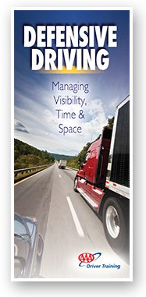

***The course has been found useful for assisting in removal of traffic tickets in some cases and possible reductions in automobile insurance premiums***, as well as reviewing or expanding knowledge of Arkansas traffic laws and regulations. Local courts and insurance agents should be contacted by the registrant for further information in this regard.

***The AID Risk Management Division offers a one-day class without program charge*** on a monthly basis at the AID offices in Little Rock that is administered by a certified instructor. Please contact the division (see below) for further information and course registration. **In addition,** **AID is available to conduct the class anywhere in the state with a minimum of five (5) attendees, also free of program charge.**

Although the program is required as outlined in the VSP for certain State employees, **any State employee may take the class**.

Please contact the AID Risk Management Division for questions about the program or scheduling of additional in-state classes.

**Arkansas Insurance Department**

Risk Management Division

(501) 371-2690

[insurance.risk.management@arkansas.gov](mailto:insurance.risk.management@arkansas.gov)

Downtown Little Rock location:

1200 West Third Street

Little Rock, AR 72201-1904

*Parking is available at the intersection of South Cross St. and West 2nd.*

