How to Schedule Exams
- Go to the Disability Services website at https://www.atu.edu/disabilities/ .
- Click on the third icon labeled “Login to the Disability Services Portal”.

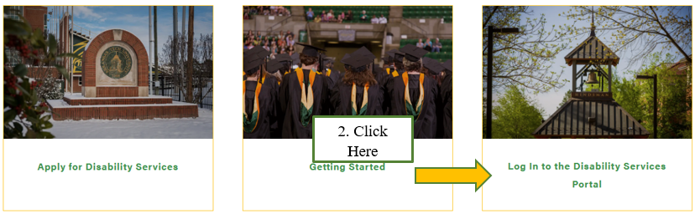

- Enter your OneTech username and password in the appropriate fields and complete the two factor authenticator.
- Complete steps to proceed to the Student Dashboard.

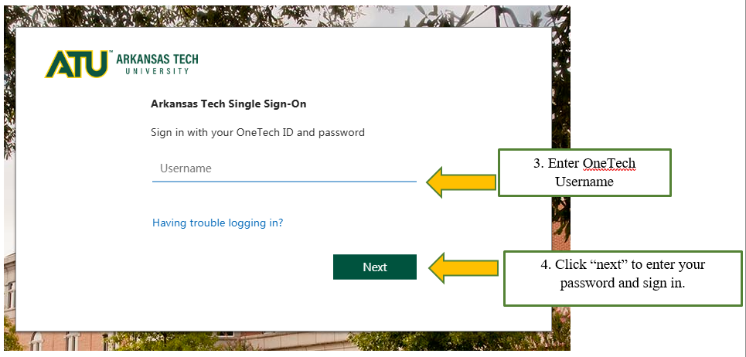

- Once you have logged into the system. On the left-hand side under “Accommodations” click “Alternative Testing”.

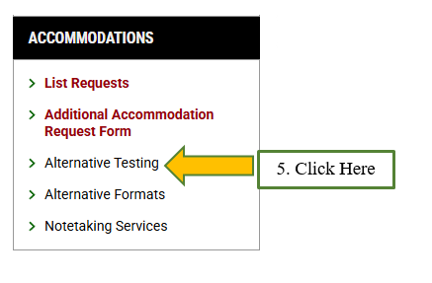

- Select the class you would like to schedule an exam for from the drop-down box. Then click “Schedule an Exam” to continue your request.

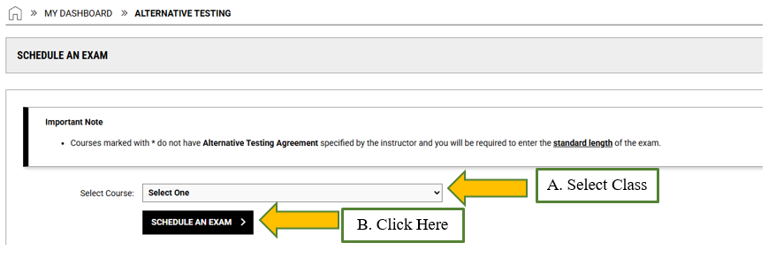

- Complete the “Exam Detail”. Then “Add Exam Request”.

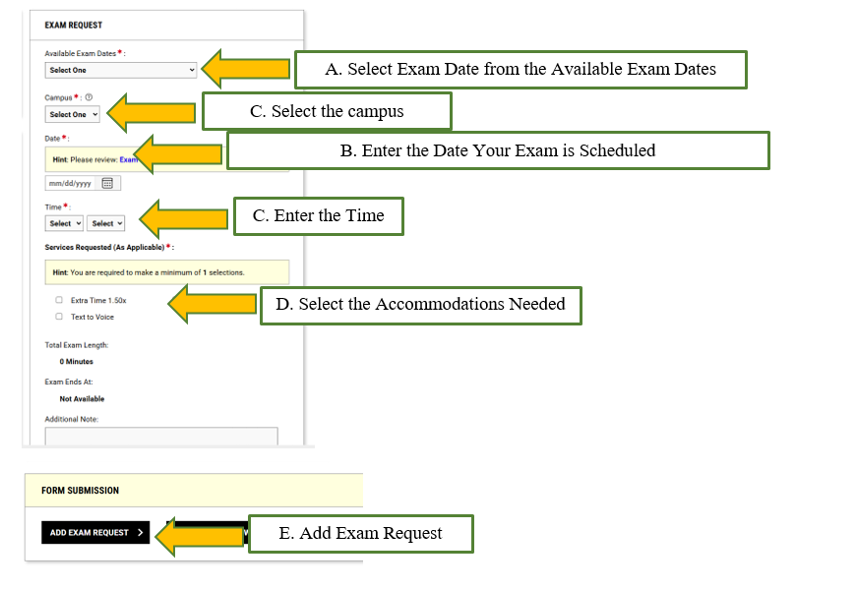
- The system will notify you that you have successfully submitted your request.

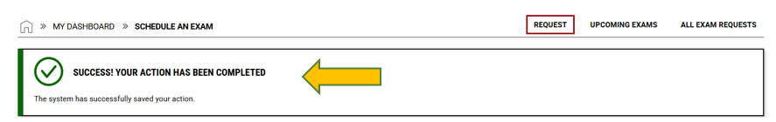
- If you go back to the “Alternative Testing” page under “Accommodations” you will be able to view the status of all your exam requests. The Office of Testing Services will review and approve your request. An email will be sent to your instructor informing them of your scheduled exam.
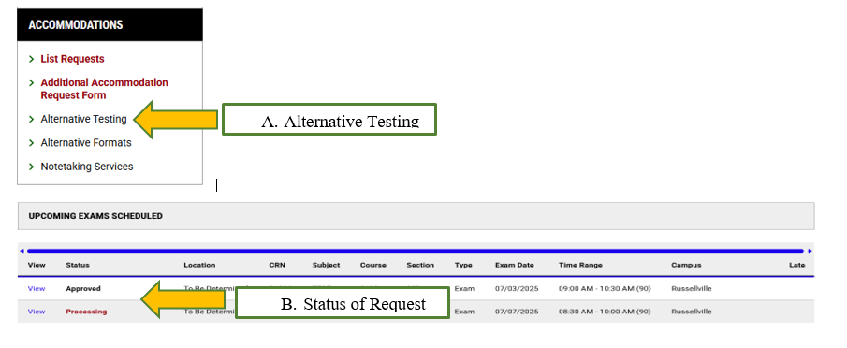
Common Error – “Date”
This error occurs when you select a test date on which the Testing Center is either closed or operating with limited hours. Please choose an alternative date when the center is open and fully operational.

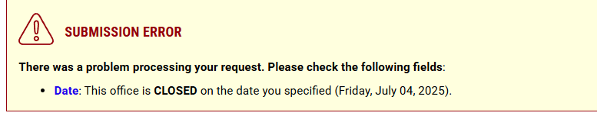

Common Error – “Exam Type”
This error typically occurs when you have another exam scheduled on the same day and during the same time range. To resolve this, you will need to select a different time for your exam. Please be sure to communicate with your instructor to approve the new test time.

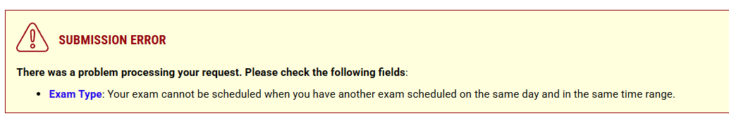

Common Error – “Time”
This error typically occurs when you attempt to schedule your exam outside the approved hours of operation. To resolve this issue, please schedule your exam within the designated time frame, making sure to account for the full length of your exam.

