Instructor AIM Guide: Overview
- Go to the Disability Services website.
- Click “Faculty Resources” tab.
- Select the “Instructor Portal” dropdown and click “Instructor Portal”
OR
- You may click the link provided in the notification letter sent by Disability Services.

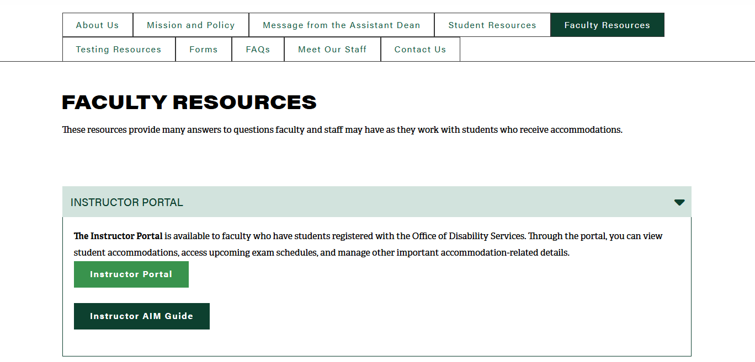
OR

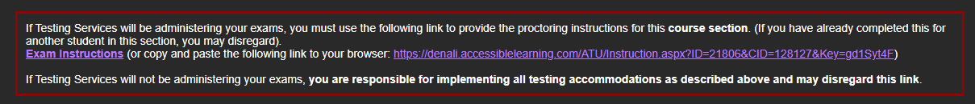



- Use your OneTech username and password to login to the Disability Services portal and click “Next”

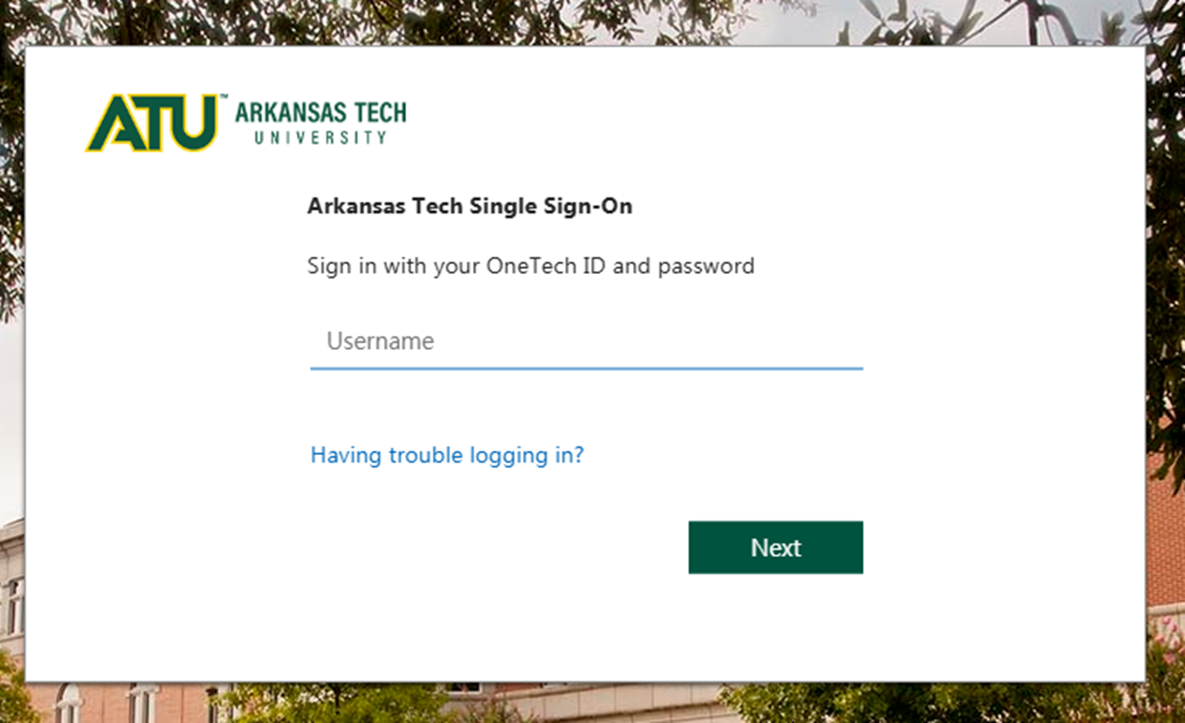

- Read and acknowledge the FERPA agreement. Then select “Continue to View Student Accommodations”

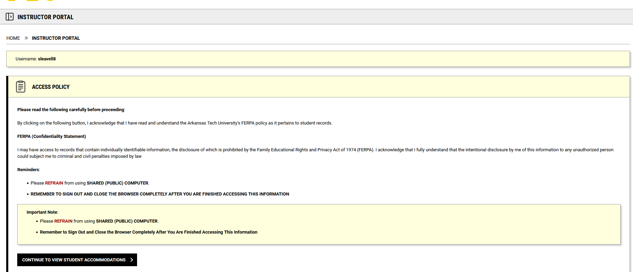

- Select “Exam Instructions”

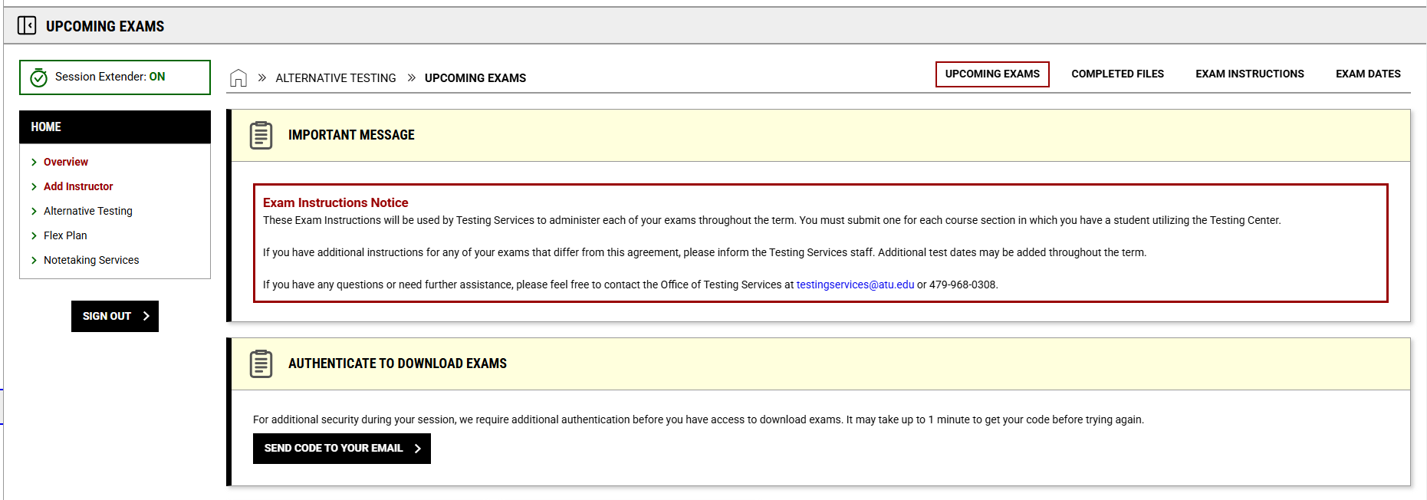

- You can select the Course using the drop down menu.
- Then click “View” to enter in the instructions for each specific class.
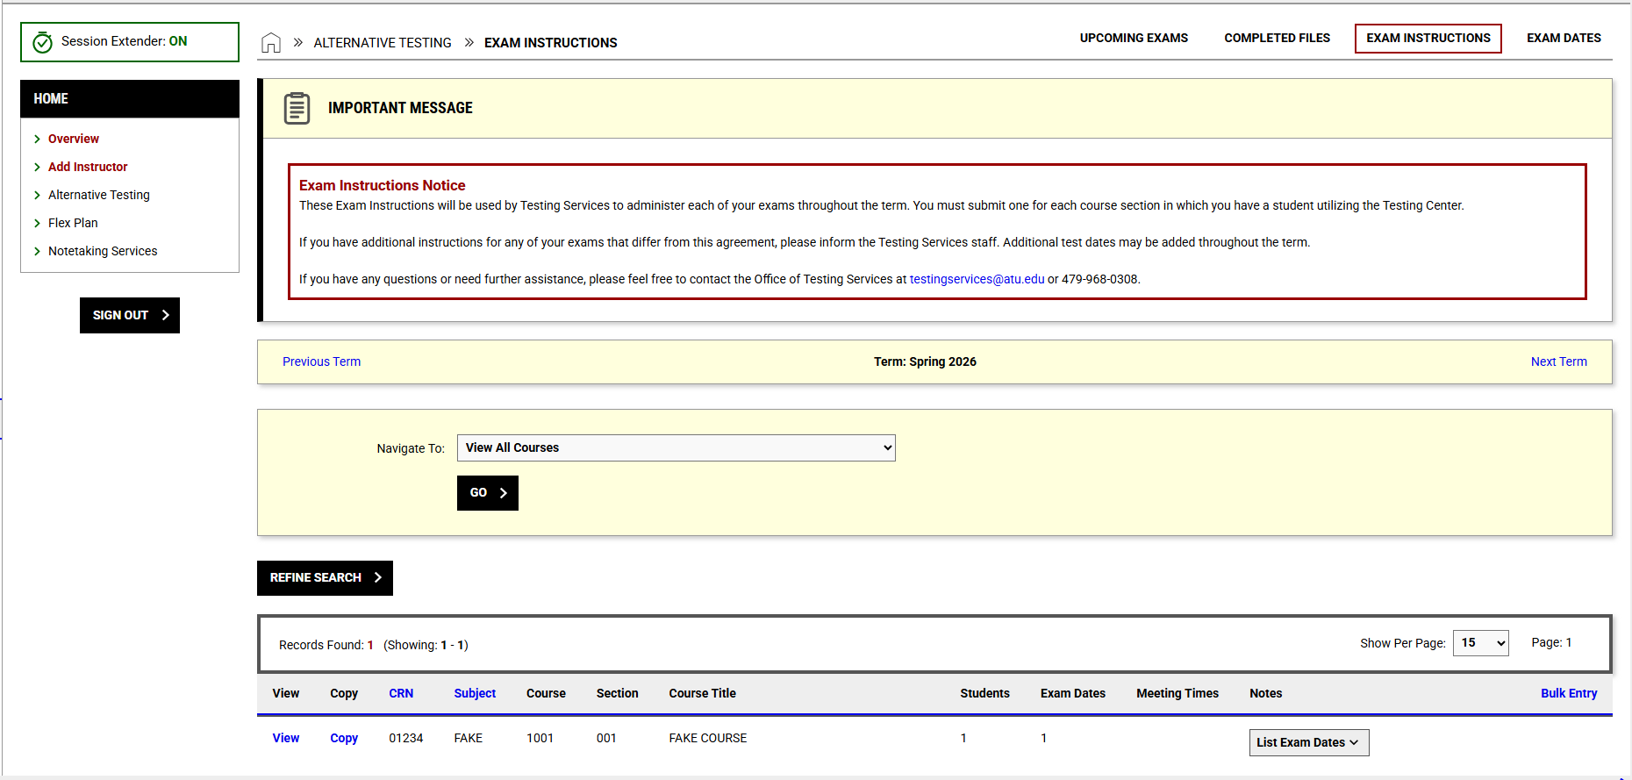

- Fill out the required fields and click “Update and View Exam Dates”.

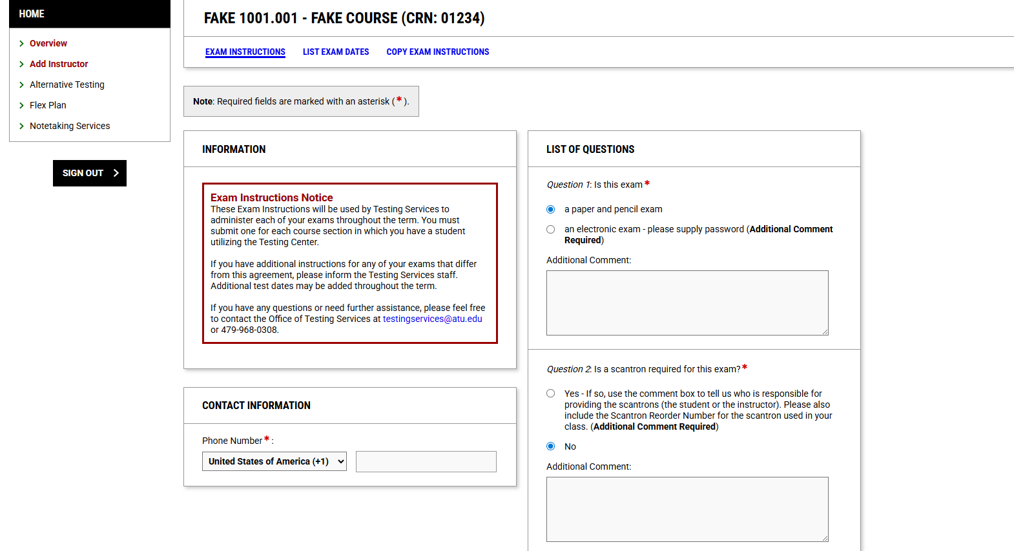
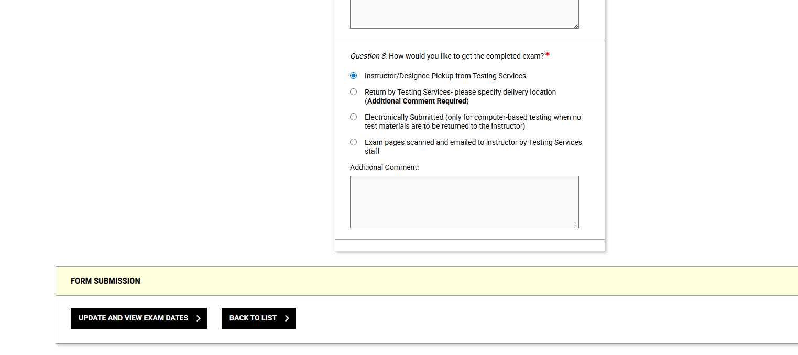

- You can modify exam dates from this menu using the “Modify” button.
- While you aren’t required to input exam dates, the following screen is where you will do so if you would like to specify when the student can take the exam. Please be sure to specify how long the class has to take the exam.
- Once you’ve finished, click “Save”.

