**Strategic Plan**

**Introduction**

The process of developing this strategic plan began in the spring of 2015 and has deliberately been a broad, transparent effort, reaching out to all parts and levels of Arkansas Tech University for dialogue. The primary generation and elaboration of ideas has occurred in the varied operations of the Strategic Planning Committee (SPC) and its working groups. The effort was ambitious. The 24 members of the SPC met weekly, or more often, through the fall of 2015, and the 49 members of five working groups met still more often as they produced white papers on key topics. The SPC and its working groups were led by faculty with full participation by administrators and staff, as well as students and community members. Public discussion was invited through multiple open forums and the ability to comment on the website. The SPC developed the first full draft of the plan--all drafts of the plan and the completed white papers were available to the campus community on the website [(www.atu.e](http://www.atu.edu/strategicplanning))d[u/strategicplanning).](http://www.atu.edu/strategicplanning))

The SPC has recommended its draft of the plan to the Executive Planning Council (EPC). The EPC, comprised of faculty, senior administrators and a member of the board of trustees has refined the plan and has recommended the revised plan to the president. Upon review and possible modifications by the president, the plan will be communicated broadly with further comments taken into account. Finally, it will be presented by the president to the board of trustees for adoption in the spring of 2016.

Part of the reason for beginning with this description of the process is to show that the process has been exhaustive and the participation broad. Another reason is to suggest that the intensiveness of the effort has been very important. The goals are sweeping and the action items to achieve them are quite specific, even hardnosed in some cases. This serious effort, particularly by the working groups and SPC, led to rational ideas, but also to expressed passion for and about Arkansas Tech University. The phrase One University was used by several of these groups and seems to capture the passion that developed at the core of the effort. For that reason, the plan itself is framed in terms of this image of One University.

**The Plan for Arkansas Tech University**

Arkansas Tech University is a comprehensive public higher education institution that is committed to teaching and learning supported by scholarship and service. The paths to Arkansas Tech University taken by our students, faculty, staff, and alumni, the central essence of our university, have been many, and there will no doubt be additional paths to the idea and actuality of our university in the future. While the paths have been diverse, the goal is a oneness where the relations, actions, and connections of the university’s human core develop, cohere, and flourish. For us, this is Arkansas Tech University at its best, as One University.

This is not a simple or limiting oneness but a rich, dynamic, participatory and integrating oneness: it is the oneness of teaching, learning, scholarship, and service engaged in by faculty and students, supported and made possible by staff; it is the oneness of multiple campuses as One University—Russellville, Ozark, and the Career Center; it is the oneness of introductory studies, technology-based studies, and a broad variety of university studies; it is the oneness of a rich variety of ethnic origins, genders, sexual orientations, nationalities, religions, social and economic classes, intellectual stances, and political persuasions. It is also the oneness of multiple levels of certificates and degrees from associate to doctorate. Further, it is the oneness of our university positioned within a city, a region, a state and a global community. Finally, it is the oneness of Arkansas Tech University as a family, a family fully committed to the academic and career success of its students.

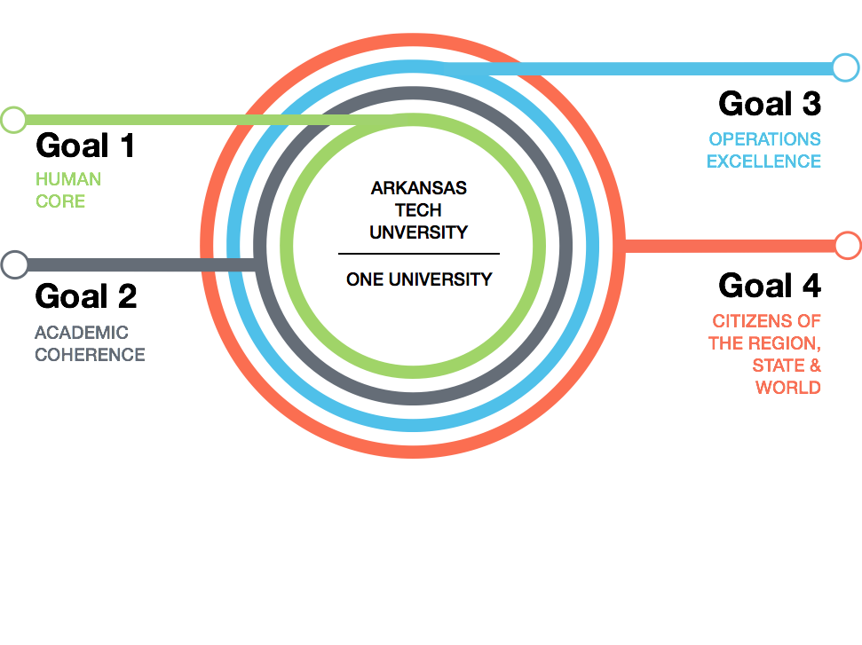

The power of this oneness comes from our human core, which must be attended to and supported if the conceptual framework of One University is to be fully realized. This will require attention to a variety of issues in order to progress from where we are now to a more fully developed embodiment of what we can be. To bring out the best in our human core, for students, we must ensure their success by helping them enter the university in a manner that sets up achievement, reducing unnecessary barriers, and ensuring that they complete their degrees and move into their futures and careers prepared to succeed, just as they have at Arkansas Tech University. For faculty, we must work toward fair compensation and course loads. For staff, we must offer fair compensation and sufficient resources to accomplish their required tasks. For alumni, we must maintain or elevate the prestige of the degrees they have earned. This attention to and support of the human core leads to goal #1.

**Goal 1: Provide the learning environments needed for students to flourish and graduate from ATU equipped for a meaningful and satisfying future. At the same time, provide the support needed for faculty and staff to do the best work possible in their roles as teachers, scholars, mentors and as supporters and facilitators of learning, respectively.**

Action Items

1) Using the national graduation rate average as the benchmark, achieve a minimum annual increase of the graduation rate of one percentage point per year.

2 Establish and achieve employee compensation targets using the median of the CUPA regional comparison group or the appropriate comparison data, local/regional salaries of similar positions, and recognition of merit and years of service at Arkansas Tech.

3) Develop staffing-level policies and plans for both faculty and staff.

Implement any non-additive adjustments as soon as reasonably possible and make any additive adjustments required as resources become available.

4) Enhance the University’s administrative research and planning capabilities, including the ability to generate, analyze, and communicate the import of data in support of student recruitment, enrollment, retention, and completion.

5) Develop scholarships and financial aid policies which are more deliberate in addressing the needs of socio-economic realities as well as incentivize students to regain lost scholarships.

6) Establish a robust, sophisticated, and proactive human resources function to ensure compliance with all HR-related legal requirements, to help hire strong and diverse employees, and to analyze employee issues (e.g., stepped-down or phased retirement) and propose responses in support of enhanced job performance and high morale.

7) Develop and implement a diversity and inclusion plan to include all stakeholders for our campuses.

8) Recognize, encourage and promote the use of co-curricular and high-impact educational practices (e.g. athletics, student research, student learning, internships, research, service learning, interdisciplinary project-based courses, study abroad, learning communities).

9) Establish an Office of Grants and Research Support that assists in securing external funds for student success initiatives, high-impact learning experiences, professional development and community engagement opportunities, and scholarly activities.

The next circle out from the human core is the academic structure and organization of our university. Arkansas Tech University should seek to be fully recognized in the Arkansas higher education landscape by prospective students, the public, and employers as the premier regional comprehensive university (SREB Four-Year Category 3) with recognition of its technology disciplines. This will require increased clarity and coherence of academic structures, so that they encourage synergy and efficiency as well as recognizing roots in disciplines and campuses and at the same time making connections across disciplines and campuses. Several opportunities exist to bridge and strengthen academic programs at ATU. Most immediately there are favorable conditions to grow in the areas of health, agriculture, and technology, as well as to explore initiatives in regional economic, cultural, and artistic development.

Greater clarity about deciding when courses should be delivered in person and when they should be delivered online will be important, particularly given the increasing market demand that comes from online courses. Further, students need degrees that connect with each other such that, for example, an associate’s degree from Ozark can lead smoothly to a bachelor’s degree that is completed in Russellville. Still further, providing recognition of multiple stages of increasing academic accomplishment by students can lead to greater rates of retention and completion.

To accomplish an evolution of academic structure, faculty members and administration will need to fully embrace their participation in shared governance and accept the responsibilities that it brings. All of this results in goal #2.

**Goal 2: Seek and implement new and stronger connections between courses or programs that will increase coherence as well as relevance to current and future students; develop an online program strategy; ensure that there are clear and available degree paths through the university such that more students achieve higher-level degrees.**

Action Items

1) Faculty Senate and Executive Council should collaborate to define the parameters and implementation of shared governance to accomplish the academic goals of the university.

2) Academic Affairs, in collaboration with appropriate university stakeholders, will directly oversee all university retention efforts by establishing a Student Success Center.

3) The University, through the Graduate College and in collaboration with other Colleges, will develop a comprehensive strategy for a renewed graduate education initiative that will propose new programs, develop services to promote success for graduate students, and create a marketing plan as appropriate.

4) The University, through the College of eTech and in collaboration with other Colleges, will develop a comprehensive strategy for a renewed online education initiative that will collaborate with Departments and Colleges to ensure innovation and sound pedagogy of existing online programs, will foster and support development of existing face-to-face programs into an online environment, will propose additional online educational opportunities (e.g., student success initiatives, certificates, undergraduate and graduate degree programs), will develop services to promote success for online students, and will create a marketing plan as appropriate.

5) Develop a strategy to review and modify all academic and co-curricular programs, and general education curricula (including additions and eliminations of programs no longer viable) to promote high academic standards, ensure currency within the field of study, and address current and future workforce trends.

6) To provide viable stackable degree opportunities within and between campuses which do not diminish the distinct educational objectives of each campus, existing curricula will be restructured and new programs will be developed (e.g., curricula in degree programs will be structured to provide certificates and/or other degrees during the natural progression of the educational pathway).

7) The VPAA and the Ozark Chancellor will give leadership to the development of academic programs that utilize the faculty and resources from different colleges and between campuses, resulting in greater coherence and continuity between existing programs and the creation of new programs which will address the changing educational/training workforce needs of the 21st century.

8) In collaboration between Academic Affairs and Student Services, develop a university ethics statement, develop and implement a method of tracking academic misconduct between courses, and investigate the need for a university-wide honor code for all stakeholders that addresses academic and professional behavior.

9) In collaboration between Academic Affairs and Student Services, develop and implement a plan to coordinate Student Services programming with the academic mission of the university.

The third concentric circle symbolic of One University is the support structure of robust and well-managed finances along with well-designed physical and technological infrastructure that is renewed in a timely fashion. Significant to the successful elaboration and functioning of this support structure is the ability to produce, analyze, communicate, and use multiple data sources. Along with data, there needs to be broad communication and transparency regarding operating budgets and capital expenditures, in clear language and in settings that allow for questions, discussion, and comment. Seeking clarity and understanding via an established communication process is important to the continual re-invigoration and full partnership of the human core at the heart of the university. Additionally, it is important to offer an infrastructure that is safe, accessible and well prepared. This circle of financial and physical support leads to goal #3.

**Goal 3: Ensure that ATU’s finances and infrastructure are appropriate to good stewardship in the changing landscape of higher education.**

Action Items

1) Optimize university revenue by understanding and recruiting students for specific programs, as well as reviewing and changing pricing strategies commensurate with the University’s brand strength within the state.

2) Redesign the university’s advancement function to enhance giving and increase grant awards.

3) Continue to develop a budgeting process that is transparent and well understood by stakeholders, has periodic evaluations and is designed to optimize university resources (including additions and eliminations of programs no longer viable).

4) Develop a campus facility master plan as a basis of a coherent, multi-year approach to facility and infrastructure needs. This master plan should be reviewed annually.

5) Develop a facilities and technology capital financial plan, including sources and uses of funding, that looks out up to ten years while focusing on the next five years, and is updated annually. The plan should include new buildings, technology, and infrastructure, as well as renovation and renewal of existing assets in these categories.

6) Develop and implement effective strategies of disseminating information across all levels of the university and determining if/what additional information would benefit faculty, staff, students, and/or Board of Trustee members.

7) The university will develop environmental sustainability initiatives.

The outermost concentric circle of One University is the participation of Arkansas Tech University as a public university in its cities, region, state and the global community. With the strength of its human core, its academic coherence and excellence, and its attention to strong operation by prudent financial management and a robust physical infrastructure, Arkansas Tech University makes and provides connections to its various communities. And this goal does not wait for the accomplishment of the other three goals, but must take place simultaneously—all the goals are interconnected. As an institution of Russellville and Ozark, Arkansas Tech University must work with official and non-official structures to support the off-campus life of its students, for their good and the good of the cities.

Engagement through student volunteer efforts and academic connection to the city and region through experiential learning further enhances a high-quality education. Pathways should be found to use new and existing knowledge to contribute to and support economic development. This collaboration can result in strengthened economic development and also be a benefit to the university and its students. This means increasing faculty and administrative connections with industry and business, particularly in contexts where listening can occur to better understand how Arkansas Tech University’s academic enterprise can be leveraged for regional economic and social benefit. The experiences of the Ozark campus may be particularly important because they have previously developed and valued connections with industry and business leaders.

Enhancing Arkansas Tech University’s visibility and recognition are important to successful engagement. The natural coherence and clarity that develop around One University is important, but professional help with communicating the university’s identity will also be needed to accomplish the public good components of the university mission and facilitate a clear public understanding of who and what defines Arkansas Tech University. The invigoration of Arkansas Tech University’s presence and participation outside its own campuses is the fourth and final goal.

**Goal 4: Increase ATU’s presence and effective participation in our cities, region, state, and world.**

Action Items

1) Increase the visibility of the University by strengthening the mission and vision statements, developing a 21st century brand identity, and conducting a detailed marketing analysis.

2) Improve the career readiness of students and alumni by establishing stronger and broader career services efforts, including collaborating with businesses to enhance these services and provide curricular recommendations.

3) Develop and implement a comprehensive plan for internationalization and global education.

4) Partner in economic development efforts with community, industry and regional and state governments to help recruit new business to the River Valley and Ozark regions, including the utilization of the El Paso- Glenwood Avenue extension corridor to unify Arkansas Tech

University with the city of Russellville.

5) Increase partnerships with city, regional, and state governments through marketing our established strengths and utilizing government liaisons, administration, faculty, staff, students and alumni.

**Strategic Planning Committee**

▪ Dr. Jason Warnick, Chair – *Associate Professor of Psychology*

▪ Dr. Daniel Bullock, Faculty Representative/Working Group Chair – *Associate*

*Professor of* *Electrical Engineering*

▪ Dr. Stephen Jones, Faculty Representative/Working Group Chair – *Associate*

*Dean of Business & Associate Professor of Management*

▪ Dr. Julie Mikles-Schluterman, Faculty Representative/Working Group Chair –

*Associate Professor of Sociology*

▪ Dr. Johnette Moody, Faculty Representative/Working Group Chair –

*Associate Professor of Computer & Information Science*

▪ Dr. Michael Rogers, Faculty Representative/Working Group Chair – *Associate*

*Professor of Political Science*

▪ Dr. Jon Clements, Faculty Representative – *Associate Professor of Music*

▪ Dr. John Freeman, Faculty Representative – *Director, Ed.D. Program & Professor of Educational Leadership*

▪ Dr. Eric Lovely, Faculty Representative – *Associate Professor of Biology*

▪ Dr. Lucas Maxwell, Faculty Representative – *Assistant Professor of*

*Agricultural Education*

▪ Ms. Lesley Krohn Snider, Ozark Faculty Representative – *Workforce*

*Education Faculty of Associate Degree Nursing*

▪ Ms. Aubrey Holt, Staff Representative – *Director of Campus Life*

▪ Mr. Yasu Onodera, Staff Representative – *Director of International & Multicultural Student Services*

▪ Mr. Ken Wester, Staff Representative – *Director of Information Systems*

▪ Ms. Sandy D. Cheffer – Ozark Staff Representative – *Chief Fiscal Officer*

▪ Ms. Tammy Rye, Classified Staff Representative – *Fiscal Support Analyst*

▪ Mr. Kelly Davis, Development/Alumni Representative – *Director of Alumni*

*Relations*

▪ Ms. Jocelyn Flores, Russellville Student Representative

▪ Mr. Tanner Howell, Ozark Student Representative

▪ Mr. Eliel Mendez, Russellville Student Representative

▪ Mr. Saul Pennington, Russellville Student Representative

▪ Ms. Julia Smith, Russellville Student Representative

▪ Ms. Angela Bonds, Community Representative

▪ Mayor Randy Horton, Community Representative

**Executive Planning Committee**

▪ Dr. AJ Anglin, Chair – *Interim Vice President for Academic Affairs*

* Mr. David Moseley, Vice Chair – *Senior Vice President for Administration & Finance*
* Ms. Susie Nicholson, Student Affairs Representative – *Vice President for Student Services & University Relations*
* Mr. Bruce Sikes, Ozark Administration Representative – *Chancellor, Ozark Campus*
* Mr. Patrick Hundley, Development Representative – *Interim Vice President for Development*
* Ms. Leigh Whiteside, Board of Trustees Representative
* Dr. Jason Warnick, Faculty Representative – *Associate Professor of Psychology*
* Dr. Jason Patton, Faculty Representative – *Associate Professor of Geology*
* Dr. Pat Buford, Faculty Representative – *Interim Associate Dean of Engineering & Professor of Electrical Engineering*
* Ms. Jessica Pipkins, Ozark Faculty Representative – *Adult Education Instructor*
* Dr. Robin Bowen, Ex Officio – *President*
* Ms. Shauna Donnell, Ex Officio – *Assistant Vice President for Enrollment Management*
* Mr. Wyatt Watson, Ex Officio – *Director of Institutional Research*