FACULTY SENATE HIRING PRACTICES

Items/statements used in this survey were based on statements made by faculty members to faculty senators and general issues brought before the faculty senate regarding hiring practices between 2012 and 2013. The intent of the survey was to determine if the majority of faculty shared these concerns. All statements were submitted by various faculty senate members and altered based on recommendations made by the faculty senate; that is, items were included or excluded based on the majority opinion in faculty senate. The final survey was approved by the faculty senate and then administered in Spring of 2013. What follows are the results…

Survey Overview

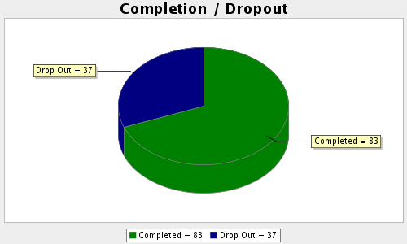
We would like to begin with some very general questions dealing with your department's practices and your opinions on the hiring process at ATU. Please indicate the extent to which you agree or disagree with the following statements by (clicking on, if online) the number corresponding to your opinion:

Our department typically forms committees of faculty members for job searches

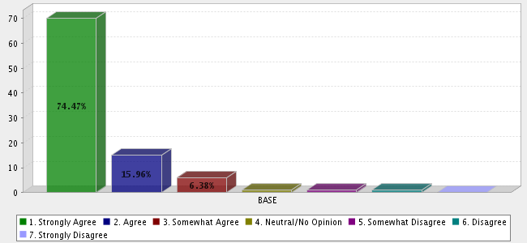
We typically appoint members from outside of our department to our job search committees

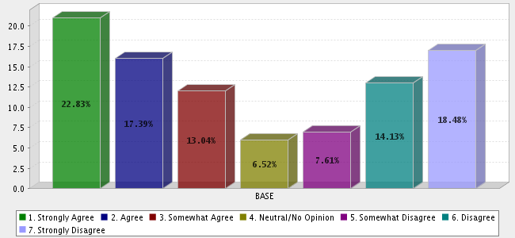
All faculty members in my department have equal input into the hiring process

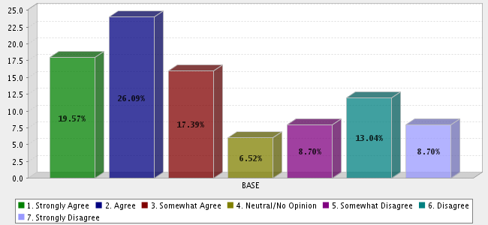
We work hard to recruit the most qualified faculty in our job hiring process

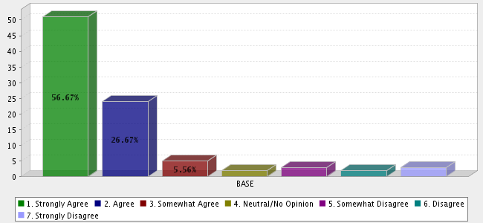
We typically hire a new faculty member based on their fit with our department's goals

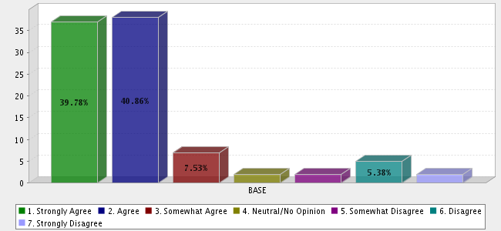
We make sure that all job candidates meet with all available faculty members during job visits

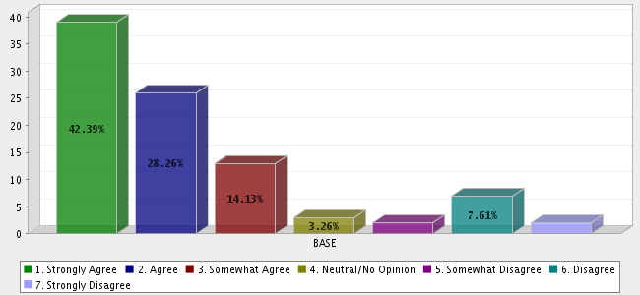
Our department head typically writes all of the job ads for hires in our department

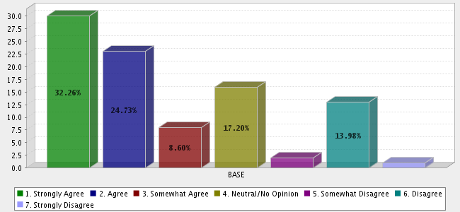
We work for consensus among all of the faculty in our department before recommending a hire

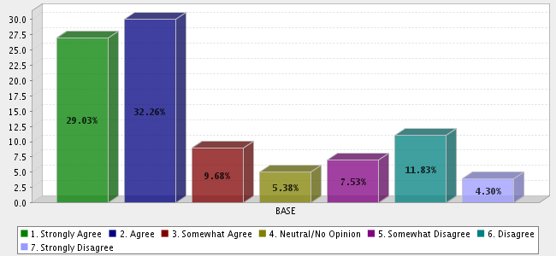
Our job searches are typically guided by clearly defined criteria/qualifications for the advertised positions

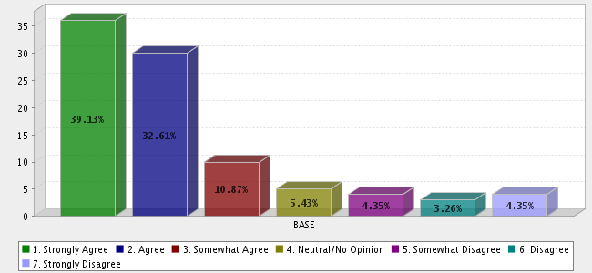
Our job search committees typically include women and underrepresented minorities

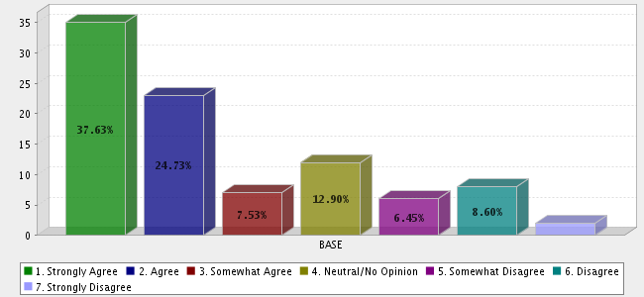
Our job search committees typically include members with different perspectives

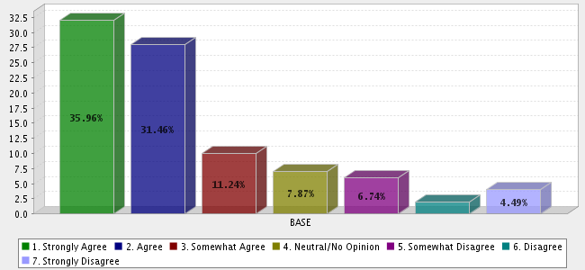
Our job search committees typically include members with diverse areas of expertise

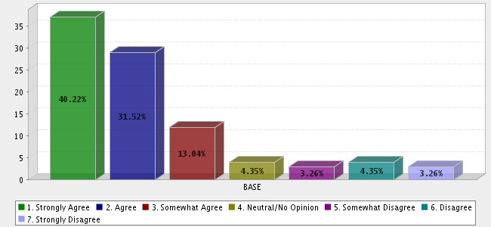
We typically hire a new faculty member based on their teaching ability

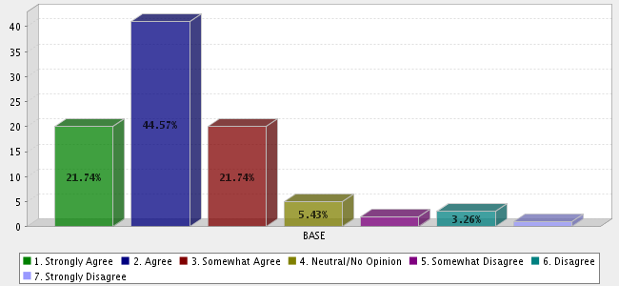
We typically hire a new faculty member based on their potential for scholarly work

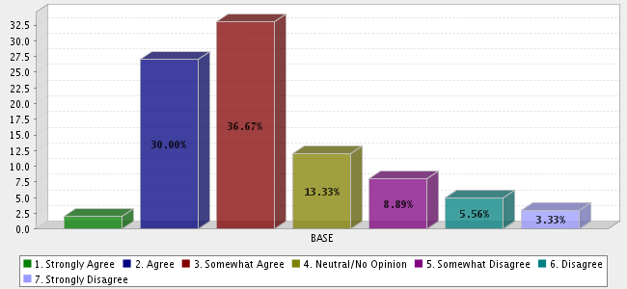
We typically hire a new faculty member based on their potential contribution to the department's climate (collegiality)

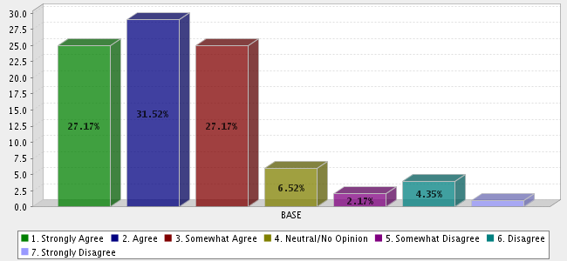
Our job candidates are required to present examples of their research to faculty and students in our department

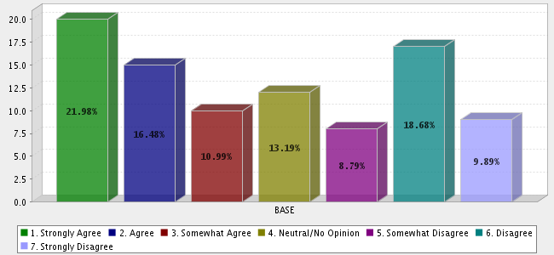
Our job candidates are required to teach a class while faculty observe

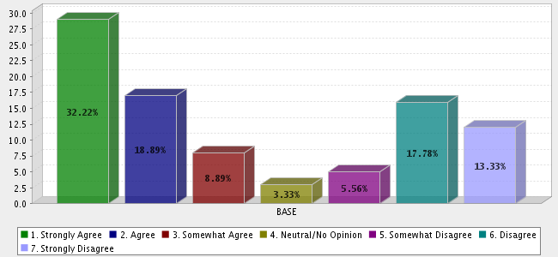
Overall, job searches in my department tend to be fair and objective

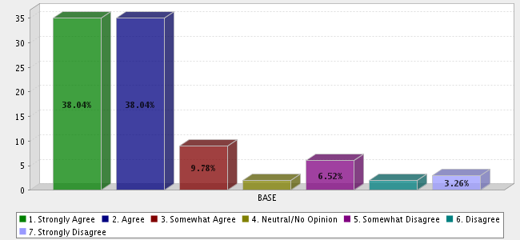
Overall, I feel that the job searches in my department are fair to job candidates

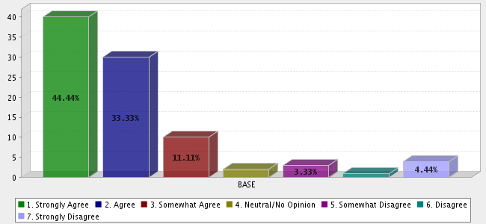
I would not change anything about the hiring practices in my department

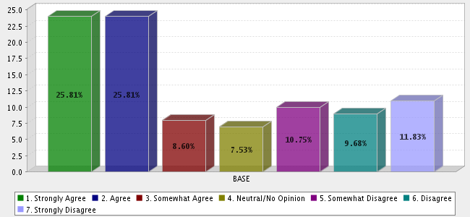
Next we would like to get some information on what you may perceive to be the problems in the hiring process at ATU. Below you will find a list of statements based on issues that have been raised with the Faculty Senate on the hiring process at ATU. While thinking about job hires in your department, please indicate the extent to which you agree or disagree with the following statements by (clicking on, if online) the number corresponding to your opinion:

The faculty hiring process at ATU is very different from the hiring process at other universities

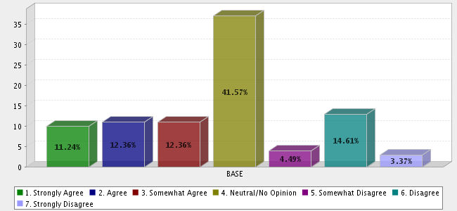
One of the problems with hiring qualified candidates is that ATU is not a welcoming place for potential new faculty

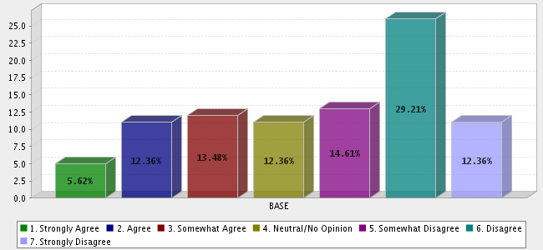
Faculty involvement in the hiring process is just for show because the administrators are the ones that decide

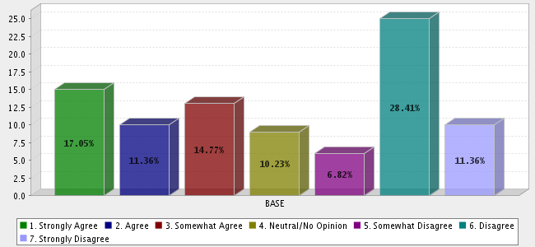
I think faculty should have greater autonomy in deciding who to hire

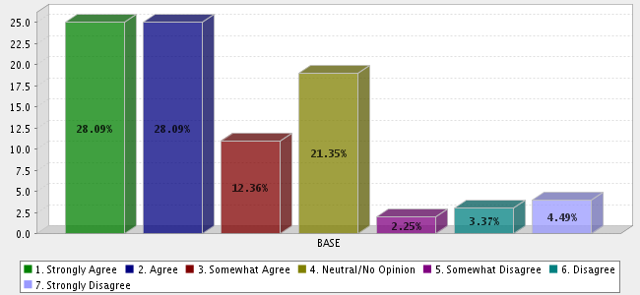
I feel like my opinion on job hires is not taken into account

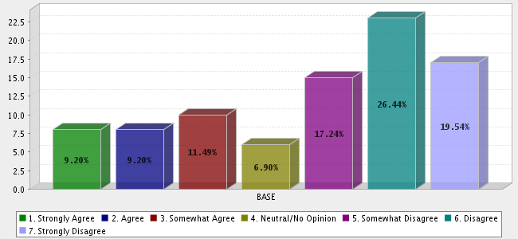
I think the administration unnecessarily interferes with our hiring process

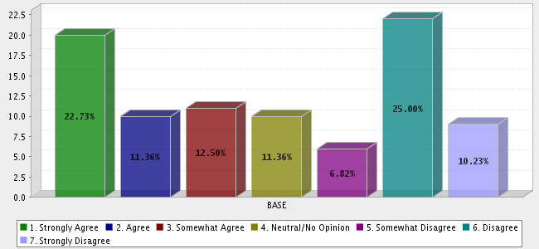
The faculty should be the ones to decide who gets hired

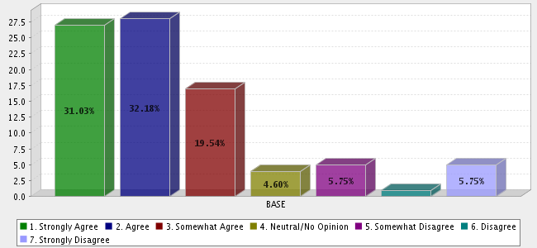
Some of the faculty members in my department interfere with the job hiring process

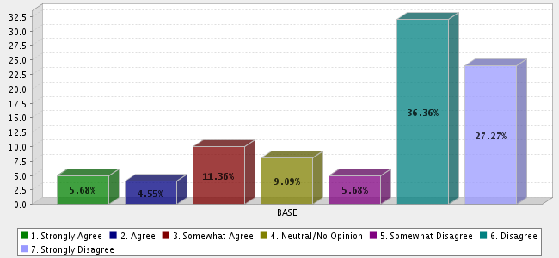
I feel like faculty decisions on job hires are ignored by the Dean

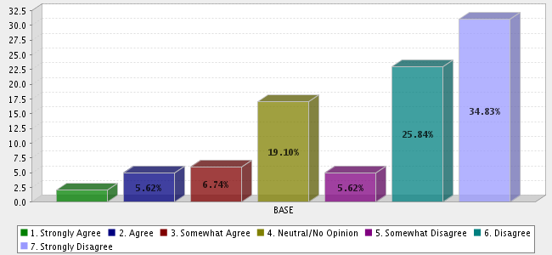
Typically, the Dean will just hire the person that s/he wants no matter what the faculty may say

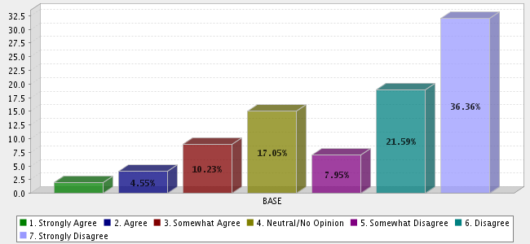
Our Dean typically supports hiring decisions made at the departmental level

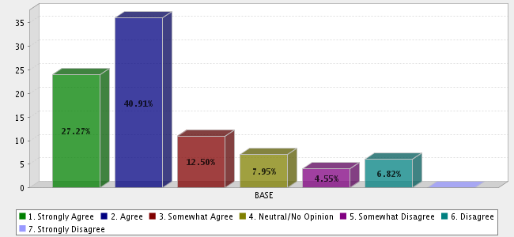
It doesn't matter how qualified the job candidate is if the Dean doesn't like him/her

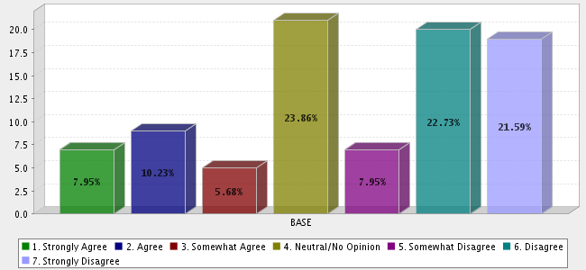
Our Department Head typically supports the hiring decisions of the faculty members in our department

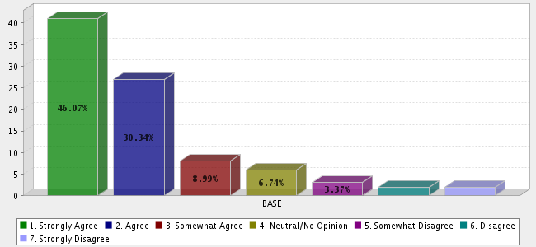
We typically have to fight the Dean to hire the person recommended by the faculty

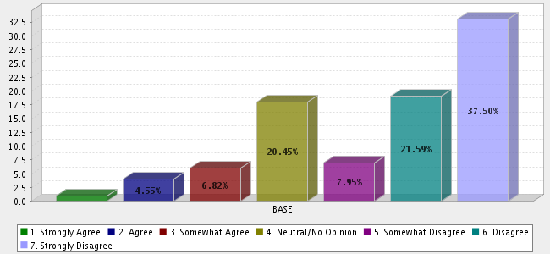
When it comes down to it, the constraints placed on our hiring process by the Dean indicate that s/he doesn't understand our departmental needs

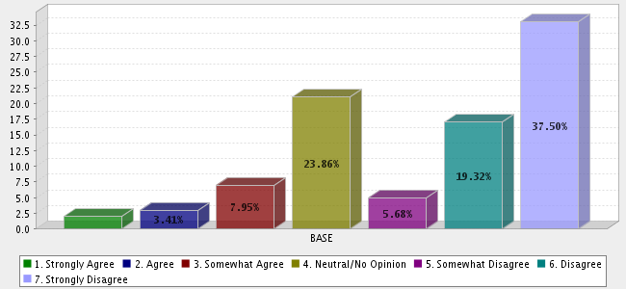
It doesn't matter how qualified the job candidate is if the administration (President, Vice-President) doesn't like her/him

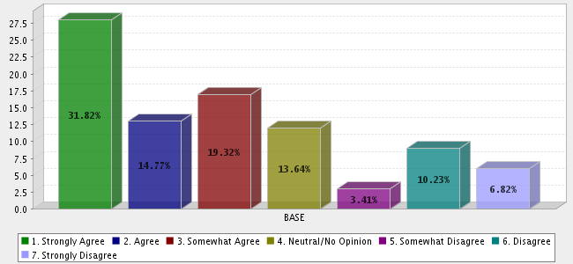
When it comes down to it, qualifications are less important in our departmental job hires than the opinion of administrators.

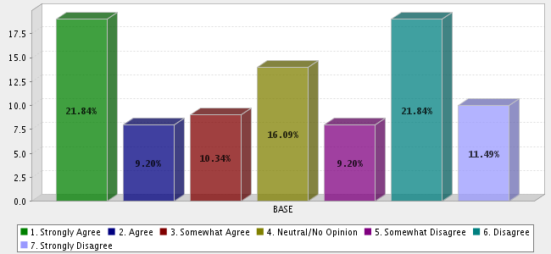
We typically have to fight the administration to hire the person recommended by the faculty

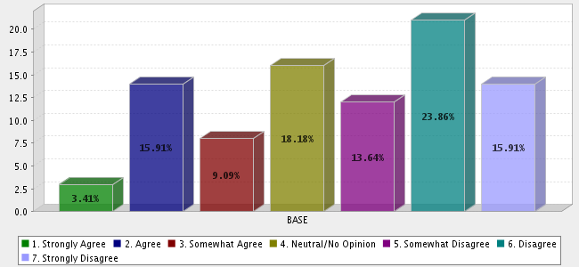
When it comes down to it, the constraints placed on our hiring process by the administration indicate that they don't understand our departmental needs

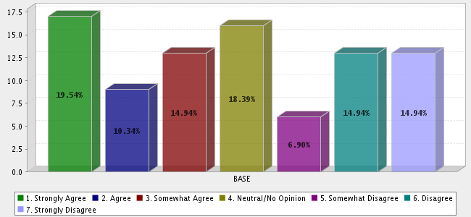
Overall, I think the hiring process in our department is unfair

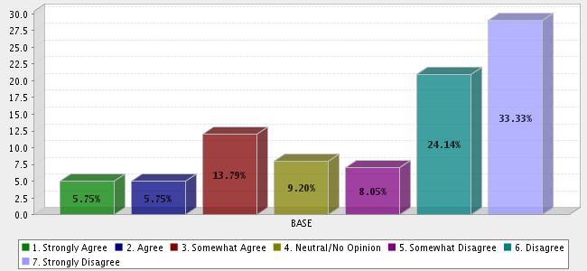
Overall, I think the Dean interferes with hiring the best possible candidates for the job

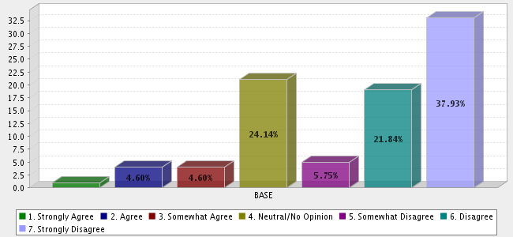
Overall, I think the administration interferes with hiring the best possible candidates for the job

