As Amended 11/13/12

Minutes of
THE FACULTY SENATE
OF
ARKANSAS TECH UNIVERSITY

The Faculty Senate met Tuesday, October 9, 2012, at 3:00 p.m. in Room 325 of the Ross Pendergraft Library and Technology Center. The following members were present:

Dr. Carey Bosold Mr. Ken Futterer
Dr. Dan Bullock Dr. Sherman Alexander
Dr. Eric Lovely Dr. Susan Underwood
Dr. Annette Holeyfield Dr. Marcel Finan
Dr. Sean Huss Dr. David Ward
Dr. Michael Rogers Dr. Robin Lasey
Mr. Neal Harrington Ms. Annette Stuckey
Dr. Kevin Mason Dr. Cathi McMahan
Dr. Molly Brant Dr. Ernest Enchelmayer
Dr. Chris Kellner

Dr. Johnette Moody was absent. Dr. John Watson, Mr. Thomas Pennington, Dr. Carl Greco, and Dr. Jeff Mitchell were visitors.

CALL TO ORDER | President Futterer called the meeting to order and asked for a motion to amend the order of the agenda to allow Dr. Watson and Mr. Pennington to speak prior to approval of the minutes.  Motion by Dr. Mason, seconded by Dr. Enchelmayer, to so amend the order of the agenda. Motion carried.
NEW BUSINESS: REPORT BY VICE PRESIDENT FOR ACADEMIC AFFAIRS | Dr. Watson stated he asked President Futterer to attend this meeting to address a sensitive issue with international faculty and to correct an inaccurate statement from the previous meeting. He mentioned there are 32 international faculty on staff and posting the minutes from the previous meeting without correction could cause those faculty undue concern for their positions. He clarified that Tech has two tenure track faculty affected by the decision to no longer sponsor faculty for visas, not 20 as stated in the previous meeting. The two affected are Dr. Julius Marpaung and Dr. Jung-Uk Lim, both in the Electrical Engineering department. Dr. Watson reported that Dr. Marpaung is working under OPT status, which expires July 4, 2013 and that Dr. Lim has an H-1B through an additional year. Dr. Watson stated at the time of Dr. Marpaung’s interview, university practice was to ask only if the candidate was legal to work in the U.S. to avoid any appearance of prejudice against those faculty requiring sponsorship. Dr. Watson stated he sent Dr. Marpaung a letter of appointment on December 14, 2011; Dr. Marpaung signed and returned the letter dated January 6, 2012. Dr. Marpaung did not inform Academic Affairs until May 15, 2012 that he was working under an OPT status and would require sponsorship. Dr. Watson stated that had Dr. Marpaung asked during the interview process, he would have explained the university did not have a contract with an immigration lawyer and therefore had no method to sponsor, but noted this discussion had to be initiated by Dr. Marpaung. Dr. Watson reported the university has since revised its practice. Practice is now to offer the position to a candidate and once accepted, state “This offer is contingent upon the results of a criminal background check, completion of a disclosure form for the State of Arkansas, and completion of an I-9 form. Please know that at present Arkansas Tech University has a policy of not sponsoring international faculty for visa renewal.” Dr. Watson encouraged the senators to bring any questions they may have concerning the practices in Academic Affairs to him for initial discussion in order to avoid dissemination of misleading information.  Dr. Greco responded to Dr. Watson that regardless of the number of international faculty affected, Dr. Marpaung was not informed until arriving in August of the university policy to not sponsor. Dr. Greco stated that every university in the state supports H-1B visas and Dr. Marpaung expected that support. He said an attorney was not necessary and the cost of $500 plus filing fee was cheaper than beginning a new search for replacement faculty. Dr. Lovely asked for the purpose of the policy. Dr. Watson replied that his experience had been costs into the thousands of dollars, much more than stated. Dr. Greco offered that he had documentation showing the cost being $500 plus filing fee. Dr. Watson responded that he had documentation proving he has spent over $15,000 on one faculty member who then left. Dr. Lovely stated he understands an H-1B to be nontransferable but would be a step toward a green card which is transferrable. Dr. Finan stated in his experience with other universities, many times visa paperwork is completed by university staff without legal expenses. Dr. Watson replied that in his experience, there is a greater cost. Dr. Greco added this policy puts the university at a disadvantage in hiring faculty due to other universities choosing to provide sponsorship. Dr. Kellner asked if Dr. Watson would consider reversing the policy if it could be proven the cost was minimal. Dr. Watson responded he was not able to answer that question at this time.  Dr. Watson also addressed the Senate regarding Faculty Research Grants. Currently, the grants have a maximum award of $2,000, and while the grant could be used for adjunct salary or an overload, this amount would not be adequate for adjunct pay. Dr. Watson stated his preference, rather than increase the award amount, would instead be to fund an adjunct or overload in addition to the grant amount when approved by the Department Head and Dean and when funds and positions are available from Academic Affairs. Dr. Watson informed the Senate the reason available adjunct positions are a concern is the university has 136 appropriated positions and is currently using all for the fall term. Dr. Rogers asked how this would be communicated to the faculty. Dr. Watson responded he would inform the Deans and put verbiage on the Faculty Research webpage. He stated the webpage and the Faculty Handbook were clear the grants could not be used for faculty salary, but would allow for release in the form of adjunct salary. President Futterer asked for clarification of whether an overload would be allowable. Dr. Watson answered an overload for the requesting faculty member would not be allowable, but an overload for another faculty would be.  Dr. Watson reported that Tech has achieved SREB 3 status but it will not be recognized until after official data reporting. Because of this upgraded status, Dr. Watson stated a new peer group would be needed for determining faculty equity and he would be using NCHEMS for this service. He explained this is a three step process in which Tech sends information, NCHEMS returns a potential peer group, and Tech can revise information based on those results. Dr. Watson welcomed input from the senators on the information to be provided to NCHEMS.  Dr. Watson stated he is proposing two changes to the Faculty Handbook. One concerns attendance accounting in electronically delivered classes. He said in the past, a student’s act of logging into the course sufficed as attendance but that no longer satisfies federal guidelines. The new guidelines require active contribution from the student in the form of a completed and submitted assignment. Dr. Watson stated this must be done before the fifth class day for condensed terms or before the eleventh class day for full term courses.  Dr. Watson also informed the Senate, in regard to common course numbering, that equivalent ACTS courses must be listed in any publication, including syllabi. Dr. Lasey asked if this would apply for courses next fall or for the coming spring. Dr. Watson asked senators to comply for spring if possible, but if not, before July 1, 2013. President Futterer informed the Senate it was a simple process to access the equivalent ACTS course information online. Dr. Watson mentioned it could even be accessed in the university’s catalog which pulls from Banner. He encouraged faculty to have departmental webpages or personal faculty pages pull ACTS course information directly from Banner as well to ensure automatic updating and prevent outdated information.  Dr. Watson thanked the Senate and excused himself from the meeting.
REPORT BY UNIVERSITY LEGAL COUNSEL | Mr. Pennington addressed the Senate in regard to legal liability for faculty members serving as advisors for a registered student organization. Mr. Pennington reported the presentation during the recent orientation session did not constitute a shift in policy, but was more for awareness. He stated in the event of an incident, the university has many times been able to represent a faculty advisor so long as the advisor was acting as a reasonable, prudent person. Mr. Pennington said that if a faculty member exhibited behavior contributing to the incident that was not reasonable, that faculty member could be advised to find his or her own attorney. While advisors are not required to attend every event, he encouraged the senators to be aware of what the students are doing and to always ask questions to be fully informed about each event. He emphasized that faculty do not stand in loco parentis. Mr. Pennington welcomed faculty to contact him anytime they needed advice concerning a student event.  Mr. Pennington reminded the Senate to demonstrate caution regarding social media and to not discuss or post information about their students in such venues.  Mr. Pennington mentioned that his expertise did not extend to immigration law. He stated each instance in the past of the university sponsoring an international faculty member’s visa, an immigration lawyer was used which he felt was appropriate.  Mr. Pennington thanked the Senate and excused himself from the meeting. The meeting resumed by order of the agenda.
APPROVAL OF MINUTES | President Futterer called for a motion to approve the minutes of the September 11, 2012, meeting.  Motion by Dr. Underwood, seconded by Ms. Stuckey, to approve the minutes as distributed.  President Futterer asked if the Senate would prefer to amend the minutes with the clarification provided by Dr. Watson.  Motion by Dr. Mason, seconded by Dr. Holeyfield, to table the final approval of the minutes to allow an amendment to be inserted and an electronic vote to be held. Motion carried.  President Futterer stated he would send the amended minutes to senators for an electronic vote once he received the final draft of Dr. Watson’s comments.
OLD BUSINESS: REPORT ON RETIREMENT FUNDS | President Futterer reported he invited Mr. David Moseley, Vice President for Finance and Administration, to attend the meeting and did not receive a response. He asked to table the discussion for now and stated he would ask Mr. Moseley to attend the next meeting for further discussion.
REPORT BY SUBCOMMITTEE REVIEWING FACULTY HIRING PRACTICES | Dr. Lovely distributed page six of the I-129 form which showed fees associated with an H-1B application and reported Tech would be responsible for $500. President Futterer stated that because the university chose to hire an attorney, there would be additional legal expenses.  Motion by Dr. Lovely, seconded by Dr. Ward, that the Senate suggest the university support Dr. Julius Marpaung to obtain his H1B visa. Motion carried.  Dr. Huss stated the survey regarding faculty hiring practices should be available for distribution within the week. President Futterer appointed Dr. Finan to this subcommittee to utilize his prior experience with immigration issues as the subcommittee continues to investigate the long term effect of this policy and research possible alternatives.
REPORT BY SUBCOMMITTEE REVIEWING ONLINE STUDENT EVALUATIONS | Ms. Stuckey reported most issues with online student evaluations had been resolved except the ability of students to participate in an online course evaluation after withdrawing from the course. Ms. Rebecca Bramlett in the Institutional Research office emailed Ms. Stuckey explaining evaluations for fall courses are populated on November 10; therefore, students enrolled at that time would still receive an email to complete an online course evaluation, even if the student were to later withdraw. Ms. Stuckey stated this was likely a very small number of instances and it would be difficult to prevent. Dr. Lasey questioned why the online course evaluations could not be populated after the last day to withdraw from a course. President Futterer requested that Ms. Chronister ask Mr. Wyatt Watson, Director of Institutional Research, for comments on this issue and stated the subcommittee would remain active until his response was reported to the Senate.
REPORT ON HIRING CONSULTANT FOR EVALUATION POLICY | President Futterer reported that he spoke with Dr. Watson concerning the use of a consultant to review the university evaluation policy. Dr. Watson supported the recommendation and recognized the advantages, but he was unable to provide an adequate funding source for such consultation. He reported that Dr. Watson also indicated any review of the evaluation policy should include discussion of post tenure review. President Futterer clarified that post tenure review is recognized by the AAUP.
REPORT BY SUBCOMMITTEE ON PROMOTION AND TENURE | Dr. Lasey stated the subcommittee has not yet met, but she offered to serve as chair.
REPORT BY SUBCOMMITTEE ON FACULTY SENATE MEMBERSHIP | Dr. Lovely distributed the constitution and bylaws of the Faculty Senate. He reported the subcommittee agreed to add tenure as a requirement for faculty to serve as a senator and to remove the appointment of senators by the administration. Dr. Lovely requested this be added to the next meeting agenda for the initial vote requiring a two thirds majority before going to the full faculty and board of trustees.  Dr. Enchelmayer stated there was no historical evidence to support that the practice of appointing members to the Faculty Senate was initiated to “fill in gaps” in the elected membership, according to Dr. Watson. He then reported when he was appointed to the Senate by Dr. Watson, he was assured he would not be questioned about the Senate discussion. Dr. Enchelmayer confirmed that he had not been approached for information, despite frequent opportunity for Dr. Watson to do so. Dr. Enchelmayer then reported the results of his research on Faculty Senate membership at institutions around the state had been varied and may present another issue to consider before bringing the amendments to the constitution and bylaws to a vote. Membership at several institutions included variations of the president, vice presidents and representation from librarians, part-time faculty, staff, and students. Membership at some institutions consisted of strictly faculty. Dr. Enchelmayer stated the majority of institutions have some representation of the administration at Senate meetings.  President Futterer suggested that, given the information provided, the Senate table the vote until the senators have had time to discuss the change with colleagues and receive any feedback they may have regarding membership.
FACULTY RESEARCH GRANTS | President Futterer stated this issued was resolved in the earlier address from Dr. Watson.
RETIRED FACULTY TEACHING AS ADJUNCTS | President Futterer stated he had spoken with Dr. Watson regarding the decision not to hire Dr. Robert Allen as an adjunct for the fall semester. President Futterer reported the decision was made entirely by Dr. Watson, and was made because Dr. Allen was solely qualified to teach the Toxicology course and would have to be hired continually in order to offer the course. If Dr. Allen decided to no longer teach, the department would then be required to hire a specialist to replace him and Dr. Watson decided, given Dr. Allen’s retirement, it was an appropriate time for the course to no longer be offered.  Dr. Lovely stated that while arrangements were made for the students in the cancelled section, it did not satisfy curriculum, especially for pre-med students. Dr. Kellner commented that it seemed the decision was made out of concern for Dr. Allen to not return in the future, but this decision instead brought that issue up immediately. President Futterer stated that while he believed this should have gone through the typical curriculum process, he did not feel this was a personal attack, but a response to the lack of qualified faculty to teach the course. Dr. Bullock asked if this was considered when a replacement for Dr. Allen was hired. Dr. Lasey replied it was not a priority for the Chemistry program. Dr. Bullock stated a curricular decision was then made by the committee in not hiring a qualified replacement to teach the course. Dr. Huss said the decision seemed retributive.  Dr. Enchelmayer responded that because Dr. Allen retired, there is no expectation he would return. President Futterer added when faculty retire, they are retiring their rank as well and while Dr. Allen has expertise, he does not have ownership of the course.  Motion by Dr. Kellner, seconded by Dr. Lovely, that the Senate recommend for the administration to offer a contract to a qualified instructor to teach Toxicology as this is in the best interest of the students and due to this course being required by certain degree plans.  Discussion following the motion included whether it was the place of the Senate to ask departments to reevaluate curriculum and if it should instead be up to the departments to find a resolution. President Futterer called for the question.  Motion failed.
OPEN FORUM | Dr. Lovely asked for the status of the upcoming curriculum for review. Ms. Chronister responded she hoped to have it posted by the end of the week. Dr. Lovely encouraged the Senate to put due diligence into reviewing the posted curriculum. He stated it was one of the most important duties of the Senate and careful review would allow for a productive discussion concerning the curriculum.
ANNOUNCEMENTS/  INFORMATION  ITEMS | Dr. Lasey informed the Senate the National Society of Collegiate Scholars was struggling for student membership and could be a valuable opportunity for service for a newer faculty member to serve as advisor.
ADJOURNMENT | The meeting adjourned at 5:16 p.m.

Respectfully submitted,
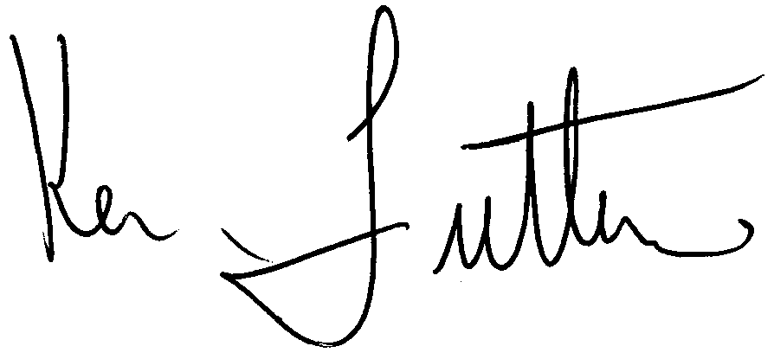
Ken Futterer, M.M., President
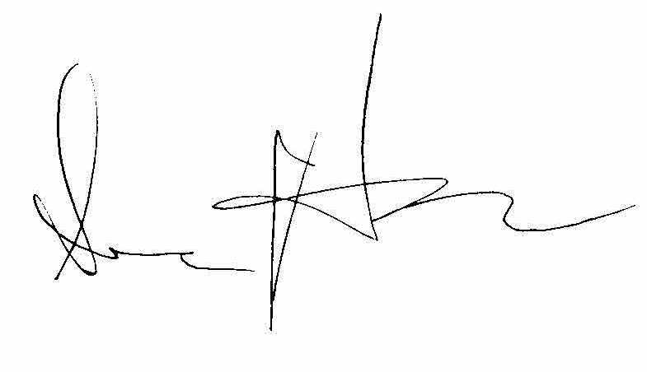
Sean Huss, Ph.D., Secretary

