Minutes of
THE FACULTY SENATE
OF
ARKANSAS TECH UNIVERSITY

The Faculty Senate met Friday, April 9, 2010, at 3 p.m. in Room 325 of the Ross Pendergraft Library and Technology Center. The following members were present:

Dr. Jennifer Helms Dr. David Eshelman
Dr. Glen Bishop Dr. Larry Morell
Dr. Eric Lovely Dr. Tom Limperis
Dr. Gill Richards Mr. David Mudrinich
Dr. Linda Bean Dr. Annette Holeyfield
Dr. Alex Mirkovic Dr. Cathy Baker

Dr. Jim Walton, Dr. V. Carole Smith, Dr. Penny Willmering, Mr. Ken Futterer, and
Dr. Jeff Robertson were absent.

CALL TO ORDER  APPROVAL OF MINUTES | President Bishop called the meeting to order and asked for action on the minutes of the March meeting. Motion by Dr. Bean, seconded by Dr. Eshelman, to approve the minutes as distributed. Motion carried.
OLD BUSINESS: SUBCOMMITTEE REPORT ON REVIEW OF PROMOTION AND TENURE POLICY | President Bishop asked Dr. Bean for a report. Dr. Bean stated the subcommittee was continuing its work and would have a final product for review at the May meeting.
RECOMMENDATION TO ESTABLISH A NEW STANDING COMMITTEE | President Bishop noted that vote on establishment of a new standing committee, the Committee on Adjunct Support, had been postponed until the April meeting to allow for greater dissemination of the Senate’s intent to create the committee. Motion by Dr. Bean, seconded by Mr. Mudrinich, to establish the new standing committee with the membership and function previously described at the March meeting. Dr. Richards questioned the role of the new committee. Dr. Bean stated the committee would represent adjunct interests on campus, and Dr. Lovely noted that adjunct faculty would now have an avenue for bringing issues through faculty governance. Motion carried. President Bishop will forward the recommendation to the Vice President for Academic Affairs.
SUBCOMMITTEE REPORT ON REVIEW OF ELECTED STANDING COMMITTEE MEMBERSHIPS | President Bishop asked Dr. Lovely for a report. Dr. Lovely distributed revised wording for Article II, Section 1, of the Constitution of the Faculty Senate. He noted that the subcommittee was working on other committee membership issues but had decided that the Senate’s membership should be reviewed and revised as soon as possible.  Old: Article II: Membership and Terms of Office  Section 1: Elective Membership – One Senator shall be elected by each of the Colleges of the University, except that a College having over twenty faculty members is eligible for one Senator for each twenty full-time faculty members or portion thereof. But a College entitled to multiple Senators may elect no more than one from each department.
The Faculty Senate – April 9, 2010 2

New: Article II: Membership and Terms of Office
Section 1: Elective Membership – One Senator shall be elected by each of the Colleges of the University, except that a College having over twenty faculty members is eligible for one Senator for each twenty full-time faculty members or additional portion thereof. A College entitled to multiple Senators may elect no more than two from each department. Any College or independent Academic Unit that has less than twenty faculty members will be combined into a Supernumerary voting block operating under the twenty faculty member rule.

Dr. Lovely noted that the old language limits the number of elected senators who can serve per department to one; however, it is conceivable that a college could qualify to have more senators due to their full-time faculty headcount than that college has departments (e.g., the college qualifies for five senators but only has four departments). He also stated that several colleges have very large departments and the college would have the option under the new proposed language to elect more than one senator from those larger departments if the college faculty so chose. Dr. Lovely reported that the additional language concerning combining colleges with less than twenty faculty members for election of a senator is the result of discussion on how to give representation to two colleges, one of which has only one faculty member currently and another which will have four faculty as of July 1, 2010.

It was noted that one college currently only has 19 faculty due to a resignation and could be subject to this same supernumerary voting block procedure. President Bishop asked the subcommittee to review the recommendation again and try to have a revised membership proposal for review by the Senate ten days prior to the Senate’s meeting in May. He advised that changes to the Senate’s constitution require review by the Senate membership ten days prior to a regular meeting at which time the proposed amendment must be approved by two-thirds of the membership of the Senate (i.e., 11 out of 17 must vote to approve). If an amendment is approved by the Senate at the May meeting, the faculty at large could then vote on the amendment during the College meetings in August.

MID-TERM GRADES | President Bishop noted concerns expressed on this issue at the previous meeting and asked for any continuing discussion. Dr. Richards reported several faculty had spoken with him concerning the Senate’s discussion with Dr. Watson in February regarding his (i.e., Dr. Watson’s) recommendation that mid-term grades now be required for all students. During that discussion several senators had indicated a preference that an expansion of the mid-term grade policy only include sophomores and not upper classmen, although the Senate did not take formal action relating to the issue as Dr. Watson had indicated he was only looking for feedback on the idea. Dr. Richards reported he had been asked to propose not requiring compulsory mid-term grades for any students. Resolution by Dr. Richards that there will be no compulsory mid-term grades. Resolution died for a second. Dr. Richards then amended his resolution and stated there should be no compulsory mid-term grades except for freshmen. The amended resolution died for a second. Dr. Helms noted that having mid-term grades for all lower-level students would make advising nursing students much easier. Dr. Morell stated he believes mid-term grades for all students would help with retention and advising. Dr. Richards noted that faculty objections to the requirement of the mid-term grades were centered on issues of academic freedom.
SET STANDING COMMITTEE ELECTION DATES | President Bishop reported that Dr. Robertson had advised setting the elected standing committee election dates for April 19 to April 30. Motion by Dr. Eshelman, seconded by  Dr. Baker, to set these dates for the online elections. Motion carried.
NEW BUSINESS:  CAMPUS RECYCLING | President Bishop reported that Mr. Brian Lasey had been unable to attend today’s meeting as he was attending a conference but would be able to attend the May meeting. He asked for any particular issues for Mr. Lasey to address. Dr. Bean questioned why there were no
The Faculty Senate – April 9, 2010 3

 | recycling containers in Rothwell Hall. Dr. Lovely asked what instructions the custodians are given relating to recycling. President Bishop asked the senators to send any other issues to him to relay to Mr. Lasey.
OPEN FORUM | President Bishop read an email from Mr. Futterer requesting that the Senate “entertain a vote of no confidence in the IT staff” at the May meeting. He stated this item would be placed on the May agenda for discussion.  President Bishop distributed information provided by Mr. Michael Stoker concerning upcoming changes to the web server and how this will affect faculty. Mr. Stoker had spoken with Dr. Morell concerning these changes and Dr. Morell was asked to speak to the issue.  Dr. Morell noted that all the university’s business is being conducted on one, old web server. He stated that Computer Services and Mr. Stoker are proposing to split this load into several virtual servers. One of the virtual servers will house faculty websites. This move will take place sometime between the end of the spring semester and the beginning of the summer terms. A standardized address for the faculty websites will need to be implemented as part of this move, and Dr. Morell reported Mr. Stoker will be contacting faculty to advise them of the change and assist them with any issues relating to their specific websites. Dr. Morell emphasized that standardizing the faculty web addresses should prevent these addresses from having to change for the foreseeable future. The Senators were asked to begin disseminating this information to their colleagues.  Dr. Richards questioned why so many issues with computer services and the web.  Dr. Morell stated his opinion that Computer Services, in particular, is “underfunded” and needs more resources and personnel. He also advised that some of the issues being discussed recently in the Senate were due to a lack of communication.  Dr. Morell reported he had asked Mr. Stoker if there was a uniform way for faculty to back up their hard drives to a central site. President Bishop expressed appreciation for  Mr. Stoker’s efforts in communicating with the Senate.  President Bishop noted the previous dissemination of information to the Senators by email of the proposed list of cosmetic curriculum changes and the email format for sending those changes to the Registrar. He distributed a revised email format which now includes the requirement of a Departmental Support Form if other departments are affected by the proposed change. Discussion centered on the effort being made to streamline the curriculum review process and allow the Curriculum Committee and Faculty Senate to meet on only those proposals determined to need comprehensive committee review. The cosmetic change will initially be reviewed by the Registrar and Academic Affairs, and if determined to be a cosmetic change, will then be posted on a website and available for review by the deans, department heads, Curriculum Committee, and Faculty Senate. If no objections to the change are made, then Academic Affairs will proceed with making the cosmetic change in the upcoming undergraduate catalog. If valid objections are made, then the change will not be considered cosmetic and the affected department head will be advised to submit the standard curriculum change form if they wish to proceed with the curriculum change.  Dr. Morell suggested having a special email address set up for faculty reviewing the cosmetic changes to use for submission of comments or objections. After discussion, President Bishop asked for a final version of the instructions and email format to be reviewed formally by the Senate at the May meeting.  Dr. Lovely questioned whether feedback had been received concerning the Senate’s resolutions on revising the hiring guidelines. President Bishop read an email he received
The Faculty Senate – April 9, 2010 4

from Dr. Watson stating “It is the position of the administration that the current process for filling faculty and administrative vacancies allows for appropriate faculty participation and that there is no need for a change at this time.” Dr. Lovely asked if this item could be placed on the May agenda for additional discussion.

Dr. Helms commented that recently a faculty member had brought to her attention that faculty no longer receive discounts for attending concerts held on campus. She noted faculty are “feeling the crunch” due to no salary increases and asked if the Senate should discuss the “perks” the faculty receive. President Bishop suggested that Dr. Helms bring the matter before the Faculty Salary, Benefits, and Awards Committee.

Dr. Mirkovic questioned whether other sections in the Senate’s constitution need to be reviewed. Dr. Lovely stated the subcommittee reviewing the standing committee memberships could look at this issue also.

Dr. Bean asked if feedback had been received concerning the Senate’s recommendation that meeting dates and times be established for standing committees to meet. President Bishop noted that Dr. Watson will be discussing this issue with the deans and department heads.

ANNOUNCEMENTS/INFORMATION ITEMS | President Bishop announced that the May meeting of the Senate will be on Reading Day, May 4, at approximately 12:30 p.m. with a lunch beginning at 12 noon in Williamson Dining Hall. He stated that Dr. Watson and Dr. Brown will also be attending the lunch. He asked that any senator unable to attend the lunch let him know.  Dr. Bean reported that the response to the latest e-waste disposal day had been overwhelming with over 130 cars coming by to drop off materials. She stated that this effort needs to be held more than once per year if possible.  President Bishop announced that a session on portfolio development relating to teaching and learning will be held this Wednesday in the Williamson Dining Hall with a lunch also being provided. This workshop is being sponsored by the Assessment Committee.  Mr. Mudrinich announced that the Senior Art Exhibit will be held from 6 p.m. to 8 p.m. tomorrow in the Norman Arts Center.  Dr. Bean reported that the spring Career Fair was held this past Wednesday with 114 students participating. She encouraged faculty to ask students who attend the career fairs to go prepared with a resume and be dressed appropriately.
ADJOURNMENT | The meeting adjourned at 4:58 p.m.

Respectfully submitted,
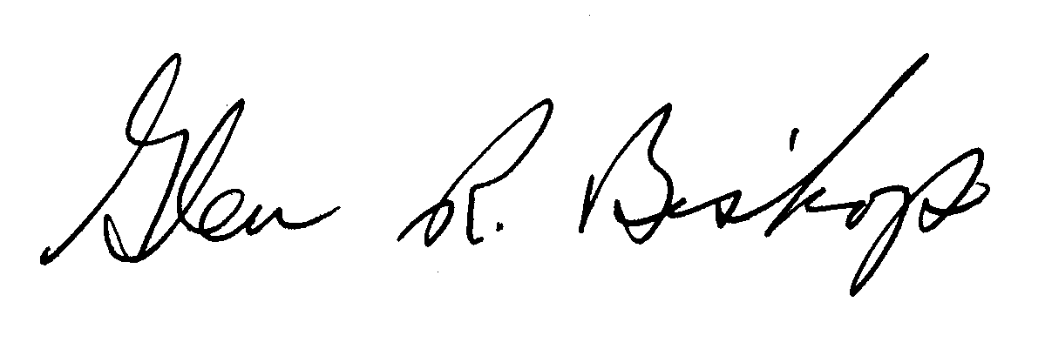

Glen Bishop, Ph.D., President

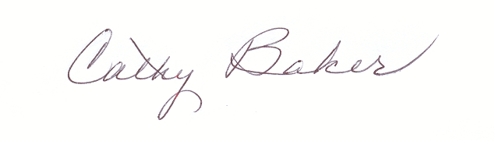
Cathy Baker, Ph.D., Secretary

