Minutes of
THE FACULTY SENATE
OF
ARKANSAS TECH UNIVERSITY

The Faculty Senate met Tuesday, February 10, 2009, at 4 p.m. in Room 325 of the Ross Pendergraft Library and Technology Center. The following members were present:

Dr. Cheryl Smith Mr. Ken Futterer
Dr. Larry Morell Dr. Cathy Baker
Dr. Eric Lovely Dr. Annette Holeyfield
Dr. Pat Buford Dr. Trey Philpotts
Dr. Linda Bean Dr. Sammie Stephenson
Dr. Andrew Cannon Mr. David Mudrinich
Dr. Hanna Norton Dr. Jeff Robertson
Ms. Beth Gray Dr. David Ward

Dr. Glen Bishop was absent. Dr. Robert C. Brown, Dr. John Watson, Dr. Jeff Mitchell, and Dr. Bob Allen were visitors.

CALL TO ORDER  APPROVAL OF MINUTES | President Norton called the meeting to order and asked for action on the minutes of the December 3, 2008, meeting. There being no amendments or corrections, motion by  Dr. Lovely, seconded by Dr. Smith, to approve the minutes as distributed. Motion carried. Motion by Dr. Robertson, seconded by Mr. Futterer, to amend the order of the agenda and allow discussion of Item A in New Business to follow Item D in Old Business. Motion carried.
OLD BUSINESS:  FREE SPEECH POLICY | President Norton reported that she had met with Dr. Brown on two occasions concerning the free speech policy proposed by the Senate and had asked him to attend today’s meeting to discuss the proposal and answer any questions. Dr. Brown commended the Senate for their “exceptionally good work” on the policy and stated he had two items to discuss. First, as an item of information, he announced he was going to move administration of the policy from Student Services to Affirmative Action, which is housed in the Academic Affairs office. Second, he asked that the second, exterior free speech location included in the policy defined as “The grass area located between Nutt Residential Hall and Chambers Cafeteria; north of Dr. Martin Luther King, Jr. Drive and south of Ross Pendergraft Library” be excluded from the policy as this is a potential construction site in the near future. President Norton questioned whether a reservation component should be included in the policy. Dr. Brown indicated his preference for the exterior free speech sites to be available “24/7.” However, he stated he would accept a recommendation made by the Senate on this issue and that he was ready to go to the Board of Trustees as soon as the policy is final.  Dr. Lovely questioned the role of Affirmative Action in administration of the policy if reservations are not required. Dr. Brown noted there are always issues that arise with a policy of this nature and this office would be available to address those issues if and when they occur. Mr. Futterer questioned whether another large area on campus could be identified to replace the location being excluded; Dr. Brown responded that any area identified must be part of the main campus by law.  Dr. Brown expressed his appreciation again for the “exemplary way” the Senate has conducted its business this year and excused himself from the meeting.
The Faculty Senate – February 10, 2009 2

 | Motion by Mr. Futterer to table further discussion on this issue until after Dr. Watson’s presentation. Motion carried.
CAMPUS SECURITY ISSUES:  DISSEMINATION OF INFORMATION TO FACULTY | President Norton asked Dr. Watson to speak to this item. Dr. Watson first expressed his appreciation to the Senate for their work on formation of the general education committee. He stated that creation of this committee was crucial to the upcoming Higher Learning Commission visit in March of 2011.  Dr. Watson distributed a draft titled “Responses to Emergencies on the Arkansas Tech University Campus” which he stated was developed in response to the Senate’s request for information being disseminated to the faculty concerning the Emergency Operations Plan. He asked that they look this over at their leisure and let him know whether the document successfully provides the information requested.
STUDENT ACCESS TO ACADEMIC BUILDINGS AFTER HOURS | Dr. Watson stated that he would respond to any questions relating to this issue. Mr. Futterer noted that the change in the policy regarding allowing students in academic buildings after hours had impacted heavily on programs in Witherspoon, especially in the fall semester. He stated that a student monitor is now in place which has alleviated the impact, but questioned why the policy was changed. Dr. Watson noted that approximately 800 requests had been made of campus security last spring to allow students in the buildings once they were locked and that security could no longer handle the volume of requests. Additionally, issues of liability had arisen and noted he would hate to have to explain to a parent why their child was not found in a building for several hours due to an incident that occurred late in the evening hours and the lack of a building monitor. Dr. Watson reported that his office had provided additional student labor funding to those departments in the School of Liberal and Fine Arts most impacted by the policy change.  Dr. Morell noted the potential for “monies being wasted” unless there was substantial coordination of student monitors in a given building. Dr. Watson reported that the academic response to the change in policy is a “work in progress” and will be modified as needed.  Mr. Futterer questioned whether a pass key system could be installed in the academic buildings. Dr. Watson responded that this is a costly solution and it does not negate the liability issue posed by Legal Counsel. Dr. Buford questioned when the student monitors need to be on duty; Dr. Watson stated that this would be after the buildings are locked at 10 p.m.
END OF TERM SCHEDULE | Dr. Watson stated that he would respond to any questions on this topic. Dr. Cannon commented that there may be other solutions to the issue of needing more instructional minutes for the MWF classes and gave an example of lengthening the class time by five minutes to each session. However, he stated the biggest problem with the change in the end of term schedule is the length of time between the end of classes and when graduation takes place. He noted that exam week and graduation were “pushed back a whole week.”  Dr. Watson reminded those senators who had been at Tech a number of years that a previous practice was to hold finals through Friday with graduation on Saturday and senior grades being due on Wednesday of finals week. Seniors literally carried around a piece of paper and had faculty enter their grades. He commented that each solution may come with its own set of problems. He also reminded the senators that one reason for delaying graduation was to give the Registrar’s Office time to verify that each graduating senior met graduation requirements.  Dr. Watson indicated he was willing to look at alternate plans and suggested that the Senate form a subcommittee to review the end of term schedule. He emphasized that, if such a committee were formed, it should include individuals from the Registrar’s Office,
The Faculty Senate – February 10, 2009 3

Admissions, Financial Aid, Housing, and other campus offices impacted by the academic schedule.

Dr. Philpotts questioned whether other institutions meet the required minutes for all of their classes. Dr. Cannon reported he had surveyed several institutions in the state and it appeared that none of them were meeting the required number of minutes. The question arose as to whether final exam hours are counted towards the required number of minutes and it was indicated that they are not. Dr. Watson noted that he will attend a Chief Academic Officers meeting tomorrow and he may question others concerning this issue.

PEDESTRIAN BRIDGE | President Norton asked Dr. Watson to address this issue. Dr. Watson reported he has spoken with members of the Executive Council concerning this issue and no one is against the idea. However, the current obstacle is funding as the university has a number of budgetary priorities needing funding. Dr. Mitchell stated the only action needing to be taken at this time is to request that the state highway and transportation department conduct a feasibility study relating to the construction of a pedestrian bridge across Highway 7. He was not sure if Tech would have to co-fund the study. Dr. Watson stated that he knew a couple of individuals who worked with the state he could contact on this issue.  Mr. Futterer pointed out the lack of bus service for the students living in Campus Courts and how dangerous it was for those students to walk to campus. Dr. Mitchell indicated he had heard Highway 124 may be widened at some future point which will complicate the issue of trying to cross Highway 7 near the Highway 124 intersection.
NEW BUSINESS:  GRADUATION ATTENDANCE POLICY (students and faculty) | Dr. Watson stated he considers it a “professional obligation” for faculty to attend graduation ceremonies in May and December. As for the new summer graduation in August, 2009, he stated the fairest policy will be to require faculty who teach in the summer to attend that ceremony. Dr. Watson emphasized that Academic Affairs has always excused any faculty member from attending graduation upon request and this policy has not changed.  Dr. Lovely advised that the policy relating to students attending graduation states the student must show a “hardship” in order to be excused. Dr. Watson stated that Academic Affairs uses the same policy for students as faculty; if the student requests to be excused, then they are excused. However, he agreed the language could be softened.  Dr. Watson asked if there were other questions. Dr. Cannon questioned whether Dr. Watson had considered tying promotion to associate professor with the awarding of tenure; he noted that many of the institutions he had looked at did this. Dr. Watson responded that he had questioned other Chief Academic Officers concerning their practices on promotion and tenure and the only institution in the state tying promotion and tenure together was the University of Arkansas (Fayetteville). He stated he is not in favor of making this change to the promotion and tenure policy and gave as an example an individual who is a good teacher but who has not progressed in terms of scholarship and service. If promotion and tenure were tied together, this individual would be let go instead of receiving tenure and being given time to develop as a faculty member. Dr. Cannon emphasized that mistakes had been made where the faculty member had believed that credit towards tenure and promotion were granted when in actuality only credit towards tenure was noted on the contract and asked how to keep mistakes like this from occurring in the future. Dr. Watson responded that he has asked the deans to give him requests for hire in writing which include all conditions of employment and stated he hopes to avoid future misunderstandings of this nature.  Dr. Watson asked to present one other item for information and distributed a proposed modification of the statement in the Faculty Handbook concerning the taking of class
The Faculty Senate – February 10, 2009 4

attendance. He noted that the current statement in the Handbook had become “cloudy” over time with the addition of statements relating to federal attendance accounting. Dr. Watson commented he had always believed throughout his career that faculty should take roll each class period and know when their students are in class.

Dr. Watson indicated that he had received input on the proposed wording from the Deans Council and from department heads through the deans. The revision is an attempt to separate out responsibilities relating to federal attendance accounting and daily attendance accounting. He asked for any comments by the first week in March.

In response to a question, Dr. Watson stated that the university had sent back approximately $436,000 for 2007-08 in federal financial aid due to an inability to accurately document student attendance.

At this time, Dr. Watson thanked the senators for their time and excused himself from the meeting.

President Norton stated that she would like to revisit the items discussed by Dr. Brown and Dr. Watson and take actions as needed before resuming the order of the agenda.

Regarding the free speech policy, President Norton asked if other changes needed to be made to the policy besides removing the exterior area identified by Dr. Brown as a potential construction site. Discussion was held concerning the need to make reservations;
Dr. Lovely pointed out that this was a free speech policy and that he did not see the need to complicate the policy with a reservation system. Motion by Dr. Philpotts, seconded by Mr. Futterer, to approve the policy with the removal of the aforementioned area. Motion carried. President Norton stated that she would forward the revised policy to Dr. Brown.

President Norton questioned whether the Senate wished to form a subcommittee to look at issues relating to the end of term schedule. Consensus was to form the subcommittee and include offices on campus as suggested by Dr. Watson. Dr. Cannon, Mr. Futterer, and
Dr. Lovely volunteered to serve on the subcommittee. President Norton stated that she would form the subcommittee with the assistance of Academic Affairs.

President Norton reported that she would follow up on the issue of the pedestrian bridge with Dr. Watson and noted the need to clarify who would pay for the initial study.

President Norton asked if the senators’ wished to discuss the proposed attendance policy at the next meeting or email feedback to Dr. Watson as he requested. Most senators advocated emailing Dr. Watson with any individual feedback.

At this time the order of the agenda was resumed.

OLD BUSINESS:  GENERAL EDUCATION COMMITTEE | President Norton announced that the general education committee proposed by the Faculty Senate was approved by the Board of Trustees in December.
PROMOTION AND TENURE CRITERIA | President Norton asked Dr. Smith to address this topic. Dr. Smith reported that minor changes had been made to the criteria for Scholarly/Creative Activity since the material was distributed in December, and she asked Mr. Futterer to distribute the revised copy.  Mr. Futterer stated that he had rewritten the professional practices criterion to encompass  other disciplines besides nursing. He stated that he had also added “in-service education
The Faculty Senate – February 10, 2009 5

programs” to the criterion concerning the conducting of workshops, short courses, forums or seminars. Dr. Smith reminded the Senate that she had also included in the teaching criteria the distribution of course grades. Dr. Morell stated that, if the grade distribution requirement is approved, this requirement will need to be added to the list of portfolio requirements in the Faculty Handbook.

Dr. Philpotts observed that he is still not sure what professional practices means. He also noted that scholarly activity generally requires a dissemination of information as a result of research and asked how the clinical practice of the nurse practitioners relates to the dissemination issue. Dr. Smith responded that the nurses are disseminating their information through skills and knowledge to their consumers. Additional discussion centered on how to further define and document professional practices and whether this criterion should be limited to the health sciences areas.

Motion by Ms. Gray, seconded by Dr. Bean, to approve the revision of the teaching, scholarly activity, and research criteria as presented. Motion carried. President Norton stated that she would send the proposed revisions to Dr. Watson for consideration.

NEW BUSINESS:  APPOINTMENTS TO ADMISSIONS, ACADEMIC STANDARDS, AND STUDENT HONORS COMMITTEE | President Norton asked Dr. Bean to address this issue. Dr. Bean stated that Ms. Rhodes, Registrar, had requested that the terms for the elected faculty on this committee be changed to two-year, staggered terms. This would allow for some continuity on the committee. Motion by Dr. Bean, seconded by Dr. Buford, to change the elected terms for this committee to two-year, staggered terms. Motion carried.
OPEN FORUM | President Norton reported that she had met with Dr. Boop in Career Services and had invited him to speak to the Senate in March. She announced several workshops being held by Career Services over the next two months: Marketing Your Liberal Arts Degree – March 11 and 12 (Witherspoon Lounge from 10:30 a.m. to noon); How to Create an e-Portfolio – April 9; I have a resume, now what – April 16; and Resources for Obtaining an Internship – April 23 (April workshops in Doc Bryan Lecture Hall from 4 p.m. to 5 p.m.).  President Norton stated she would place advising and student athletes on the March agenda.  Dr. Stephenson asked the senators to consider how faculty might honor the students at graduation. For instance, she noted one university where the faculty line up as the students exit and applaud. She asked that this be discussed at the next meeting.  Dr. Lovely asked President Norton to follow up with Dr. Watson concerning softening the language on the graduation attendance policy for students.
ANNOUNCEMENTS/  INFORMATION  ITEMS | Dr. Smith announced an all day conference for nursing students to be held in Tucker Coliseum on April 2. She stated some faculty may be called to serve as judges for the event. She advised that FFA Day will also be held that same date.
ADJOURNMENT | The meeting adjourned at 6:10 p.m.
Respectfully submitted,
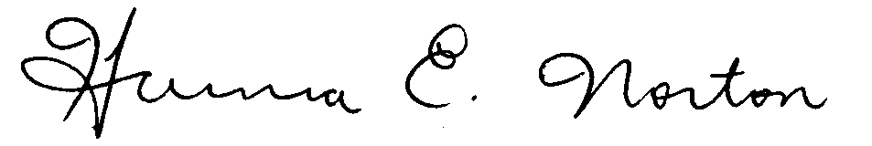 Hanna Norton, Ph.D., President
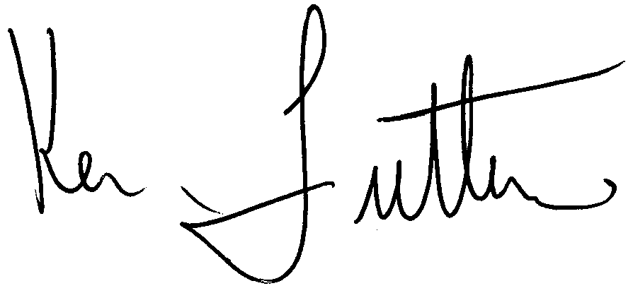
Ken Futterer, M.M., Secretary

