Minutes of
THE FACULTY SENATE
OF
ARKANSAS TECH UNIVERSITY

The organizational meeting of the 2009-10 Faculty Senate was held at 12:00 p.m., Monday, August 17, 2009, in the Private Dining Room of Chambers Cafeteria. The following members were present:

Dr. Jennifer Helms Mr. Ken Futterer
Dr. Glen Bishop Dr. V. Carole Smith
Dr. Eric Lovely Dr. Annette Holeyfield
Dr. James Walton Dr. Larry Morell
Dr. Linda Bean Dr. Penny Willmering
Dr. Alex Mirkovic Dr. Cathy Baker
Dr. David Eshelman Dr. Jeff Robertson
Mr. David Mudrinich Dr. Tom Limperis

Dr. Gill Richards was absent. Dr. Robert Brown, President and Dr. John Watson, Vice President for Academic Affairs, were visitors.

CALL TO ORDER  REPORT BY PRESIDENT  REPORT BY VICE PRESIDENT | President Bishop called the meeting to order and asked Dr. Brown for any comments.  Dr. Brown expressed his appreciation to the Senate for their good work during the previous academic year, commending them on the “orderly way in which they conducted their business.” He noted that this academic year will be very busy as the university is approaching another record enrollment with current student semester credit hours over 100,000. Dr. Brown commented that several colleges and departments are looking at possible new degree programs and potential options within existing majors, citing “academic innovation” as the “lifeblood of a university.”  Dr. Watson emphasized that he is looking forward to working with the Senate this year and commented that many of the curricular ideas being discussed are “exciting” steps for the university.  Dr. Brown commended Dr. Watson to the Senate as an “excellent leader” for this university. He asked that the Senate let him know if he can be of assistance during this academic year.  After the lunch, Dr. Brown and Dr. Watson excused themselves from the meeting.
INTRODUCTIONS/  ADDRESS BY CHAIR | President Bishop asked those present to introduce themselves and comment on any issues they would like for the Senate to discuss this year. Dr. Walton noted his interest in online and distance education.  President Bishop advised that the Senate has essentially two charges: the review of curriculum proposals and the review of administrative policies and procedures relevant to faculty with an eye to recommending changes as needed to the administration. He stated that the Senate tries to follow Roberts’ Rules of Order and asked that items of interest be framed in the form of motions for action. If the motion is complicated, the motion could be written out in advance. Motions require a second for consideration. He also advised that complicated issues may require the formation of a sub-committee.
The Faculty Senate – August 17, 2009 2

 | President Bishop asked the Senators to work with their colleagues in their colleges to determine concerns which the Senate can address. He encouraged them to read their Faculty Handbooks and familiarize themselves with changes made each year. He expressed his appreciation for the trust placed in him to be chair.
APPROVAL OF MINUTES | President Bishop asked for a motion to dispense with the reading of the minutes. Motion by Dr. Mirkovic, seconded by Dr. Willmering. Motion carried. President Bishop asked for any amendments or corrections. There being none, the minutes were approved.  President Bishop asked for a motion to amend the agenda to include the appointment of a second person to the University Promotion and Tenure Committee under Item D and to include the appointment of a Senator as liaison to the Assessment Committee as Item G. Motion by Dr. Bean, seconded by Dr. Willmering, to amend the agenda. Motion carried.
NEW BUSINESS: ELECTION OF OFFICERS | President Bishop asked for nominations for the position of Chair-Elect. President Bishop nominated Dr. Bean. There being no other nominations, Dr. Walton moved that nominations cease and Dr. Bean be elected by acclimation. Seconded by Dr. Smith. Motion carried.  President Bishop then asked for nominations for the position of Secretary. Dr. Bean nominated Dr. Baker. There being no other nominations, Dr. Walton moved that nominations cease and Dr. Baker be elected by acclimation. Seconded by Dr. Smith. Motion carried.
MEETING TIME, DAY, AND PLACE | After discussion, motion by Dr. Walton, seconded by Dr. Morell, to set the meeting time and day for 8 a.m. on Tuesdays for the fall semester. Motion failed. Motion by Mr. Futterer, seconded by Dr. Holeyfield, to set the meeting time and day for 4 p.m. on the second Friday of each month for the fall semester. Motion carried. The next meeting will be on September 11, and President Bishop stated that an attempt will be made to secure Pendergraft 325 for the meetings.
APPOINTMENTS TO ACADEMIC APPEALS COMMITTEE | President Bishop noted that he had contacted several individuals regarding committee appointments who were both eligible and willing to serve. For the Academic Appeals Committee he submitted the following names for one-year appointments: Mr. Ray Moll (College of Applied Sciences), Dr. Charles Busch (College of Arts and Humanities); Dr. Nina Goza (College of Business), Dr. Christine Austin (College of Education), and Dr. Chris Kellner (College of Natural and Health Sciences). Motion by Dr. Mirkovic, seconded by Dr. Walton, to accept these nominations. Motion carried.
APPOINTMENTS TO UNIVERSITY PROMOTION AND TENURE COMMITTEE | President Bishop reported that Dr. Theresa Herrick had consented to serve a one-year appointment on the University Promotion and Tenure Committee, an appointment created as the result of the realignment of the colleges and some of the departments. He also reported that Dr. Tim Smith had agreed to serve a three-year term. Motion by Dr. Eshelman, seconded by Dr. Willmering, to approve these nominations. Motion carried.
APPOINTMENT TO PROFESSIONAL DEVELOPMENT COMMITTEE | President Bishop announced that Dr. Rebecca Shopfner had agreed to serve a three-year term on the Professional Development Committee. Motion by Mr. Futterer, seconded by Dr. Eshelman, to approve this nomination. Motion carried.
APPOINTMENT TO GENERAL EDUCATION COMMITTEE | President Bishop stated that Dr. Ramon Magrans had consented to serve on the General Education Committee (terms by committee members will be determined at their organizational meeting). Motion by Dr. Bean, seconded by Dr. Mirkovic, to accept this nomination. Motion carried.
The Faculty Senate – August 17, 2009 3

APPOINTMENT OF LIAISON TO ASSESSMENT COMMITTEE | President Bishop asked for a volunteer to represent the Senate on the Assessment Committee. Dr. Robertson volunteered to serve. Motion by Mr. Futterer, seconded by Dr. Holeyfield, to approve this appointment. Motion carried.
OLD BUSINESS | President Bishop noted that several items of old business from the spring semester would most likely be placed on next month’s agenda. Mr. Mudrinich reminded the Senators of the merit pay issue and distributed a copy of what is currently in the Faculty Handbook and a list of possible actions that could be taken by the Senate. President Bishop stated this information was very helpful and asked the Senators to review for next month’s meeting.  Mr. Futterer and Dr. Lovely referenced the issue of the recycling law and whether Tech is in compliance. Dr. Lovely stated he will try to have information from Mr. Pennington by the next meeting.  Dr. Lovely also reported that the traffic violation appeal policy relating to faculty and staff has been amended by Public Safety and no longer requires the employee to appear before a group of students to appeal a traffic violation. Those appeals will go directly to  Mr. Lawrence, the director of Public Safety.
OPEN FORUM | President Bishop asked for any items for discussion at this time. Dr. Lovely noted that several technology issues had occurred over the summer, primarily the upgrades to Blackboard, OneTech, and Banner, the implementation of “freeze” software on instructor computers in the labs, and upgrades to web pages without the knowledge of the affected faculty and offices. He stated that faculty should be involved in making these decisions.  Dr. Morell reported that the Technology Committee had not met for several years and stated that this committee could be reactivated. Dr. Mirkovic mentioned the need for policies relating to podcasting and faculty web pages. Dr. Baker stated her belief that there appears to be a failure to communicate on the part of computer services on technology issues.  Dr. Morell volunteered to speak with Dr. Underwood in Academic Affairs concerning the Technology Committee and these issues before September’s meeting.  Dr. Lovely stated that the new tobacco free policy indicates a fine that can be levied by Tech for offenses and also states that the individual could be subject to additional fines by the Russellville Municipal Court. He stated he will talk to Mr. Pennington concerning whether this could be a case of double jeopardy.
ANNOUNCEMENTS/  INFORMATION  ITEMS | President Bishop invited the Senators to an assessment seminar beginning at noon tomorrow in the Williamson Dining Room.
ADJOURNMENT | The meeting adjourned at 1:20 p.m.

Respectfully submitted,
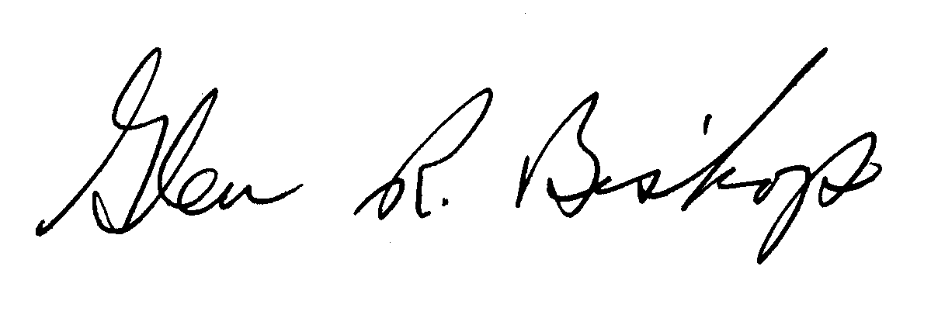

Glen Bishop, Ph.D., President

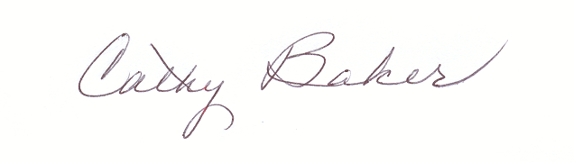
Cathy Baker, Ph.D., Secretary

