Minutes of
THE FACULTY SENATE
OF
ARKANSAS TECH UNIVERSITY

The Faculty Senate met Tuesday, April 14, 2015, at 3:00 p.m. in Rothwell 456.
The following members were present:

Dr. Carey Bosold | Dr. Chris Kellner
Dr. Glen Bishop | Dr. Timothy Leggett
Dr. Marcel Finan | Dr. Johnette Moody
Dr. Marc Fusaro | Dr. Jason Patton
Mr. Ken Futterer | Dr. Michael Rogers
Mr. Neal Harrington | Dr. Rebecca Shopfner
Dr. Annette Holeyfield | Dr. David Ward
Dr. Sean Huss
Dr. Molly Brant, Dr. Linda Kondrick, Dr. Kevin Mason, Dr. Jack Tucci,
Dr. Dana Ward and Dr. Deborah Wilson were absent. Dr. AJ Anglin,
Ms. Cynthia Callahan, Dr. Mona Chadwick Scott, Ms. Pat Chronister,
Mr. Thomas Pennington, and Mr. Wyatt Watson were visitors.
CALL TO ORDER  APPROVAL OF MINUTES | President Ward called the meeting to order and asked for a motion in regard to the minutes of the March 10, 2015 meeting.  Motion by Dr. Kellner, seconded by Dr. Huss, to approve the minutes as distributed. Motion carried.  President Ward asked for a motion to amend the agenda to add a report from  Mr. Thomas Pennington, Legal Counsel, regarding the employment of relatives as the first item of New Business, and to move “Office Hours Requirement” to the second item of New Business.  Motion by Dr. Bishop, seconded by Dr. Huss, to amend the agenda as requested. Motion carried.
NEW BUSINESS:  EMPLOYMENT OF RELATIVES | President Ward invited Mr. Pennington to address the Senate. Mr. Pennington distributed a drafted policy on the employment of relatives (Attachment A), and asked the senators for feedback. He reported the Staff Senate had reviewed and revised the policy where indicated. Mr. Pennington stated the policy would be similar to the Arkansas state law, prohibiting relatives from directly reporting to one another, but noted the proposed policy would additionally prohibit relatives from working in the same department, reporting to the same direct supervisor. He indicated any relatives currently employed in the same department would be grandfathered in under the existing policy. Mr. Pennington reported the proposed policy would be taken before the Board of Trustees in May, and if approved, would become effective at that time. He stated exceptions to the policy, once effective, would need approval by the appropriate Vice President and President.  Mr. Futterer questioned the need to implement a policy more restrictive than what is required by the state. Mr. Pennington responded the intention was to avoid possible conflicts of interest, such as a supervisor feeling pressure to retain the relative of a valued employee, even if the relative was underperforming. Dr. Bishop asked if the policy would apply to part-time employees and adjunct faculty. Mr. Pennington affirmed it would apply, but noted currently employed part-time employees and adjunct faculty would be grandfathered in as well. Dr. Fusaro noted, in academics, married couples are frequently from the same discipline, and when recruiting faculty candidates, the ability of a department to also employ the spouse in some capacity can be beneficial. Dr. Kellner asked if the university was regularly encountering conflicts related to the employment of relatives.  Mr. Pennington responded he was not aware of any existing issues, but he had been asked to draft the policy to prevent future issues. Dr. Fusaro suggested the simpler solution may be to address such issues on a case by case basis, rather than implementing a restrictive policy and considering exceptions on a case by case basis.  Motion by Dr. Bishop, seconded by Dr. Fusaro, to form a subcommittee to revise the language of the proposed policy.  Discussion following the motion centered on the ability of a subcommittee to revise the language satisfactorily if the Senate collectively did not support the base intent of the proposed policy. President Ward called for the question.  Motion failed.  Motion by Dr. Rogers, seconded by Dr. Kellner, to write a letter, stating the existing state law is a sufficient policy for the employment of relatives. Motion carried.  Mr. Futterer agreed to draft the letter and circulate it to the senators for feedback.  Mr. Pennington thanked the Senate and excused himself from the meeting.
OFFICE HOURS | President Ward distributed a proposed revision to the existing office hours and academic advising policy in the Faculty Handbook (Attachment B).  Motion by Mr. Futterer, seconded by Dr. Huss, to approve the proposed revision as presented.  Discussion following the motion centered on how to both define and determine student contact hours and university business hours. Dr. Patton expressed opposition to including hours for university business in the office hours policy, stating office hours should be specifically for student contact. Dr. Huss reminded the Senate of the concern over the appearance of reducing the amount of time faculty are available to students, and noted the proposed revision was a compromise to alleviate that concern. Dr. Rogers indicated reducing the required office hours to five could imply faculty are only expected to invest five hours outside of the classroom to be available to students, either on campus or virtually. Dr. Patton stated issues such as a faculty member not being available for departmental meetings should be addressed separately, but that office hours should be for student contact.  Motion withdrawn by Mr. Futterer.  Motion by Dr. Huss, seconded by Mr. Futterer, to revise the proposed language to the following:  Each faculty member is expected to schedule adequate and regular office hours for consultation with students and colleagues (i.e. minimum of six hours per week). Office hours are defined as those hours a faculty member is available in person or electronically (e.g. email, phone, videoconference, etc.). The total and spacing of these office hours should be planned to permit adequate student contact. Faculty members who expect to be away from the campus during scheduled office hours should notify their Department Head and should post a notice showing the approximate time of return. Ordinarily, the Department Head should be apprised of where the faculty member could be reached. Deviations from these above requirements for faculty members must be approved by the Department Head.  Motion carried.
REPORT FROM BOARD MEETING | President Ward reported at the Board of Trustees meeting on Thursday, April 16, 2015, the changes to the elected standing committees with appointments, which received a vote of support by the Faculty Senate at the February 10, 2015 meeting, was approved by the Board.  President Ward also stated the strategic planning consultants had given a report to the Board of Trustees, which included a projection for the high school graduation rate in the State of Arkansas to be flat over the next five years, followed by a decline. He indicated this would be a relevant factor to consider as the university begins the strategic planning process.
FACULTY WELFARE COMMITTEE PROCEDURES | President Ward distributed a letter from Dr. Mona Chadwick Scott, Chair of the Faculty Welfare Committee (Attachment C), regarding concerns about the process for faculty grievances, as well as sample procedures for faculty grievances and appeals (Attachment D).  Dr. Chadwick Scott asked the Senate for assistance in reviewing the grievance policy and process. Dr. Fusaro suggested the Faculty Welfare Committee submit proposed changes to the Faculty Senate for feedback. Dr. Patton volunteered to collaborate with the Faculty Welfare Committee on the proposal for the Senate.  Dr. Chadwick Scott thanked the Senate and excused herself from the meeting.
OLD BUSINESS:  ONLINE COURSE EVALUATIONS | President Ward invited Mr. Wyatt Watson, Director of Institutional Research, to address the Senate. Mr. Watson provided the following statistics requested by the senators at the March meeting: The response rate during the fall 2014 pilot for face to face courses utilizing online course evaluations was 53% for lower division courses, 58% for upper division courses, and 58% for graduate courses. He stated the response rate during fall 2013 for face to face courses was 64%.  The following discussion centered on the next action for the Faculty Senate in regard to online course evaluations, and the need for an extended pilot.  Motion by Mr. Futterer, seconded by Dr. Patton, to discontinue the use of the ClassClimate software by the Office of Institutional Research and move forward with the purchase of a new software for fully online evaluations. Motion carried.  Mr. Watson thanked the Senate and excused himself from the meeting.
REPORT ON COLLABORATION WITH ADMINISTRATION | Motion by Dr. Rogers, seconded by Dr. Huss, to table the discussion until the following Faculty Senate meeting. Motion carried.
PROMOTION AND TENURE | President Ward reported he had collected input from 25 faculty members who had been nominated or volunteered to review the promotion and tenure procedures. He stated he then collaborated with Dr. Jeff Woods, Dean of the College of Arts and Humanities, to combine input from both the faculty group and the Deans into a seven page list of questions. He reported there had been a significant amount of overlap in the issues identified by the faculty group and by the Deans. President Ward invited the Senate to continue to send suggestions to him.
HONOR CODE | Dr. Rogers requested the “Honor Code University” agenda item be discussed at the following Senate meeting and suggested writing a letter to Dr. Bowen asking that it be included in the strategic planning discussions. Dr. Patton suggested the letter also include any other items the Senate has discussed this year to be incorporated into strategic planning.
OPEN FORUM | Dr. Kellner distributed a document referencing the existing classroom visitation policy (Attachment E) for the senators to review and discuss at the following Senate meeting.
ANNOUNCEMENTS/ INFORMATION ITEMS | Dr. Huss encouraged the senators to participate in the Be The Match events on April 14-15.  Mr. Harrington announced the senior graphic design exhibit would be on display in the Norman Hall Art Gallery from April 12 until May 1.
ADJOURNMENT | The meeting adjourned at 5:00 p.m.

Respectfully submitted,

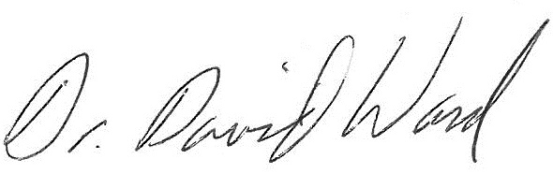
David W. Ward, Ph.D., President

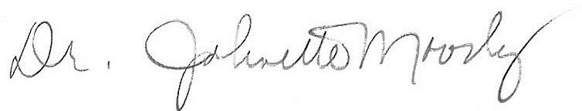
Johnette Moody, DBA, Secretary

Attachment A
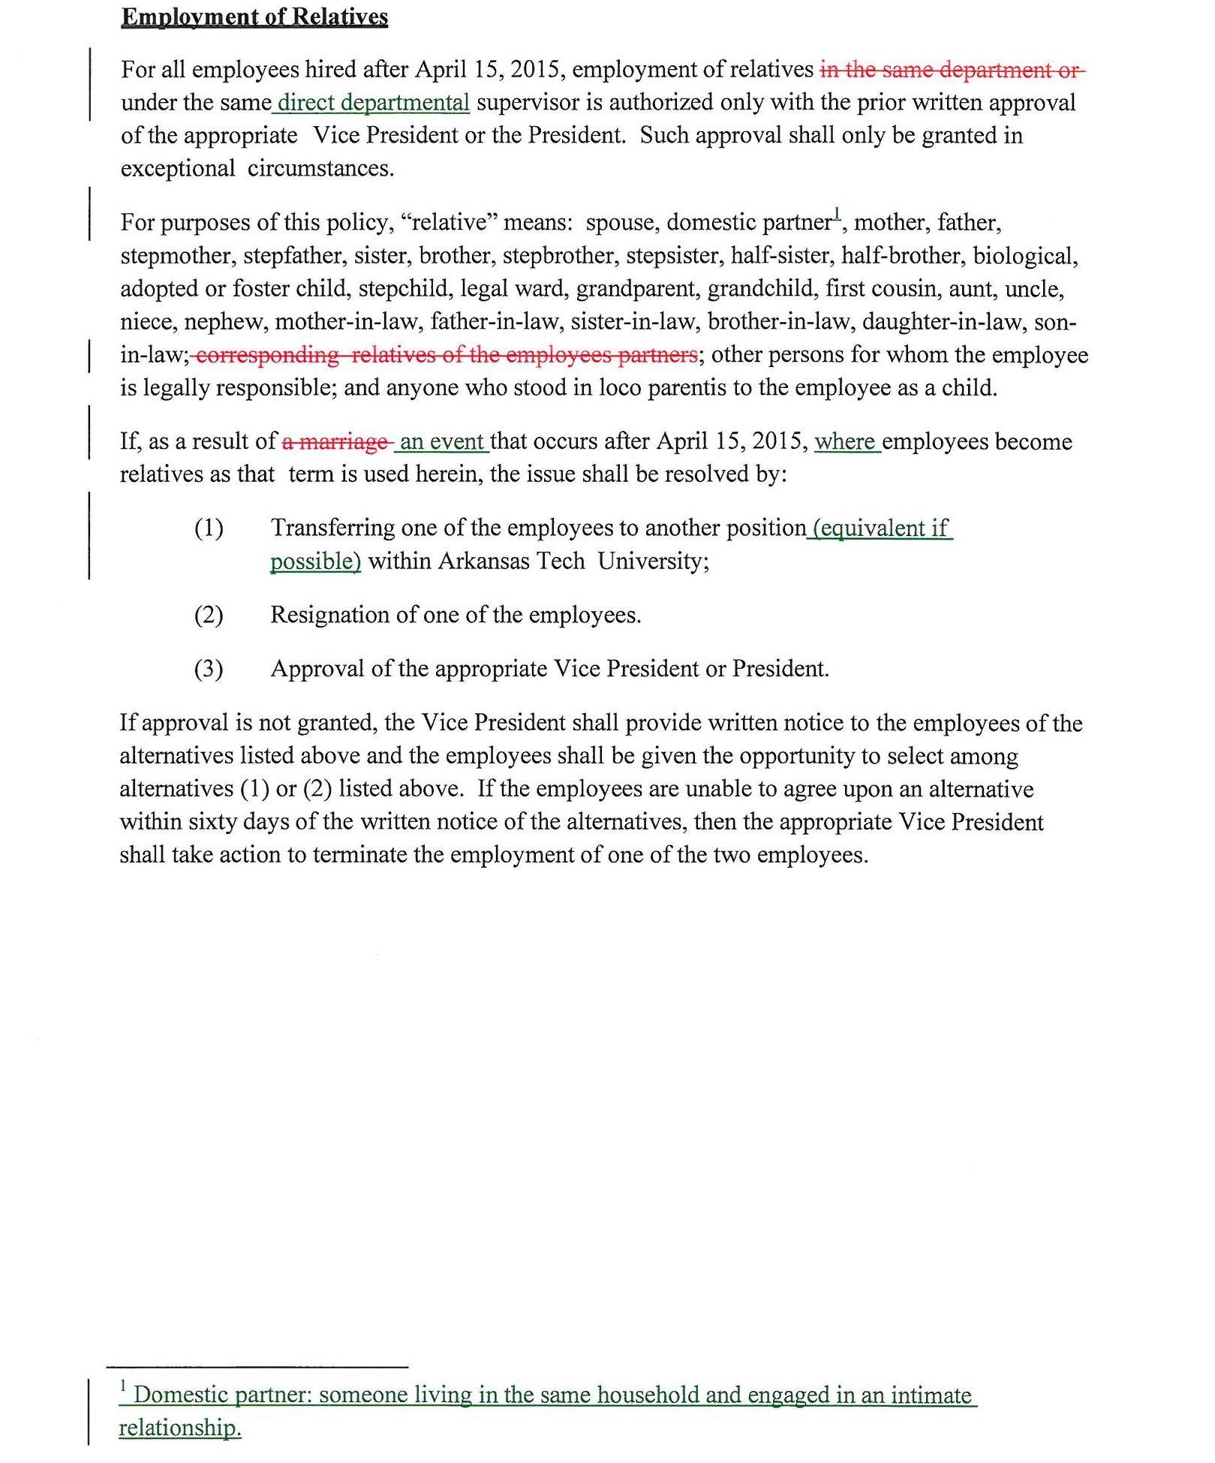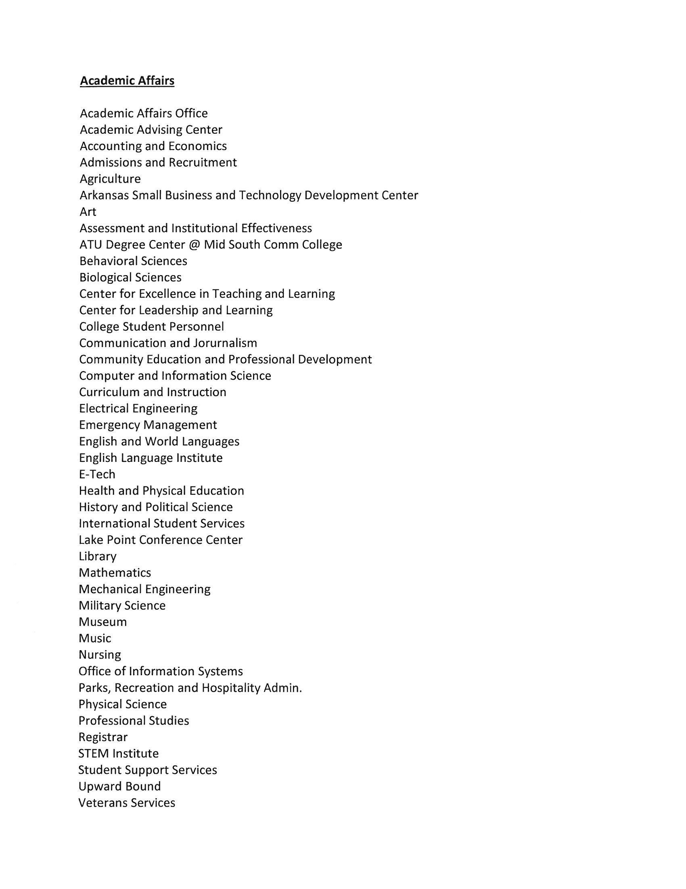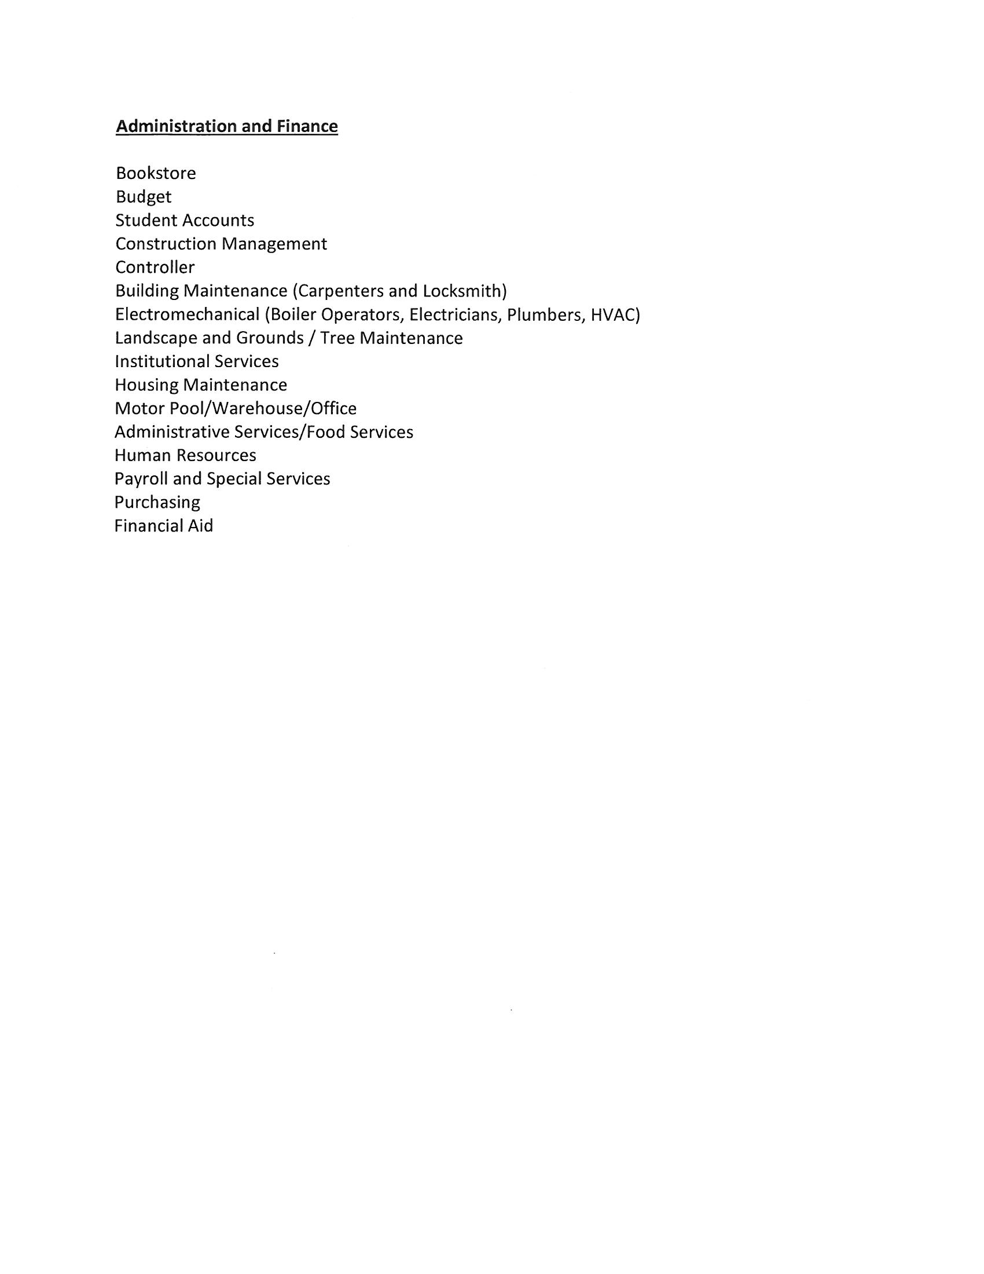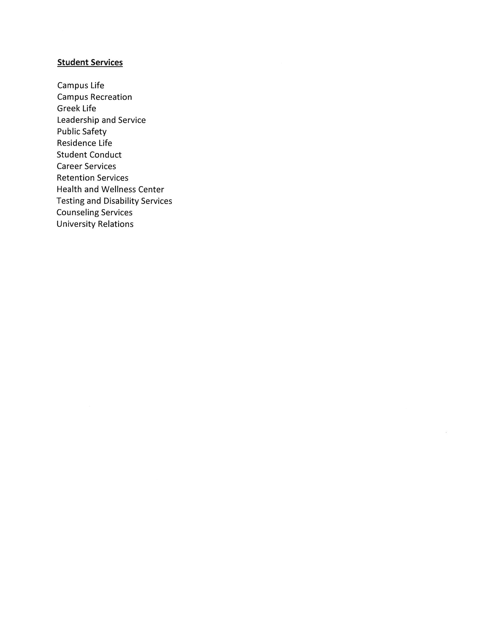
Attachment B

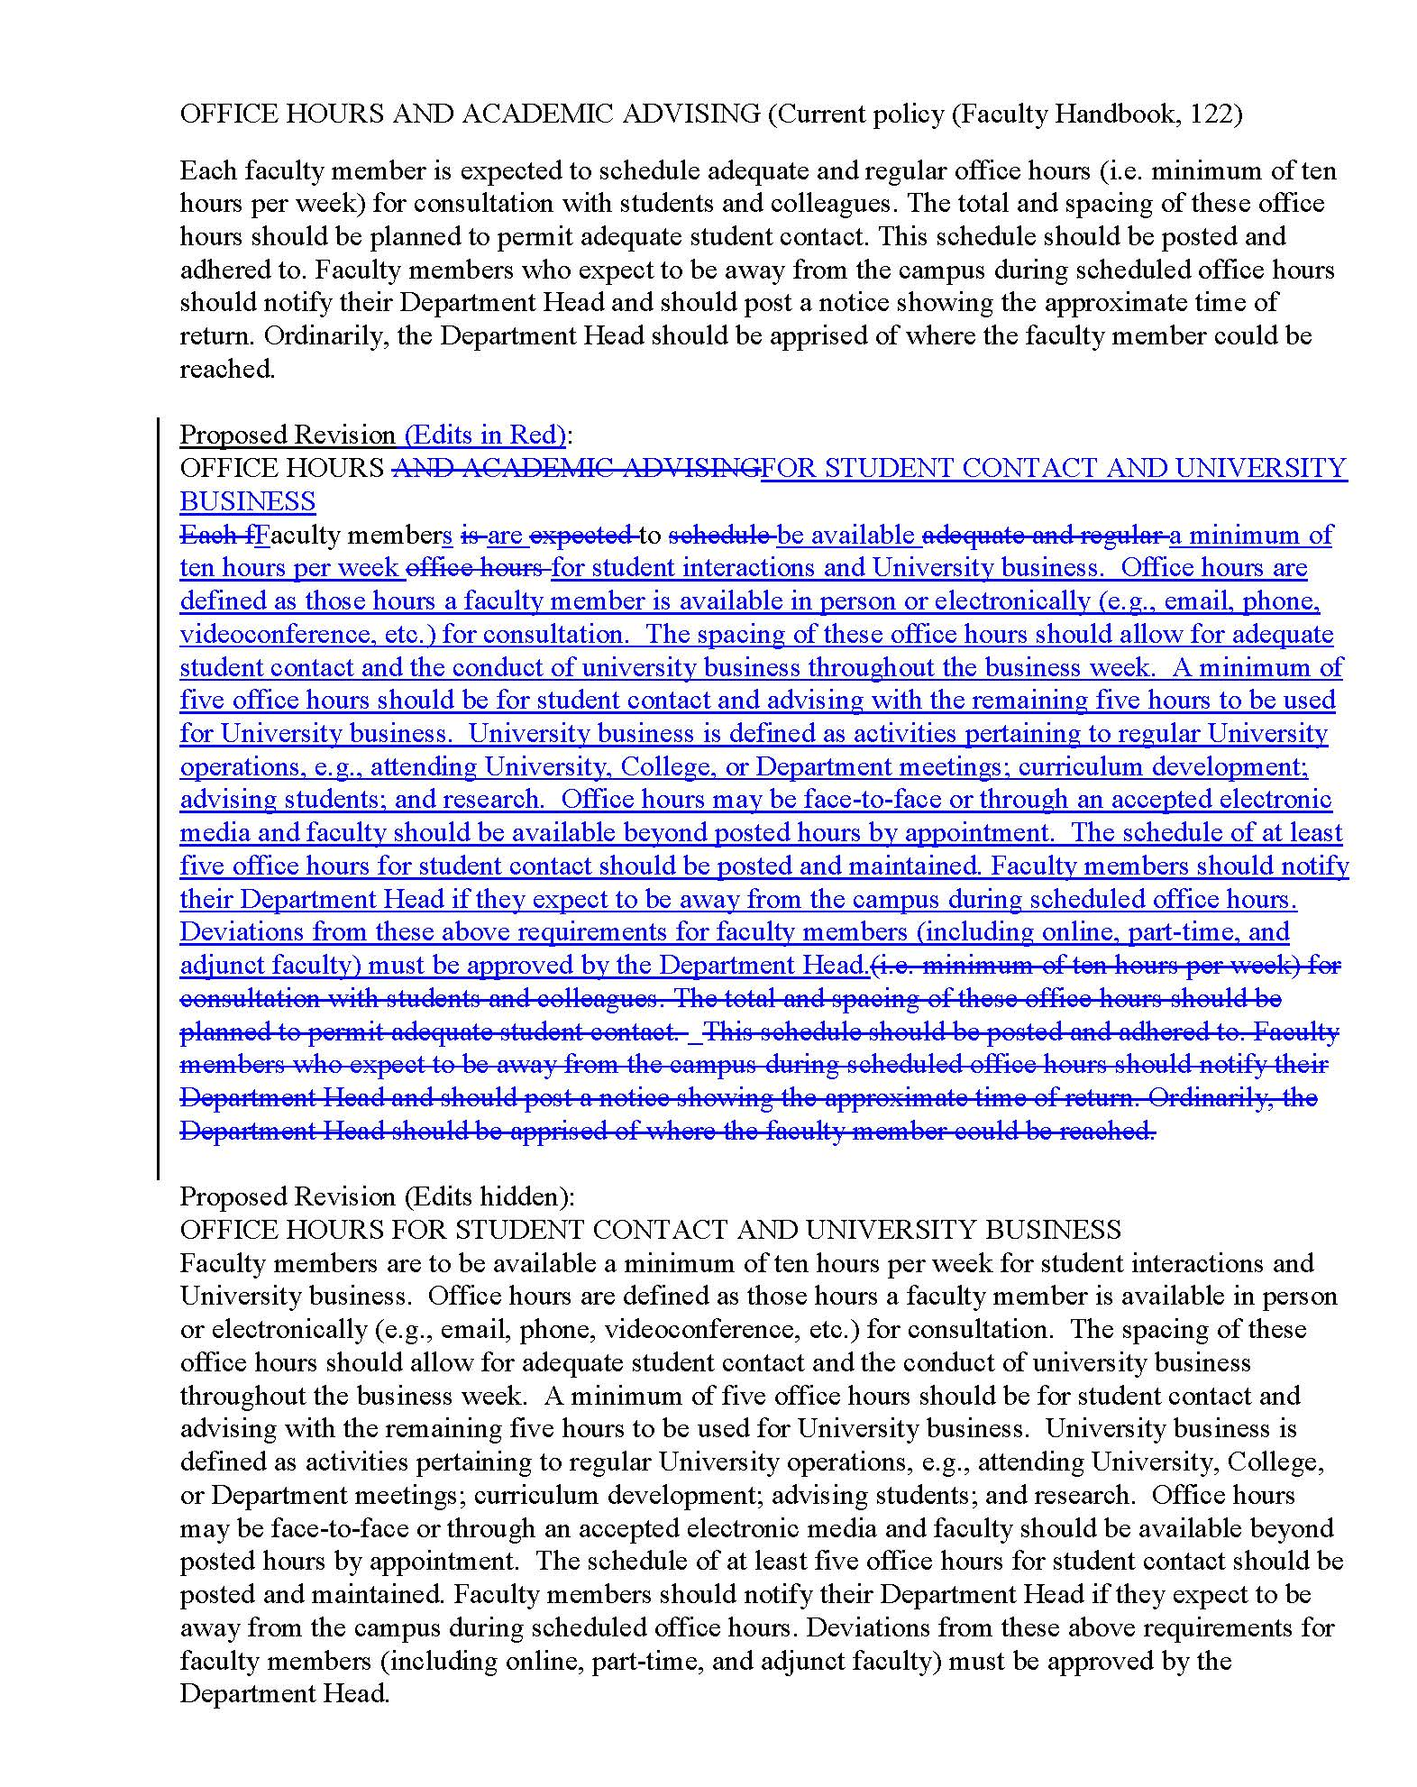
Attachment C

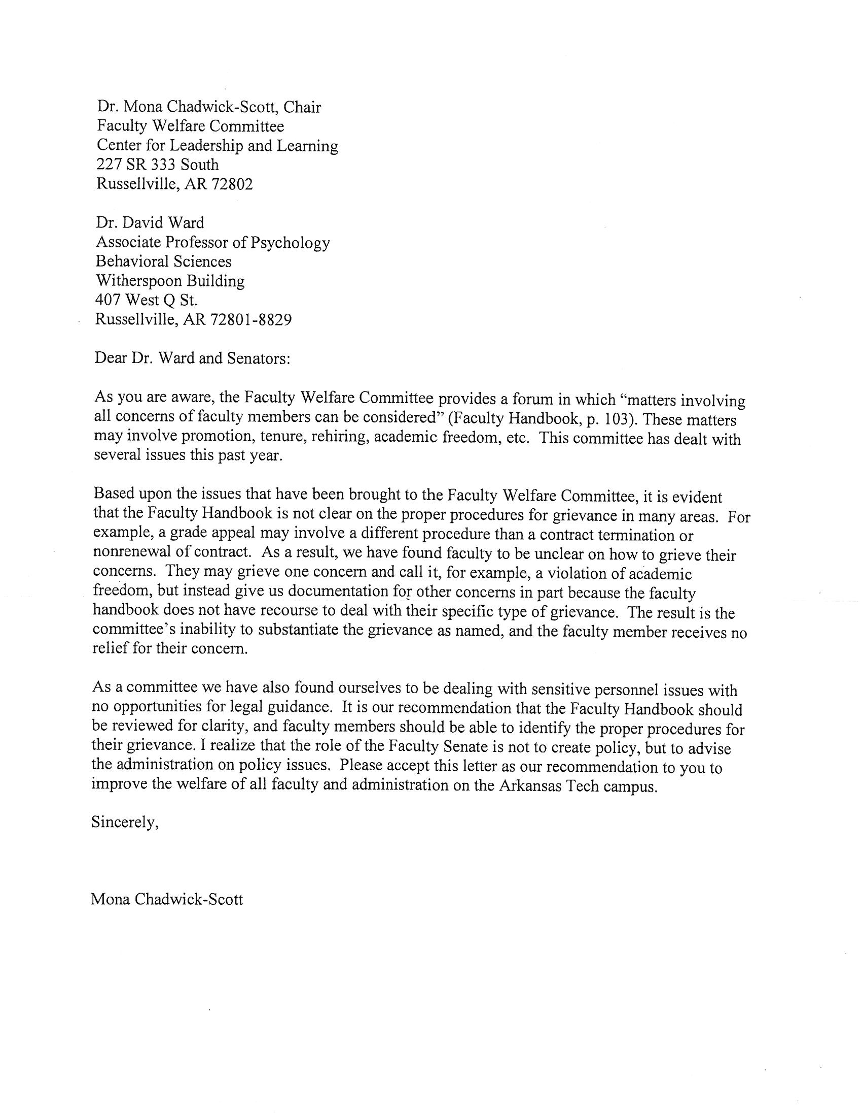
Attachment D
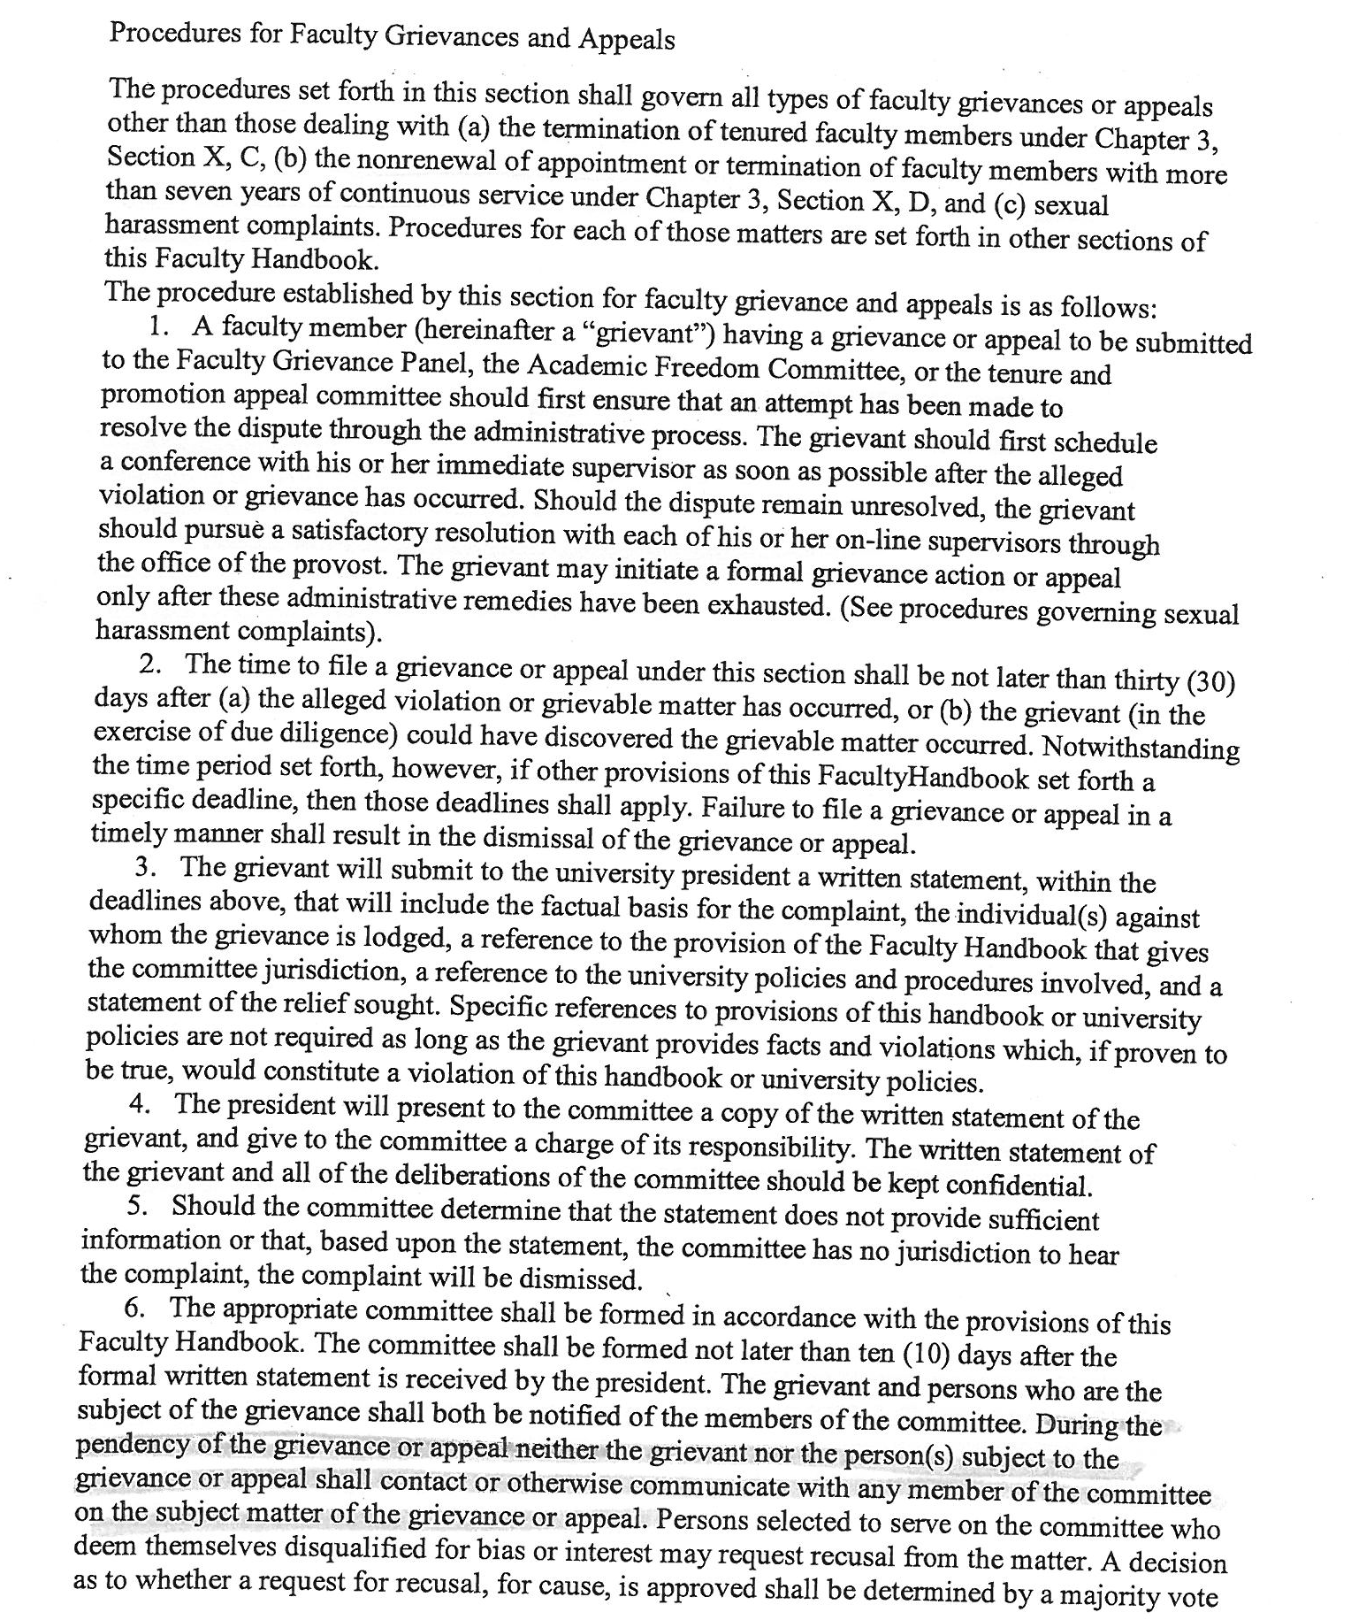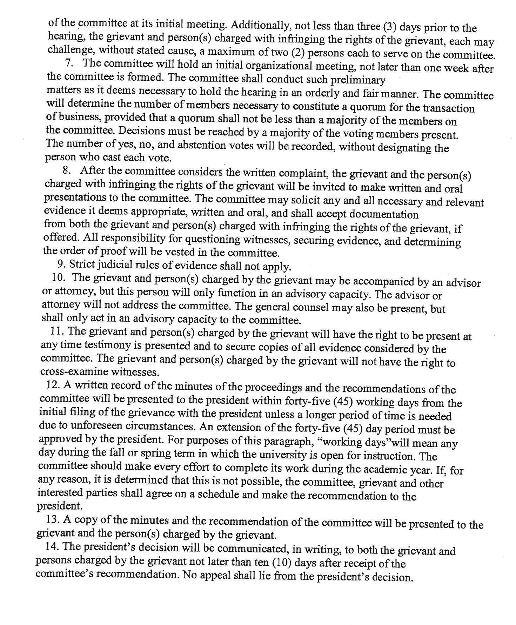
Attachment E

