Minutes of
THE FACULTY SENATE
OF
ARKANSAS TECH UNIVERSITY

The Faculty Senate met Tuesday, April 28, 2015, at 1:00 p.m. in Rothwell 456.
The following members were present:

Dr. Carey Bosold | Dr. Linda Kondrick
Dr. Glen Bishop | Dr. Timothy Leggett
Dr. Marcel Finan | Dr. Kevin Mason
Dr. Marc Fusaro | Dr. Jason Patton
Mr. Ken Futterer | Dr. Michael Rogers
Mr. Neal Harrington | Dr. Rebecca Shopfner
Dr. Annette Holeyfield | Dr. Jack Tucci
Dr. Sean Huss | Dr. Dana Ward
Dr. Chris Kellner | Dr. David Ward
Dr. Molly Brant, Dr. Johnette Moody, and Dr. Deborah Wilson were absent.
Dr. AJ Anglin, Ms. Cynthia Callahan, Ms. Pat Chronister, Dr. Jon Clements,
Dr. Debra Hunter, Dr. Shelia Jackson, Dr. James Stobaugh, and Dr. Jeff Woods were visitors.
CALL TO ORDER  APPROVAL OF MINUTES | President Ward called the meeting to order and introduced four faculty who would be serving on the Faculty Senate beginning in August 2015: Dr. Jon Clements,  Dr. Debra Hunter, Dr. Shelia Jackson and Dr. James Stobaugh. He stated  Ms. Melissa Darnell will also be serving next year as a newly elected senator, but was unable to attend. He reported he had invited the elected senators in an effort to promote continuity of the Senate’s current initiatives into the following year.  President Ward asked for a motion in regard to the minutes of the April 14, 2015 meeting.  Motion by Dr. Rogers, seconded by Dr. Huss, to approve the minutes as distributed.  Following the motion, Dr. Rogers provided two grammatical corrections to the proposed office hours policy included in the minutes:  1) Each faculty member is expected to schedule adequate and regular office hours for consultation with students and colleagues (i.e. a minimum of six hours per week).  2) Ordinarily, the Department Head should be apprised of where the faculty member could can be reached.  Motion by Dr. Rogers, seconded by Dr. Huss, to approve the minutes as amended. Motion carried.  President Ward asked for the agenda to be amended to add “Election Results” as the first item of New Business and move the discussion of the promotion and tenure review to the second item of New Business.  Motion by Dr. Kellner, seconded by Mr. Harrington, to amend the agenda as requested. Motion carried.
NEW BUSINESS:  ELECTION RESULTS | President Ward announced the results of the standing committee elections had produced a tie for the untenured, at-large position on the Faculty Welfare Committee. He distributed a paper ballot for the senators to cast a vote. The vote resulted in the election of  Ms. Susan Self to the Faculty Welfare Committee.
PROMOTION AND TENURE | President Ward introduced Dr. Jeff Woods, Dean of the College of Arts and Humanities. Dr. Woods reported, in an effort to update and improve the procedures for promotion and tenure, a group of Deans and a group of faculty had reviewed the existing policy and provided feedback. Dr. Woods stated he and President Ward had then compiled the feedback into a single document of questions to be addressed. He indicated the two groups had been consolidated into a representative committee: Dr. Jeff Woods, Dr. David Ward,  Dr. Jim Musser, Dr. Pam Carr, Dr. V. Carole Smith, Dr. Theresa Herrick, Dr. Pat Buford, and Dr. Jeremy Schwehm. He stated one final position on the committee would be for a Faculty Senate representative.  Dr. Holeyfield nominated Dr. Shelia Jackson to serve as the Faculty Senate representative on the committee reviewing the promotion and tenure procedures. Mr. Futterer seconded her nomination. Dr. Huss nominated Dr. Chris Kellner to serve as the representative.  Mr. Futterer seconded his nomination.  Motion by Dr. Holeyfield, seconded by Dr. Huss, to cease nominations for a representative. Motion carried.  The vote resulted in the election of Dr. Shelia Jackson to the committee reviewing promotion and tenure procedures.  Dr. Woods stated the process would require continuous feedback from the faculty and the university at large. He reported the next step would be to develop a survey based on the compiled list of questions. He indicated a website would be dedicated to the promotion and tenure review process, where faculty will be able to submit feedback and view information on the progress to date and timeline for the future.  Dr. Woods thanked the Senate and excused himself from the meeting.
EMPLOYMENT OF RELATIVES | Mr. Futterer distributed a list of questions and concerns from various faculty members and senators (Attachment A) concerning the proposed policy to prohibit the employment of relatives under a common supervisor.  Motion by Mr. Futterer, seconded by Dr. Bishop, for the Faculty Senate to oppose the proposed policy, which would be more prohibitive than the Arkansas state law. Motion carried.
CLASSROOM VISITATION | Dr. Kellner reported a concern from a faculty member regarding classroom visitation without permission from the instructor. He stated the faculty member had consulted with Legal Counsel, who responded the Faculty Handbook only required permission from the instructor for classroom visitation conducted as a part of peer review; otherwise, permission was not required. Mr. Futterer stated, as a member of the group which drafted the original peer review section of the Handbook, the intent was for classroom visitation to be prohibited, except for the purpose of peer review, which required permission from the instructor. Dr. Bishop expressed concern with prohibiting classroom visitation, and noted such visitation makes peer review more effective. Dr. Kellner recommended the wording in the Faculty Handbook be expanded to require permission of the instructor for any classroom visitation. Dr. Kondrick questioned the feasibility of a policy requiring a Dean to seek permission to visit a faculty member’s class.  The following discussion centered on the credibility that classroom visitation may lend to peer review and the evaluation process, and the negative perception students and colleagues may have of an administrator observing an instructor in the classroom for any reason.  Dr. Huss stated the two were separate issues and should be handled individually. President Ward suggested tabling the discussion until the Senate reconvenes in the fall. Mr. Futterer agreed, noting this issue may arise as part of the promotion and tenure review.
OLD BUSINESS:  REPORT ON COLLABORATION WITH ADMINISTRATION | Dr. Rogers circulated recommended revisions to the constitution of the Faculty Senate (Attachment B).  Motion by Mr. Futterer, seconded by Dr. Huss, to accept the proposed amendments to the constitution of the Faculty Senate as presented, to be voted upon by the faculty in spring of 2016. Motion carried.  Following the motion, Dr. Finan questioned the advantage of electing senators based on the number of faculty in each college, rather than one senator per department. He also noted the two appointed members should be elected by faculty, rather than appointed by the administration. Dr. Anglin suggested the Senate request a meeting with himself and  Dr. Bowen to discuss the appointive membership, as Dr. Bowen may be receptive to such a change. Mr. Futterer stated, in response to the representative membership of the Senate, there were benefits and disadvantages to each form of representation and suggested  Dr. Finan draft a proposal, as such a change would alter the focus and structure of the Faculty Senate.
HONOR CODE | Dr. Rogers reported the Senate had previously discussed drafting a letter to the administration, listing items to be considered during the strategic planning process, including the development of a university honor code.  Motion by Dr. Rogers, seconded by Mr. Futterer, to recommend the adoption of a university honor code in the course of the strategic planning process and for the Faculty Senate to provide the materials from earlier research of an honor code to the Strategic Planning Committee. Motion carried.  Dr. Rogers stated he would send the materials to be shared for inclusion in the minutes (Attachment C).
FACULTY WELFARE PROCEDURES | President Ward asked for a report. Dr. Patton stated he had not yet met with the Faculty Welfare Committee, and suggested revisiting this topic once the committee had information to share with the Senate.
OPEN FORUM | Dr. Kellner asked if a written policy existed for the hiring and employment of international faculty, particularly those needing sponsorship. Dr. Anglin reported the moratorium on sponsoring international faculty had been lifted in fall 2014, and the university is working with those faculty in compliance with federal guidelines.  Dr. Kellner then asked if the Senate would consider drafting a hostile work environment policy for inclusion in the Faculty Handbook. Dr. Anglin responded the grievance policy covers complaints of hostile work environment, and that policy was included in the Handbook.  Dr. Rogers reported he had emailed Ms. Chronister and Dr. Anglin regarding the payment of adjuncts and faculty overloads. He expressed the concern that payments were not received in a timely manner, as the first payment is distributed approximately six weeks after the beginning of classes. Ms. Chronister reported the payment schedule is largely driven by the deadline for the departments to submit the faculty load spreadsheets from which both adjunct contracts and faculty overloads are created. She stated revisions to the schedule of courses (i.e., cancelling classes, etc.) result in changes to adjunct assignments and faculty overload assignments, with many revisions occurring up to the date classes begin. She emphasized these revisions to the schedule of courses could result in incorrect contracts and payment amounts, if contracts were created earlier than the beginning of classes. Ms. Chronister also expressed concern for providing an adjunct faculty member a contract and payment prior to receiving approval from the Board of Trustees. Dr. Holeyfield stated, as a department head, she must be able to respond to student and faculty needs, often very close to the beginning of classes. Dr. Rogers suggested the university explore all possibilities such as paying every two weeks rather than once monthly, or paying in the middle of the month rather than the end. Ms. Chronister stated there would be many elements to take into consideration such as withholdings and other payroll functions she may not be aware of.  Dr. Anglin indicated he would discuss this further with the involved offices and report back in the fall.
ANNOUNCEMENTS/ INFORMATION ITEMS | Mr. Futterer thanked President Ward for his hard work throughout the academic year as Senate President. President Ward thanked the senators for their cooperation and collaboration with the administration.
ADJOURNMENT | The meeting adjourned at 2:36 p.m.

Respectfully submitted,

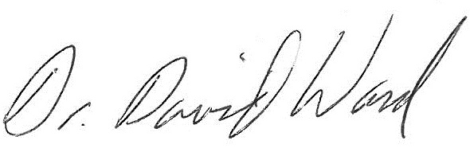
David W. Ward, Ph.D., President

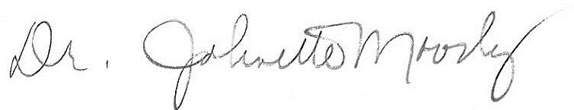
Johnette Moody, DBA, Secretary

Attachment A

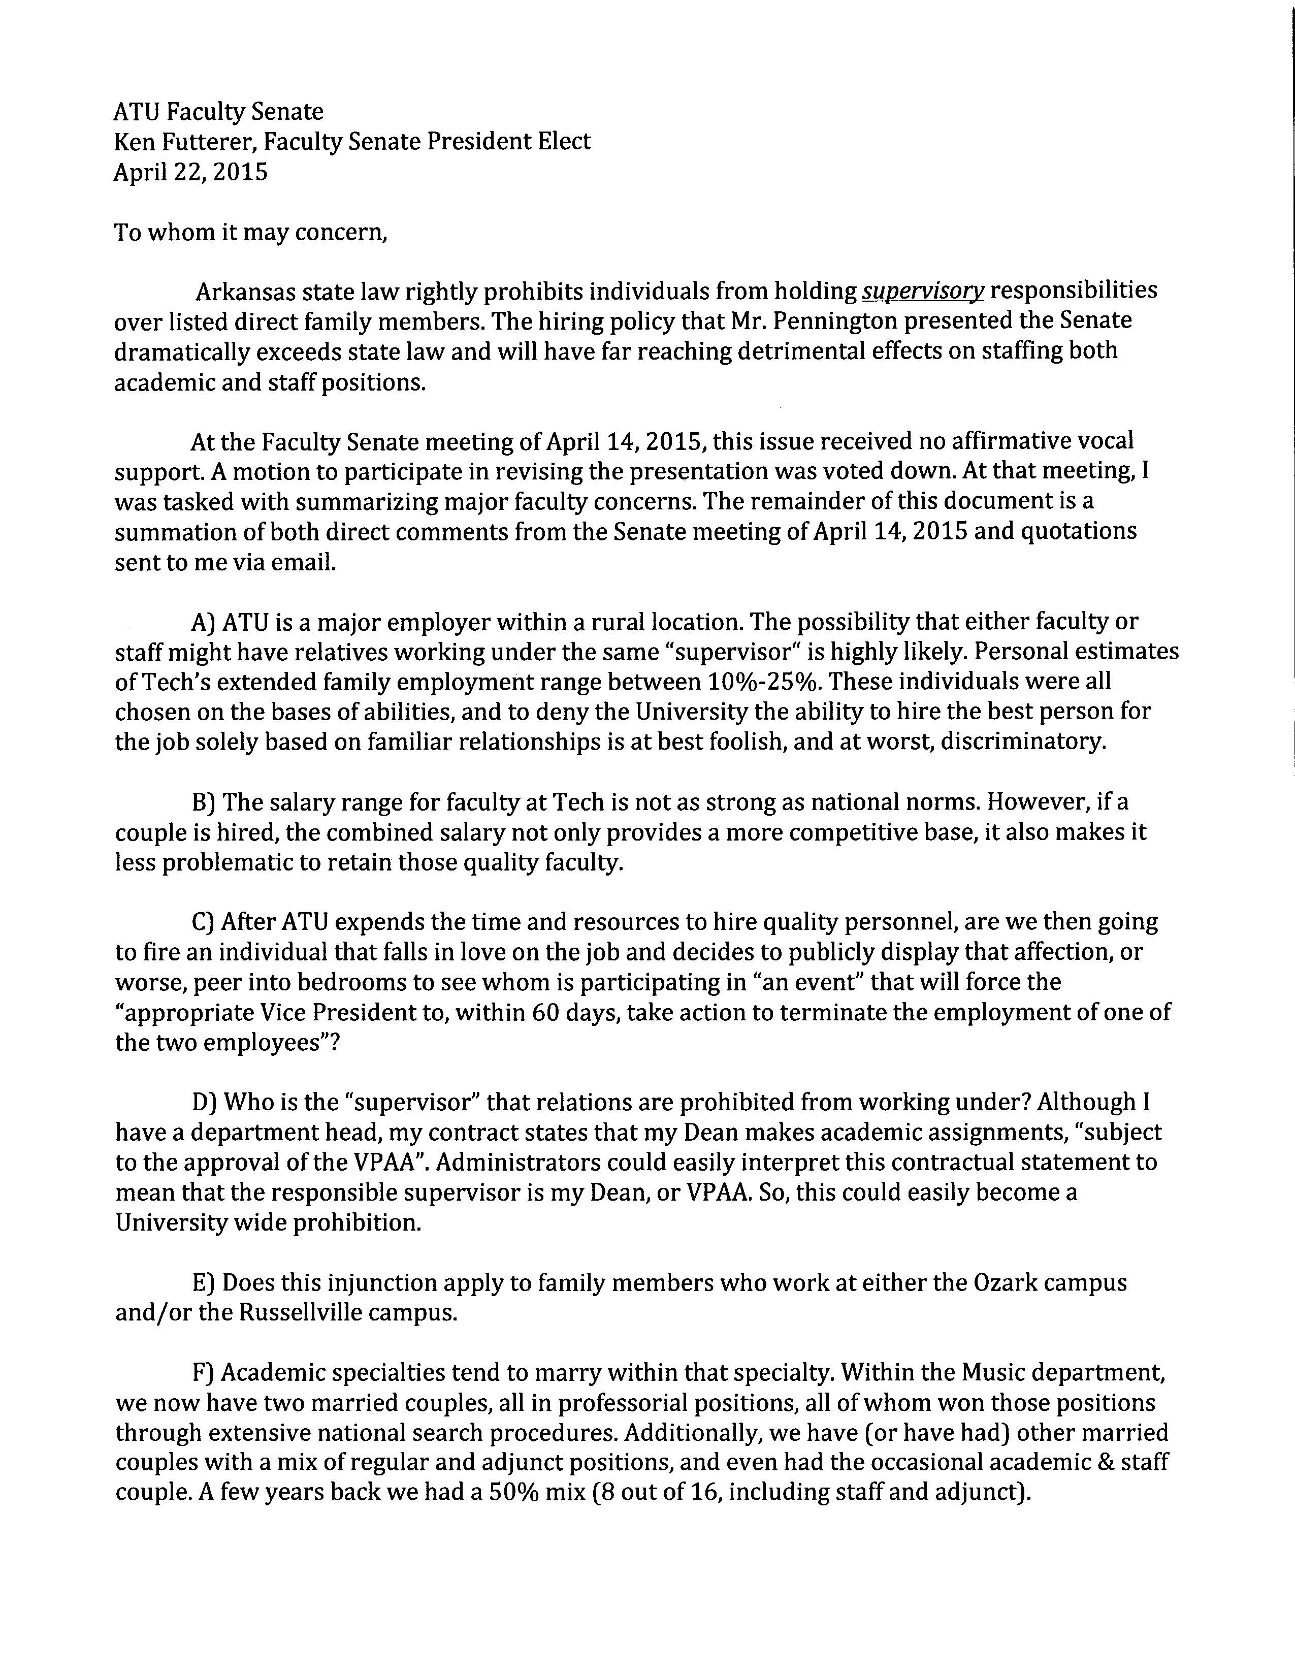
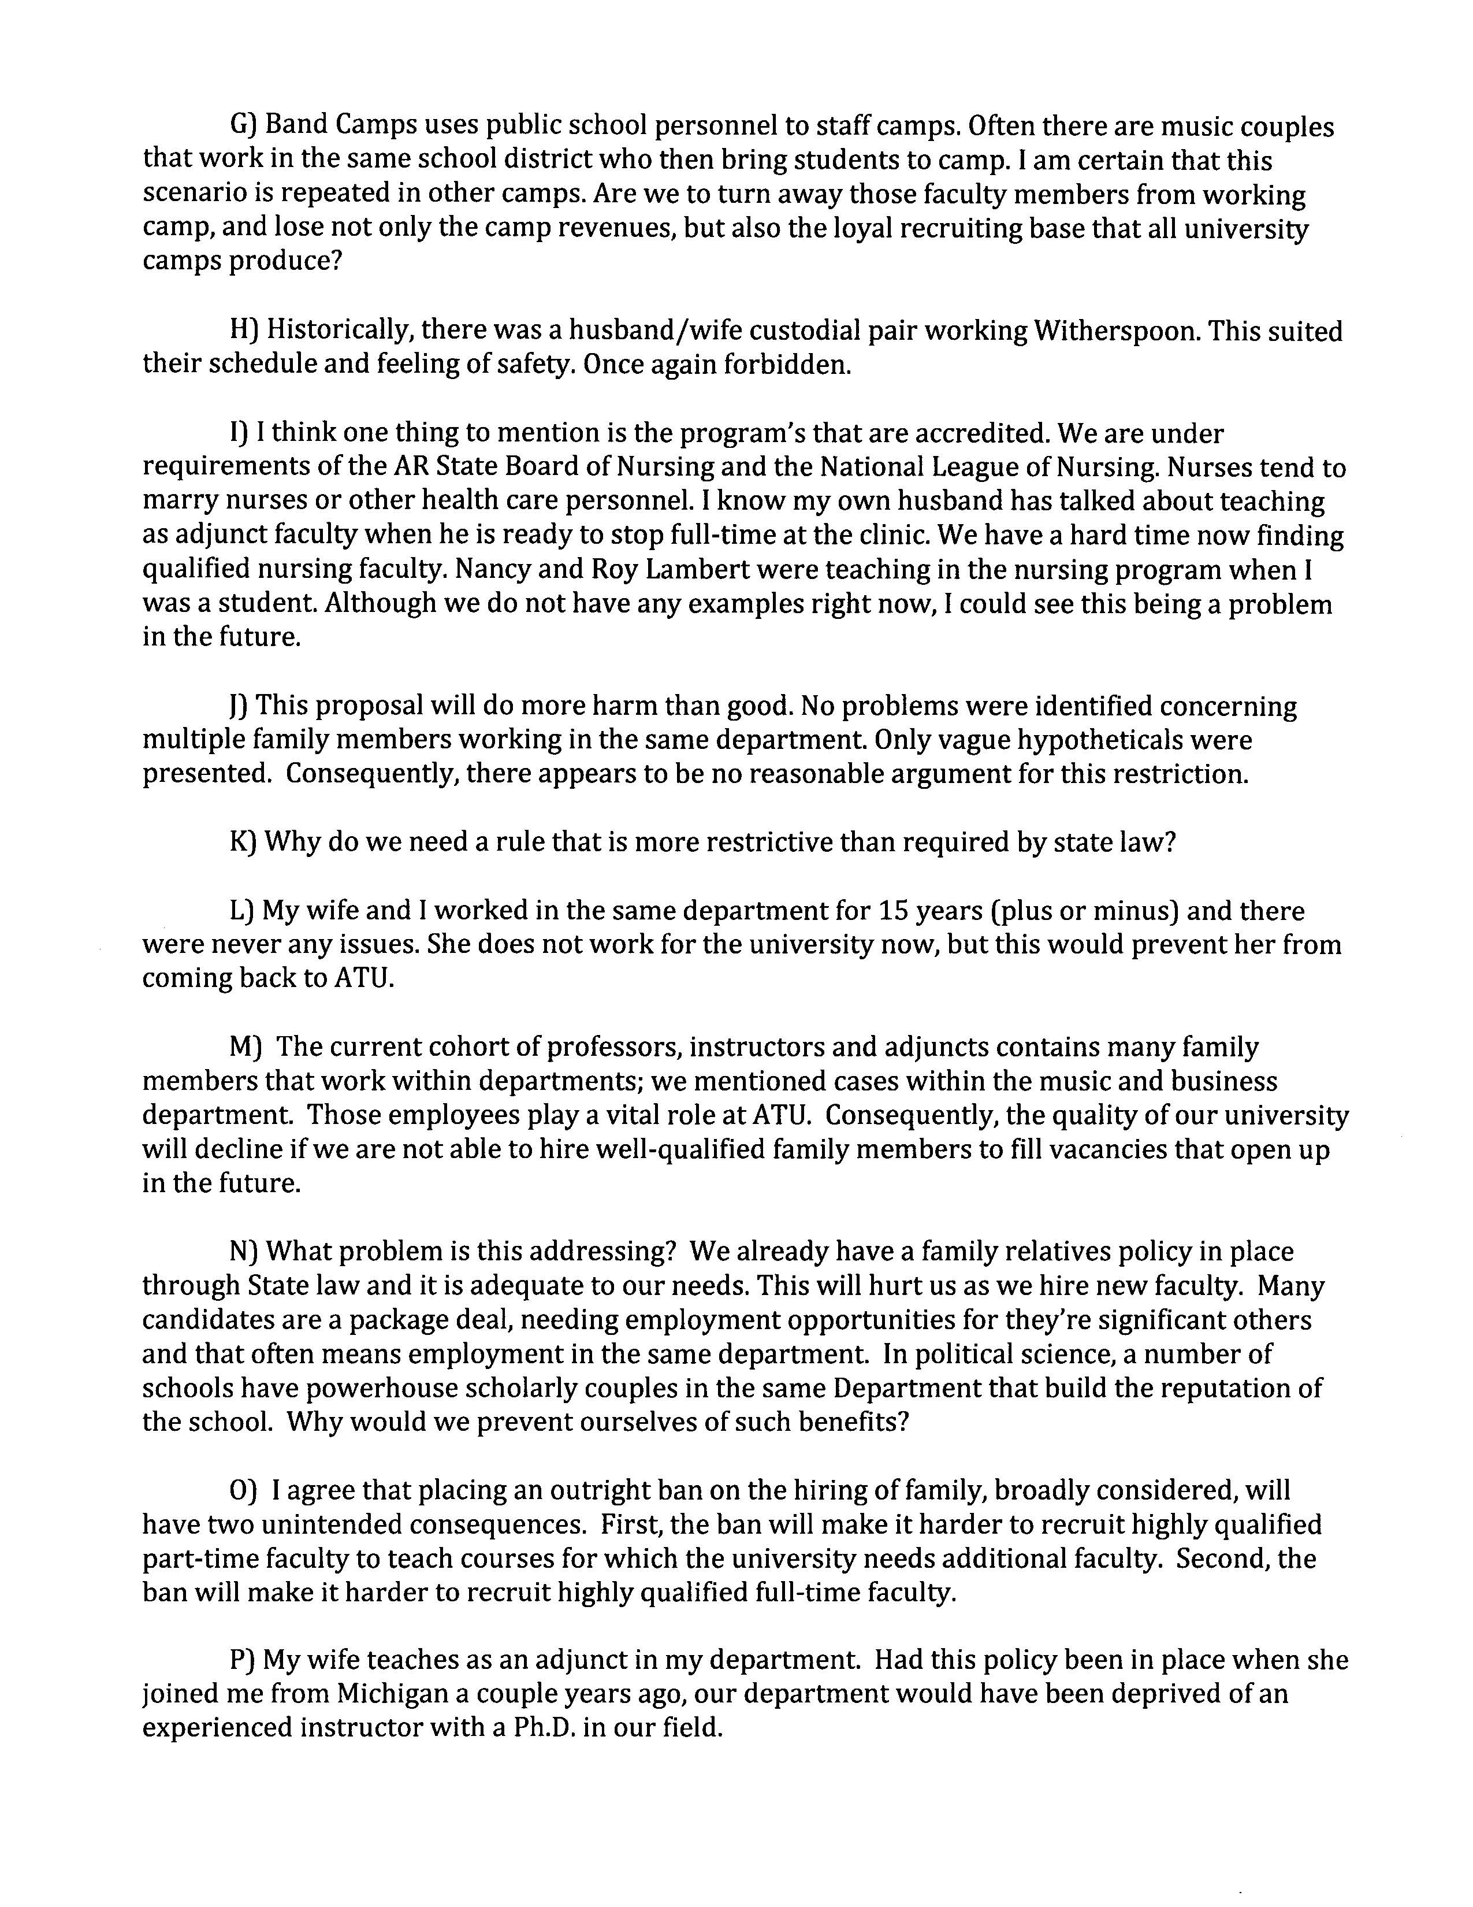
Attachment B

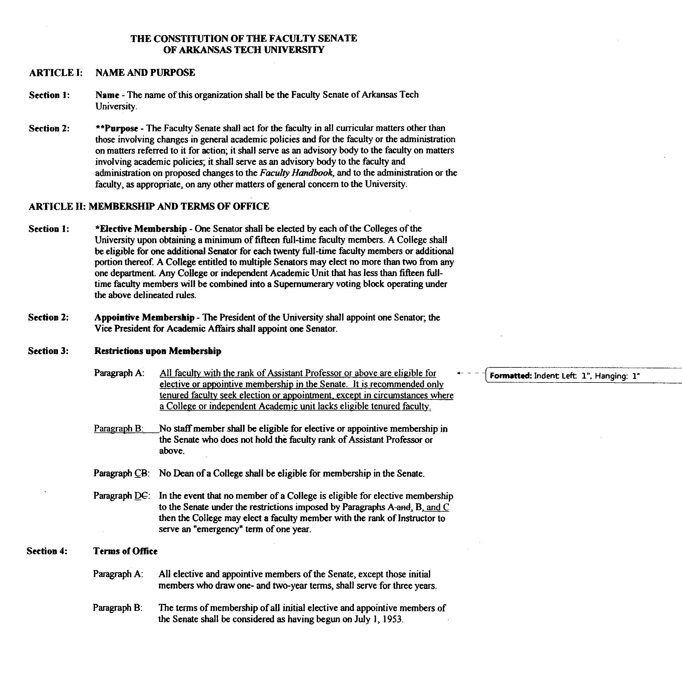
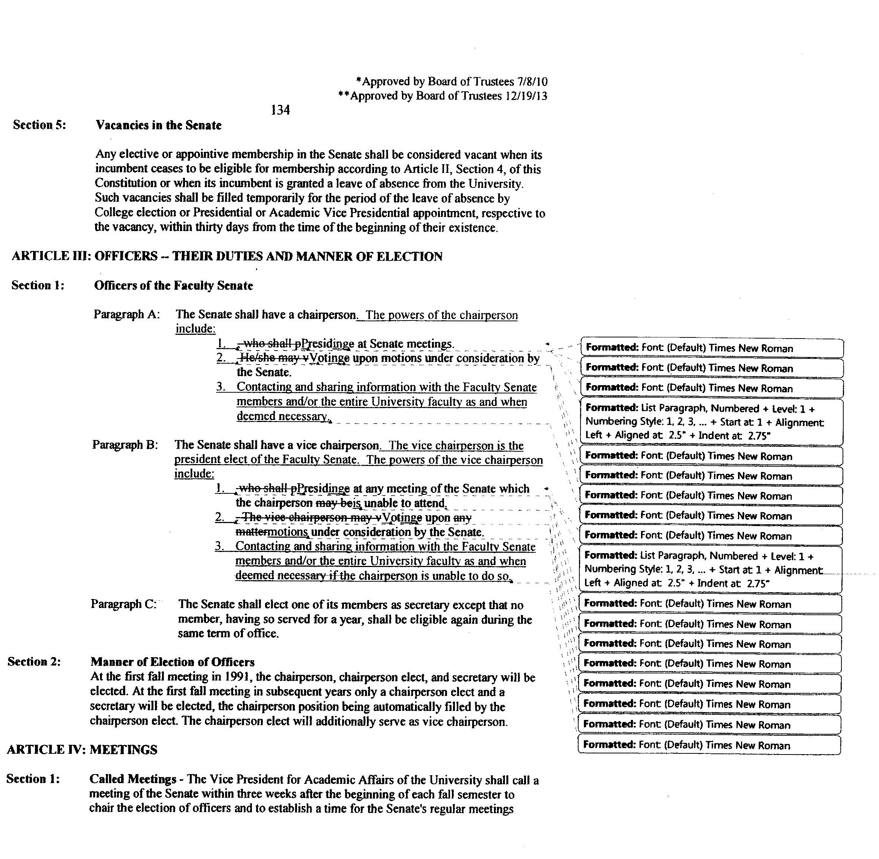
Attachment C

Goals & Objectives Necessary for the Development of an Honor Code
ARKANSAS TECH UNIVERSITY

POLICY DEVELOPMENT
In order to assure support of the honor system on campus, the proposed honor code must be reviewed and discussed widely throughout the campus community. A final vote of approval must take place by early spring semester 2009 in order to implement an honor system by Fall Semester 2009.

Goal 1: To build consensus around implementing an honor code among key university constituencies.

- Create a working group to begin writing honor code. Involve students, faculty, university counsel, student services, etc.
- Begin discussion and revision of honor code with groups who are a part of consensus-building process (Faculty Senate, Student Government Association, upper administration—V-Ps, President, Board of Trustees, etc.).
- Initiate discussions relating to jurisdiction and adjudication structures.
- Hold informational sessions about the Honor Code process and timelines with various stakeholders: all academic departments, Graduate Studies, Admissions, athletics, Advising Center, CSP1013, Honors programs, International Student Office, Residence, Greek Life, various student services offices, Disability Services, etc.

Goal 2: To complete a draft of the honor code by Fall 2008, and revise for final approval by Spring 2009 which includes input from all parts of the university community.

- Create honor code and complete revisions with input from the groups who are a part of consensus-building process (Faculty Senate ad hoc committee, Student Government committee, and other university governance bodies).

Goal 3: To have the final vote of approval take place by __________.

- Gain final approval of Honor Code by Faculty, Staff, graduate and undergraduate students.
- Gain final approval of Honor Code by the Board of Trustees.

AWARENESS CAMPAIGN
The success of effective implementation of the Honor Code hinges on the entire community’s knowledge and support of the honor system.

Goal 1: To create symbols and easy recognition of the honor code

- Design logo to be identified with the Honor Code Student Board and the Honor Code itself. Possibly, there can be one logo for both purposes.
- Design plaques or framed statements of the Honor Code to hang in classrooms and public spaces.

Goal 2: To publicize the Honor Code within the university community and externally.

- Create a fact sheet for use in on-going discussions and briefings about the Honor Code.
- Create a brochure on the Honor Code explaining philosophy, statement, and procedures.
- Conduct informational sessions about the Honor Code for the Admissions, Communications, and Alumni Development staffs to enable them to begin marketing and publicizing the Honor Code.
- Applications for new students should include a letter, informational brochure and statement for students to sign and return upon acceptance to the university.
- Have a symbolic first signing of Honor Code with a student athlete, Honors scholars, greek students, Student Senate, Honor Code student board, etc. Take publicity photos for on campus and off campus publications.
- Create traditions surrounding the honor code.
- Include the press in special events that highlight the Honor Code.

EDUCATION, EVALUATION, AND TRAINING
Academic integrity issues are complex. Training, workshops, and discussions will need to be ongoing to increase the overall campus knowledge about these issues.

Goal 1: Design sessions specifically addressing faculty concerns.

- Deliver a series of faculty workshops created and delivered by faculty on academic integrity topics (e.g. disruptive behavior in the classroom, effective syllabi use in creating academic integrity climate, recognizing cheating patterns, test and assignment design, etc.).
- Invite a nationally known speaker on academic integrity to address the university community. (Sally Cole/Don McCabe-National Center for Academic Integrity-effectiveness of honor systems).

Goal 2: Create a training program for university community members who will serve on the boards adjudicating academic dishonesty violations.

- Institute a training program for the Academic Conduct Review Board and the Appeals Board.

Goal 3: Continue to have opportunities for students to explore academic integrity issues.

- Hold academic integrity discussion in mentor groups and CSP1013 classes.
- Academic Integrity Days

Goal 4: Include the university staff in on-going discussions about the Honor Code.

- Hold Brown Bag lunch topics specifically targeted for staff.

Goal 5: Gather data to learn where the community currently stands on the issues surrounding academic honesty.

- Conduct an academic integrity survey to gain baseline results for comparison with future assessments after implementation of the Honor Code takes place.

HONOR CODE IMPLEMENTATION & INCORPORATION INTO CULTURE
Until this new culture is well-established at ATU (a process which generally takes at least five years or a cycle of an undergraduate class), explicit measures will need to be taken and repeated to demonstrate the University’s commitment to this ideal.

Goal 1: Determine central location for housing records and reporting structure.

Goal 2: Create an Honor Code Student/Faculty Board that has primary responsibility for administering the code.

- Establish selection criteria for board members.
- Join Center for Academic Integrity and send representatives to conference.
- Train members on adjudication.
- Set up reporting and administration protocols.

Goal 3: Each current tradition at ATU needs to search for meaningful ways to incorporate Honor. Special new traditions focusing solely on Honor can also be developed to foster the new culture.

- University Convocation
- Orientation
- Greek Week/Convocations

Goal 4: Information about the Honor Code needs to be included in current events and programs at ATU. Sharing the philosophy and values of the Honor Code needs to begin with the first contact and continue through a student’s matriculation at the University.

- Hold targeted sessions for students and their families during the following events: orientation, Homecoming, etc.

Goal 5: Establish new programs which will become part of the academic year calendar to keep Academic Integrity issues in the forefront of the campus consciousness.

- The Center for Teaching and Learning will create opportunities for faculty to design an event highlighting Academic Integrity issues.
- Academic Integrity Days will be held each semester prior to mid-terms to highlight issues of academic integrity and targeted specifically to student needs. These can incorporate mock hearings, forums, movies, role plays, speakers, etc.

PUBLICATION INTEGRATION
A university’s publications are essential to imparting the values of the academy. Reference to the Honor Code must be made in every piece of written material advertising or relating to the University.

Goal 1: Create a brochure on the Honor Code explaining philosophy, statement and procedures.

Goal 2: Incorporate the Honor Code into University publications.

- University Bulletin
- Student Handbook
- Admissions materials
- Faculty Handbook
- World Wide Web pages

Honor Code Statement
In its earliest years, Arkansas Tech University (ATU) recognized the importance of truth and honesty in the pursuit of knowledge. As one of the earliest ATU student governments established, the primary guiding code of DO RIGHT is still applicable today. We continue to believe—as this early student government did—that the intent is to give each member of the ATU community “all the freedom that he/she can use for the good of him/herself, him/her companions, and his/her college.” Community members do not ask for more and should not be given less (adapted from cite). Thus, while respecting and promoting the pursuit of knowledge, we accept that academic integrity at ATU depends on the individual and collective efforts of students, faculty and the administration and staff to DO RIGHT.
In the area of academic integrity, all members of the ATU community are committed to promoting an educational environment free of cheating, plagiarism, and other forms of academic dishonesty. As the ATU mission states, we are a community dedicated to “nurturing scholastic development, integrity and professionalism.” This cannot be achieved without a university-wide emphasis on the highest level of integrity and ethics in academics.
Philosophy
- Education on correct behavior first, punishment second.

PROCESS
- Statement of Honor Code

While respecting and promoting the pursuit of knowledge, the community at ATU accept that academic integrity depends on the individual and collective efforts of students, faculty, the administration and staff to DO RIGHT.
Excerpt from the Faculty Handbook, p. 74
- Reporting Process
2. The professor will notify the Academic Integrity Clearinghouse (AIC) of the alleged violation, providing evidence and proposed academic penalty.
a. First time alleged offense of academic dishonesty
1. Faculty disposition to handle situation internally imposing academic penalty as per his/her syllabus.
2. Faculty option to turn over case to Academic Affairs.
a. Academic Affairs collects evidence from faculty and student, hears the case and determines academic penalties and other actions, if needed.
b. Student has right of appeal as per steps 6-9 of faculty handbook, p. 75
b. Past offenses of academic dishonesty
1. Academic Affairs handles the case.
a. Academic Affairs collects evidence from faculty and student, hears the case and determines academic penalties and other actions, if needed.
b. Student has right of appeal as per steps 6-9 of faculty handbook, p. 75

Excerpts from the Faculty Handbook, p. 75
(http://www.atu.edu/academics/docs/Section_IV_2009.pdf)

- Alleged Academic Integrity Violation Flow Chart
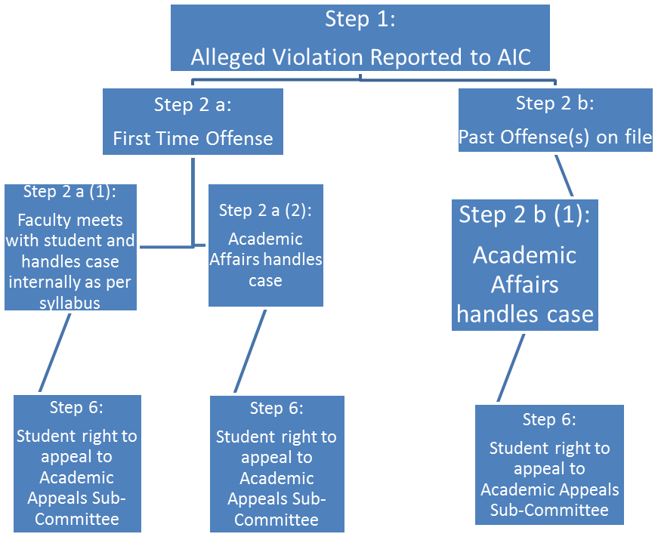

- Academic Affairs Organization Chart
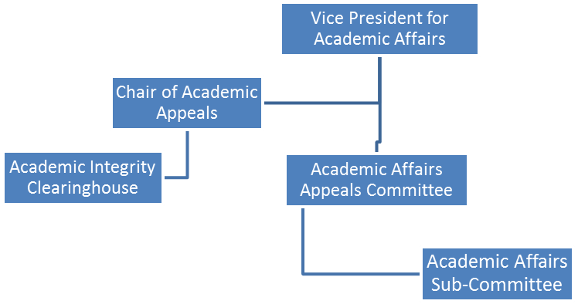

- Timeline for Policy Endorsements
Students Date
Student Government Association Feb. 2010
Student Body April 2010

Faculty
Faculty Senate Feb. 2010
Deans Council March 2010
College Department Head Meetings April 2010

Administration & Staff
Academic Affairs & Student Services Spring 2010
President’s Executive Council Spring 2010
Board of Trustees Spring 2010

Satellite Campus
Ozark Student Government Association Spring 2010
Ozark Chancellor Dr. Jo Alice Blondin Spring 2010

APPENDIX
Supporting Documents:

Arkansas Polytechnic College bulletin. (1928). Russellville, AR: Russellville Printing Company, p. 11.
ATU MISSION
Arkansas Tech University, a state-supported institution of higher education, is dedicated to nurturing scholastic development, integrity, and professionalism. The University offers a wide range of traditional and innovative programs which provide a solid educational foundation for life-long learning to a diverse community of learners (http://www.atu.edu/about.shtml).
Core Values
Arkansas Tech University is committed to
- Teaching excellence with a focus on student learning, scholarship, and innovation.
- Attention to individual students that nurtures personal growth and lifelong success.
- Supportive relationships that encourage a sense of belonging.
- The highest level of integrity and ethics.
- Continuous improvement of all programs and services.
(http://www.atu.edu/strategicplanning/focus1.shtml)
Academic Honesty Code Task List
Reporting Process
- Need a flow chart for how faculty report alleged honesty violations by students
  - See Flow Chart 1
- Need a flow chart for how students report alleged honesty violations by student
  - See Flow Chart 1
- Need a flow chart for how faculty report alleged honesty violations by faculty
  - See Flow Chart 2
- Need a flow chart for how students report alleged honesty violations by faculty
  - See Flow Chart 2
- Need universal form for faculty and students to use in reporting alleged honesty violations
Institutional Requirements
- Creation of a Academic Honesty Judicial Board
  - Makeup: 2 students, 2 faculty and 1 administrative member
  - Tenure should be limited to _______ semesters or academic years?
  - Members are to be chosen how?
    - Faculty selection?
    - Student selection?
    - Administrative staff selection?
  - Criteria for how can serve?
    - Faculty criteria?
    - Student criteria?
    - Administrative staff criteria?
- Academic Honesty Clearing House to maintain all student and faculty records
  - Staff
    - CSP Graduate Assistant(s)
  - Operational Funding
  - Responsibilities would be:
    - Advising students and faculty on reporting of alleged honesty violations
    - Maintaining and updating student and faculty honesty records
    - Scheduling and coordinating Academic Honesty Judicial Board hearings
    - Collecting and distributing educational pamphlets and web materials on academic honesty
- Integration of the Academic Honesty Clearing House and Academic Honesty Judicial Board into the existing Academic Affairs and Student Services organizational structures
  - See Academic Honesty Organizational Chart

2 Tier Honesty Outcomes System
First Violation: Emphasis on Educational Honesty Training
- First time violations that are deemed unintentional and/or not sever either by the reporting faculty member or Academic Honesty Judicial Board
  - Recommended outcome is Educational Honesty Training
    - Counseling one-on-one by the faculty member in meeting with student
    - Counseling through staff of Academic Honesty Clearing House if proscribed by Academic Honesty Judicial Board
  - For the course faculty discretion to apply any additional penalties he/she deems appropriate consistent with his/her syllabus
- First time violations that are deemed intentional and/or severe by the faculty member
  - Hearing before the Academic Honesty Judicial Board
  - Recommended outcome if allegations deemed valid
    - Educational Honesty Training
    - Academic Honesty Judicial Board collaborates with faculty member to determine appropriate course penalty and/or VP of Academic Affairs to determine appropriate school sanction
Second Violation: Emphasis on Combination of Educational Honesty Training and Punitive Penalty
- Automatic hearing by Academic Honesty Judicial Board
  - Recommended outcome if allegation deemed valid by board is:
- combination of Educational Honesty Training through Academic Honesty Clearing House and
- punitive sanction determined through collaboration with faculty member and/or VP of Academic Affairs to determine appropriate school sanction
3 or More Violations: Escalating Punitive Penalties
- Automatic hearing by Academic Honesty Judicial Board
  - See recommended outcome of second violation with the following added proviso:
    - Three strikes and your out policy-If the Academic Honesty Judicial Board has found 3 violations that are intentional and/or severe for the same student, the penalty will be expulsion from the university for _____.

Academic Honesty Organizational Chart

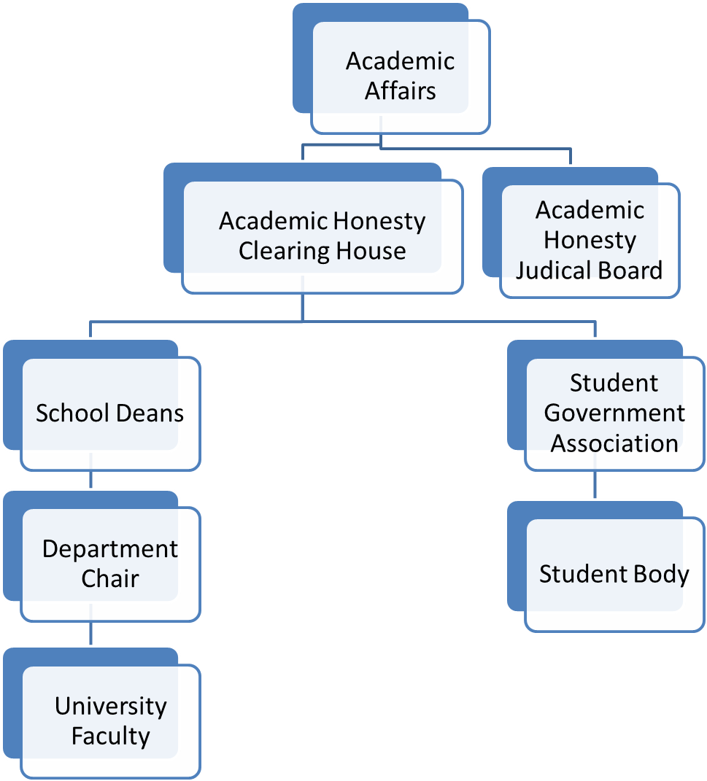

Plagiarism Contract
Plagiarism is a serious violation of the student code of conduct. You will fail this course for plagiarism. You can be expelled from the University for Plagiarism.
Here are two definitions of plagiarism from Arkansas Tech University publications:
From the Student Handbook, P. 12:
The term “plagiarism” includes, but is not limited to, the use, by paraphrase or direct quotation, of the published or unpublished work of another person without full and clear acknowledgement. It also includes the unacknowledged use of materials prepared by another person or agency engaged in the selling of term papers or other academic materials.
From the Faculty Handbook, P. 74:
Plagiarism is stealing the ideas or writing of another person and using them as one's own. This includes not only passages, but also sentences and phrases that are incorporated in the student's written work without acknowledgement to the true author. Any paper written by cutting and pasting from the Internet or any other source is plagiarized. Slight modifications in wording do not change the fact that the sentence or phrase is plagiarized. Acknowledgment of the source of ideas must be made through a recognized footnoting or citation format. Plagiarism includes recasting the phrase or passage in the student's own words of another's ideas that are not considered common knowledge. Acknowledgement of source must be made in this case as well.
If you turn in a paper that has no in-text citations, you are committing plagiarism by lying because you are representing someone else’s work as your own.
If you turn in a paper that has no in-text citations, you are committing plagiarism by stealing because you are taking someone else’s ideas and information from them without their permission.
Committing plagiarism has nothing to do with intent, but is based solely on the paper you turn in.
If your term paper is plagiarized, you will fail this course and be referred to the Chair of the Department of History and Political Science for additional administrative punishment.
I have read this information, understand it, and am fully aware of the consequences should I commit plagiarism.

Printed Name: Date:

Signature:

