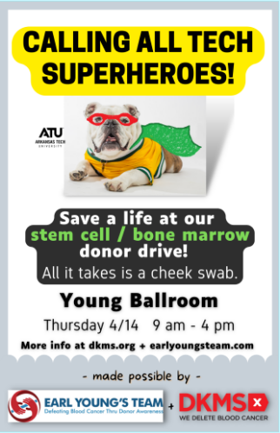Staff Senate-March-April 2022

**Bone Marrow Drive**

April 14th in the Young Ballroom

Starting at 9am until 4pm

We have been awarded two-$500 scholarships through a random draw for students that attend.

A HUGE shout out to the Earl Young Foundation, DKMS, and ATU staff for helping make this event possible!

**Staff Senate Elections** will be held in April. Please be thinking if you would like to serve on the committee and even become an officer.

**Upcoming events**

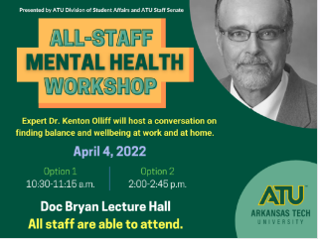

**All Staff Mental Health Workshop**

*Dr. Kenton Olliff*

*April 4th*

*Session One-10:30am-11:15am  
Session Two-2:00pm-2:45pm*

*How to find balance and wellbeing at work and at home after the pandemic.*

# **Join our Virtual meetings**

First Thursday of each month

10:00am-11:00am

<https://atu.webex.com/webappng/sites/atu/meeting/info/12458c421b5344c1bd1116e9b08fb9d0?siteurl=atu&MTID=m22f796d9375395a27b60449d37dbbd8b>

By Phone: 1-469-210-7159

Email us here for comments, concerns, or questions.

**Please Remember….**