Arkansas Tech University ROTC History 2000-Present

Acknowledgements:
This history project was sponsored by Major General (MG) (Retired) Bill Harmon, who has devoted unmeasurable support to the continuance of the Reserve Officer Training Corps (ROTC) program at Arkansas Tech University. Dr. Jeff Woods, Dean of the College of Liberal and Fine Arts, authorized the writing of this history as a senior project for two ROTC cadets. Cadets Julio Standridge and Cody Hartmann spent two semesters researching, conducting interviews, and writing the original document that covered the years 2000-2014. As this is a living and continuing history, Lieutenant Colonel (LTC) (R) Stephen White, hired as a government contractor in June 2018, took on the responsibility of adding information to keep the history up-to-date.
Thank you MG Bill Harmon, Dr. Jeff Woods, First Lieutenant (1LT) Julio Standridge, Captain (CPT) Cody Hartmann, and LTC (R) Stephen White for your efforts in preserving the history of Arkansas Tech University ROTC.

Very Respectfully,
Matthew S. Sweeney
Major, Artillery
Assistant Professor of Military Science

The Invisible Years
The Arkansas Tech University Reserve Officer Training Corps (ATU ROTC) program has a long and rich history. This history was temporarily disrupted when the program was deactivated in 1991. The ATU ROTC History project in 2013 aimed at capturing the history of the program since its reestablishment in the fall semester of 2000. All ranks of the military personnel mentioned are the ranks they held during the time period described.
During the “invisible years” of 1991 to 2000, the ATU ROTC program lived on through its alumni. Retired alumni and the alumni still serving during these years were active advocates for the reestablishment of the program. Their efforts were successful one year before the Global War on Terrorism era was initiated through the events on September 11th, 2001.
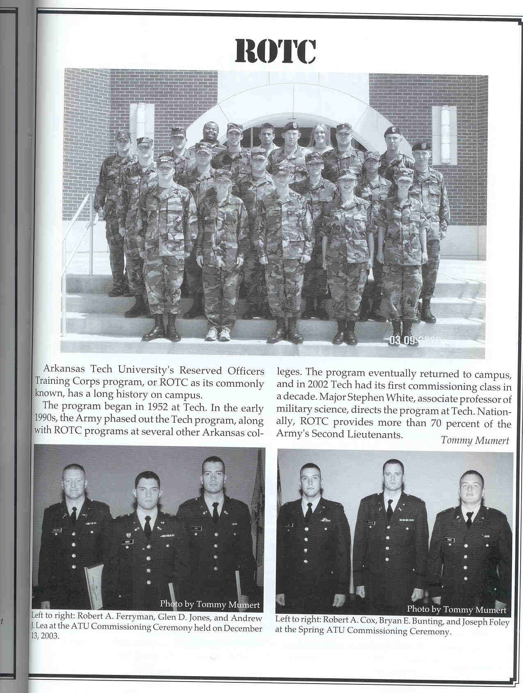
Reestablishment
In the fall semester of 2000, ROTC returned to Arkansas Tech University. While serving as the Executive Officer of the University of Central Arkansas (UCA) ROTC program, Captain Anthony Gortemiller (ATU Class of 1987) began actively recruiting cadets at Arkansas Tech to meet UCA’s mission. After becoming the Recruiting Operations Officer (ROO), CPT Gortemiller shifted his focus to Arkansas Tech, becoming the defacto Assistant Professor of Military Science. He was the first cadre at the program and remained at the program for over three years. During this period, UCA ROTC established the Bayonet Battalion consisting of partnership programs at Arkansas Tech, Henderson State University/Ouachita Baptist University, and the University of Arkansas Little Rock. UCA ROTC served as the host program. Sergeant First Class (SFC) Rex Surrette, Arkansas Army National Guard, and Brian Crotts, a UCA ROTC contractor, assisted CPT Gortemiller as instructors.
ROTC page in the 2004 Agricola
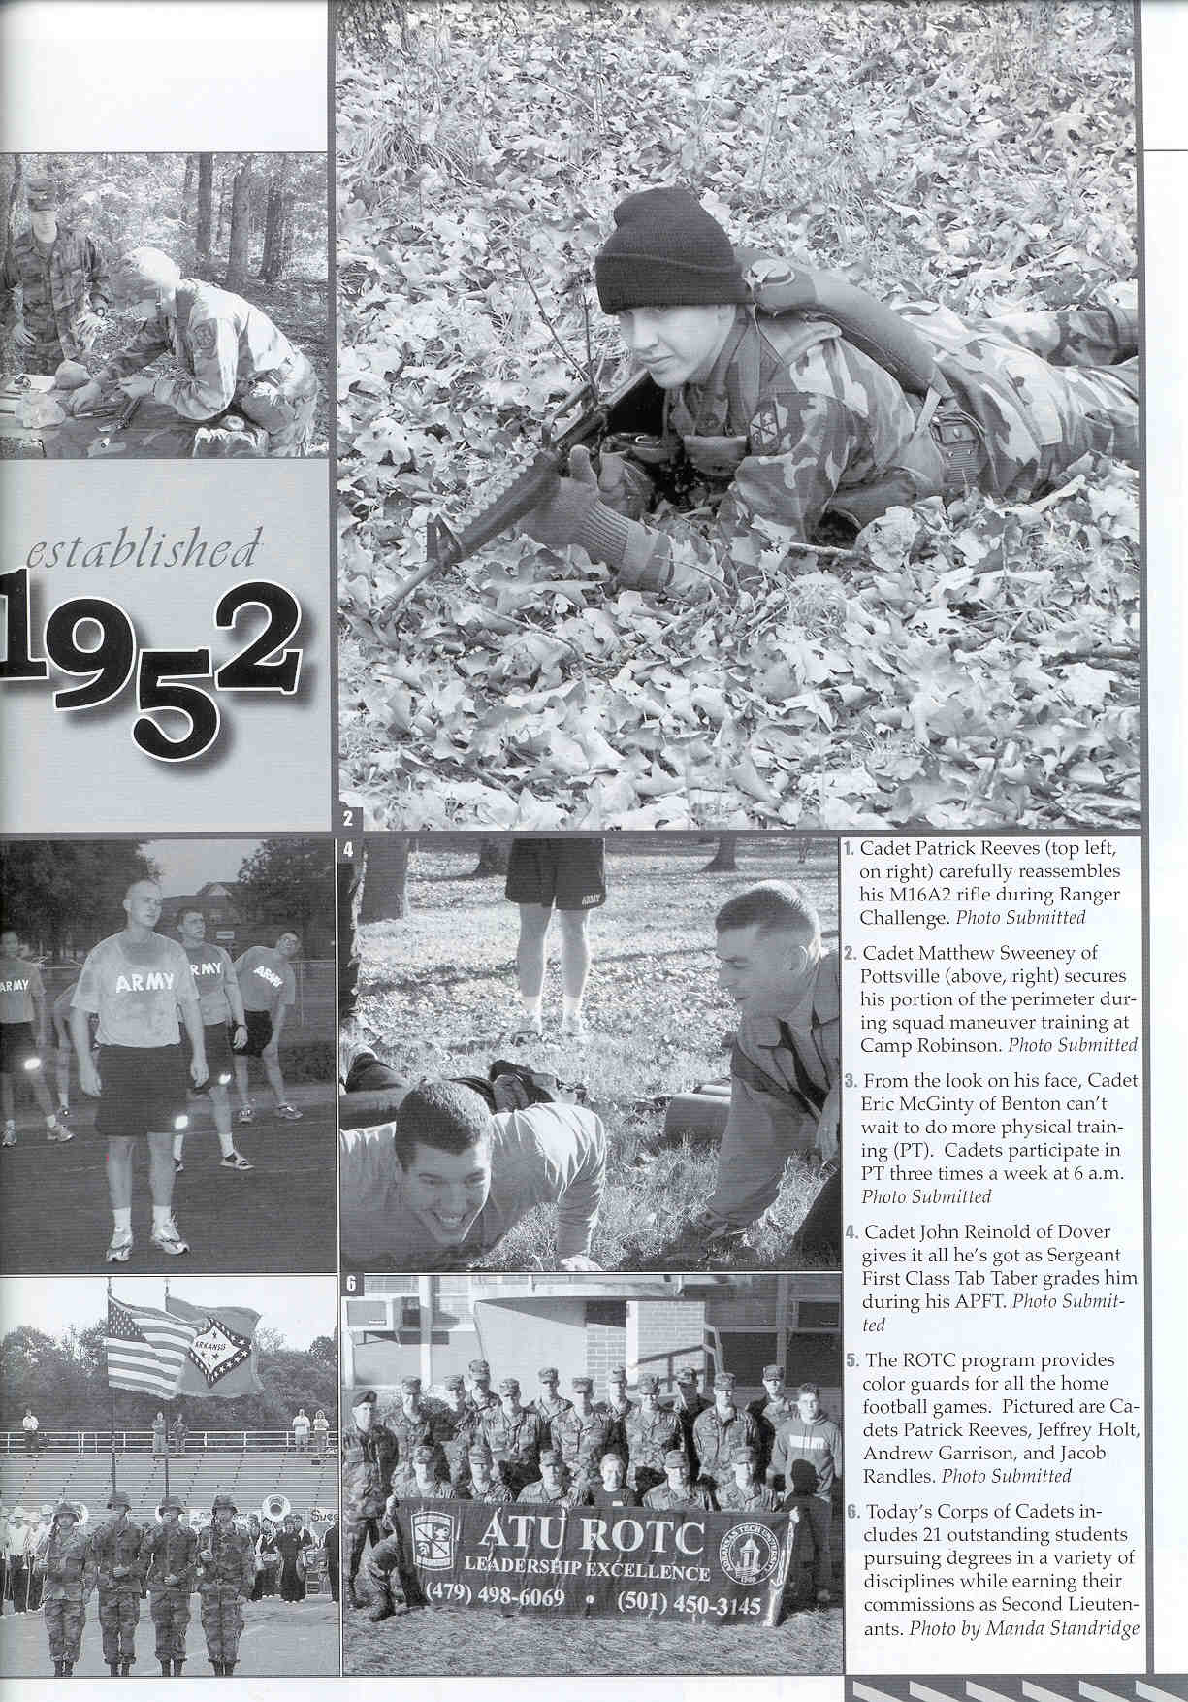
CPT Gortemiller focused heavily on recruiting during the first year. Williamson Hall, the program’s former main building, was taken over by Hotel and Restaurant Management, and Stroupe Hall was being used by varsity athletic teams, so ATU ROTC was initially based in Dean Hall. ATU ROTC depended on support from UCA ROTC, local national guard units, Arkansas Tech, and alumni. During the nine years ATU had no ROTC program, university and local high school relationships were lost and had to be reestablished.
For an ROTC program to function effectively, proper ratios between senior (MS4), junior (MS3), and freshman/sophomore (MS1/2) cadets are necessary. Juniors form the backbone of the program and are the focus of most training activities. Senior cadets fill in management positions and plan most program activities. Initially, CPT Gortemiller recruited enough juniors to make the program function but had to do all the planning and managing himself. CPT Gortemiller reestablished the color guard which presented the colors for Arkansas Tech athletic events.
Collage from 2006
By the fall of 2001 there were 15 cadets enrolled in the program. Local high schools were key recruiting pools, especially the Dardanelle Junior ROTC program. Efforts to establish a JROTC at Russellville High School were not yet fruitful, but later would assist the ATU ROTC tremendously. The events of September 11, 2001 and the start of Operation Enduring Freedom were key factors in the initial growth of the program. Many of the cadets joined the program out of patriotic fervor, which was very high at the time. By the time Operation Iraqi Freedom started the program saw on average twenty to twenty-five cadets enrolled.
ATU ROTC was able to secure equipment from local Army National Guard units and alumni support. The 206th and 217th units out of Russellville were very supportive of the ATU ROTC program during these formative years. MG(R) Bill Harmon (ATU ROTC Class of 60) was a key asset during the initial reestablishment and provided continuous support throughout the first decades of the twenty-first century. LTC Hall, UCA ROTC Professor of Military Science (PMS) assigned two enlisted cadre from UCA to travel to ATU once a week in order to teach. Only years later was ATU assigned its own enlisted staff. Initially the cadets were also not able to gain a minor in military science through their completion of four years of ROTC.
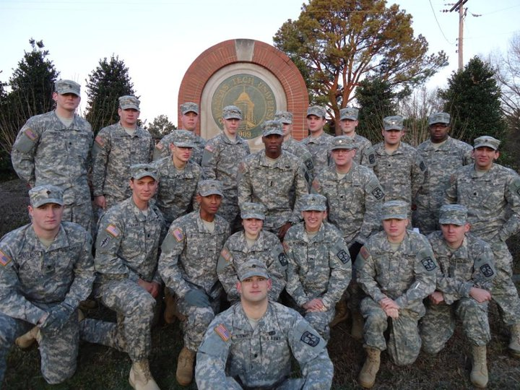
The ATU ROTC program had no steady location in the first few years of rebuilding. First it was assigned a classroom in Dean Hall. One semester it was placed in the Arts Building. Another semester it moved to Witherspoon. In 2002, the program was assigned work rooms and a supply room in the Wilson dormitory. The program stayed there for a few years before moving to Tucker Hall, then temporary buildings behind the baseball field. It was moved again to the Bryan building, where it was assigned several offices, a classroom, and a supply room. The program remained at Bryan until the building was demolished to make room for the new Brown building. In Spring 2013, the ATU ROTC program relocated to the rear of the Alumni building. Regardless of its location, the Arkansas Tech administration ensured the program had excellent facilities.
All ATU Cadets who were enrolled in spring 2011.
CPT Gortemiller was the founding father of the reestablished program. The onset of the Afghanistan and Iraq wars contributed to the strong growth rates in the first three years. At the same time, the severe deterioration of the conditions in Iraq during 2004-05 made it more difficult to recruit cadets for the program.
Growth and Tribulations
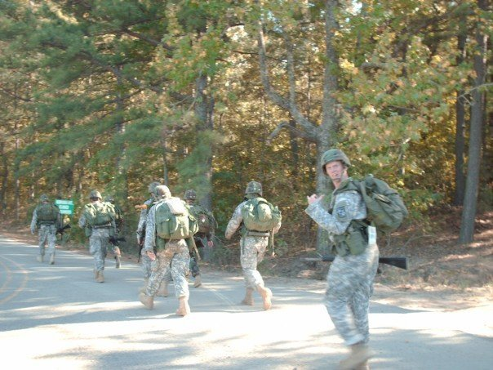
The Arkansas Tech University ROTC program continued to grow and adapt as an extension of the University of Central Arkansas ROTC program. Major (MAJ) Stephen White (ATU Class of 1985) was the only permanently assigned cadre member at Arkansas Tech in 2004, and relied on his senior cadets to assist in the training and evaluating of freshman, sophomore, and junior cadets at Arkansas Tech University. He was ably assisted by SFC Surrette who taught the MS 1 class. Classes on tactics were taught on Thursdays on campus, and tactical evaluations as well as land navigation courses were conducted one weekend a month at Camp Joseph T. Robinson in North Little Rock. According to CPT Matthew Sweeney(ATU Class of 2007), who enrolled in the Fall of 2005 after his deployment in support of Operation Iraqi Freedom 2, the program of 20 cadets relied heavily on basic infantry skills and training conducted with UCA’s corps of cadets and their cadre at the monthly leadership labs conducted at Camp Robinson. ATU ROTC reestablished its own Ranger Challenge team during this period. Limited faculty and resources were overcome with help from the Vice President of Academic Affairs, Dr. Jack Hamm, and Dr. H. Michael Tarver, Head of the Department of History and Political Science.
A 10 kilometer forced march conducted by the Ranger Challenge team in 2007.
Cadet Jacob Randles (ATU ROTC Class of 2007) was selected as one of 100 ROTC cadets throughout the United States to be commissioned at the White House by Secretary of Defense Robert Gates on May 20, 2007. Two cadets from either Army, Navy, or Air Force ROTC programs from each state were invited to the ceremony with President George W. Bush serving as the commissioning speaker. 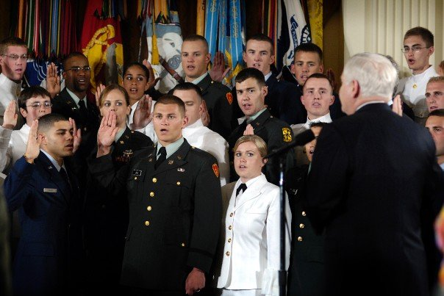
Cadet Randles (center) taking his commissioning oath from Secretary of Defense Gates
After Major White was reassigned, Master Sergeant (MSG) Stinson from the University of Central Arkansas program was assigned to the ATU program. MSG Stinson took ATU cadets to conduct their tactical training and evaluation at UCA for Thursdays’ leadership lab exercises, as the lack of resources forced the Arkansas Tech program to depend on its host school’s program. And this dependence continued until the ATU ROTC program’s turning point in 2009.
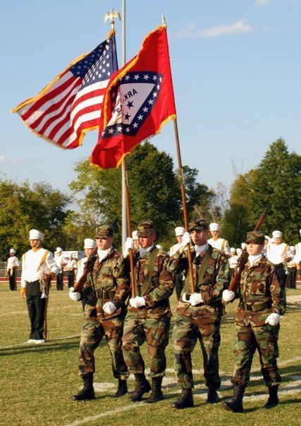
Staff Sergeant (SSG) Scott Wood was assigned to Tech and joined Sergeant First Class (SFC) Butler in August 2008 after Master Sergeant (MSG) Stinson was reassigned to a Ranger battalion that deployed in support of Operation Enduring Freedom. The program had 5 seniors, 3 juniors, 2 sophomores, and no freshmen. Then, a month later, SFC Butler was reassigned, which left SSG Wood to be the Training Non-commissioned Officer, as well as the Recruiting and Retention Non-commissioned Officer (NCO) for the program. Once again, the Arkansas Tech ROTC program was left to one man’s efforts until SFC Travis D. Lamb’s arrival in March 2009. SFC Lamb was assigned to ATU after a tour in Iraq with the 39th Infantry Brigade Combat Team, Arkansas Army National Guard. SFC Travis D. Lamb took on the responsibilities and duties of training the juniors and seniors, while SFC Scott Wood focused on recruiting and training the freshman and sophomore classes of cadets. After a year of experience and SFC Travis Lamb’s arrival, the program started “congealing and making a clearer picture,” SFC Wood recollected.
Color Guard for an ATU football game in spring 2010.
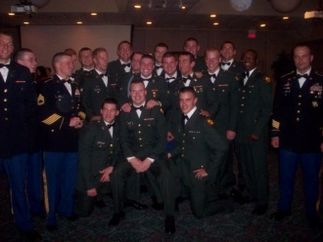
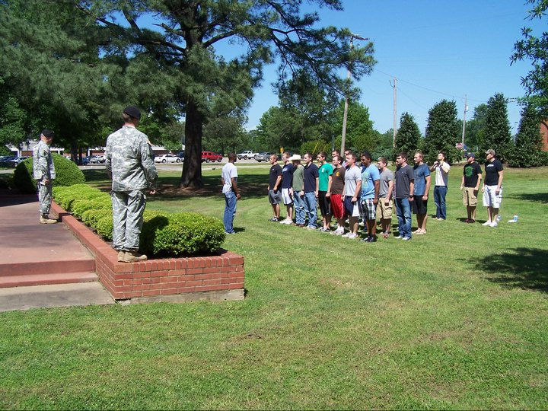
A formal dining out in spring 2010 (left) and an awards ceremony in spring 2011 (right). The Army transitioned from the Green Class-B’s to the blue Dress Blues in 2010-12.

Turning Point
Then, in the summer of 2009, Lieutenant Colonel (LTC) Vixen James, Arkansas Army National Guard, became the Assistant Professor of Military Science (APMS) at Arkansas Tech University under Lieutenant Colonel Larry Aikman, the Professor of Military Science (PMS) at UCA. LTC James addressed the university’s board of trustees about the needs of the program, established relationships, and gained the support of the university. Through LTC Vixen James’ continued relationships with Dr. Robert Brown (University President), Dr. Tarver , Dr. John Watson (Vice President of Academic Affairs), Dr. David Underwood (Assistant Vice President of Academic Affairs), Major General “Bill” Harmon (ATU ROTC Class of 60), and Major General William Wofford (ATU ROTC Class of 71), he was also able to gain financial support from the university as well as from the National Guard to purchase training equipment and resources. LTC James and LTC Aikman met with the board and were able to procure offices for the program.
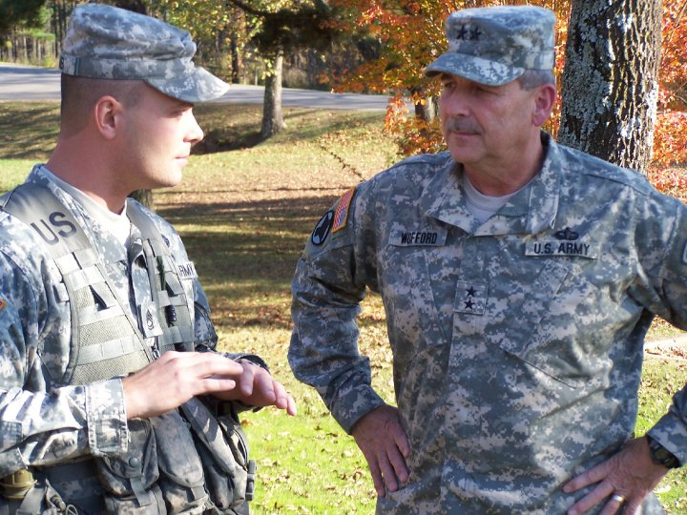
In Spring 2010, there were four dedicated cadre members at Tech: LTC Vixen James, SFC Scott Wood, SFC Travis Lamb, and MSG John Folkenroth. MSG Folkenroth became the MS2 instructor, freeing SFC Wood to focus on teaching the MS1 classes and recruiting. By Fall 2010, there were 30 cadets in the program. In less than one year the program more than doubled. By Spring 2011, there were a total of 45 cadets with 25 under contract. If a cadet contracts with the program, he or she is paid a small stipend every month during the semester and is obligated to attend every physical training, tactics training, recruiting and other events the ROTC program organizes or participates in.
Major General Wofford (right, ATU ROTC Alumnus) and SFC Travis Lamb (left) talking at a tactical exercise.
Major Lynn Alexander replaced LTC James in the summer of 2012. The number of cadets began to fluctuate, and after SFC Wood was reassigned in May 2012 the program plateaued.
In Spring 2013, Captain Michael Bennett became the APMS and senior instructor at Arkansas Tech. MSG Folkenroth was reassigned to Ft. Bliss. SFC Lamb was reassigned to the State’s 233rd Regimental Training Institution at Camp Robinson in Little Rock in the summer of 2013. Mr. Larry Roberts (retired Major and HSU cadre) joined the program as a government contractor to teach the MS4 class in Fall 2013, and SSG Thomas Roots, Arkansas Army National Guard, was assigned to the program to teach the MS2 class from Fall 2013 to Spring 2015. MSG Traye McCool, 4th Battalion, 414th Infantry Regiment (Training) United States Army Reserve, began teaching the MS1 class in 2013, which he continues to do today.
In 2013-14, the program was once again challenged as a large reduction in force, with a corresponding reduction in the mission to commission officers into all components of the U.S. Army caused the program to shrink. As the Army transitioned to fewer, smaller missions in Afghanistan and Iraq, recruiting became more difficult.
MAJ Matthew Sweeney was assigned as the APMS in July 2015 and was quickly joined by SFC Ashley Kennedy. SSG David Sims, Arkansas Army National Guard, taught the MS2 class for 2015-2016. This new team of cadre, increased the number of cadets in the program back into the 30s relying primarily on enlisted national guard members and the use of Minuteman scholarships. Over the course of three years, the number of contracted cadets increased from 11 in Fall 2015 to 21 in Spring 2018.
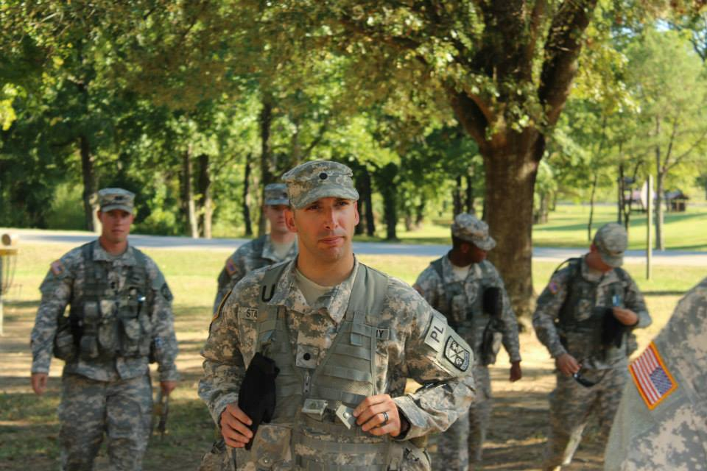
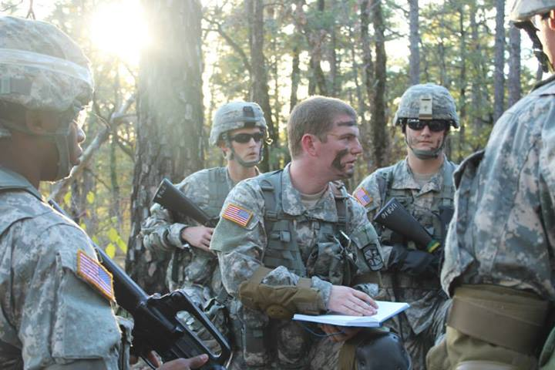
Left: Cadet Caleb Land (Junior) in his position as squad leader briefed a mission to his squad during a weekly lab in the fall of 2013. Right: Cadet Julio Standridge in his position as platoon leader (Senior) oversaw training at lab.

First Commissionees
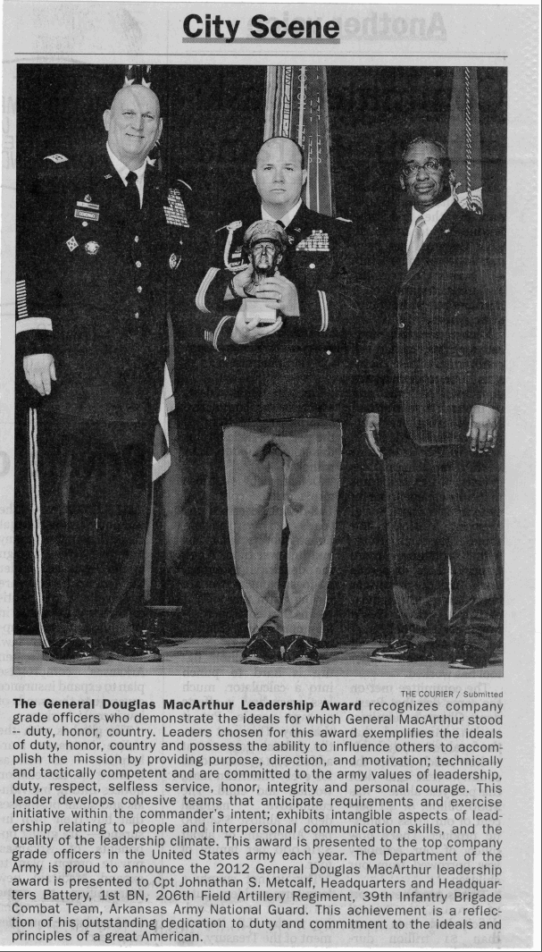
In the spring semester of 2002, the first cadet commissioned from the reestablished program was Larry LaRoe. LaRoe was a Major in Military Intelligence. The years of 2003 and 2004 saw the following Cadets commissioned: Raymond Willis, Boe Stricklin, Ronny Denton, Shawn Jackson, Robert Ferryman, Aaron Cox, and Jessica Boudra. In 2013, Boe Stricklin served as a Liaison Officer in Hawaii for the Army Reserve. Ronny Denton went on to become a Major in the 39th Infantry Brigade Combat Team (IBCT) and a coach in Booneville. Shawn Jackson deployed several times and was a Captain in 2013. Robert Ferryman served as a Captain on active duty in the Air Defense Artillery and deployed multiple times. Aaron Cox served on active duty and deployed multiple times to- Iraq. Cadet Jessica Boudra commissioned into active duty and served several deployments. She left the military as a Captain.
Cadet Jonathan Metcalf was commissioned in the field artillery with the Arkansas Army National Guard. He received the General Douglas McArthur award in 2012, an award given to the top Company leaders of the year. CPT Metcalf was the first alumnus of ATU to receive this award.
Distinguished Alumni
Graduates of Arkansas Tech’s ROTC program have gone on to high ranks in the military, government civil service, and Congress. MG (R) William Harmon and MG (R) Harley Davis (ATU ROTC Class of 63) both retired from the regular army after extremely distinguished careers. MG (R) Donald Chastain (ATU ROTC Class of 72) became The Adjutant General (TAG) of the Arkansas National Guard. MG (R) William Wofford became the next Adjutant General of the Arkansas National Guard, giving Arkansas Tech the unique distinction of providing two consecutive TAGs. Brigadier General (BG) (R) Larry C. Newman (ATU ROTC Class of 74) and BG (R) Gracus Dunn (ATU ROTC Class of 82) also retired from the regular army after extremely distinguished careers. MG Gary Johnston (ATU ROTC Class of 87) continues to serve with distinction in the regular army. Colonel (COL) (R) William Speer (ATU ROTC Class of 72) served at the senior executive service level (general officer equivalent) in the civil service, and COL (R) Dalton Jones (ATU ROTC Class of 80) continues to serve at the senior executive level. COL (R) Steve Womack (ATU ROTC Class of 79) currently serves as the U.S Member to the House of Representatives for the 3rd Congressional District.
Chief of Staff of the Army Raymond T. Odierno (left) presented the Douglas McArthur award to Captain Jonathan Metcalf (middle) in 2012. Source: Newspaper article in The Courier.
In 2017, ATU ROTC alumni established the ROTC Hall of Honor to recognize outstanding graduates who distinguished themselves in the military, the community, or the nation. Captain Jimmy Cartwright (ATU ROTC Class of 1960), the only ATU ROTC commissioned officer to die in combat in Vietnam, was conducted into the Hall posthumously. Other inductees include all of the officers mentioned in the paragraph above and LTC (R) William J. (Bill) Sidebottom (ATU ROTC Class of 67), recipient of the Silver Star for gallantry in Vietnam.
Activities
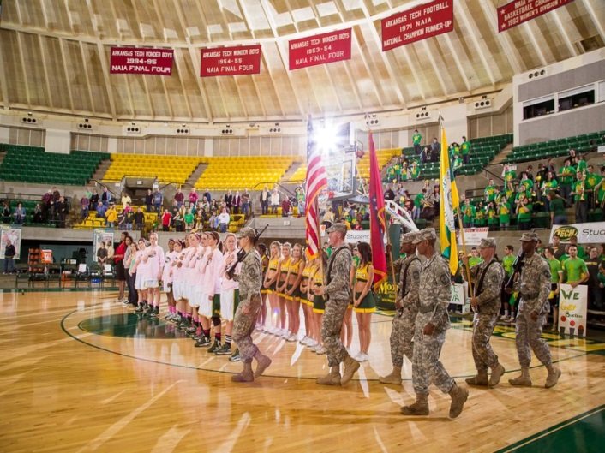
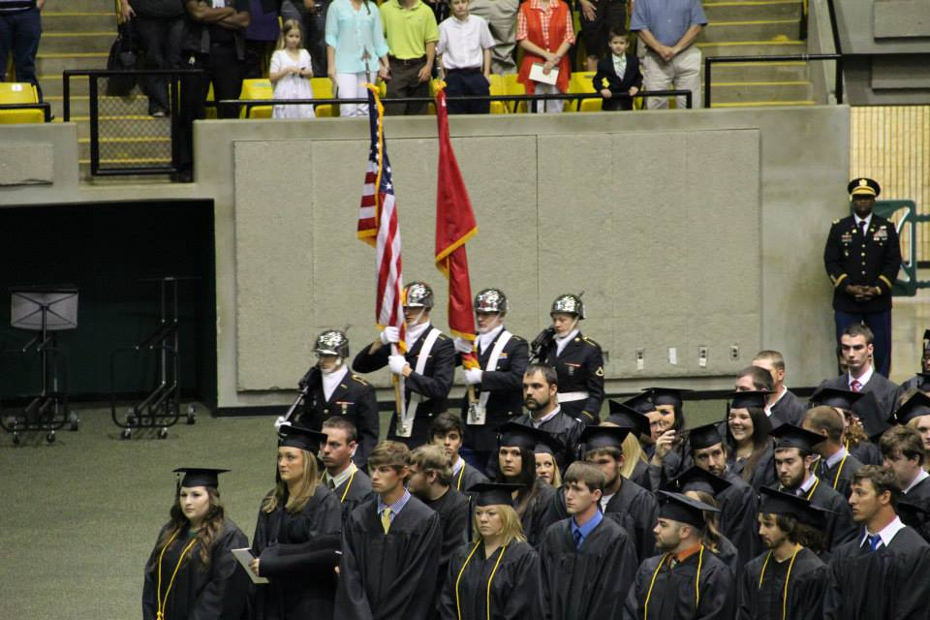
ATU cadets have provided color guards for official campus events since the program’s reestablishment in 2000. In 2004, ATU began fielding its own Ranger Challenge team, and in 2017 the team won first place in the one rope bridge competition. ATU cadets have served as the official escort for Jerry the Bulldog, Arkansas Tech’s Ambassador, since 2013. In 2014,
Two color guards conducted in the spring semester of 2013. Left: A color guard for the graduation ceremony in May. Right: Presenting of the colors for an ATU Basketball game. ATU ROTC cadets presented the colors at every home football and basketball game.

cadets began assisting new students move into the dormitories. The pre-1991 ATU ROTC program had prestigious extracurricular clubs such as Scabbard & Blade; however, these clubs have not been reestablished. Cadets continue to participate in various non-military clubs and activities on campus.
Future Expectations
As the war in Afghanistan wound down in 2013, the ATU ROTC program fought for its continued existence in the face of large-scale force reductions. The program prided itself with a focus on producing tactically proficient quality officers, but realized that a secondary focus on recruiting needed be established. In most ROTC programs around the country, almost ninety percent of cadets are scholarship cadets recruited from high schools, and ten percent are Green-to-Gold or members of the National Guard and Reserves. In the ATU program, over eighty percent of the cadets were simultaneous members of the National Guard in 2013. Several members of the Army Reserve were recruited for the spring semester 2014 to add to the prior service mix. High school recruiting in Pope and neighboring counties and a JROTC program at the Russellville High School became priorities for continuous sources of new cadets and the long-term success of the ATU ROTC program. Russellville High School established a JROTC program beginning in Fall 2017, and ATU ROTC formed a partnership with the University of the Ozarks (U of O) beginning in Fall 2018 allowing U of O students to cross enroll in ATU ROTC classes. The partnership with U of O reestablished a relationship begun under ATU ROTC’s original program.
As the host program for ATU’s ROTC program, the University of Central Arkansas ROTC program has been instrumental in supporting ATU with personnel, funding, vehicles, and supplies. Similar support from the Arkansas Army National Guard has allowed the ATU ROTC program to expand. Beginning with CPT Gortemiller and continuing through SFC Kennedy, UCA ROTC has detached an active duty officer or NCO from its own organization to support ATU’s ROTC program. The ARNG has provided the APMS at ATU since LTC James (with the exception of CPT Bennett) and provided numerous NCOs since the program was reestablished. The U.S. Army Reserves have provided two APMS’s and one NCO to the program. ATU has repaid this support by providing qualified cadets to help UCA move towards its annual commissioning mission, providing excellent junior officers to the ARNG, USAR, and regular army. Commissionees from the reestablished ATU ROTC program continue to excel, maintaining ATU ROTC’s long standing tradition which has seen seven alumni reach general officer rank. The ATU ROTC program is scheduled to move into the Public Safety building during the 2018-2019 school year. The future of the ATU ROTC program looks bright with continuing support from Arkansas Tech University, UCA, the ARNG, and the USAR.
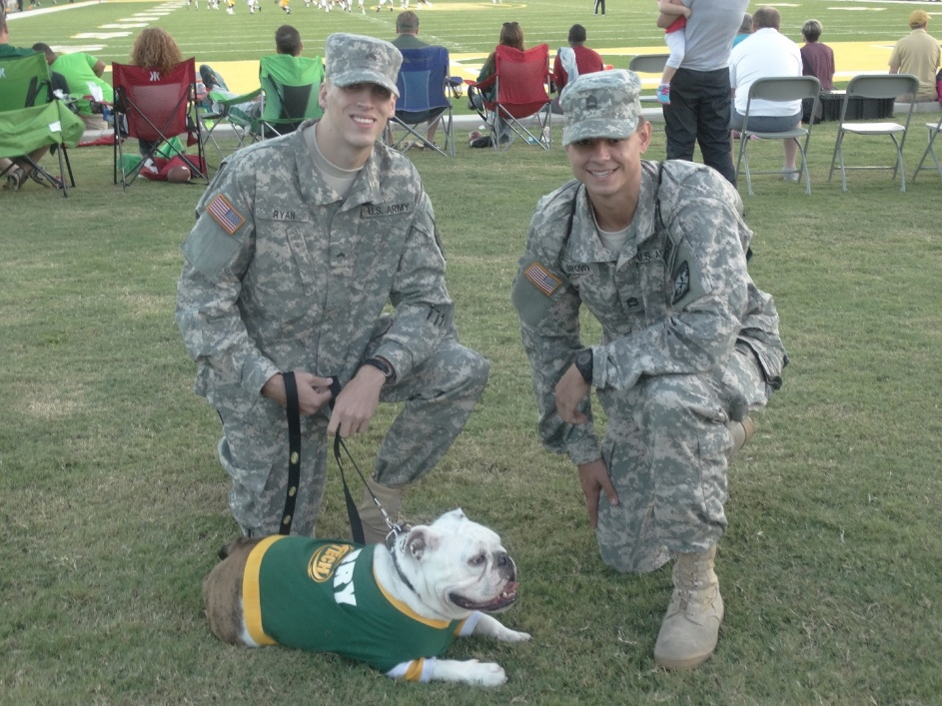
Since 2013, ATU ROTC has escorted Jerry the Bulldog to official Arkansas Tech events. Seen here are Cadets Austin Brown and Peter Ryan with Jerry at a 2015 Wonder Boys football game.

List of ATU Commissionees since the Reestablishment (2000-2018)
Year | Branch | Name
Cross-enrollments with UCA:
1997 |  | Colston, Matthew
1998 | Ordnance | Posey, Anthony
1999 | Ordnance | Heimbrock, Andrew
Commissionees of the Reestablished Program:
2001 | Military Intelligence | Laroe, Larry
2002 | Ordnance | Willis, Raimond
2002 | Quartermaster | Stricklin, Larry
2002 | Ordnance | Owens, Dustan
2002 |  | Dial, Jonathan
2002 | Infantry | Denton, Ronnie
2002 | Infantry | Campbell, David
2003 | Military Intelligence | Watson, Wesley
2003 | Adjutant General | Watson, Ashley
2003 |  | Walters, Joshua
2003 | Engineer | Taylor, Forrest
2003 | Signal Corps | Lea, Andrew
2003 | Field Artillery | Jackson, Shaun
2004 |  | Jones, Glenn
2004 | Infantry | Foley, Joseph
2004 | Ordnance | Cox, Robert
2004 | Military Police | Bunting, Bryan
2005 | Military Intelligence | Witherington, Sherwet
2005 | Field Artillery | White, Steven
2005 | Medical Services | Davis, Jonathan
2005 | Transportation | Boudra, Jessica
2006 | Quartermaster | Warren, Ryan
2006 | Army Aviation | Reeves, Patrick
2007 | Field Artillery | Sweeney, Matthew
2007 | Engineer | Randles, Jacob
2007 | Infantry | Holt, Jeffrey
2008 | Ordnance | Schafer, James
2008 | Field Artillery | Patterson, Joshua
2008 | Ordnance | Gilbreath, Robert
2008 | Field Artillery | Battle-Smith, Michael
2008 | Quartermaster | Ashley, Nicholas
2009 | Ordnance | McGinty, Eric
2009 | Army Nurse | Faircloth, Brandon
2010 | Infantry | Davis, Owen
2010 | Signal Corps | Folmon, Andrew
2010 | Field Artillery | Stovall, Waylon
List of ATU Commissionees since the Reestablishment (2011 - 2018)
Year | Branch | Name
2011 | Engineer | Bluhm, Seth
2011 | Engineer | Jackson, Corey
2011 | Infantry | Jones, Jamel
2012 | Engineer | Duran, Christopher
2012 | Army Nurse | Mabry, Zach
2012 | Army Nurse | Manatt, Joshua
2012 | Ordnance (EOD) | Pickartz, Jeffrey
2012 | Infantry | Stewart, Nick
2013 | Engineer | Bluhm, Zach
2013 | Military Police | Boykin, Lee
2013 | Army Aviation | McDaniel, Keith
2013 | Military Intelligence | Richter, Eric
2013 | Army Aviation | Roberts, Michael
2013 | Military Police | Underwood, Allen
2014 | Infantry | Drewry, James
2014 | Military Intelligence | Hartmann, Cody
2014 | Army Aviation | O’Daniel, Conner
2014 | Medical Services | Patton, Jordan
2014 | Quartermaster | Quillin, Christopher
2014 | Field Artillery | Standridge, Julio
2015 | Infantry | Baer, Anthony
2015 | Chemical | Davis, Hayden
2015 | Army Nurse | Reaves, Christopher
2016 | Engineer | Calito, Bryant
2016 | Engineer | Land, Caleb
2016 | Engineer | Payne, Thomas
2016 | Aviation | Plumlee, Zack
2016 | Engineer | Risinger, Robert
2016 | Infantry | Turney, John
2016 | Signal | Vick, Kristen
2017 | Ordnance | Fisk, John
2017 | Engineer | Runion, Corey
2017 | Engineer | Ratzlaff, Jonathan
2017 | Medical Service | Brown, Austin
2018 | Infantry | Perrott, William
2018 | Medical Corps (Ed Delay) | Singleton Gideon

