
A Division of


Secure Destruction
Services Information

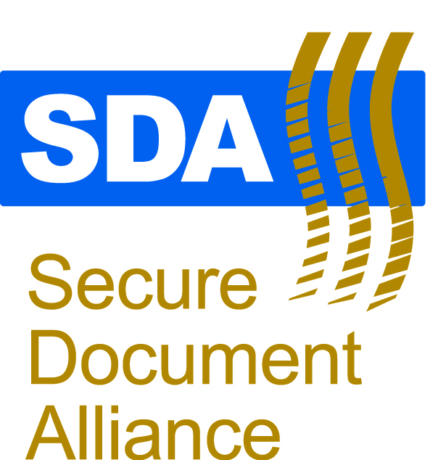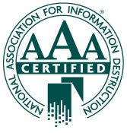

Security Measures

Deployment. Trucks are deployed to locations based on a customized schedule that meets the needs of each location.
Pickup. Materials (in the secure locked containers) are picked up by trained, insured, and bonded drivers who transport the material in a locked truck to the secure shredding facility.
Weighing and Staging. Materials are co-mingled in preparation for shredding and contaminants (e.g., binders, metal items) are removed. Material is co-mingled prior to shredding as a security feature to ensure that final baled material is destroyed and disposed of using a security feature to ensure that final baled material cannot be reconstructed
Destruction. Material is shred to 5/16 inch strips, and then baled into 1,500-pound bales. In the case of non-paper media, material is destroyed and disposed of.
Final Disposal. Baled material is then sent to the local GP Harmon recycling facility for final pulverizing and recycling.
The chain of custody is complete and the loop of destruction closed. This final step makes it virtually impossible to reconstruct material
GFG locations use redundant security systems to certify that material is being transported in a secure manner. These features include:
  - GPS vehicle tracking
    - Available in all trucks that transport material
    - Constant tracking from deployment, pickup, and delivery
  - Truck security programs
    - Comprehensive training for drivers.
    - Uniformed drivers with identification tags
    - Locking containers
    - Locking truck box equipped with vehicle immobilization
    - Secured staging area
  - Container tracking systems
    - Logs information during each stage of pickup and destruction
    - Provides an auditable report of our processes
    - Containers tracked on pickup, weigh-in, staging, and shredding
  - Digital video recording equipment
    - 24/7 video monitoring of the facility
    - All movements in facilities are recorded
    - Provides evidence of certified destruction
Redundant Systems Security ensures procedures overlap, cross validate, and produce auditable records to ensure your information is always secure.

Chain of Custody:

I thought it may be beneficial to include an overview of the GFG chain of custody used to secure all confidential material from deployment of containers in your facility through the final destruction and 100% recycling of materials.

Clients:

I also though that you would be interested in seeing just a few of the clients that we are currently servicing.

Arkansas Department of Finance and Administration
National Bank of Arkansas
General Motors
All Health South Rehabilitation Hospitals in Arkansas
Arkansas Department of Human Services
US Federal Government (14 locations across AR, TN, LA, & MO)
Staffmark
Heifer International
Wells Fargo
Mainstream Technologies
City of North Little Rock
North River Surgical
Saline County
Arkansas Insurance Department
Crews & Associates
Arkansas Scholarship Lottery
ASAP Personnel Services
First Security Bank
Birch Tree Communities
Premier Staffing
American Medical Rentals
Boone County Special Services
Container Sizes Available:

Consoles: Looks like office furniture and hold approximately 32 gallons worth of paper

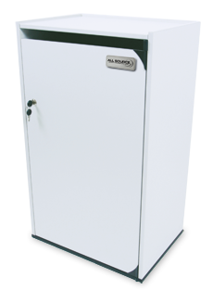

Dimensions: 36”H x 211/2”W x 16”D
• Capacity: 70-80lbs

64 gallon bins: Looks like a medium sizes trash can with wheels, looking lid, and paper slot on top

95 gallon bin: Larger version of the 65 gallon bin

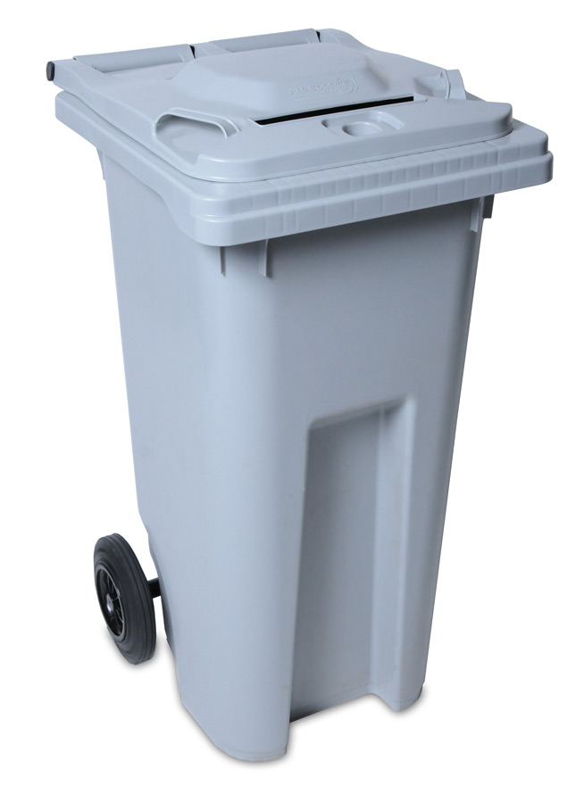

All containers are Executive Grey and kept in like new condition.

