ARKANSAS TECH UNIVERSITY
Young Building East End
203 West O Street
Russellville, AR 72801-2222

TABLE OF CONTENTS

Purchasing Staff and Contacts

Code of Ethics

Ergonomic Tips

Electronic Requisitions—General Information

Requisition Manual

Account Numbers

Ship to Codes

State Contracts

Purchase Types
Street Addresses

Prepared by

Purchasing Department
Tel: 479-968-0269
Fax: 479-968-0633

http://www.atu.edu/purchasing/

PURCHASING STAFF MEMBERS

As of August 16, 2006

NAME | TITLE | E-MAIL
Jessica Holloway | Purchasing/Program Manager | jholloway@atu.edu
DeAnna Kile | Purchasing Coordinator | dkile@atu.edu
Jennifer Warren | Buyer | jwarren2@atu.edu
Cindy Hubbard | Fiscal Support Specialist | chubbard@atu.edu
Jenny Langford | Accounting Technician I | jlangford3@atu.edu

TELEPHONE & FAX | PRIMARY LINE | SECONDARY LINE
Telephone | (479) 968-0269 | (479) 880-4120  (479) 356-2169  (479) 968-0260
Fax | (479) 968-0633

purchasing@atu.edu

CODE OF ETHICS

The Arkansas Tech University Purchasing Department subscribes to the Code of Ethics developed by the National Association of Educational Procurement:

1. Give first consideration to the objectives and policies of my institution

2. Strive to obtain the maximum value for each dollar of expenditure

3. Decline personal gifts or gratuities

4. Grant all competitive suppliers equal consideration insofar as state or federal statute and institutional policy allows.

5. Conduct business with potential and current suppliers in an atmosphere of good faith, devoid of intentional misrepresentations.

6. Demand honesty in sales representation whether offered through the medium of a verbal or written statement, an advertisement or a sample of the product.

7. Receive consent of originator of proprietary ideas and designs before using them for competitive purchasing practices.

8. Make every reasonable effort to negotiate an equitable and mutually agreeable settlement of any controversy with a supplier; and/or be willing to submit any major controversies to other third party review, insofar as the established policies of my institution permit.

9. Accord a prompt and courteous reception insofar as conditions permit to all who call on legitimate business missions.

10. Cooperate with trade, industry and professional associations and with govern-mental and private agencies for the purposes of promoting and developing sound business methods.

11. Foster fair, ethical and legal trade practices.

12. Counsel and cooperate with NAEB members and promote a spirit of unity and a keen interest in professional growth among them.

ERGONOMIC TIPS

Rule No. 1: If it hurts, STOP doing it. Find another way to do it that doesn’t hurt.

Rule No. 2: Your Mother was right –sit up straight and keep your feet on the floor!
In other words, practice good posture.

Rule No. 3: Don’t spend hours doing one thing. Break up your routine by changing tasks and/or by taking short breaks.

TELEPHONE | DO: Hold the receiver with your hand or use a headset.  DON’T: Hold the receiver between your cheek and shoulder.
MONITOR | DO: Place screen directly in front of you  Place screen at or slightly lower than eye level.  Avoid glare by keeping work area evenly lit  DON’T: Sit sideways or with head twisted  Sit with your head tilted back or stuck out
KEYBOARD  &  MOUSE | DO: Place keyboard at or slightly below elbow height  Place mouse near and on the same level as the keyboard  Have arms hanging straight down from shoulders  Have forearms at a 90° angle to arms  Keep wrists straight  DON’T: Rest wrists on keyboard  Work with hands bent back at the wrist  Reach for the mouse
CHAIR | DO: Sit all the way back in the chair  Sit with lower back fitted into lumbar support  Have thighs parallel to the floor  Have knees slightly higher than hip joints  Keep feet flat on floor or on a footrest  DON’T: Slouch or sit hunched over  Twist around and reach behind you  Sit on your feet

ELECTRONIC REQUISITIONS

GENERAL INFORMATION:

Always check One Tech for messages regarding the Banner system before entering requisitions.

A requisition is only a request for a purchase. An official Purchas Order will be the authorized document used to place an order with a vendor. A requisition only reserves funds. Funds will not be encumbered until a purchase order is issued.

For internal requisitions (such as Bookstore, Physical Plant, Motor Pool, etc) see appropriate section of this manual.

APPROVALS:

Requisitions from grants or special funds – regardless of the amount - require the approval of the Budget Office or the Office of the Vice President for Administration and Finance. These requisitions will be automatically forwarded to the appropriate area for approval BEFORE they are forwarded to Purchasing.

Requisitions exceeding amounts set by the appropriate vice president will be forwarded by Purchasing for approval by the appropriate vice president. The Purchasing Department cannot process requisitions that have not been approved.

CHANGES/CORRECTIONS TO REQUISITIONS:

The Purchasing Department will not be able to modify a requisition once it has been through the approval process (such as account number, increase/decrease quantity, add an item, etc). It will be necessary for the requesting department to cancel the requisition and issue another.

Also, any requisition that is “disapproved” will be canceled by the Purchasing. The requesting department will be notified of the cancellation.

PURCHASE ORDERS:

As verification that an order has been placed, a DEPARTMENTAL COPY of the purchase order will be e-mailed to the requesting department. If you do not receive a copy of the purchase order within a reasonable time (three working days for regular orders and three weeks for bids), please contact the Purchasing Department.

TRAVEL:

After any necessary approvals, requisitions for travel (object codes 704000), will be electronically forwarded to the Budget Office for processing. Call 356-2034 for assistance or if you have questions relating to travel. See the appropriate section of this manual for additional instructions.
Self Service Requisition Manual

Table of Contents
Page 2 | Accessing the Requisition Form
Page 3 | Requisition Form
Page 4 | Requisition Form – Dates / Vendor ID
Page 5 | Requisition Form – Document Text
Page 6 | Requisition Form – Commodity
Page 7 | Requisition Form – Accounting – Dollars - Index
Page 8 | Requisition Form – Accounting – Percents - Index
Page 9 | Code Lookup Instructions
Page 10 | Requisition – Save Template

Accessing Requisition Form:

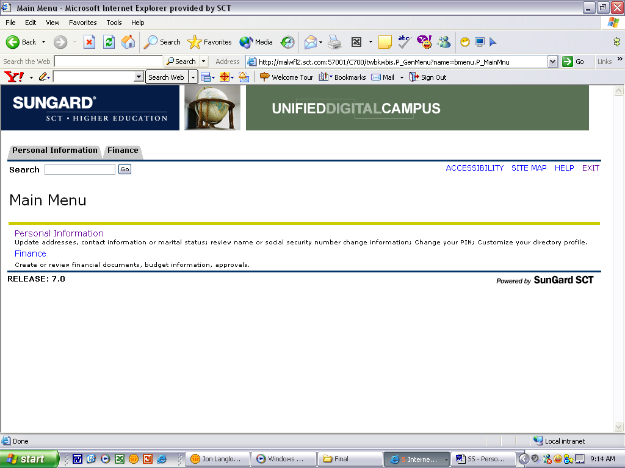
- Click on Finance

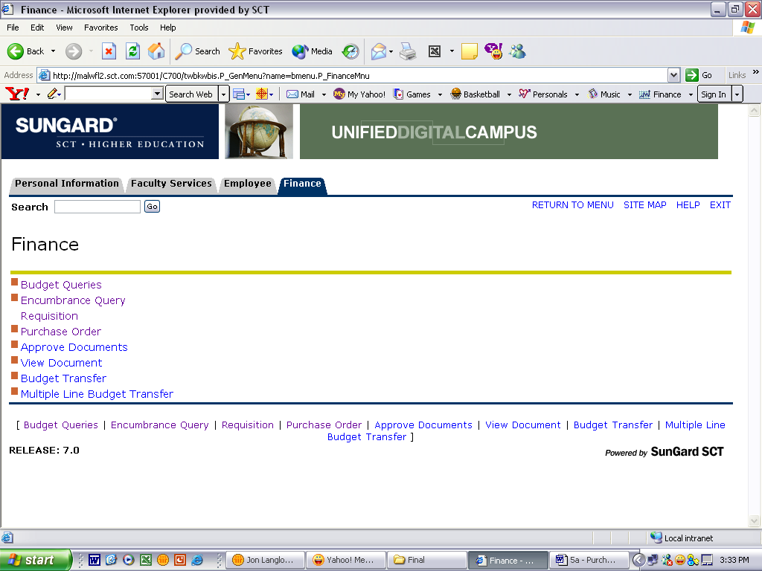
- Click on Requisition
Requisition Form:

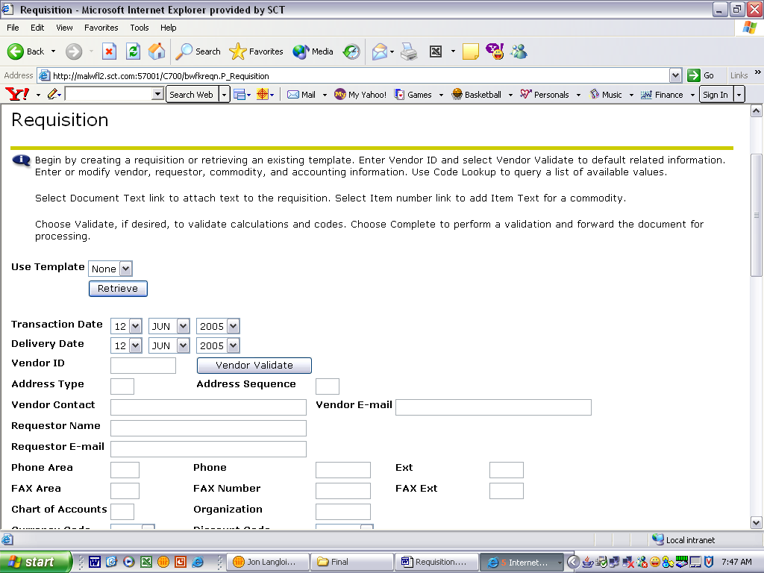
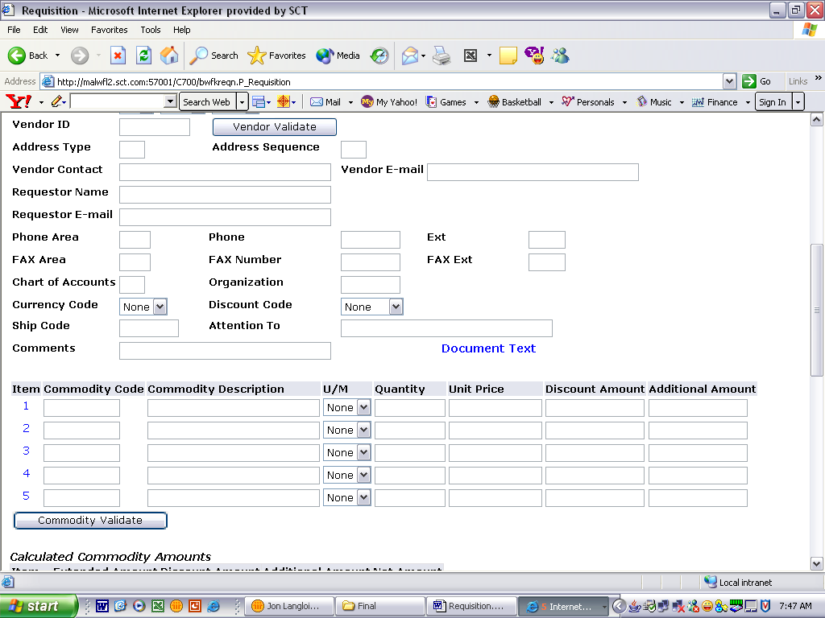
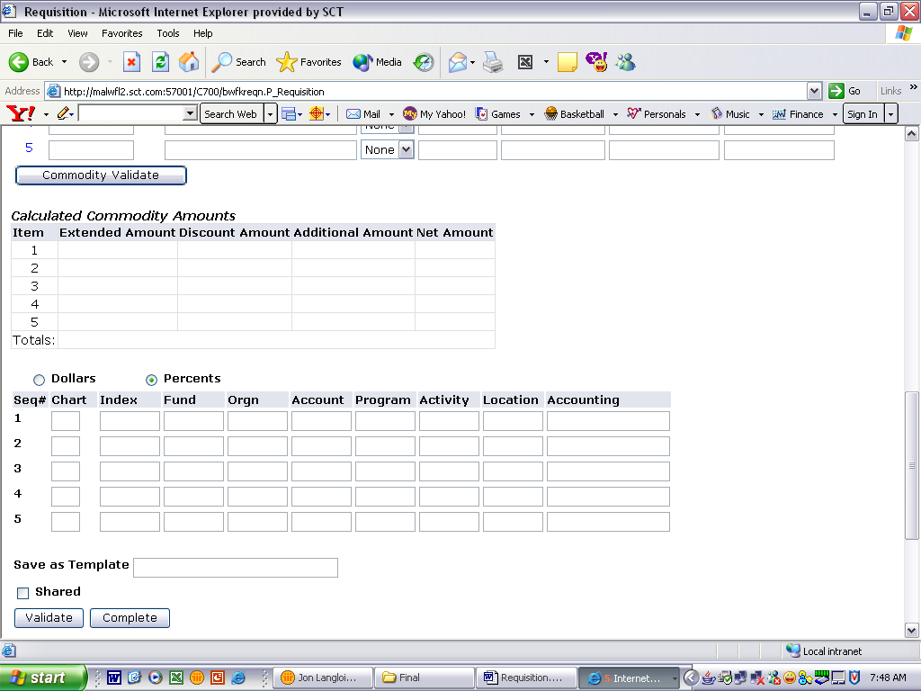
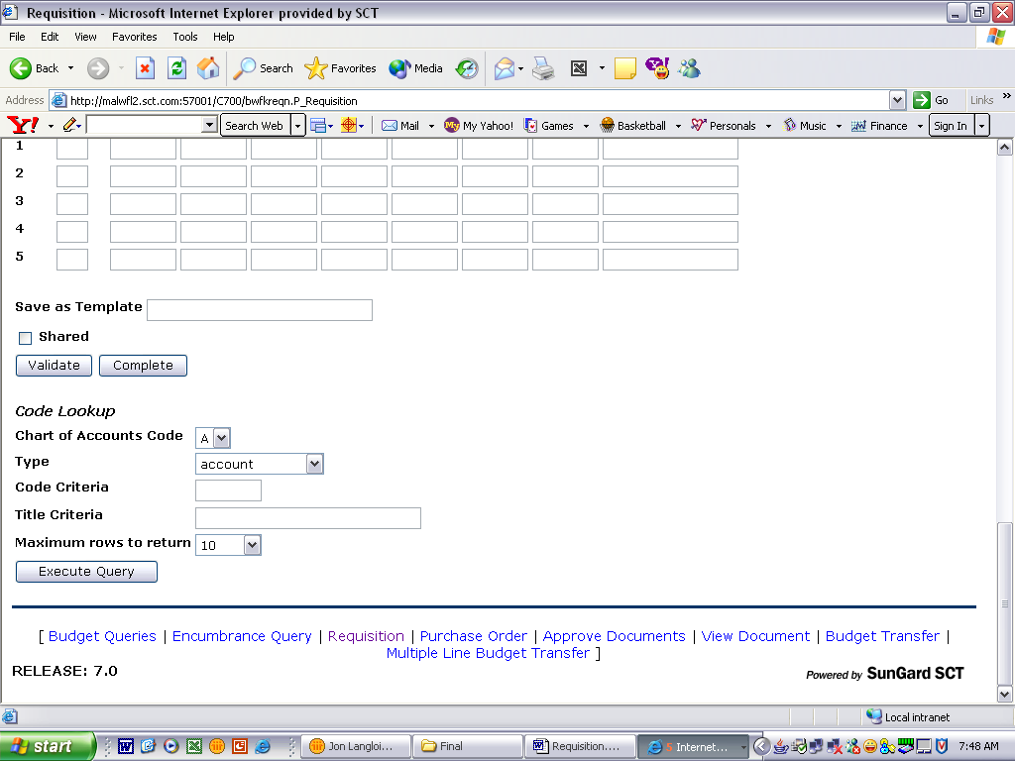

*Note* - The recommended ways of navigating through this form are using the “Tab” key or the mouse. Using the “Enter” key will result in errors in the form.

*Note* - Self Serve times out after one hour of inactivity. All information will be lost.
Requisition Form – Dates / Vendor ID:

- Enter Delivery Date by using pull down menu:
*Delivery Date must be equal to or greater than the transaction date.*

- Enter Vendor ID in the field shown:
- To search for Vendor ID go to Lookup Section
- If a vendor is not in the system, a Request for New Vendor must be completed.

- Click on Vendor Validate button:
  - The following information should automatically fill in
    - Address Type
    - Address Sequence *Note*
    - Chart of Accounts – (Required Field)
    - Organization – (Required Field)
    - Ship Code – (Required Field)
    - Attention To
*Note* - Vendor Address will default as sequence 1. To view vendor’s alternative addresses, change the sequence number and click the Vendor Validate button.

  - The following information will automatically fill in if data is in the Banner Finance System
    - Vendor Contact
    - Vendor E-mail
    - Requestor Name
    - Requestor E-Mail
    - Phone Information
    - Fax Information

- Type any comments in the Comments field
*Note* - Information entered in the Comments field will not print on the Requisition or Purchase order. If Purchasing needs the information, put it in a field that prints, such as Document Text.

- To enter Document Text see next section
Requisition Form – Document Text:

- Click Document Text

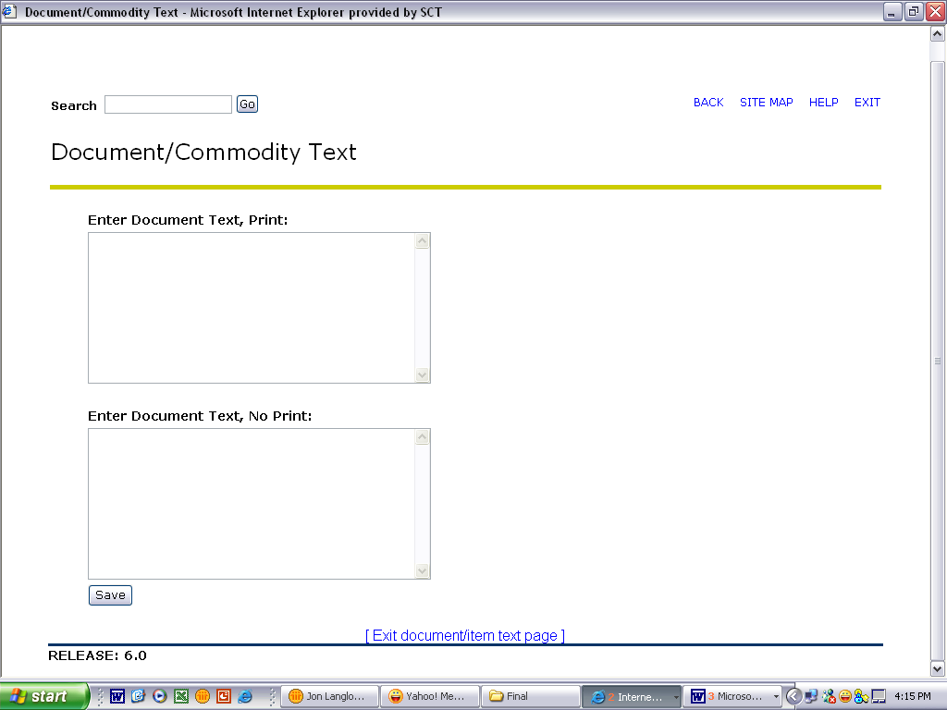

- Type in top or bottom box
  - Text in top box will print on Requisition. If you want Purchasing to see the text, enter it here.
  - Text in bottom box will not print on Requisition

- Click on Save button:

Requisition Form – Commodity:

- Type In Commodity Description: *Required*

- For additional item text, click on the number at the beginning of each line.
  - Type Text in the top box so that it will print on the Requisition
  - Click on Save button:
- Select U/M (Unit of Measure) from the pull down menu: *Required*

- Type in Quantity: *Required*

- Type in Unit Price: *Required*
- Must have decimal point if cents are included
- Do not type dollar signs ($) or commas (,)

- : -Do not use this field.
- : -Do not use this field.

- Repeat steps 1-6 for Items 2 thru 5
  - If you have more than five (5) items, you will have to do multiple requisitions. Select “Another Requisition, Same Vendor.” 

- Click on Commodity Validate button:

- The Calculated Commodity Amounts will fill in automatically

Requisition Form – Accounting – Percents - Index:

When the Percents radio button is selected, the total Percent amount of the commodities listed above must equal the total Percent amount listed in the Accounting Column.

- Click the Percent radio button

- Type “T” in the Chart of Accounts Code in the field *Required*

- Type Index Code in the field
(To search for code go to Lookup Section)

- Click Validate button
  - An error Message will appear 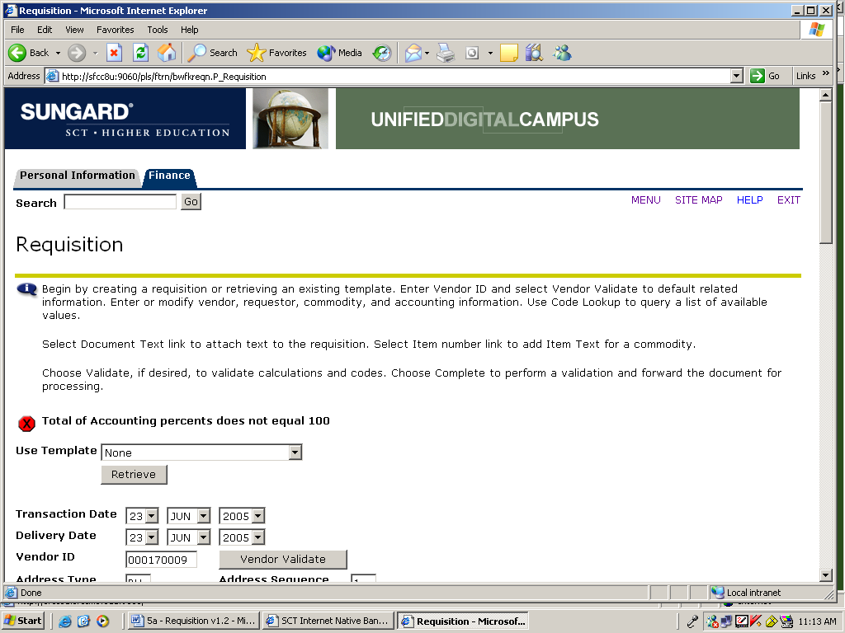
  - Scroll back down to Accounting Section
  - This will populate the Fund, Orgn and Program
  - Index Code will no longer be displayed

- Type Account in the field *Required*
Remember, this is the old object code, with 70 in front
(For questions about Account Numbers, call the Controller’s Office at 968-0394)

- Type in Percent Amount in Accounting Field *Required*
  - Total of Accounting Column must equal 100

- Repeat Steps 2-6 until all accounting has been entered

- Click Validate button again

- The message at the top of the form should read:
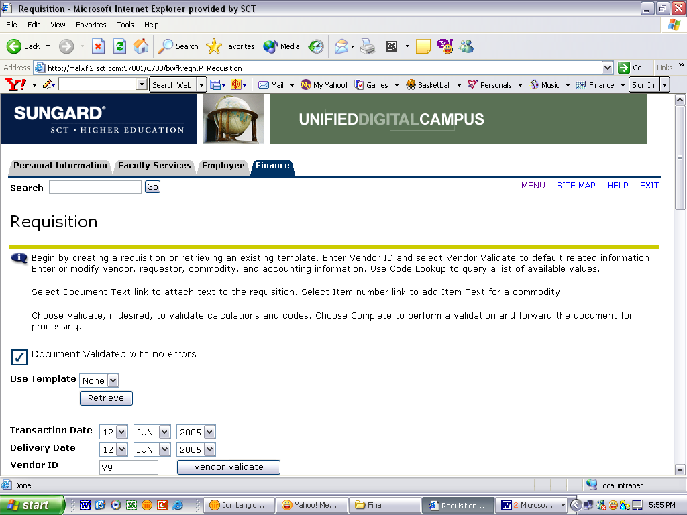

- Double check the Requisition once more for errors. Remember that once complete, Requisitions CANNOT be changed. Click Document Complete

Requisition Form – Accounting – Dollars - Index:

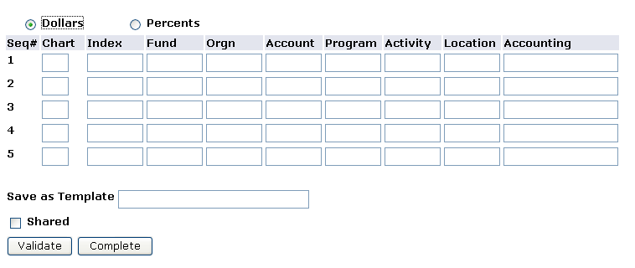

When the Dollars radio button is selected, the total dollar amount of the commodities listed above must equal the total dollar amount listed in the Accounting Column.

- Click the Dollar radio button

- Type “T” in the Chart of Accounts Code in the field *Required*

- Type Index Code in the field
(To search for code go to Lookup Section)

- Click Validate button
  - An error Message will appear
  - Scroll back down to Accounting Section
  - This will populate the Fund, Orgn and Program
  - Index Code will no longer be displayed

- Type Account in the field *Required*
Remember, this is the old object code, with 70 in front
(For questions about Account Numbers, call the Controller’s Office at 968-0394)

- Type in Dollar Amount in Accounting Field *Required*
  - Total of Accounting Column must equal Net Amount

- Repeat Steps 2-6 until all accounting has been entered

- Click Validate button again

- The message at the top of the form should read:

- Double check the Requisition once more for errors. Remember that once complete, Requisitions CANNOT be changed. Click Document Complete
- Do not click the Save and Process button.

Code Lookup Instructions

Code Look-Up is located at the bottom of the form. It allows you to search for a many things, including indexes, ship to addresses, and vendors. There are two ways to search, by code or by title

*This is case sensitive. Always capitalize the first letter of names.*

To search by Code, used when you only know part of the code:
- Select “T” Chart of Accounts Code from pull down menu: 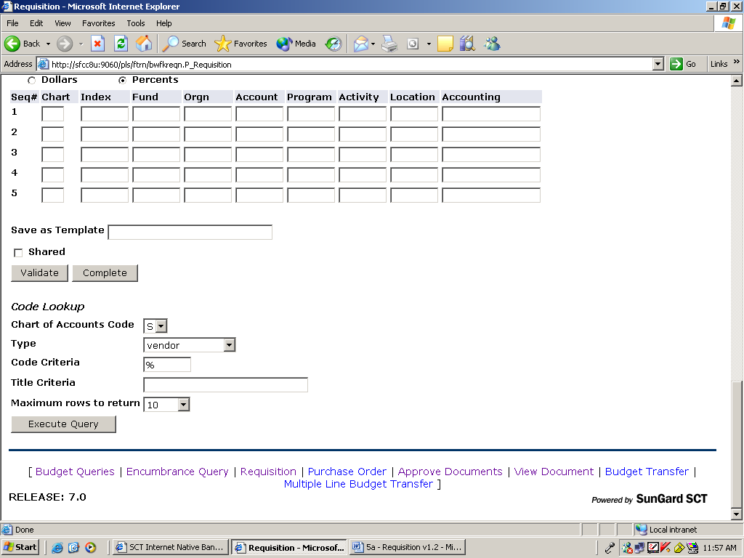
- Select type from pull down menu: 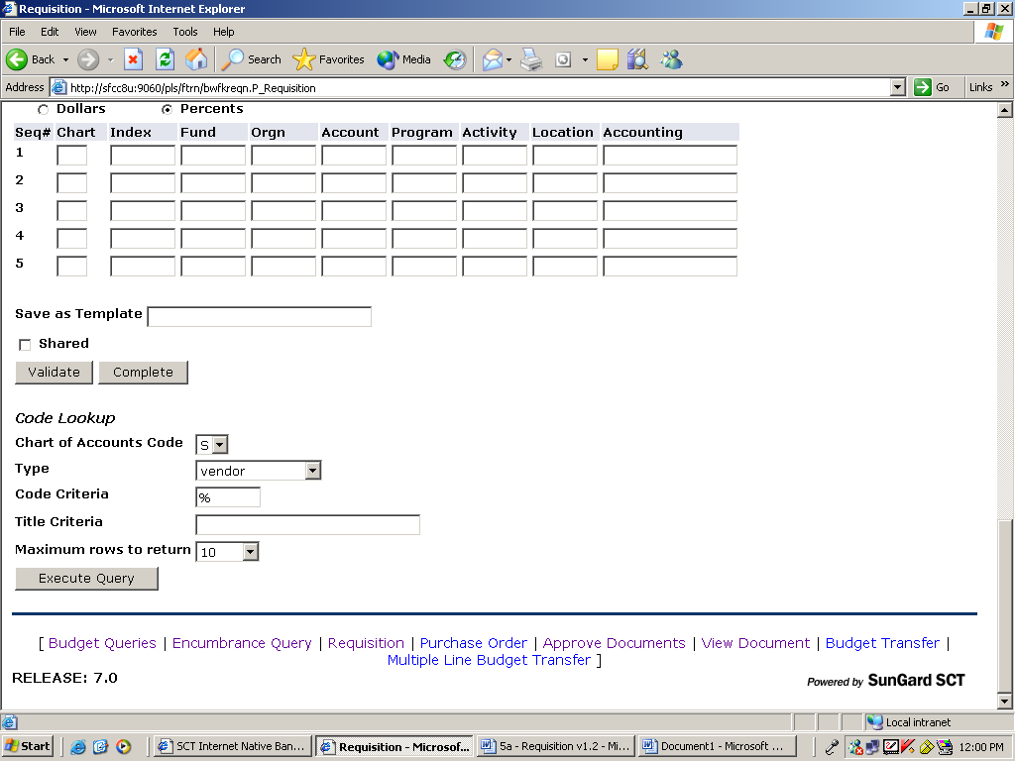
- Type in part of the Code followed by a %. If no part is known then type %.
  - Note: (%) is called a Wildcard
- Select the Maximum Rows to Return from Pull-down Menu 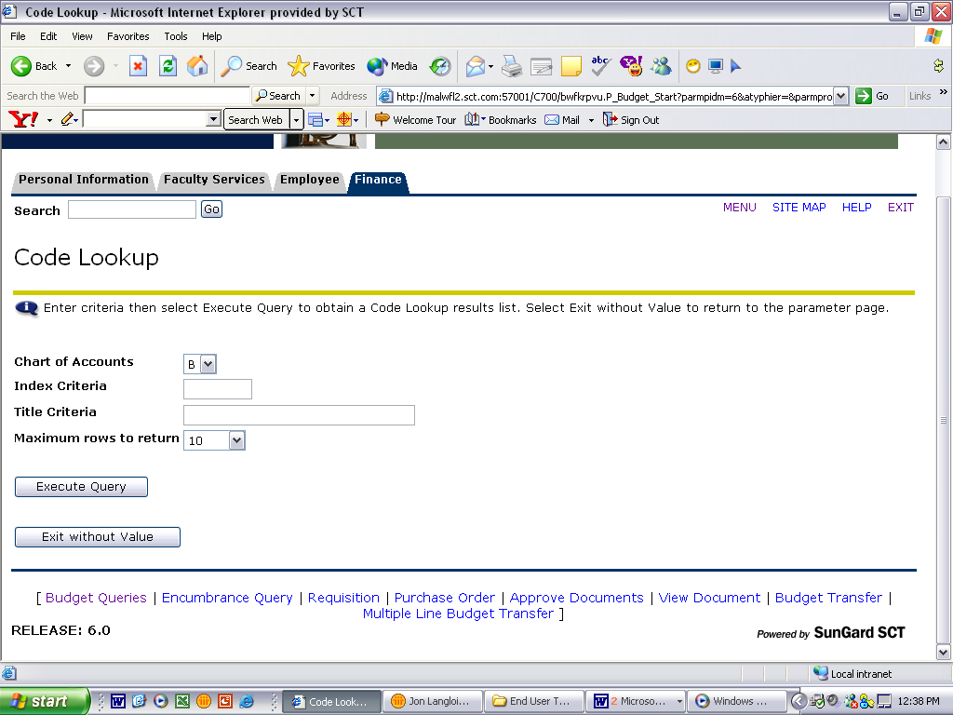
- Note – The amount of rows that will be shown can be adjusted by selecting a different number from the pull down menu
- Click Execute Query button:
- Results will appear at the top of the form. Make note of Code and scroll down to enter.

To search by Title, used when you only know part of the name:
- Select “T” Chart of Accounts Code from pull down menu:
- Select type from pull down menu:
- Type in part of the Title followed by a %. If no part is known then type %.
  - Note: (%) is called a Wildcard
- Select the Maximum Rows to Return from Pull-down Menu
- Note – The amount of rows that will be shown can be adjusted by selecting a different number from the pull down menu
- Click Execute Query button:
Results will appear at the top of the form. Make note of Code and scroll down to enter.

Requisition – Save Template
Do not use a Shared Template. These templates cannot be deleted!
Templates speed up the requisition process to companies that you frequently requisition, such as Office Depot or Dell.
- Create name of Template and type in “Save as Template”

Table of Contents
Page 2 | Accessing the Requisition Form
Page 3 | Requisition Form
Page 4 | Requisition Form – Dates / Vendor ID
Page 5 | Requisition Form – Document Text
Page 6 | Requisition Form – Commodity
Page 7 | Requisition Form – Accounting – Dollars - Index
Page 8 | Requisition Form – Accounting – Percents - Index
Page 9 | Code Lookup Instructions
Page 10 | Requisition – Save Template

Accessing Requisition Form:

- Click on Finance

- Click on Requisition
Requisition Form:

*Note* - The recommended ways of navigating through this form are using the “Tab” key or the mouse. Using the “Enter” key will result in errors in the form.

*Note* - Self Serve times out after one hour of inactivity. All information will be lost.
Requisition Form – Dates / Vendor ID:

- Enter Delivery Date by using pull down menu:
*Delivery Date must be equal to or greater than the transaction date.*

- Enter Vendor ID in the field shown:
- To search for Vendor ID go to Lookup Section
- If a vendor is not in the system, a Request for New Vendor must be completed.

- Click on Vendor Validate button:
  - The following information should automatically fill in
    - Address Type
    - Address Sequence *Note*
    - Chart of Accounts – (Required Field)
    - Organization – (Required Field)
    - Ship Code – (Required Field)
    - Attention To
*Note* - Vendor Address will default as sequence 1. To view vendor’s alternative addresses, change the sequence number and click the Vendor Validate button.

  - The following information will automatically fill in if data is in the Banner Finance System
    - Vendor Contact
    - Vendor E-mail
    - Requestor Name
    - Requestor E-Mail
    - Phone Information
    - Fax Information

- Type any comments in the Comments field
*Note* - Information entered in the Comments field will not print on the Requisition or Purchase order. If Purchasing needs the information, put it in a field that prints, such as Document Text.

- To enter Document Text see next section
Requisition Form – Document Text:

- Click Document Text

- Type in top or bottom box
  - Text in top box will print on Requisition. If you want Purchasing to see the text, enter it here.
  - Text in bottom box will not print on Requisition

- Click on Save button:

Requisition Form – Commodity:

- Type In Commodity Description: *Required*

- For additional item text, click on the number at the beginning of each line.
  - Type Text in the top box so that it will print on the Requisition
  - Click on Save button:
- Select U/M (Unit of Measure) from the pull down menu: *Required*

- Type in Quantity: *Required*

- Type in Unit Price: *Required*
- Must have decimal point if cents are included
- Do not type dollar signs ($) or commas (,)

- Type in Discount Amount: *Optional*
- If vendor does not have discounts set up in the Banner Finance System this column will not appear.
- Must have decimal point if cents are included
- Do not type dollar signs ($) or commas (,)

- Type in Additional Amount: *Optional*
- For example, use for shipping
- Must have decimal point if cents are included
- Do not type dollar signs ($) or commas (,)

- Repeat steps 1-6 for Items 2 thru 5
  - If you have more than five (5) items, you will have to do multiple requisitions. Select “Another Requisition, Same Vendor.”

- Click on Commodity Validate button:

- The Calculated Commodity Amounts will fill in automatically

Requisition Form – Accounting – Percents - Index:

When the Percents radio button is selected, the total Percent amount of the commodities listed above must equal the total Percent amount listed in the Accounting Column.

- Click the Percent radio button

- Type “T” in the Chart of Accounts Code in the field *Required*

- Type Index Code in the field
(To search for code go to Lookup Section)

- Click Validate button
  - An error Message will appear
  - Scroll back down to Accounting Section
  - This will populate the Fund, Orgn and Program
  - Index Code will no longer be displayed

- Type Account in the field *Required*
Remember, this is the old object code, with 70 in front
(For questions about Account Numbers, call the Controller’s Office at 968-0394)

- Type in Percent Amount in Accounting Field *Required*
  - Total of Accounting Column must equal 100

- Repeat Steps 2-6 until all accounting has been entered

- Click Validate button again

- The message at the top of the form should read:

- Double check the Requisition once more for errors. Remember that once complete, Requisitions CANNOT be changed. Click Document Complete

Requisition Form – Accounting – Dollars - Index:

When the Dollars radio button is selected, the total dollar amount of the commodities listed above must equal the total dollar amount listed in the Accounting Column.

- Click the Dollar radio button

- Type “T” in the Chart of Accounts Code in the field *Required*

- Type Index Code in the field
(To search for code go to Lookup Section)

- Click Validate button
  - An error Message will appear
  - Scroll back down to Accounting Section
  - This will populate the Fund, Orgn and Program
  - Index Code will no longer be displayed

- Type Account in the field *Required*
Remember, this is the old object code, with 70 in front
(For questions about Account Numbers, call the Controller’s Office at 968-0394)

- Type in Dollar Amount in Accounting Field *Required*
  - Total of Accounting Column must equal Net Amount

- Repeat Steps 2-6 until all accounting has been entered

- Click Validate button again

- The message at the top of the form should read:

- Double check the Requisition once more for errors. Remember that once complete, Requisitions CANNOT be changed. Click Document Complete

Code Lookup Instructions

Code Look-Up is located at the bottom of the form. It allows you to search for a many things, including indexes, ship to addresses, and vendors. There are two ways to search, by code or by title

*This is case sensitive. Always capitalize the first letter of names.*

To search by Code, used when you only know part of the code:
- Select “T” Chart of Accounts Code from pull down menu:
- Select type from pull down menu:
- Type in part of the Code followed by a %. If no part is known then type %.
  - Note: (%) is called a Wildcard
- Select the Maximum Rows to Return from Pull-down Menu
- Note – The amount of rows that will be shown can be adjusted by selecting a different number from the pull down menu
- Click Execute Query button:
- Results will appear at the top of the form. Make note of Code and scroll down to enter.

To search by Title, used when you only know part of the name:
- Select “T” Chart of Accounts Code from pull down menu:
- Select type from pull down menu:
- Type in part of the Title followed by a %. If no part is known then type %.
  - Note: (%) is called a Wildcard
- Select the Maximum Rows to Return from Pull-down Menu
- Note – The amount of rows that will be shown can be adjusted by selecting a different number from the pull down menu
- Click Execute Query button:
Results will appear at the top of the form. Make note of Code and scroll down to enter.

Requisition – Save Template

Templates speed up the requisition process to companies that you frequently requisition, such as Office Depot or Dell.
- Create name of Template and type in “Save as Template”
Templates cannot be deleted!

Ship Code | Department | Building | Contact
VIPR | Accademic Affairs | Administration | Karen Riddell
ACCT | Accounting Dept | Corley Bldg
ACTG | Accounting Office | Administration | Katy Ehemann
ADVI | Advising/Registration Center | Bryan Hall Lobby | Rhonda Rogers
ART | Art Department | Art Bldg | William Tomlin
AGRI | Agricultural Dept. | Dean Bldg. | Susan Morris
ALUM | Alumni Office | Alumni House | Terry Holland-Finley
AVPR | Assoc VP Admin and Finance | Bryan Hall | Sandi Bradley
DIRC | Athletic Director | Hull Bldg | Lindsey Porter
BAND | Band and Choir | Witherspoon | Bonnie Heathcoat
BSBM | Baseball Office | Stroupe Bldg | Peggy Gregory
BEHV | Behavorial Science Dept. | Witherspoon | Susan Johnson
BIOS | Biological Science Dept. | McEver Bldg | Regina Storment
BRDT | Board of Trustees | Administration | Beverly Shively
BKST | Bookstore | Young | Johnny Sue Christy
RLBR | Brown Hall |  | Aaron Hogan
BDGT | Budget Office | Bryan Hall | Karen Alexander
BUAD | Business & Economincs | Corley Bldg
CPPL | Career Planning & Placement | Doc Bryan Bldg | Jayne Sewell
CNTR | Center for Teaching & Learning | Pendergraft Library
FOOD | Chambers Cafeteria |  | Doug Walton
CSPL | College Student Personnel | Bryan Hall
CMED | Community Ed & Professional Dev | Dean Bldg. | Rebecca Baker
COMS | Computer & Info Science | Corley Bldg | Ellen Crane
COSV | Computer Services | Corley Bldg | Merrell Shoptaw
CONT | Controllers Office | Administration | Sandi Mitchell
COUN | Counseling Center |  | Kristi Stokes
CNLL | Center for Leadership & Learning | Crabaugh Bldg | Heather Edgemon
CURR | Curriculum Instruction | Crabaugh Bldg | Natalie Maples
PSFT | Department of Public Safety |  | Anita Riddley
DVVP | Development Office | Administration | Lisa Harris
DISB | Disablilty Services | Bryan Hall | Kimberlee Mealy
ELEG | Electrical Engineering | Energy Center | Carla Terry
EAMT | Emergency Admin & Mgt | Bryan Hall | Tracy Eichenberger
ENGL | English Dept. | Witherspoon | Wanda Choate
FTBM | Football | Hull Bldg | Becky Rachel
FGNL | Foreign Language Dept. | Dean Bldg. | Monica Miller
GSDN | Graduate Studies | Tomlinson Bldg | Regina Thompson
HLPE | Health & Physical Education | Hull Bldg | Lindsey Porter
HRES | Human Resource | Bryan Hall | Amber Tennison
INMU | International Studies | Doc Bryan Bldg | Sabrina Anwar
LEGL | Legal Counsel | Administration | Thomas Pennington
MATH | Mathematics Dept | Corley Bldg | Erica Newman
MCEG | Mechanical Engineering | Energy Center | Carla Terry
BKTM | Men's Basketball | Tucker Coliseum | Peggy Gregory
GLFM | Men's Golf | Tucker Coliseum | Peggy Gregory
MUSC | Music Dept | Witherspoon | Karen Greer
NEWS | News Bureau | Bryan Hall | Rhonda Signor
NURS | Nursing Dept. | Dean Bldg. | Patti Fernandez
OZARK | Ozark Campus |  | Dianne Bell
RLPA | Paine Hall |  | Aaron Hogan
PRHO | Parks Recreation Hospitality | Williamson Bldg | Bobbi Haralson
PLANT | Physical Plant | Critz Bldg | Sandra Tritt
PHSC | Physical Science Dept | McEver Bldg | Linda Norris
BKPO | Post Office | Young Bldg | LeAnne Riley
PRES | President's Office | Administration | Beverly Shively
PBRL | Public Relations | Administration | Brandi Collins
PURC | Purchasing Dept. | Young Bldg | Jennifer Warren
KXRJ | Radio Station | Crabaugh Bldg | Christie White
REGR | Registrars Office | Doc Bryan Bldg | Christina Pacheco
RLDR | Residence Life | Doc Bryan Bldg | Janet Roys
STJN | Speech Theater Journalism | T-1 Bldg | Pat Bullard
INFO | Sports Information Director | Tucker Coliseum | Paul Smith
STAC | Student Accounts Office | Doc Bryan Bldg | Mary Hoyt
FINA | Student Financial Aid | Doc Bryan Bldg | Nita Brashear
HLTH | Student Health Services | Dean Bldg. | Julie Hood
STSV | Student Services Admin. | Doc Bryan Bldg | Crystal Taylor
RLSU | Summit Hall |  | Aaron Hogan
TEST | Testing Center Operations | Bryan Hall | Kimberlee Mealy
RLTU | Turner Hall |  | Aaron Hogan
TV6 | TV Station | Crabaugh Bldg | Christie White
UPBD | Upward Bound Math & Science | Bryan Hall | Jill Hendrix
VPAF | VP Adminitration & Finance | Administration | Cheryl Moody
VPST | VP Student Services | Doc Bryan Bldg | Brandi Collins
WARE | Warehouse |  | Sandra Tritt
BKTW | Women's Basketball | Tucker Coliseum | Peggy Gregory
CRCW | Women's Cross Country | Tucker Coliseum | Peggy Gregory
GLFW | Women's Golf | Tucker Coliseum | Peggy Gregory
SFTW | Women's Softball | Buerkle Fieldhouse | Peggy Gregory
TENW | Women's Tennis | Tucker Coliseum | Peggy Gregory
VOLW | Women's Volleyball | Tucker Coliseum | Peggy Gregory
ATCC | Area Technical Career Center | High School Campus | Jennifer McIntare
ARKA | Speech Theater |  | Tommy Mumert
ADSV | Admin Services | Bryan Hall | Fred Clayton
Chaffee | Air Conditioning & Refridg | Ozark Campus | Kenneth Beeler
CMATCH |  | Rothwell Hall | Nathan George
CONST | Construction | Administration | Galen Rounsaville
CUST | Custodial | Physical Plant | Lisa Wesley
DEAN | College of Business | Rothwell Hall | Lori Bartlett
EDUC | College of Education | Crabaugh Bldg | Lawana Hamilton
ELI | English Language | Tomlinson Bldg | Donna Ogle
ETCH | Technology Center | Pendergraft Library | Ken Wester
FADV |  | Tomlinson Bldg | Tawana Daniel
LIBG |  | Pendergraft Library | Pam Curry
MUSG | Museum | Techionary | Judith Stewart-Abernathy
NHDEAN | Biological Science Dept. | McEver Bldg | Valli Wanzer
TRAIN | Sports Medicine | Hull Bldg | Duke Walden
VETS | Veteran Services | Doc Bryan Bldg | Marsha Oels

