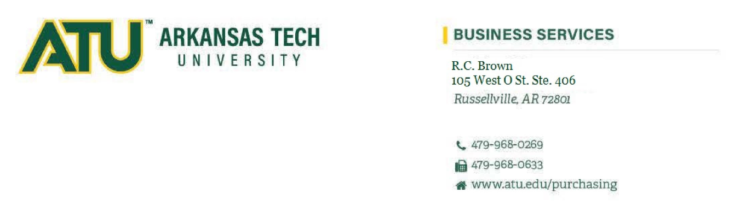
Procurement Services
514 West M Street

Amendment 1
RFQ 26-044 Outside Legal Counsel Immigration Services
This amendment is issued to extend the deadline for responses to October 12, 2026 at 2 p.m.

Thank you

