Cardholder responsibilities
The Cardholder must only use the P-Card for legitimate Arkansas Tech University business purposes. Misuse of the card will subject Cardholder to disciplinary action in accordance with University Policies and Procedures relating to disciplinary action and termination for cause.
The Cardholder MUST:
- Only use the P-Card for University business.
- Adhere to purchase limits/restrictions imposed on your P-Card.
- Obtain ALL sales slips, register receipts, etc. and provide these to the person within your department who will be responsible for reconciling these charges.
- Return the P-Card to the Purchasing Department upon terminating employment, or if no longer using the P-Card.
- If in doubt as to whether or not something can be purchased, please contact the Purchasing Department.

lost/misplaced/stolen procurement cards
Cardholders are required to immediately report any lost or stolen Procurement Card to US Bank toll-free at 1-800-344-5696 (24 hours a day, 365 days a year) and Visa at 1-800-847-2911. The Cardholder must also immediately notify the Tech Purchasing Department at the first opportunity during normal office business hours.

charges not allowed
- Airfare, Hotel, Car rental, Restaurants (Anything to do with Travel)
- Alcoholic Beverages
- Any purchase that would involve a trade-in
- Cash Advances
- Fuel
- Gift Certificates
- Phone services
- Professional Services, Contracted Services, Telemarketing, etc
- State Contract Items
- Computers
- Printing
- Personal type of purchases of any kind (gift certificates, greeting cards, flowers, etc.) __________________________
US BANK
Customer Service
1-800-344-5696
QUICK CHECK LIST
- Get detailed receipt or other supporting documentation from vendor.
- Give receipts to person within you department responsible for reconciling these charges.

procurement card (P-Card)
pocket guide
Tech Purchasing Department
Phone: 479-968-0269
Fax: 479-968-0633
Web Information:
http://purchasing.atu.edu

How Does the procurement card work?
The Procurement Card issued by US Bank is a special VISA credit card. It works similarly to your personal credit cards, except the charges are billed directly to the University and paid by the Accounts Payable/Disbursing office.
The purpose of the State of Arkansas Procurement Card program is to establish a more efficient, cost effective alternative for departments to make supply type purchases. The P-Card should greatly reduce, if not eliminate, the need for blanket and low dollar Purchase Orders.
Using the P-Card will be a benefit to Arkansas Tech University, its suppliers, and to you and your department. The University will save time and money by consolidating paperwork, suppliers will receive payment more quickly, and you and your department will get the supplies you need without unnecessary delays.
PERSONAL CHARGES ARE STRICTLY FORBIDDEN. The adherence to policy allows continued process savings, accountability, and audibility of purchases.

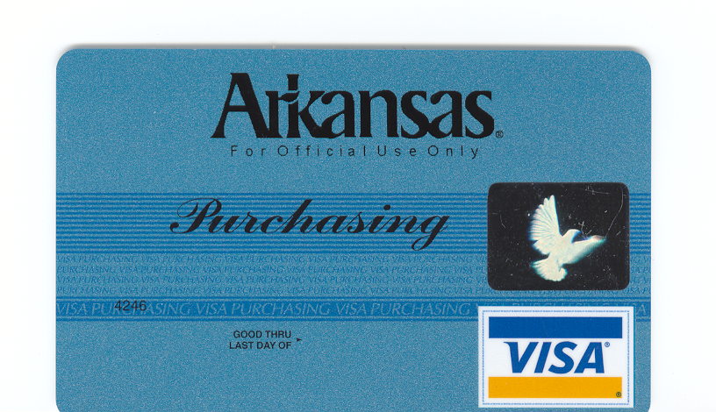

What do I do with my receipts?
!!!IMPORTANT!!!
Whether a purchase is made in person or via telephone, internet, fax, or mail, you must obtain some form of official supporting documentation, such as:
- Detailed cash or sales receipts
- Packing slips with dollar amounts
- Any other detailed document, which shows the cost and the vendor name.
These documents MUST be given to the person in your department responsible for completing the P-Card Transaction Log each month.
IN ORDER FOR THE P-CARD PROGRAM TO BE SUCCESSFUL YOU MUST RETAIN AND TURN IN YOUR RECEIPTS TO APPROPRIATE PERSONNEL WITHIN YOUR DEPARTMENT!

monthly billing cycle

The monthly billing cycle for P-Cards will be the 15th of each month. The monthly billing statement will be posted on the US Bank website. This statement should be printed and attached to the P-Card Transaction log, receipts and sent to the Purchasing Department for auditing. A copy of the Transaction log is to be emailed to the Accounts Payable office.

How will my P-Card be audited?
Not only will P-Cards be audited by Legislative and system auditors, but they will also be audited by the Purchasing Department and Accounts Payable staff. Auditors will be looking at the following for compliance:
- Have detailed receipts for charges and/or credits been sent to the Purchasing Department?
- Have the downloaded charges and credits from US Bank been approved?
- Are items being purchased that are not allowable due to Procurement regulations and/or laws?
- Is the charge being split in order to avoid the transaction limit on card?
Non-compliance with any of the above may result in a minimum 30-day suspension for first offense. Second offense could result in complete removal from P-Card program.

Merchandise Returns and Exchanges
When necessary, items should be returned according to vendor specifications. The cardholder is responsible for ensuring that proper credit is posted for any returned items.
Documentation showing the credit for the return must be retained for the monthly P-Card Transaction Log.
*P-Card Transaction Logs must be complete and received in the Purchasing and Accounts Payable Departments no later than the 20th of each month or your P-Card may be suspended for an unspecified amount of time.

