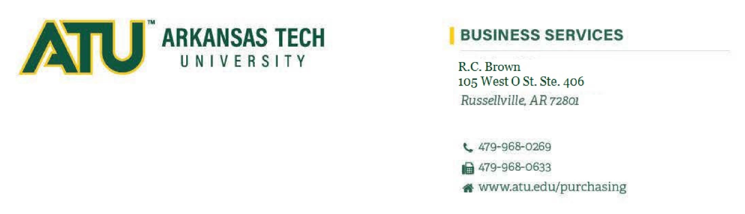

***404 N El Paso Ave.***

June 1, 2024

Current positions with contractual signature authority for Arkansas Tech University:

* President
* Ozark Chancellor
* Vice President of Administration & Finance
* Assoc. Vice President of Administration & Finance - Business Service, APO

Thank you,

Business Services