

Adjunct Faculty Guide

2016-2017
Revised August 2017
Revised August 2019
Revised August 2020
This page left intentionally blank.

Table of Contents

- General Information Page 1
II. Facilities and Contacts Page 2
Academic Affairs Page 2
Human Resources Page 2
Payroll Page 3
Office of Information Services Page 4
Student Accounts Page 4
Ozark Campus Library Page 5
Ross Pendergraft Library & Technology Center Page 5
Office of Student Services Page 6
Public Safety Page 6
III. Instruction Responsibilities Page 7
Course Syllabi Page 7
Utilization of Class Time Page 8
Textbooks Page 8
Child Maltreatment and Reporting Policy Page 8
Faculty Evaluation Page 8
Class Records Page 9
University Grades and Attendance Page 9
Federal Attendance Accounting Page 9
Class Attendance Page 9
Faculty Page 9
Students Page 9
Grading – Policy and Reporting Page 10
Grading System Page 10
Grading Page 10
Reporting Grades Page 11
Examinations Page 11
Plagiarism Page 12
Student Academic Conduct Policies Page 12
Definitions Page 13
Academic Appeals and Admissions Committee Page 13
Procedure for Charges of Academic Dishonesty Page 14
Procedure for Charges of Academic Misconduct Page 15
Student Rights Page 16
Student Academic Grievance Procedure Page 17
IV. Policies and Procedures Page 19
Criminal Background Check Policy Page 19
FERPA Page 19
Disability Services for Students Page 20
Sexual and Gender Harassment Page 20
Sexual Misconduct Policy Page 21
Consensual Relations Page 56
Affirmative Action Page 56
Conflicts of Interest Page 57
Non-Discrimination Policy Page 57
Non-Compliance Policy Page 58
Campus Safety and Preparedness Page 58
V. Technology Page 59
eTech Page 59
Tech eMail Page 60
Teaching Web Courses with Blackboard Learn Page 62
Banner Help and Instructions Page 63
Navigating Within Banner Self-Service Page 64
Recording Non-Attendance for Classes Page 67
Midterm Grading in Self-Service Page 72
Final Grading in Self-Service Page 75
Ozark Campus Map Page 78
Attendance Policy – First Memo Page 79
Attendance Policy – Second Memo Page 82
Attendance Policy – Third Memo Page 85

ACKNOWLEDGMENT

I understand that the Arkansas Tech University-Ozark Campus Adjunct Faculty Guide, located at http://www.atu.edu/ozark/academics/facultyresources.php, along with the Arkansas Tech University-Ozark Campus Faculty Handbook (update 2018), constitutes the general policies and procedures of Arkansas Tech University-Ozark Campus, and I will familiarize myself with the information therein. All policies, procedures, and guidelines are subject to review, revision, and modification during any academic year.

I will also familiarize myself with the Sexual Misconduct Policy (Faculty Handbook pages 9-39) and the Clery Act (http://www.atu.edu/securityact/docs/CampusSecurityReport2018.pdf).

_____________________________________
(Signature)

_____________________________________
(Please Print Name)

_____________________________________
(Date)

*****************************

Please sign and return this form to the Office of Academic Affairs in Room 152, Technology And Academic Support Building. This signed form will be retained as part of your permanent record. This signed form may be faxed to 479-667-1410 or scanned and emailed to ozarkacademicaffairs@atu.edu.

This page left intentionally blank.

GENERAL INFORMATION

Welcome to Arkansas Tech University–Ozark Campus. This adjunct guide is designed to assist all non-regular, part-time faculty in the application of their instruction. This guide acquaints part-time faculty with the goals of Arkansas Tech University-Ozark Campus, introduces various offices on the Ozark Campus, and provides significant instructional guidelines from The Office of Academic Affairs, The Arkansas Tech University-Ozark Campus Faculty Handbook (FH), and Student Handbook (SH). The guide will also introduce faculty to the Arkansas Tech University E-mail system and Blackboard.

Adjunct faculty are an integral part of a University whose mission is to provide quality instruction to students. Through quality leadership and instruction, Arkansas Tech University-Ozark Campus continues its pursuit of excellence in degree programs and instruction.

University Mission Statement:
(adopted October 19, 2016)
Arkansas Tech University is dedicated to student success, access, and excellence as a responsive campus community providing opportunities for progressive intellectual development and civic engagement. Embracing and expanding upon its technological traditions, Tech inspires and empowers members of the community to achieve their goals while striving for the betterment of Arkansas, the nation, and the world. (http://www.atu.edu/catalog/ozark/).

Vision Statement
(adopted October 19, 2016)
Arkansas Tech University: where students succeed, innovation thrives, and communities flourish (http://www.atu.edu/catalog/ozark/).

FACILITIES AND CONTACTS

There are many offices on the Arkansas Tech University-Ozark Campus with which adjunct faculty need to become familiar. Each administrative office manages a variety of functions. A few are listed below with applicable information to assist adjunct faculty. The first is the Office of Academic Affairs.

Academic Affairs
Sheila R. Jacobs
Chief Academic Officer
Technology and Academic Support Building
1700 Helberg Lane
Ozark, AR 72949
Phone: 479-667-1707
Fax: 479-667-1410
E-mail: sjacobs3@atu.edu

Faculty must provide official transcripts of all college course work and degrees to the
Office of Academic Affairs, located in the Technology and Academic Support Building, Room 151. Transcripts should be sent directly from the university attended to Academic Affairs. A completed, signed Faculty Record form, along with a current resume must also be submitted. The form is located at http://www.atu.edu/academics/facultyrecord.php.

Human Resources

“The Office of Human Resources provides management and oversight of employee services, benefits, and personnel policies and procedures and facilitates long-range programs and services which support faculty and staff in providing a quality learning environment for students”.

Faculty are required to complete a hire packet supplied by Human Resources that includes information requests. Complete these forms and return them to the Human Resources Office. Also included in the hire packet is an adjunct faculty identification (ID) card which is to be used at Arkansas Tech University for identification purposes, such as to obtain a Library card.

Assistance is available from the Human Resources office in the completion of any forms and packets required by the University.

Human Resources
Mitzi Reano
Technology and Academic Support Building
1700 Helberg Lane
Ozark, AR 72949
Phone: 479-667-2117
Fax: 479-667-1026
E-mail: mreano@atu.edu

Office hours are Monday through Friday, 8:00 a.m. to 5:00 p.m.; the office is closed during the noon hour from 12:00 p.m. – 1:00 p.m. Contact Mitzi Reano (mreano@atu.edu) with any human resources questions.
Payroll

The payroll office is located in the Technology and Academic Support Building. “The Director of Payroll and Special Services is responsible for the processing of University payrolls in compliance with related employment regulations, and various reporting responsibilities including employment and non-resident alien taxation, the issuance of student form 1098-T and other miscellaneous reports as requested by University management.”.

Adjunct faculty are normally paid in four equal installments each fall or spring semester.
For the fall semester, installments are paid at the end of September, October, and November,
with the final installment due to the faculty member on the last working day of December prior
to the Christmas break. During spring, installments are paid at the end of February, March, April,
and May. For the summer, the first summer session payment is made at the end of June, and the
second summer session payment is made at the end of July. Classes with unusual beginning or
ending dates may necessitate a different payment schedule from that described above, which
would be noted on the “Notice of Appointment” (i.e., contract).

Adjunct faculty will receive their disbursement on the last working day of the month, or
they may choose Direct Deposit. A Direct Deposit authorization form is included in the Human
Resources hire packet.

Adjunct faculty receive the following benefits:
- Admission to regular Tech sporting events for the adjunct faculty and one guest

- Faculty discounts at the Tech and Ozark Campus bookstores (10% on apparel and supplies; there is no discount on books)

- Admission to the Tech racquetball courts during faculty/community hours for the adjunct faculty and immediate family members (spouse and children).

Adjunct faculty should present a picture ID along with the paper ID issued by Human
Resources when requesting these benefits.

Payroll
Stacie Harden
Technology and Academic Support Building
1700 Helberg Lane
Ozark, AR 72949
Phone: 479-667-2117
Fax: 479-667-667-2106
E-mail: sharden@atu.edu

Office hours are Monday through Friday, 8:00 a.m. to 5:00 p.m.; the office is closed during the noon hour from 12:00 p.m. – 1:00 p.m. Contact Stacie Harden (sharden@atu.edu) with any payroll questions.

Office of Information Services

All technology access is controlled by the Office of Information Services. Each adjunct
faculty member is provided with an e-mail account upon employment. The username and
password for the e-mail account provides access to library search and many other campus
technology resources.

Most adjunct faculty will find they do not need computer access beyond the standard
Banner Self-Service for faculty that is automatically applied to your role as a faculty member.
However, if you should find you are in need of additional access such as Internet Native
Banner, or if you need to manage one or more budgets and therefore have a need for Banner
Finance access, please contact Academic Affairs. The Chief Academic Officer will be able to help you decide what access you truly need and will direct you in filling out a Banner Data Access Request Form. For security reasons, access to university systems other than those accessed by the e-mail account, are based on a demonstrated need for the service and must be approved by the Chief Academic Officer.

For help related to computer services, contact Angela Linden, Campus Support Administrator, in Pendergraft, Room 150.

Office of Information Services
Campus Support
Pendergraft, Room 150
305 West Q Street
Phone: 479-968-0646
Toll Free: 866-400-8022
Fax: 479-964-0565
E-mail: campussupport@atu.edu

Campus Support Center is open 24 hours a day 7 days a week. (NOTE: When the Library is closed there will only be email and telephone service available.)

Student Accounts
Becky Krebs
Student Services and Conference Center
1700 Helberg Lane
Ozark, AR 72949
Phone: 479-667-2950
Fax: 479-667-2106
E-mail: rkrebs@atu.edu

A red hangtag can be purchased at the Student Accounts Office for a $15 fee. Office Hours are Monday through Friday, 8:00 a.m. – 4:00 p.m. Contact Becky Krebs (rkrebs@atu.edu) with any student account questions.

Ozark Campus Library

Visit the library and encourage students to do the same. You may place on reserve selected library holdings, such as periodicals, documents, or books that are of interest to your classes. Please email kmoore36@atu.edu for additional information

Ozark Campus Library
Kristie Moore, Librarian
Alvin Vest Student Union
1700 Helberg Lane
Ozark, AR 72949
Phone: 479-508-3321
Fax: 479-667-1410
E-mail: kmoore36@atu.edu

Library Hours are Monday through Friday, 8:00 a.m. – 5:00 p.m. Contact Kristie Moore (kmoore36@atu.edu) with any library questions.

The Ross Pendergraft Library and Technology Center (RPL)

You may also activate your library account at the Ross Pendergraft Library and Technology Center on the Russellville Campus at the Circulation Desk. The multimedia reserves are located in
the Music Lab on the second floor. Faculty can check out multimedia items, so visit the Music
Lab.

Each fall semester, the library offers orientation sessions of approximately forty-five minutes in length for Composition classes, or new students or faculty who are unfamiliar with the Library. These introductory sessions will orient new students and faculty to the library’s web services, acquaint them with the online catalog, and more. Please email pendergraftlibrarycirc@atu.edu for additional information.

The Ross Pendergraft Library and Technology Center
Brent Etzel, Director
305 W. Q Street
Phone: 479-968-0289 (Administrative Specialist) 479-968-0417 (Director)
479-964-0569 (Circulation Department) 479-498-6060 (Technology)
E-mail: pendergraftlibrarycirc@atu.edu
Website: library.atu.edu
Library hours are Sunday, 2:00 p.m. – 12:00 a.m.
Monday through Thursday, 7:00 a.m. – 12:00 a.m.
Friday, 7:00 a.m. – 6:00 p.m.
Saturday, 10:00 a.m. – 6:00 p.m.

Office of Student Services

The Office of Student Services serves a variety of functions, from admissions, financial aid, and registration to working with high school and transfer students. The Office of Student Services advises students of all majors. They strive to increase student success and retention through their Early Warning Program, which is designed to assist faculty in locating and resolving student attendance matters. The office sends an Early Warning Program reminder to all faculty at the beginning of the semester. Contact Richard Harris, Chief Student Officer, (rharris1@atu.edu) for further information.

Office of Student Services
Richard Harris, Chief Student Officer
Student Services and Conference Center, Room 104
1700 Helberg Lane
Ozark, AR 72949
Phone: 479-667-2117
Fax: 479-667-1422
e-mail: rharris1@atu.edu

Public Safety

To report a crime or emergency call Public Safety. The Public Safety office is located in the Collegiate Center.

Public Safety Department
David Spicer, Public Safety Officer
Collegiate Center
1700 Helberg Lane
Ozark, AR 72949
Phone: 479-508-3359 non-emergency
479-667-2117 on-campus; 911 – emergency
E-mail: dspicer1@atu.edu

For additional information or questions about policies and procedures pertaining to adjunct
faculty at Arkansas Tech University-Ozark Campus, see the Office of Academic Affairs. An Arkansas Tech University-Ozark Campus map has been included in this guide for your convenience.

INSTRUCTIONAL RESPONSIBILITIES

All faculty have the responsibility of upholding the University’s mission statement and
high standard of instruction. Since many non-regular faculty are not on campus on a regular
basis, it is imperative that a timely system for communication, including the use of e-mail and
faxes, is used. When departments request the return of a form, textbook request, etc., or when
deadlines are set for reporting of class attendance or grades, please respect the deadline given
and comply as early as possible. Departments shall provide information to adjunct faculty as
soon as possible so that he or she is given adequate time to reply to any request that is made.

The Chief Academic Officer is responsible for the curriculum and quality of instruction and
therefore requests that the following guidelines be adhered to. Both web courses and
classroom courses must be taught in a consistent manner to ensure the highest level of
instructional quality and integrity.

Course Syllabi

Course syllabi must be prepared according to the template, which is required by Academic
Affairs and submitted for approval to the department head at the beginning of each semester. The
syllabus should contain specific information regarding the evaluation process and how the instructor
will assign grades.

The Deans Council in August, 1999, approved guidelines for creating and distributing
course syllabi. Syllabi should be distributed in each class during the first week of the semester.
For electronically delivered classes, syllabi should be posted when the course is developed. The
following information should be included for both face-to-face and electronic course delivery:

- Course number (e.g., HIST 1503; to also include the appropriate Arkansas Course Transfer System or ACTS, course number when applicable)
- Course title
- Name of instructor, office hours, contact information (telephone, e-mail)
- Mode of Delivery
- Catalog description
- Text required for course
- Bibliography (supplemental reading list)
- Justification/rationale for the course
- Course objectives (learning outcomes)
- Description of how course meets general education objectives (courses included in the general education component should show how the course meets one or more of the objectives contained in General Educational Objectives listed in the undergraduate catalog)
- Assessment methods (include grading policy with specific equivalents for A, B, C)
- Policy on absences, cheating, plagiarism, etc.
- Course content (outline of material to be covered in course)
- Emergency procedures statement: (In case of emergency or severe weather, students will be notified and are asked to follow the emergency guidelines posted in each room.)
- Disability statement
- COVID-19 Information Sheet

Utilization of Class Time

Adjunct faculty should maintain the course schedule and time slated for each class period. If
faculty need assistance in the preparation of materials for instruction, they should talk to the
department head or faculty supervisor:

“Faculty members are to meet their classes at the time and for the period scheduled. Early
dismissals or absences for legitimate purposes should be considered only after consultation and approval of the Program Chair or Chief Academic Officer” (http://www.atu.edu/ozark/academics/facultyresources.php).

Textbooks Continue from here

Program Chairs will obtain and distribute the instructor’s textbooks or request forms
used for each course. Textbook selection is completed as soon as the schedule for each semester
is finalized; therefore, any specific requests for textbooks must be submitted to chairpersons
promptly so that the Arkansas Tech University-Ozark Campus Barnes & Noble Bookstore can order and receive the books in a timely manner.

Child Maltreatment and Reporting Policy

Act 703 of 2007 (Arkansas Code Annotated § 6-61-133) requires that Arkansas institutions of higher learning provide training in child maltreatment reporting for students enrolled in degrees that are a prerequisite for licensure or certification in a profession under the Child Maltreatment Act.

Institutions must submit an assurance to the Arkansas Department of Higher Education that each graduate has received training in:

- Recognizing the signs and symptoms of child abuse and neglect
- The legal requirements of the Child Maltreatment Act and the duties of mandated reporters under the Act
- Methods for managing disclosures regarding child victims.

Faculty Evaluation

The Faculty Handbook requires that teaching be evaluated by a standard, university-wide student evaluation. The current student evaluation system is electronic and available through your OneTech account.

All courses are evaluated when they reach 80% completion. At that point, students are sent an invitation email to complete the evaluation. Follow up emails are sent until the evaluation is completed or the survey closes. Results are analyzed and distributed by the Office of Institutional Research through the online evaluation system.

CLASS RECORDS

University Grades and Attendance

“It is the responsibility of the faculty member to maintain adequate records necessary for
grading and for accurate record keeping regarding daily student attendance throughout the
semester/term. Class rolls and records are the property of Arkansas Tech University. They should be retained for at least six months following the conclusion of the course or turned over [to the program chair or Chief Academic Officer] in the event that the faculty member leaves the University” (http://www.atu.edu/ozark/academics/facultyresources.php).

Federal Attendance Accounting

Attendance accounting is required to fulfill a federal requirement regarding financial aid
disbursement and to determine whether a student must be dropped for non-attendance or non-payment. At the beginning of each semester, faculty members are expected to notify the Registrar concerning students on class rolls who have not reported to class.

For electronically delivered classes, the faculty member must ascertain whether students have actively contributed to the course at least once on or before the attendance verification date for the course. For purposes of attendance accounting, this means that faculty are required to have students complete the Blackboard Federal Initial Attendance Participation Module or submit an assignment on or before the attendance verification date for the course.

*Attendance accounting is completed electronically in the Banner system. Instructions are provided to all faculty members prior to the beginning of each semester and can be found at the end of this guide.

Class Attendance

The following statements regarding faculty and student attendance and the faculty members’ responsibility to set student attendance expectations for each class do not release the faculty from the responsibility to maintain daily student attendance records throughout the semester/term.

Faculty. Any time that a faculty member must miss a class, the students are entitled to
advance notice or, if the absence is due to a last-minute emergency, to notification at the time
they report to class. Absence by a faculty member must have the prior approval of the
Program Chair or Chief Academic Officer, as appropriate.

Students: The policy of the University in regard to class absences may be stated as the
considered belief that regular class attendance is essential to the maximum growth and
development of the student, and that students, in their own interest, are therefore responsible for
attending all classes for which they are enrolled. For electronically delivered classes, where
physical attendance is not a reasonable requirement, equivalent on-line interaction must be
documented in lieu of attendance. Absence/participation policies and procedures are applicable
both to the regular terms and to the summer sessions.

The procedure for implementation of this policy (as adopted by the faculty on
September 9, 1966, and as amended by the Faculty Senate on September 27, 1990) is as follows:

- Control of class attendance is vested in the teacher who has the responsibility for clearly defining in each course, early in the semester, the standards and procedures in regard to regularity and punctuality of class attendance.
- Students will not be penalized by their instructors for class absences that result from participation in officially sanctioned University activities. It is the responsibility of students to present to their instructors notice and verification of authorized participation in such activities. Individual instructors retain the authority to determine how students in their classes will avoid academic penalties for the resulting absences.
- Before invoking the most severe penalty for unsatisfactory class attendance – dropping a student from a course with a grade of “FE” (i.e. F for excessive absences) – the instructor is obligated to notify the student, in writing, that an additional absence would result in this penalty.
- A student accumulating an excessive number of unjustifiable absences in an audited course may be administratively withdrawn at the request of the instructor.
- The action of dropping a student from a course for excessive absences becomes final when the instructor reports this action in writing to the Chief Academic Officer. The student who chooses to protest such action as unjustified has recourse through the grievance procedure for appeal of an academic grade as outlined in the Faculty Handbook.

The following comments and suggestions may be of some value to the faculty in the discharge of
their responsibility for student class attendance:

- Individual instructors have the option, and may find it advisable in some cases, to prescribe different class attendance requirements for different classes; i.e., between freshman and upper-level classes, or between class and laboratory requirements for a single course.
- Certain departments may find it desirable to establish uniform absence policies within the department, particularly in those departments with multi-section courses.
- In general, students who miss classes should be held responsible for making up the work through written reports or other appropriate means.
- Each instructor is fully justified in requiring student promptness and in barring from class any student who persists in being tardy”.

GRADING--POLICY AND REPORTING

Grading System

“Arkansas Tech University uses the four-point system of computing grade points: A, 4
points; B, 3 points; C, 2 points; D, 1 point; F, 0 points.

Students may repeat courses they have taken at Arkansas Tech University for the purpose of grade point adjustments (1) only by re-enrolling in the same courses at Arkansas Tech University and (2) subject to the following provisions. For repeated courses, only the grade from the best attempt of the repeated course is calculated into a student’s cumulative grade point, although all grades and all attempts are recorded on the student’s academic record. Students may not repeat a course in which the highest grade possible has already been earned. Adjustments to cumulative grade points are not made for courses transferred from other colleges or universities.

Grading

Although Arkansas Tech University does not require fixed percentages in individual classes,
equitable grading requires certain rough proportions which should, generally, approximate the
normal grade curves. This system is more applicable to lower level courses; upper-level courses
will usually depart from this pattern.

Grades are reported through an on-line grading system at the conclusion of each semester or
term. Mid-term grades are reported for freshmen and sophomores only. A grade of “I” may be
recorded for a student who has not completed all the requirements of a course only in situations
where the student has an illness or other circumstances beyond the student’s control, and has
completed seventy-five percent of the course requirements. If a grade of “I” is assigned, the
instructor will set a reasonable time limit within the following semester in which the work must be completed. Beginning the first summer term, 1990, and thereafter, a grade of "I" will not be computed in the grade-point average for the semester recorded; however, the "I" will be automatically changed to a grade of "F" for grade and grade point purposes at the end of the next regular semester (fall or spring) unless course requirements are completed and the final grade is reported before the end of the semester. A grade of "I" recorded prior to the first summer term, 1990, will be computed as an "F" for grade-point purposes until the "I" is removed. The change of a grade of "I" to a permanent grade is accomplished by written notification from the instructor to the Office of Academic Affairs.

No grade other than "I" may be changed after it is recorded, except if an instructor finds that a
grade has been erroneously reported. In such instances, the instructor may correct the grade by
submitting a Grade Change Request form with an explanation of the change to the Chief Academic Officer.

Reporting Grades

Grades are to be reported at mid-term (for freshmen and sophomores only) and the end of a
semester through an on-line grading system. Only final grades are reported in each summer
term. Faculty members are obligated to report grades on schedule as requested by the Chief Academic Officer.

After grade submission due dates, grades are available on the student’s OneTech account.
Notification is sent to students in academic jeopardy.
(http://www.atu.edu/ozark/academics/facultyresources.php)

Examinations

“At the end of each fall and spring semester, approximately one week is set aside for
examination week. Examination week is established as a time to administer end-of-course
examinations. For laboratory, internship, and other special courses approved by the Chief Academic Officer, examination week will be the last week of classes. For all other courses, examination week will be the week after the last day of classes. The end-of-course examination schedule is published by the Academic Affairs office. It is Arkansas Tech University–Ozark Campus policy that each full-time and each part-time faculty member will administer, at the assigned time, an end-of-course examination appropriate for each course assigned to the faculty member. Failure to administer an end-of-course examination, at the assigned time, may be considered an act of insubordination. Any deviation from the end-of-course examination schedule must be approved by the Chief Academic Officer.

Instructors who wish to administer a single test to multiple sections of a course should submit such a request to the Academic Affairs office at least two months before examination week. In the summer terms, there is no separate schedule of examinations; instructors give the end-of-course examinations the last day of the summer term.

Within a semester, instructors may schedule a test for multiple sections, normally early in the evening, by submitting such request to the Chief Academic Officer not later than the end of the third week of a semester. For each test the request will specify the number of students involved, the classroom desired, the dates (preferably with alternate dates), and the hours for beginning and
ending the test. The appropriate instructor has the responsibility of synchronizing the
scheduling of these tests, for checking against activities and with others who may be involved,
and for publishing an official schedule of these tests in order that others concerned may plan
accordingly.

Any student who has a justifiable reason for missing a test scheduled in the late afternoon or at
night is to be excused by the instructor from the test and is to be given the privilege of taking a
comparable examination at another time which is suitable to the student and to the instructor”
(http://www.atu.edu/ozark/academics/facultyresources.php).

Plagiarism

Should faculty encounter cases of academic dishonesty, they may refer to the Arkansas Tech University-Ozark Campus Faculty Handbook for Student Academic Conduct Policies and Procedures:

“Plagiarism is stealing the ideas or writing of another person and using them as one’s own.
This includes not only passages, but also sentences and phrases that are incorporated in the student’s
written work without acknowledgement to the true author. Any paper written by cutting and pasting
from the Internet or any other source is plagiarized. Slight modifications in wording do not change the fact that the sentence or phrase is plagiarized. Acknowledgment of the source of ideas must be made through a recognized footnoting or citation format. Plagiarism includes recasting the phrase or
passage in the student’s own words of another’s ideas that are not considered common knowledge.
Acknowledgement of source must be made in this case as well.” http://www.atu.edu/ozark/academics/facultyresources.php).

STUDENT ACADEMIC CONDUCT POLICIES

A university exists for the purpose of educating students and granting degrees to all students who complete graduation requirements. Therefore, Arkansas Tech University–Ozark Campus requires certain standards of academic integrity and conduct from all students. Arkansas Tech University–Ozark Campus expects an academic atmosphere to be maintained in all classes. This atmosphere is created by both the instructor and the class to enable all students enrolled to reach their academic potential. Students are expected to attend class, conduct themselves in a non-disruptive manner in class, and refrain from cheating, plagiarism, or other unfair and dishonest practices. Students should also realize that the classroom is under the control of the instructor who will give students a statement of his or her classroom policies in a syllabus at the beginning of the semester.

Academic offenses involving dishonesty and misconduct are defined in the Definitions section. These definitions are not all inclusive, and conduct not expressly set forth in the definitions may also be considered academic dishonesty or academic misconduct.

A. Definitions

Academic Dishonesty refers to the various categories of cheating and plagiarism in the classroom.
- Cheating on an examination, quiz, or homework assignment involves any of several categories of dishonest activity. Examples of this are: a) copying from the examination or quiz of another student, b) bringing into the classroom notes, messages, or crib sheets in any format which gives the student extra help on the exam or quiz, and which were not approved by the instructor of the class; c) obtaining advance copies of exams or quizzes by any means; d) hiring a substitute to take an exam or bribing any other individual to obtain exam or quiz questions; e) buying term papers from the Internet or any other source, and f) using the same paper to fulfill requirements in several classes without the consent of the instructors teaching those classes, g) use of any electronic device and/or any other mans of text messaging will be considered a form of dishonesty.

2. Plagiarism is stealing the ideas or writing of another person and using them as one's own. This includes not only passages, but also sentences and phrases that are incorporated in the student's written work without acknowledgement to the true author. Any paper written by cutting and pasting from the Internet or any other source is plagiarized. Slight modifications in wording do not change the fact that the sentence or phrase is plagiarized. Acknowledgment of the source of ideas must be made through a recognized footnoting or citation format. Plagiarism includes recasting the phrase or passage in the student's own words of another's ideas that are not considered common knowledge. Acknowledgement of source must be made in this case as well.

Academic Misconduct - Academic misconduct concerns the student's classroom behavior. This includes the manner of interacting with the instructor and other students in the class. For example, students may disrupt the learning environment in a classroom through inappropriate behavior, such as, talking to students, unnecessary interruptions, attempting to monopolize the instructor’s attention, or being chronically late to class. Misconduct also covers verbal or nonverbal harassment and/or threats in relation to classes. Student behavior should not infringe on the rights of other students or faculty during a class.

B. Academic Appeals and Admissions Committee

Composition of Committee

- The Academic Appeals and Admissions Committee is an official committee of Arkansas Tech University–Ozark Campus and will be formed each year as a pool of qualified faculty and students to hear student academic honesty and misconduct appeals. At the beginning of fall term, the Chief Academic Officer will appoint one faculty member from each division: Allied Health, Adult and Continuing Education, Business Technology, General Education, Industry/Technology and one representative from The Student Government. The faculty on the committee will elect a Chair.

- The Academic Appeals Committee will form a pool from which a subset can be drawn to serve on a subcommittee hearing a specific case.

- When a student appeal of a decision concerning academic dishonesty or academic misconduct is filed with the Chair of the Academic Appeals, the Chair shall select a three-person sub-committee from the pool in the following manner: one faculty member from the department involved in the appeal is located, one faculty member from the division at large, and one representative from the Office of Student Services. If the department grieved is represented by only one faculty member, then an alternate will be selected from the division.

C. Procedure for Charges of Academic Dishonesty

Since charges of academic dishonesty may have serious consequences, an instructor who suspects a student of any category of academic dishonesty must have facts and/or evidence to support the charge.

1. The instructor will meet with the student and present him or her with a written outline of the alleged academic dishonesty and the evidence supporting the charge. Penalties for various levels of academic dishonesty vary from giving an ‘F’ on a particular quiz or exam, to giving an ‘F’ on a term paper or other written work, or giving the student an ‘F’ or ‘W’ for the course. The instructor may also have different penalties for particular cases of academic dishonesty.

2. The instructor will notify his or her Program Chair (or Chief Academic Officer if the instructor is a Program Chair) of the charge, evidence and penalty.

3. If the student accused of academic dishonesty denies the charge or disagrees with the evidence presented by the instructor, the student should make an appointment with the relevant Program Chair (or Chief Academic Officer; in which case, skip steps 4 and 5). The student may remain in class during the appeal process.

4. If the student is still dissatisfied after meeting with the Program Chair, he or she should make an appointment with the Chief Academic Officer who will seek resolution of the problem.

5. If a resolution is not found, the Program Chair will refer the student to the Academic Appeals and Admissions Committee.

6. The student should then submit a written appeal to the Chair of the Academic Appeals and Admissions Committee.

7. If the Academic Appeals Sub-Committee determines that academic dishonesty has occurred, it will confirm the recommendation of the instructor concerning the penalty. Such a decision will be given both to the Chair of the Academic Appeals and Admissions Committee and the Program Chair from which the appeal originated. The student will be notified of the Sub-Committee's decision by the Chair of the Sub-Committee that sat for the appeal. The Chair shall also notify the Chief Academic Officer of the decision. The Chief Academic Officer will review the case and forward the outcome to the Registrar after the three-day appeal period.

8. The student shall have the right to appeal the decision of the Academic Appeals Sub-Committee by filing a Notice of Appeal with the Chancellor within three working days of receiving notification of the sub-committee's decision of the Chair of the Sub-Committee. The decision of the Chancellor will be final.

9. If the Academic Appeals Sub-Committee determines that academic dishonesty has not occurred or evidence is insufficient, the sub-committee will forward all pertinent information to the Chancellor. The Chancellor will confer with the Chief Academic Officer, Program Chair, and faculty member to facilitate the return of the student to class without penalty. The Program Chair will notify the student of the decision.

D. Procedure for Charges of Academic Misconduct

1. The instructor of a class being disrupted by academic misconduct will speak with the disruptive student. Proper behavior and possible consequences for not modifying the behavior will be discussed with the student. Extreme incidents of academic misconduct, in which the student becomes verbally or physically abusive in class, will be dealt with immediately by asking the student to leave the class. If the student refuses to leave, Campus Security personnel will be called to remove the student, and the Chief Student Officer will also be informed of the behavior.

- If the student has refused to respond or has ignored the instructor’s first and second warning of the academic conduct or disruptive behavior, the student will be suspended for a period not longer than three days from the class where the warnings were given. Within 24 hours of the initial suspension a notification will be sent to the Chief Student Officer who will adjudicate charges of misconduct

- The student may appeal the Chief Student Officer’s decision through the appeals process as outlined below.

4. The Academic Appeals Sub-Committee will be appointed, and a hearing conducted by the Academic Appeals Sub-Committee will be conducted within three working days after the date of the adjudication.

5. On the same date of adjudication, the student will be advised by the Chief Student Officer that he or she has the right to submit a written appeal to the Academic Appeals Sub-Committee addressing the alleged incident of academic misconduct. The student’s written appeal as well as the instructor’s written statement shall be delivered to the Chair of the Academic Appeals and Admissions Committee at least 24 hours prior to the hearing.

6. The Academic Appeals Sub-Committee will consider the written statements of the instructor and the student involved in the incident of academic misconduct. The Program Chair will also provide a statement that the warning procedure has been followed and that the student has been suspended from attending the particular class pending the decision of the Academic Appeals Sub-Committee. The Sub-Committee has the right to pursue further information from the instructor, Program Chair and student.

7. If the Academic Appeals Sub-Committee determines that academic misconduct has occurred, it will confirm the recommendation of the Chief Student Officer concerning the penalty. Such a decision will be given both to the Chair of the Academic Appeals and Admissions Committee and the Program Chair. The student will be notified of the Sub-Committee's decision by the Chair of the Sub-Committee that sat for the appeal. The Chair shall also notify the Chief Academic Officer of the decision. The Chief Academic Officer will review the case and forward the outcome to the Registrar after the three-day appeal period.

8. The student shall have the right to appeal the decision of the Academic Appeals Sub-Committee by filing a Notice of Appeal with the Office of the Chancellor within three working days of receiving notification of the sub-committee’s decision from the Chair of the Sub-Committee. The Chancellor’s decision will be final.

9. If the Academic Appeals Sub-Committee determines that academic misconduct has not occurred or evidence is insufficient, the Sub-Committee will forward all pertinent information to the Chancellor. The Chancellor will confer with the Chief Academic Officer, Program Chair, and instructor to determine the course of action to be followed and the status of the student in regards to the class in question. The Program Chair will notify the student of the decision.

E. Student Rights

If a student feels unfairly treated in regard to grades, grading, or treatment by the instructor or other students within the classroom, the student should address these concerns in the following manner.

Informal Process

1. Make an appointment to speak with the instructor of the class to discuss the problem. Students must begin with the instructor of the class, as many problems can be worked out satisfactorily with a simple discussion.

2. If the student is still dissatisfied after discussing his or her problem with the instructor of the class, an appointment should be made with the head of the department in which the course is taught. The Program Chair will seek satisfactory resolution of the problem with both the student and instructor.

3. If the student is still dissatisfied, an appointment should be made with the Chief Academic Officer. The CAO will again seek resolution, and failing satisfactory resolution, will point out to the student the appropriate appeals process for the student's complaint.

Formal Process

1. If the student complaint involves an assigned grade, the student will follow the Appeal of Academic Grade procedure as outlined in the Student Handbook.

2. If the student wishes to pursue an appeal based on a grade associated with a charge of academic dishonesty further than the Chief Academic Officer of the school, the student may file an appeal within three working days according to the outlined procedure for the Academic Appeals and Admissions Committee.

3. Final appeals, whether informal or formal, will be passed by the Chief Academic Officer of the school to the Chancellor for final decision, if necessary.

Student Academic Grievance Procedures

The following regulations apply to the appeal of academic grades and academic program dismissal (grades having been assigned by an instructor and program dismissal having been made by a departmental committee):

A. Appeal of Academic Grades or Academic Program Dismissal

1. Appeal of a grade must be made by the student directly affected.

2. An appeal, in order to be heard, must be made during or immediately following the conclusion of the course involved (appeal of grade) or immediately following the dismissal decision (appeal of program dismissal). (Immediately, here, means before the beginning of another semester or summer term.)

3. All appeals of a grade must begin with the student making a written appeal to the instructor involved and explaining the nature of the problem. Upon receipt of a program dismissal decision from a departmental committee, the student wishing further consideration must make a written appeal of the decision to the head of the department in which the academic program is administered. Discussion based upon the written appeals and evidence of attempted resolution in this direct manner must precede any further step.

4. If either appeal is not resolved in Step 3, the student wishing further consideration must take the issue to the head of the department in which the course is taught, or to the Chief Student Officer should be the instructor involved (appeal of a grade); or the student may appeal to the Chief Student Officer if it is an appeal of program dismissal. If the appeal of a grade is not resolved at this level, the student may appeal to the Chief Academic Officer.

5. If either appeal is not resolved in Step 4, the student may appeal to the Chief Academic Officer and ask for a formal hearing. At the time a student asks for a formal hearing, he/she must submit a written formal presentation of the case, with all related supporting documents, to the Chief Academic Officer. The hearing committee can then either reject the grievance on the basis of its content or proceed to investigate further.

6. Each hearing committee will be an ad hoc committee sitting for an individual appeal. The committee will be composed of the academic appeals committee. The committee members will be appointed by the Chief Academic Officer. The committee will select its own chairperson.

7. The committee will have full cooperation of all parties in gathering information and conducting interviews and the hearing. Once an issue is before the committee, the committee shall have the authority to recommend a lower grade, a higher grade, or no change (appeal of a grade); or recommend that the student be retained in the program or confirm the original dismissal decision of the departmental committee (appeal of program dismissal).

8. The committee recommendation will be conveyed to the Chief Academic Officer. The Chief Academic Officer will seek resolution based on the recommendation (appeal of the grade). The committee recommendation will be conveyed to the Chief Academic Officer (appeal of program dismissal). In the case of academic program dismissal, the Chief Academic Officer will forward the following to the Chancellor for review and action: (a) the recommendation of the departmental review committee; (b) a narrative of attempts to resolve the appeal; and (c) the committee’s recommendation. Appeal of academic program dismissal ends here upon final action by the Chancellor.

9. Failing resolution in Step 8 in the case of appeal of a grade, the issue will be reviewed by the Chancellor who will initiate action in accordance with provisions in Step 10.

10. In the case of an instructor who has terminated his/her association with the University, the Chief Academic Officer shall carry out the recommendations of the committee. Otherwise, a grade will be changed only if a majority of the division members in which the course was offered (not including the faculty member involved with the case) agree with the proposed grade change.

B. Other grievances relating to an instructor will proceed through an appeal to the Program Chair, Chief Academic Officer, and Chancellor. The Chancellor will evaluate the grievance to determine if the charge and evidence warrants initiating proceedings against the instructor under appropriate provisions in the "Regulations on Academic Freedom and Tenure" approved by the Board of Trustees.

POLICIES AND PROCEDURES

Criminal Background Check Policy

Arkansas Tech University is committed to providing a safe environment by protecting the health, welfare and safety of all students, employees and visitors to our campus. As such, it shall be the policy of the University to conduct pre-employment criminal background checks for all applicants selected for new employment. This policy shall apply, without limitation, to all individuals selected during the hiring process for full and part-time faculty, classified and non-classified employees, staff, extra labor, and graduate assistants. An applicant who refuses to provide information necessary to conduct the criminal background check, or who provides false or misleading information, will not be considered for the position for which he or she has applied.

Criminal background checks are performed once a preferred candidate has been selected for employment. All offers of employment will be contingent upon successful completion of a criminal background investigation. Specifics on those subject to criminal background checks and the procedures for conduction such investigations are detailed in the Pre-Employment Screening Procedures available in the Office of Human Resources.

In accordance with federal and/or state law, a previous conviction will not automatically disqualify an applicant from consideration for employment. Each applicant identified with a criminal conviction will be evaluated on a case-by-case basis by the Criminal Background Check Committee which is composed of a representative from Human Resources, Academic Affairs, Administration and Finance, and Student Affairs. University Counsel will be available for advisory purposes only. The following factors will be considered for those applicants with a criminal conviction history in determining whether to extend an offer of employment:

1. The nature or gravity of the offense(s); and
2. The time since the conviction and/or completion of sentence; and
3. The nature of the job held or sought.

Should Arkansas Tech University consider an adverse decision on the applicant based on the criminal background check information, the applicant must:

- Be notified of the potential adverse decision based on the criminal background information;
- Be provided a copy of the criminal background report; and
- Be given the opportunity to provide to the Criminal Background Check Committee additional written information to dispute within five business days the accuracy of the criminal background report.

A final employment decision shall not be made until the applicant’s additional information has been considered or such time that the applicant fails to respond as required.

Family Education Rights and Privacy Act (FERPA)

“As stated in the Arkansas Tech University catalogs, FERPA legislation seeks to assure
confidentiality of the educational records containing information directly related to a presently
enrolled student, a former student, or alumni. As a matter of policy, Tech makes every effort to

abide within the confines of confidentiality and security of educational records as prescribed in
the FERPA laws and regulations.

Questions about specific access to information or the release of information to any third party
should be referred to the Office of Student Services (http://www.atu.edu/ozark/academics/facultyresources.php).

Disability Services for Students

“Arkansas Tech is subject to and endorses both the Americans with Disabilities Act and
Section 504 of the Rehabilitation Act of 1973. The Disabilities Coordinator serves as the
coordinator for these federal programs. The Disabilities Coordinator is located in the Technology and Academic Support building, and may be contacted by calling (479) 667-2117. http://www.atu.edu/ozark/academics/facultyresources.php).

Sexual and Gender Harassment

As stated in the Faculty Handbook, “It is the policy of Arkansas Tech University to
maintain the University community as a place of work and study for staff, faculty, and students
free of harassment, including sexual and gender harassment and all forms of sexual intimidation
and exploitation. All students, staff, and faculty should be aware both that the University is
concerned and prepared to take action to prevent and correct such behavior” http://www.atu.edu/ozark/academics/facultyresources.php).

Consensual Relations

“Sexual relations between students and faculty members with whom they also have an
academic or evaluative relationship are fraught with the potential for exploitation. The respect
and trust accorded a professor by a student, as well as the power exercised by the professor in an
academic or evaluative role, make voluntary consent by the student suspect. Even when both
parties initially have consented, the development of a sexual relationship renders both the faculty
member and the institution vulnerable to possible later allegations of sexual harassment in light
of the significant power differential that exists between faculty members and students.

In their relationships with students, members of the faculty are expected to be aware of their
professional responsibilities and to avoid apparent or actual conflict of interest, favoritism, or
bias. When a sexual relationship exists, effective steps should be taken to ensure unbiased
evaluation or supervision of the student.

An employee, whether faculty or staff, should not develop a dating or sexual relationship
with a student whenever the employee is in a “position of authority” over that student. An
employee is in a “position of authority” whenever he or she is that student’s teacher, or when the
employee is either evaluating or supervising the student. The “position of authority” may also
include formally advising the student or when that student is a major in the employee’s
department.

A supervisor, whether faculty or staff, should also not develop a dating or sexual relationship
with an employee when the supervisor has a “position of authority” with respect to the employee.
Should a dating or sexual relationship develop or exist, the person with the greater position of
authority must consult with an appropriate supervisor. The supervisor, with advice from
University Counsel, shall develop a mechanism to ensure that objective evaluation is achieved,
that conflicts of interest are avoided, and that the interest of the other individual and University
are fully protected. If this policy is violated, any discipline, if necessary, shall be reviewed on a
case by case basis” http://www.atu.edu/ozark/academics/facultyresources.php).

Affirmative Action Policy

Arkansas Tech University-Ozark Campus will provide equal opportunity in employment to all persons. This applies to all phases of the personnel process, including recruitment, hiring, placement,
promotion, demotion, separation, transfer, training, compensation, discipline, and all other
employment terms, conditions, and benefits. Arkansas Tech University-Ozark Campus prohibits discrimination based on race, color, religion, national origin, sex, sexual orientation, gender identity, age, disability, genetic information, or veteran status.

Arkansas Tech University-Ozark Campus will provide a copy of this policy to all applicants for employment. All faculty and staff will be notified annually of the policy. Further, Arkansas Tech University will consider through a designated grievance procedure, the complaints of any person who feels that he or she has been discriminated against on the basis of race, color, religion, national origin, sex, sexual orientation, gender identity, age, disability, genetic information, or veteran status.

Arkansas Tech University-Ozark Campus will have an Affirmative Action Plan that contains a set of specific and result-oriented procedures to apply every good faith effort to achieve prompt and full
utilization of minorities, women, those with disabilities or veterans at all levels and all segments
of its workforce where deficiencies exist. Additionally, Arkansas Tech University-Ozark Campus will continually monitor and evaluate its employment practices to ensure that they are free of bias or
discrimination based upon race, color, religion, national origin, sex, sexual orientation, gender identity, age, disability, genetic information, or veteran status.

A copy of the Affirmative Action Plan, including specific responsibilities and provisions for
implementation and compliance will be made available upon request.

Responsibility for implementation and compliance with this Affirmative Action policy has
been delegated to the Affirmative Action officer.

Conflicts of Interest

All members of the Arkansas Tech University community, including faculty, staff and
members of the Board of Trustees, should remain free from conflicts of interest. The following
describe areas of possible conflict of interest:

- Using or attempting to use their official position to secure special privileges or exemptions for themselves or their spouses, children, parents, or other persons standing in the first degree of relationship, or for those with whom they have a substantial financial relationship that are not available to others except as may be otherwise provided by law.

- Accepting employment or engaging in public or professional activity while serving as public officials and in which they might reasonably expect would require or induce to them to disclose any information acquired by them by reason of their official positions that is declared by law or regulation to be confidential.

- Disclosing or using information gained by reason of their position for their personal gain or benefit.

Receiving gifts for the performance of the duties and responsibilities of their position. This does not apply to gifts from friends, professional associates and relatives that are not work related or to awards recognizing achievement. Nominal gifts (having a value of $100 or less) among faculty, staff and students are also excluded. http://www.atu.edu/ozark/academics/facultyresources.php).

Non-Discrimination Policy

Arkansas Tech University does not discriminate on the basis of color, sex, sexual orientation, gender identity, race, age, national origin, religion, veteran status, genetic information, or disability in any of its practices, policies, or procedures. This includes, but is not limited to, employment, admissions, educational services, programs or activities which it operates, or financial aid.

Arkansas Tech University complies with all applicable state and federal laws including, but not limited to, Title VI and Title VII of the Civil Rights Act of 1964 as amended, Title IX of the Educational Amendments of 1972, Section 503 of the Rehabilitation Act of 1973, Section 504 of the Rehabilitation Act Amendments of 1974, Age Discrimination Act, Vietnam Era Veterans Readjustment Assistance Act, Uniformed Services Employment and Reemployment Act, the Civil Rights Restoration Act of 1987, the Americans with Disabilities Act of 1990, and the Civil Rights Act of 1991. Responsibility for implementation and compliance with this Non-Discrimination Policy has been delegated to Jennifer Fleming, Affirmative Action officer who can be reached by emailing affirmative.action@atu.edu or calling 479-498-6020. (FH page 6)

Non-Compliance Policy

The faculty member is expected to conduct himself/herself in a professional manner. This includes, but is not limited to, working collaboratively and collegially with colleagues, program chairs, staff and administration. Academic standards are to be upheld, not only in the classroom, but in all segments of the faculty member’s professional life. Noncompliance with adjunct instructor and/or university regulations may be used to make future personnel decisions.

Campus Safety and Preparedness

“As stated in the Faculty Handbook, Arkansas Tech University-Ozark Campus places the highest priority on the health and safety of its on-campus population and visitors. In the event of a threatening situation Tech will communicate vital information as quickly and efficiently as possible for our students, faculty, staff and visitors….

The Campus Emergency Procedures provide guidance to be followed in the event of
threatening situations to which the campus is vulnerable. Students, faculty, and staff should
review these procedures and have ready access to them if needed. A copy of these procedures is
located in every room by the door.

The Emergency Operations Plan defines lines of authority and responsibilities, promotes
working relationships, and imparts knowledge necessary to protect lives and property and to
maintain the operational integrity of the University. http://www.atu.edu/ozark/academics/facultyresources.php).

TECHNOLOGY

eTech

eTech is a campus-wide initiative which enhances and supports the delivery of online courses. eTech
facilitates faculty development by emphasizing pedagogical foundations and technology integration in the
design and delivery of quality, engaging courses. eTech can be accessed at http://etech.atu.edu.

The Faculty Handbook requires that teaching be evaluated by a standard, university-wide
student evaluation. The current student evaluation system is Evaluation Kit.

Online courses are subject to the same requirements as traditionally taught courses. An
online course is evaluated when it reaches 80% completion. At that point, students are sent an
invitation email to complete the evaluation. Follow-up emails are sent until the evaluation is
completed or the survey closes. Results are analyzed and distributed by the Office of Institutional
Research using the same procedures as those evaluations used in face-to-face courses.

eTech course developers work under the auspices of the University’s approved Course Ownership
Policy. A copy of the policy is included on pages 89-90 of the Arkansas Tech University Faculty Handbook.

eTech uses Blackboard as the course management system for the delivery of online courses.
Links are available on the eTech site (http://etech.atu.edu) to the most current version of Blackboard
and additional support materials.

eTech works collaboratively with the Office of Information Systems (formerly Computer Services). For technical support with OneTech and/or Blackboard, please contact the Help Desk at 479-968-0646 or 1 (866) 400-8022 or visit the Office of Information Systems (formerly Computer Services) website at http://ois.atu.edu. Assistance with general technical issues is available at campussupport@atu.edu.

The Office of Information Systems is also on Facebook at http://facebook.com/ATUInfoSys and Twitter at
http://twitter.com/ATUInfoSys.

OneTech and Tech e-mail

Arkansas Tech University’s e-mail can be accessed by simply using an internet browser.

To access your OneTech account and TECH e-mail from any location, open up OneTech from https://onetech.atu.edu/. The OneTech page will appear as pictured below.



How to Log-in

Arkansas Tech uses a single sign-on to allow you to log into all of the systems on campus, including
computer systems, the OneTech portal, Blackboard, e-mail, etc. Your OneTech ID will be your
first initial combined with your last name. If you have a common last name, then your ID might
end in a number as well. For example, if your OneTech ID is jdoe, your e-mail address would be
jdoe@atu.edu. You would also log into campus computers using jdoe as your username. If you
have never logged into your Tech email before, you will need to activate your OneTech account. To activate your OneTech account and to change your password, you will need to access the Account Management System. Just click on the “Having trouble logging in?” link below the Login icon on the Login page.

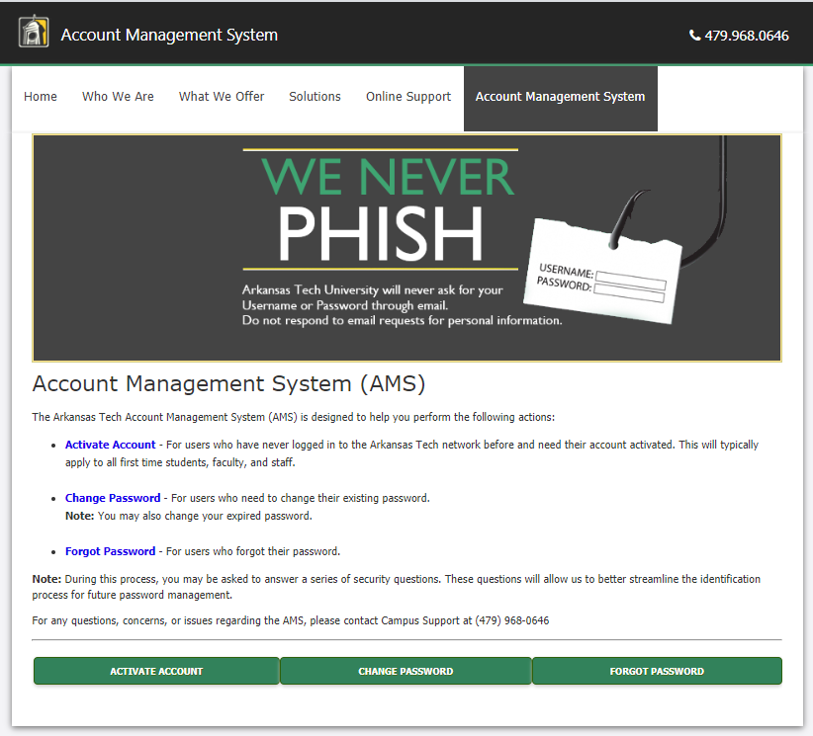
On the Account Management System screen, click on the Activate Account button at the bottom left of the screen.

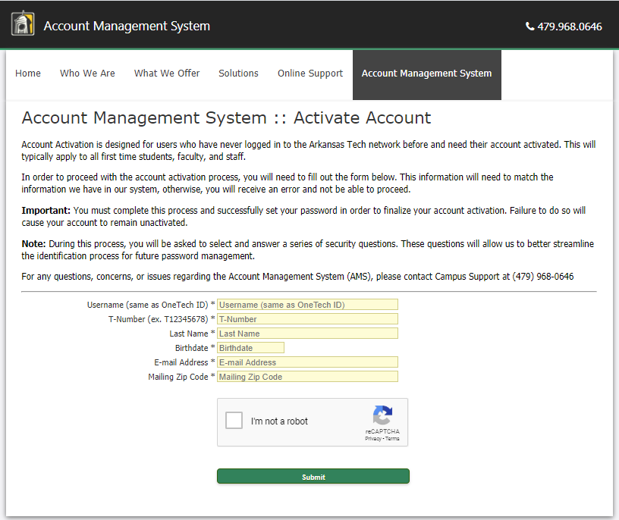

You will be asked to enter your user name, T-number, and other information. Fill in all of the fields and click the “I’m not a robot” box, then click submit.

You will be asked to create security questions that will help identify you in the future if you forget your password. NOTE: You must change your password every 90 days. You will get an email reminding you to do so.

Now, you can log into your OneTech account. Go to: http://onetech.atu.edu/. Log into your OneTech account using the password you just activated. You will be taken to the Home page of OneTech.

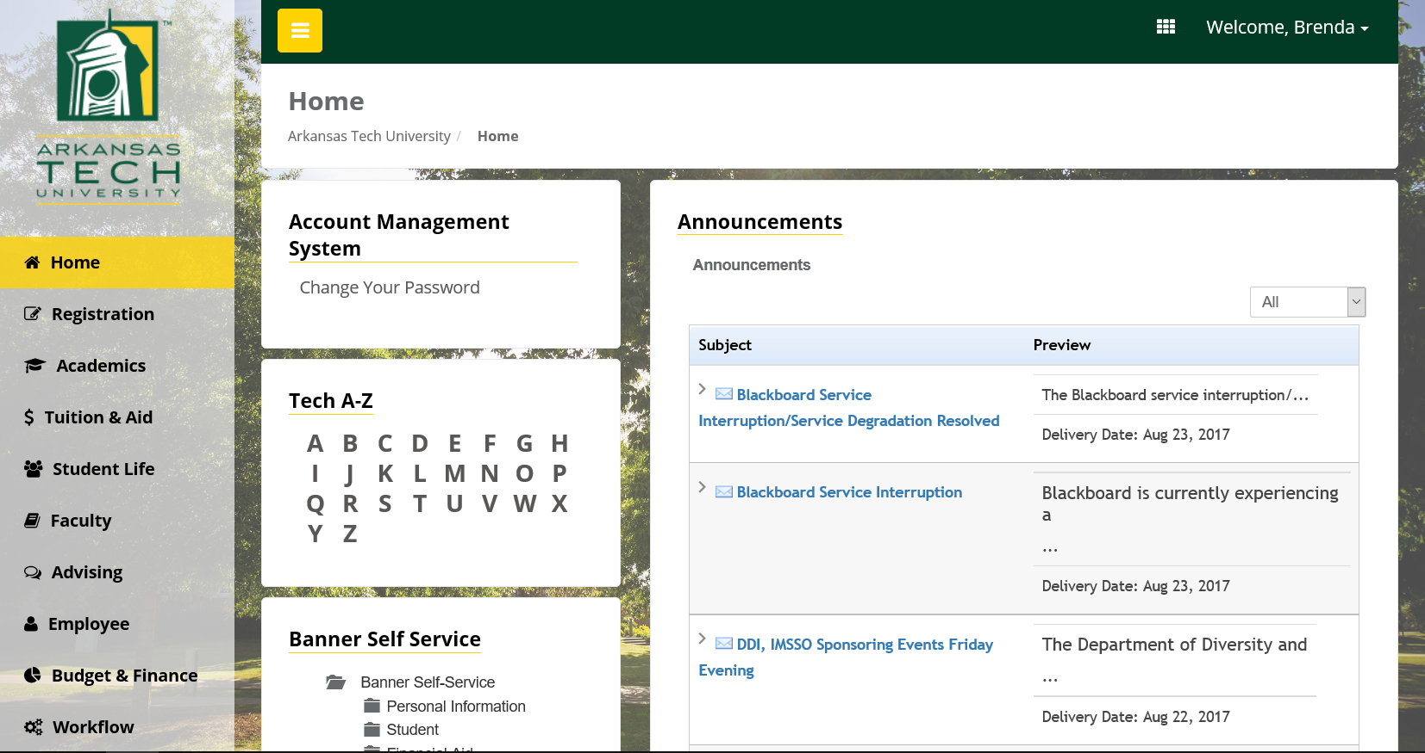

To access your email, click on the square grid menu box in the upper right corner, to the left of your Welcome. From here, just click the Email link and it will take you to your email account. (You can also go to the Library or to the Blackboard account from here.)

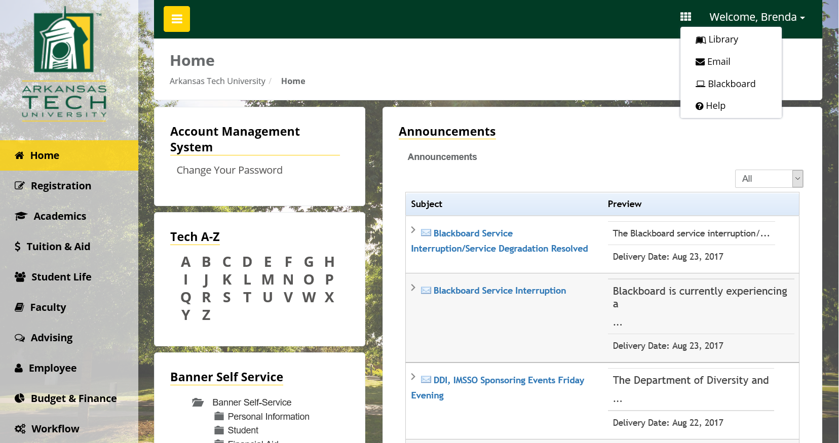

Enter your OneTech single sign on username and password and click Sign in. You can also go directly to this login screen by typing http://mail.atu.edu in your browser command line. For more information contact the Help Desk at 479-968-0646 or campussupport@atu.edu.



You can now access your email account.

You can also download a free copy of Office 365 and use it for as long as you are teaching for us. Just click the words Office 365 at the top left of the page and follow the directions.

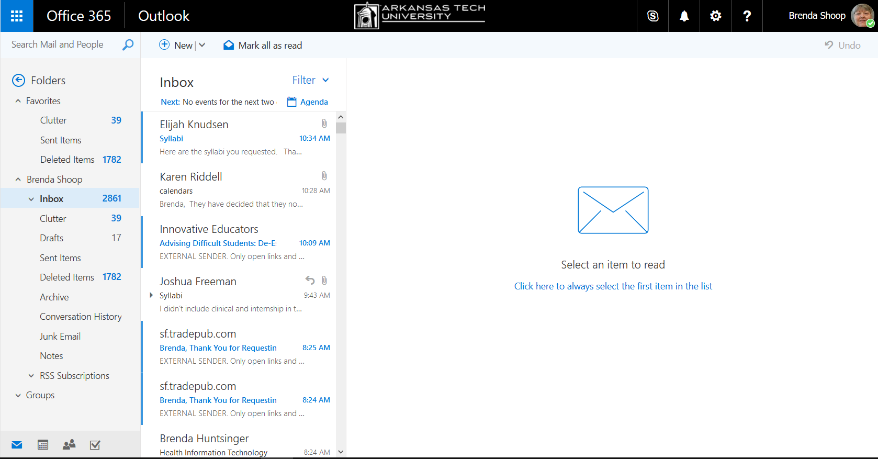

To log out of OneTech from email or any OneTech page, click your name and a dialog box will drop down. Click Sign out.

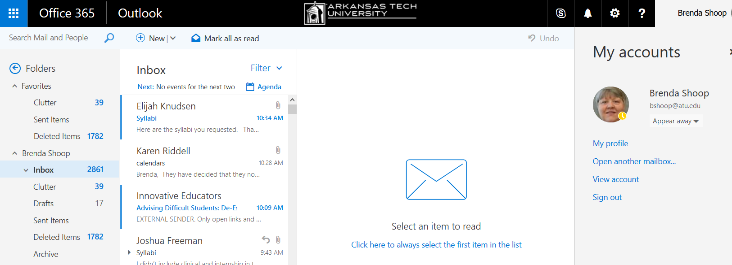

For security reasons, after you click Sign Out, wait for a browser window to come up that says you are signed out of your account.


Using OneTech for Common Faculty Functions

Attendance Accounting

Log into OneTech. Be sure you are on the Home screen. If you are not, click on the Home link in the navigation pane on the left.

Under Banner Self Service, click the Faculty and Advisors folder to bring up your options.

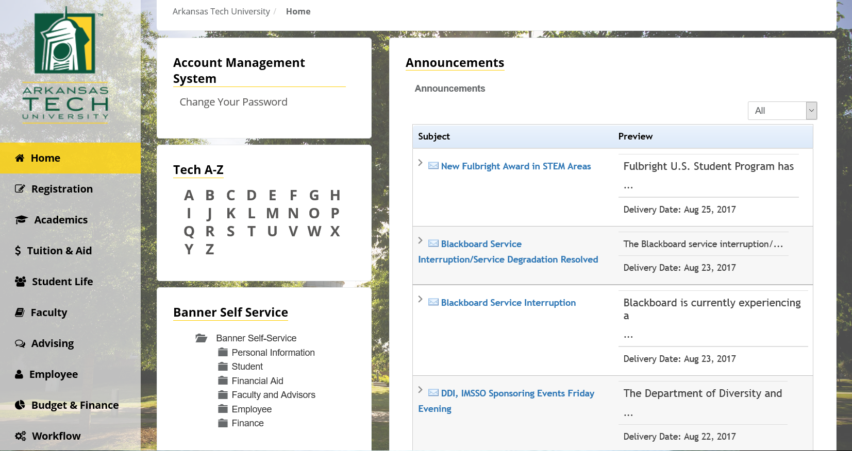

There are many things you can do from this menu. The most common ones that you will use are: Attendance Accounting, Midterm Grades, Final Grades, and maybe Academic Early Warning.

The first thing you might use is Academic Early Warning, if a student is not coming to class.

The first thing you will definitely use is Attendance Accounting. At the beginning of the semester, you will get an email telling you to begin taking attendance. On or about the 11th class day (5th day in summer), you will receive another email telling you to report attendance. Here is where you will report it.

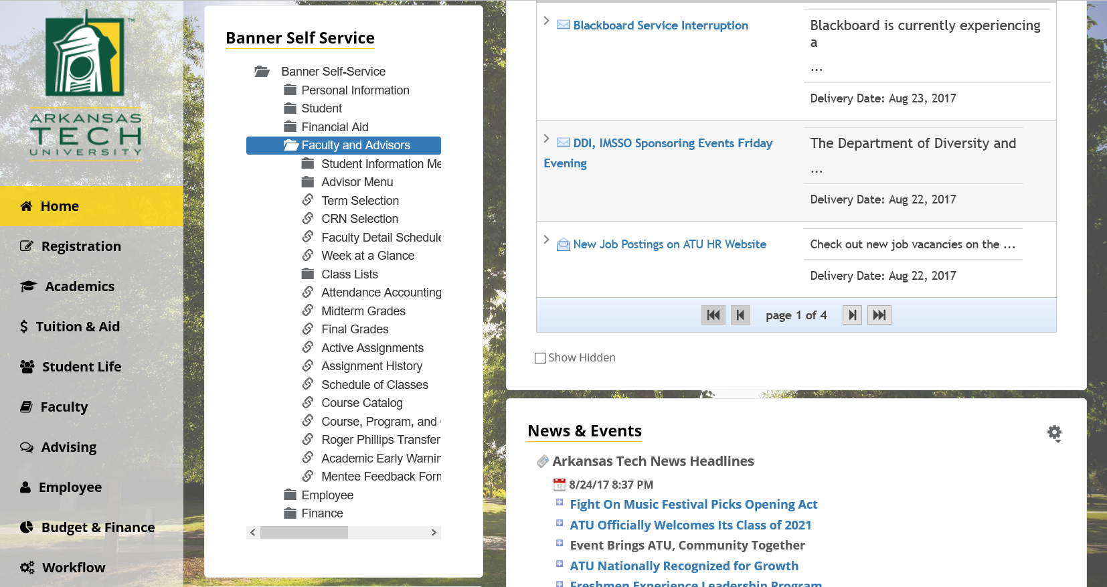
Select the term you are reporting. Then click the Submit button.

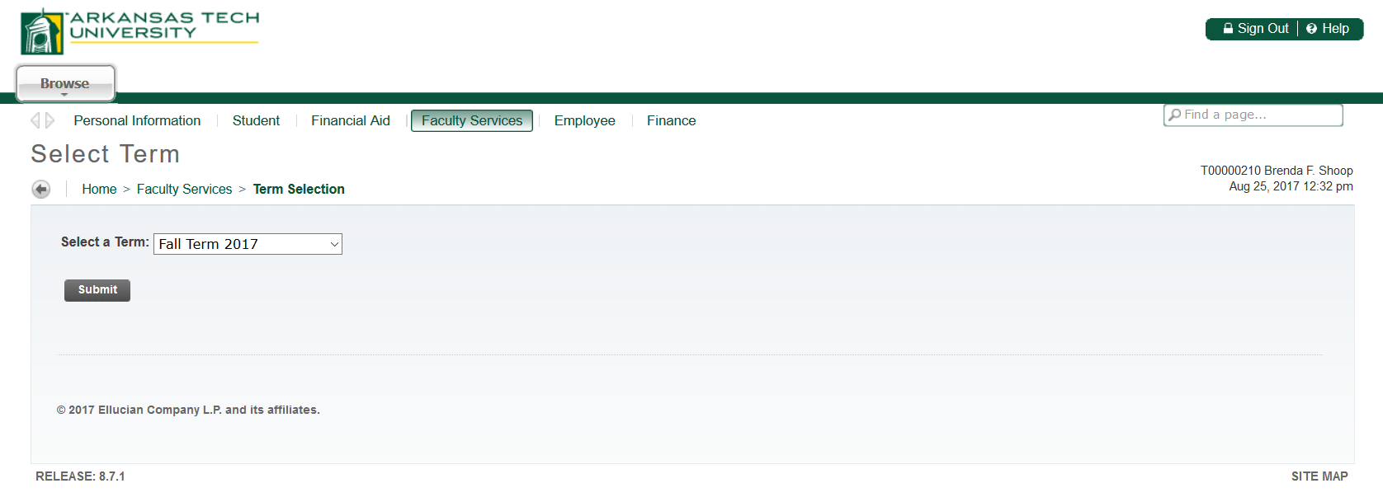

Select the course you are reporting. If you have more than one class, click the down arrow at the end of the course name and you will see the other class(es). Click on the class name. Repeat this procedure for each class.

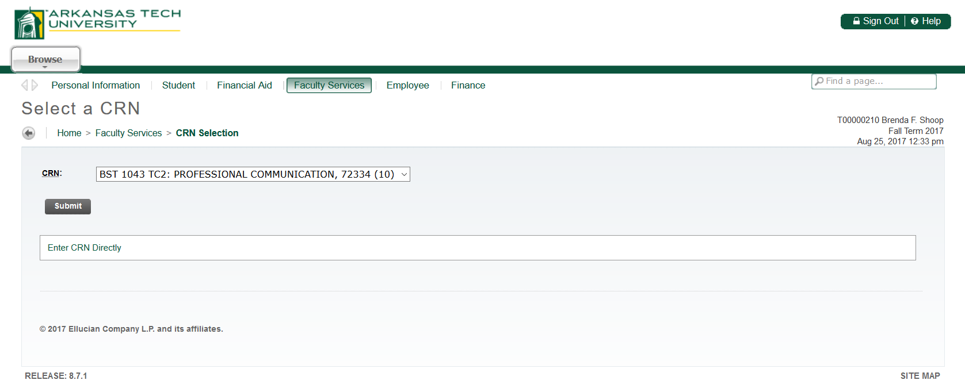

The class roster for your class will load. You may see students on this roster that are not in your class. If a student enrolled in your class then dropped it, depending on the date of the drop, they may still show up on your Attendance Accounting roster – one reason it is very important to take attendance every day. If there is a student on this roster that has never come to your class a single time and has not completed the Attendance Policy in Blackboard, you will check the box under the Did NOT Attend column. (The boxes only show up when Attendance Accounting is active.)

You will see a date under the Blackboard Attendance Policy Completed column. If a student completed the attendance requirement, you may not be able to select the Did NOT Attend box – even if they never came to class.

If all students attended at least one time, there will be a box at the bottom left of the screen where you will type in your initials indicating that you reviewed all of the names on the roster and can verify from your attendance that all have attended.

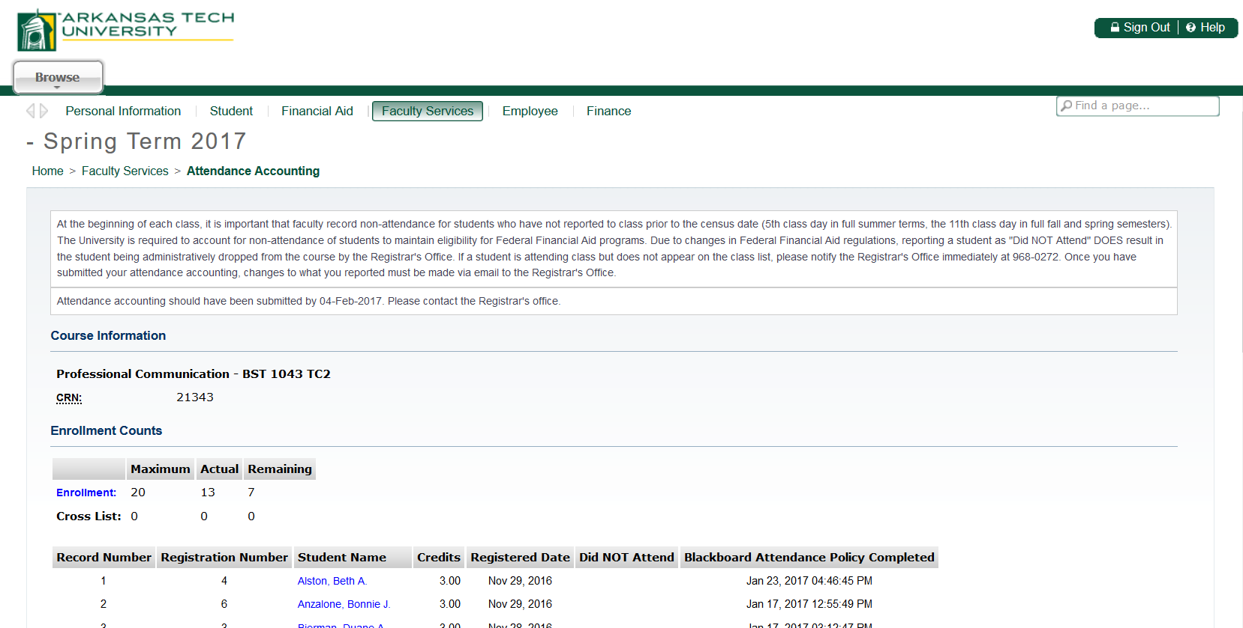
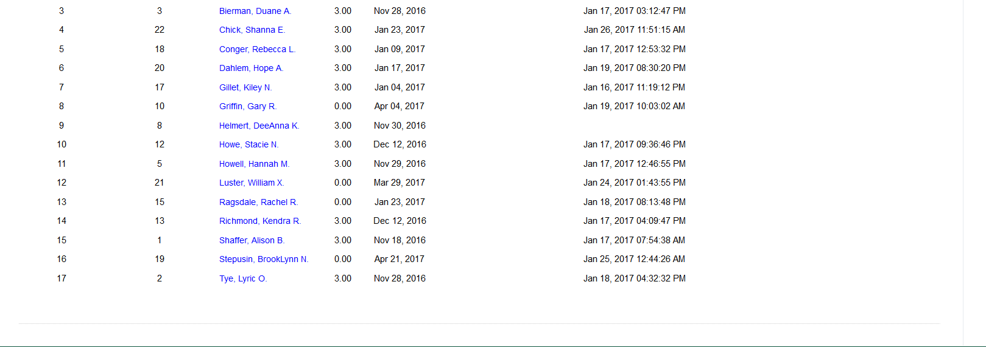

Click the Submit button. You should get a message with a checkmark telling you your changes were saved successfully. If you do not get that message, look over your roster to see if you can tell why it didn’t save. If you need help, just call Academic Affairs at (479) 667-1707 and we can help you.

When you have attendance posted for your first class, repeat the procedure for all remaining classes. To go to the next class, the easiest way is to X out of the active tab at the top of your screen, click Attendance Accounting again, and repeat the procedure for each class.

You should also know the other way to go to the next class. When you have finished posting attendance for the first class and have gotten your successful save message, click the Faculty
Services tab at the top of the page.

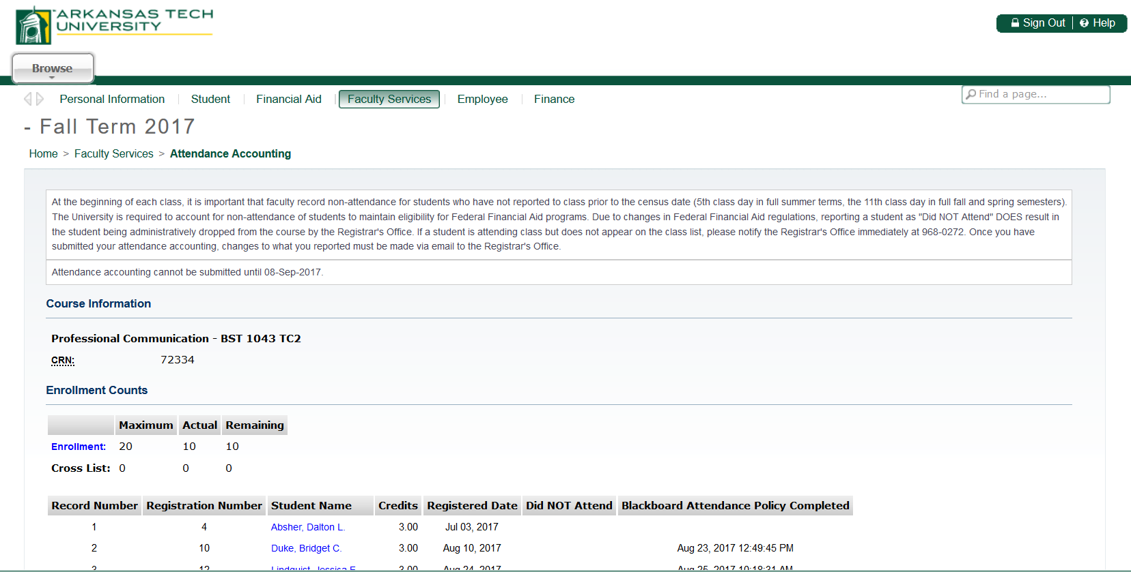

Click the box labelled Attendance Accounting.

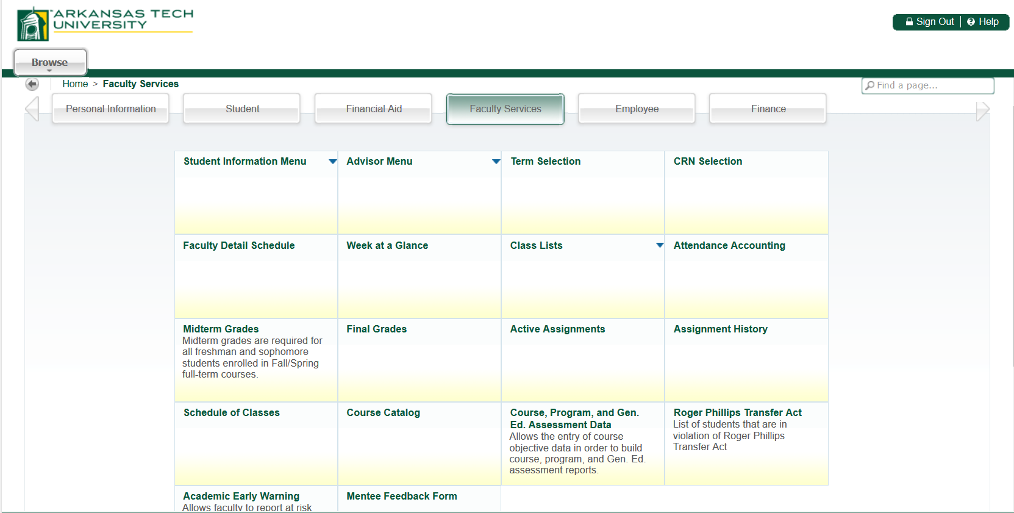

You will automatically be taken to your next class. Repeat the process for each class.

Mid-Term Grading

Mid-term grades will be recorded in October. To submit Mid-Term Grades, follow the same path as Attendance Accounting but select the Midterm Grades folder.

Select the term for which you are reporting grades.

Select the course for which you are reporting grades.

The class roster for your class will load. You will see only the students who are classified as Freshman and Sophomores. If a student has earned 60 or more earned hours, you will not report a mid-term grade for that student.

To record grades, click the down arrow at the end of the box in the Grade column. (It contains the word None.) When you click the down arrow, the grade choices will appear. Click on the appropriate grade for that student. Be careful that the grade stays when you go to the next student. We have to be very careful with grades when going from one student to the next, especially if you have a sensitive mouse.

Do not enter anything in the Last Attend Date or Attended Hours fields for mid-term grading.

After you have entered all mid-term grades, click the Submit button. You should get a message with a checkmark telling you your changes saved successfully. If you do not get that message, look over your roster and if you need help, just call Academic Affairs at (479) 667-1707 and we can help you. It will not submit the grades if you left something blank.

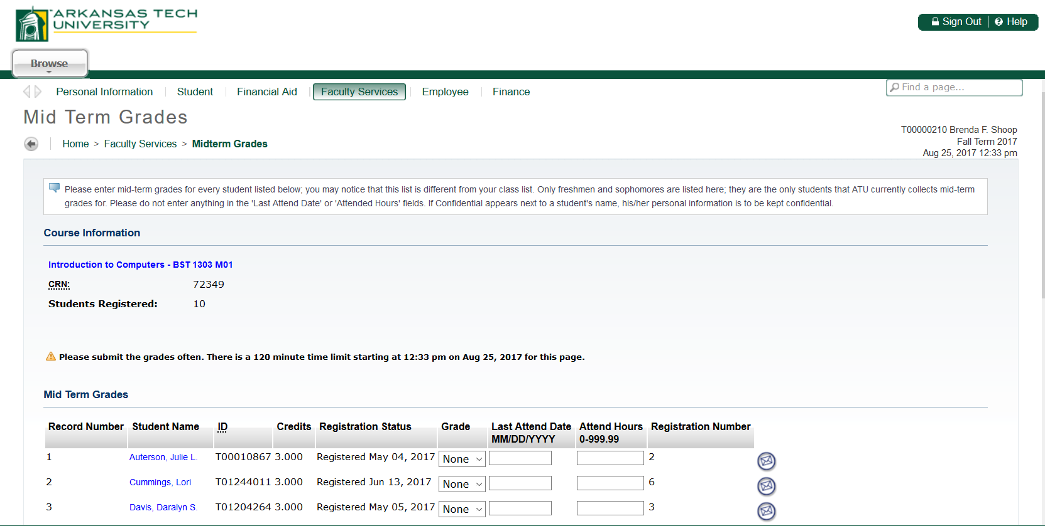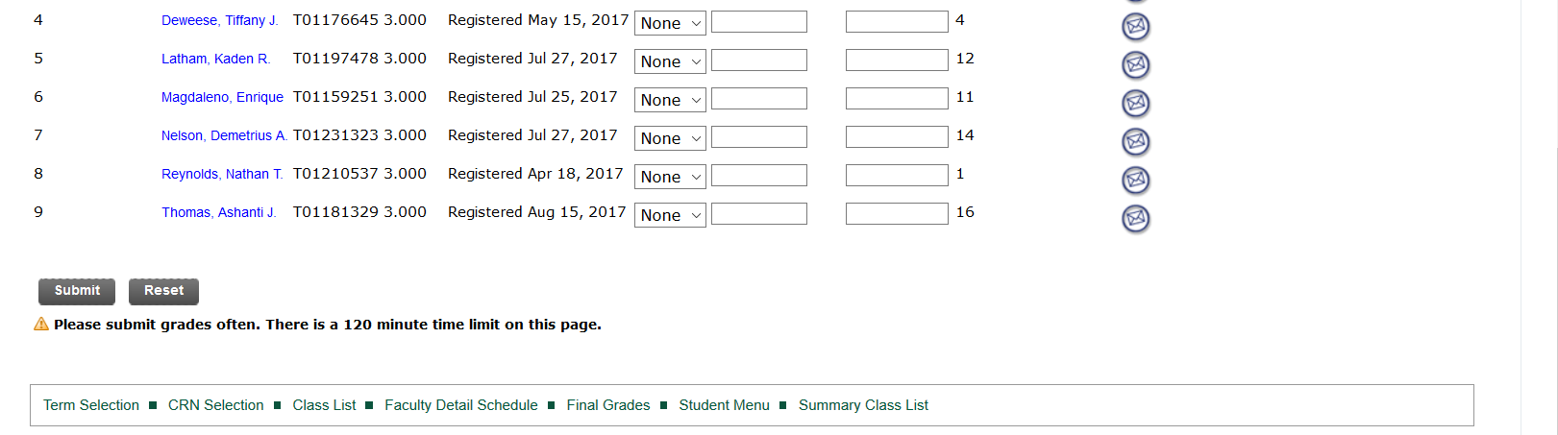
Do not enter anything in the Last Attend Date or Attended Hours for Mid-Term grading.

If you have more than one class, when you have all grades posted for your first class, repeat the procedure for all remaining classes. To go to the next class, the easiest way is to X out of the active tab at the top of your screen, click Mid-Term Grades again, and repeat the procedure for each class.

You should also know the other way to go to the next class. When you have finished posting mid-term grades for the first class and have gotten your successful save message, click the CRN Selection link at the bottom of the page.

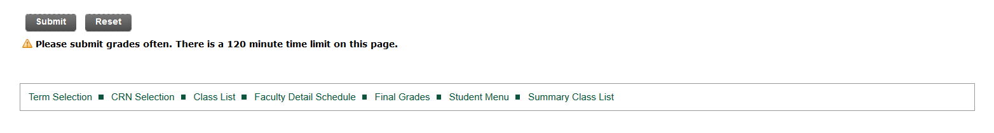

Click the down arrow after the class name and select the next course for which you are reporting grades. Repeat the process for each class for which you are recording mid-term grades.

After you have assigned grades to all of your classes, email Shirley at sbonner3@atu.edu and let her know that you have finished posting grades. She will run a report to see if there are any errors.

Final Grading

Select the term for which you are reporting grades.

Select the course for which you are reporting grades.
The class roster for your class will load. To record the grade, click the down arrow at the end of the box in the Grade column. It contains the word None. When you click the down arrow, the grade choices will appear. Click on the appropriate grade for that student. Be careful that the grade stays when you go to the next student. We have to be very careful with grades when going from one student to the next, especially if you have a sensitive mouse.

If you assign the grade of “F”, you must enter the Last Attend Date (the last date student attended your class). Adding a date lets us know if the student quit coming or if they came to class the whole time and did not do well. Do not enter a date for any grade other than an “F”.

If a student NEVER attended your class a single time, post the grade of F and immediately send an email to ebrickley@atu.edu to report the student as non-attending, and indicate the reason federal attendance accounting wasn’t accurately reported when initially submitted.

When all grades are entered, click the Submit button. You should get a message with a checkmark telling you your changes saved successfully. If you do not get that message, look over your roster and if you need help, just call Academic Affairs at (479) 667-1707 and we can help you. It will not submit the grades if you left something blank.

Large classes may have more than one page. Submit grades for page 1, then click on the second Record Set to enter grades for Page 2. You must click Submit for each page separately.

If you have more than one class, click the down arrow at the end of the course name and you will see the other class(es). Click on the class name.

When you have all grades posted for your first class, repeat the procedure for all remaining classes. To go to the next class, the easiest way is to X out of the active tab at the top of your screen, click Final Grades again, and repeat the procedure for each class.

You should also know the other way to go to the next class. When you have finished posting mid-term grades for the first class and have gotten your successful save message, click the CRN Selection link at the bottom of the page.

Click the down arrow after the class name and select the next course for which you are reporting grades. Repeat the process for each class for which you are recording mid-term grades.

After you have assigned grades to all of your classes, email Shirley at sbonner3@atu.edu and let her know that you have finished posting grades. She will run a report to see if there are any errors.

Other

There are others links you might find useful and interesting. Click around and see where the links take you. Some you will not use, but you will get an idea of how versatile OneTech has become.

Teaching Web Courses with BLACKBOARD LEARN TM

Arkansas Tech University has adopted Blackboard as the course management system platform for the delivery of distance education and for web-enhanced face-to-face instruction on campus. The system is supported by a Blackboard administrator and a staff of highly trained network specialists who maintain the software and hardware necessary for success. The Blackboard system has built-in help functions and the Blackboard administrator is available through email and by telephone. Blackboard can be accessed at https://bblearn.atu.edu.

Faculty are provided with technology training as needed or requested to allow them to effectively use the technology to support course objectives. eTech includes information such as developer resources, technology resources, and teaching resources as well as other information.

Blackboard Help Desk
RPL 150
Phone: 479-968-0646
Toll Free: 866-400-8022
E-mail: campussupport@atu.edu

Log into Blackboard using your OneTech single sign on user ID and password.



Click on the drop-down arrow after Current Courses to select the appropriate term, then locate the class you want to work in and click that link.

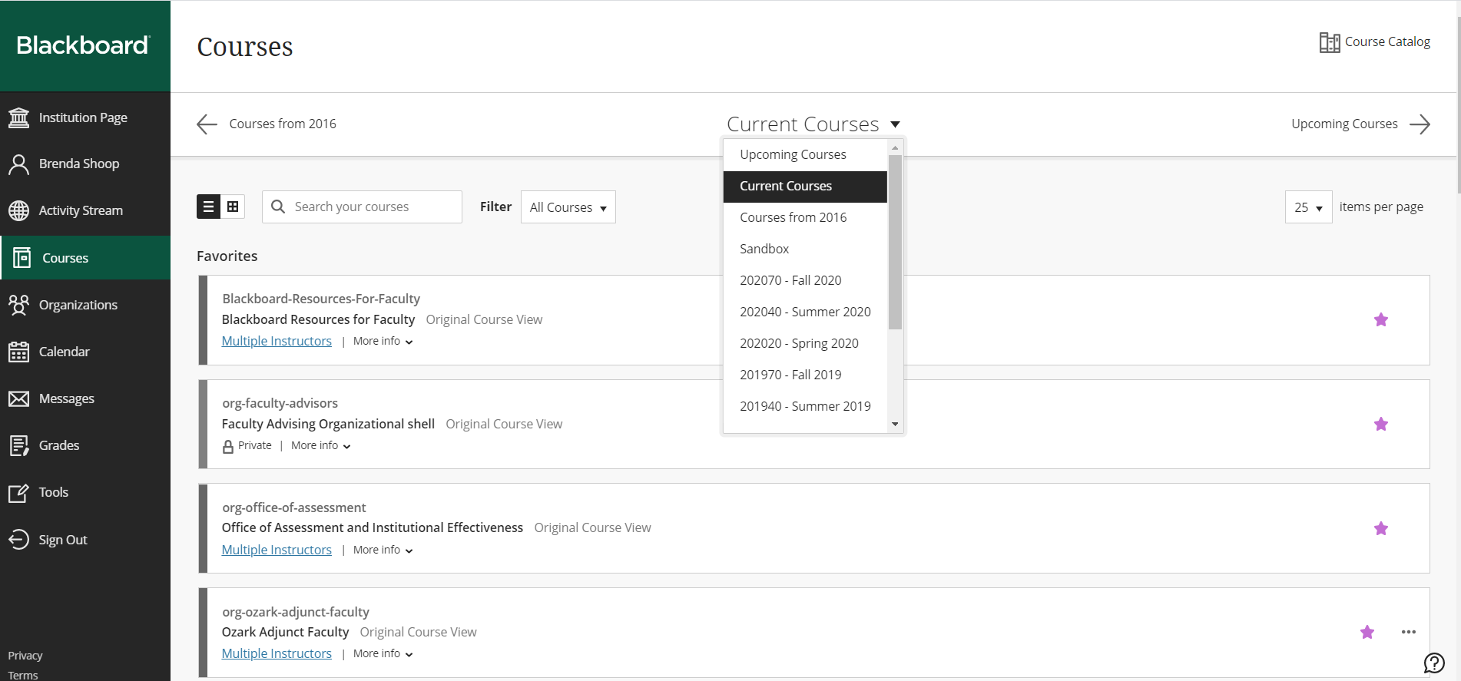

Your Blackboard course shell initially opens up to the Federal Attendance Module for all students to complete the Policy Agreements. After all students have completed, or the deadline has passed for Attendance Accounting, you can change where the course will open.

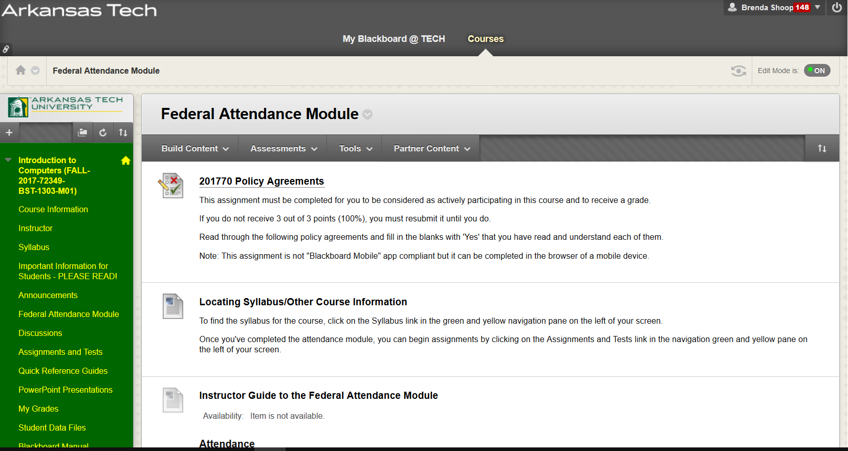

The course is open, so you can now click on any of the items in the navigation pane on the left, or scroll down to use any tool (like Grade Center) in the Control Panel.



To exit your Blackboard course shell, click on the green box with an X in it in the upper left corner.

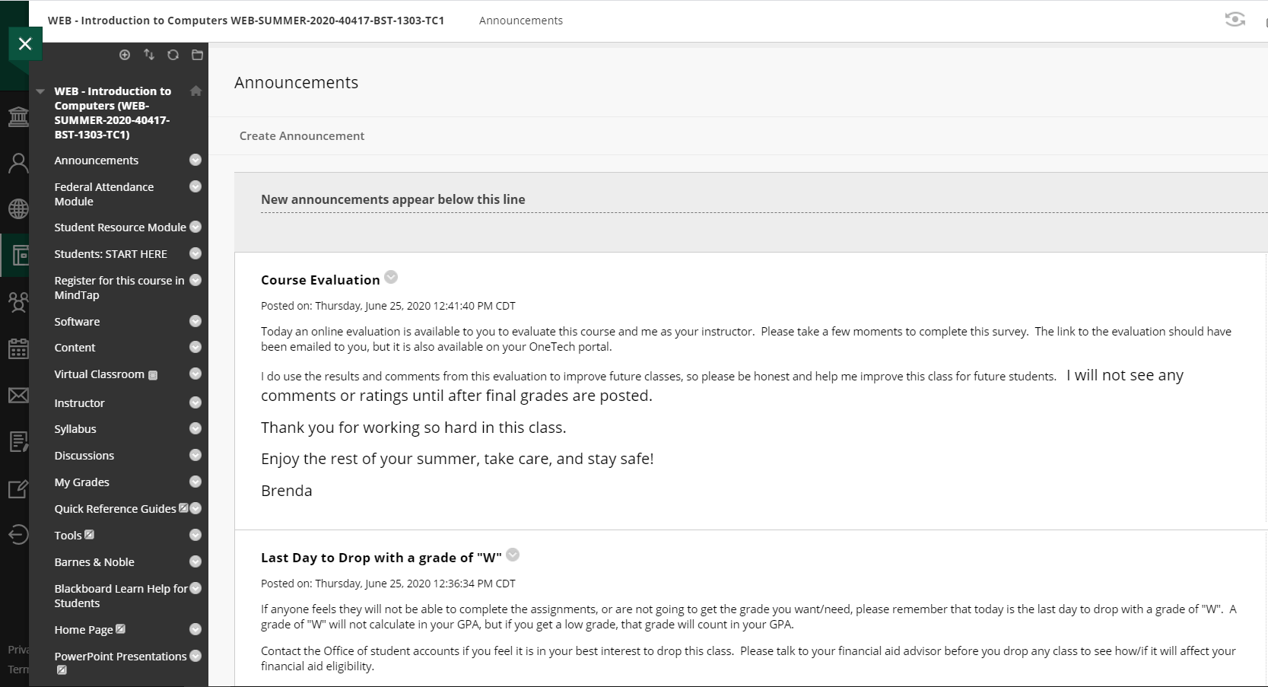

To log out of Blackboard, when all courses are closed, click on the Sign Out link on the bottom left of the screen.

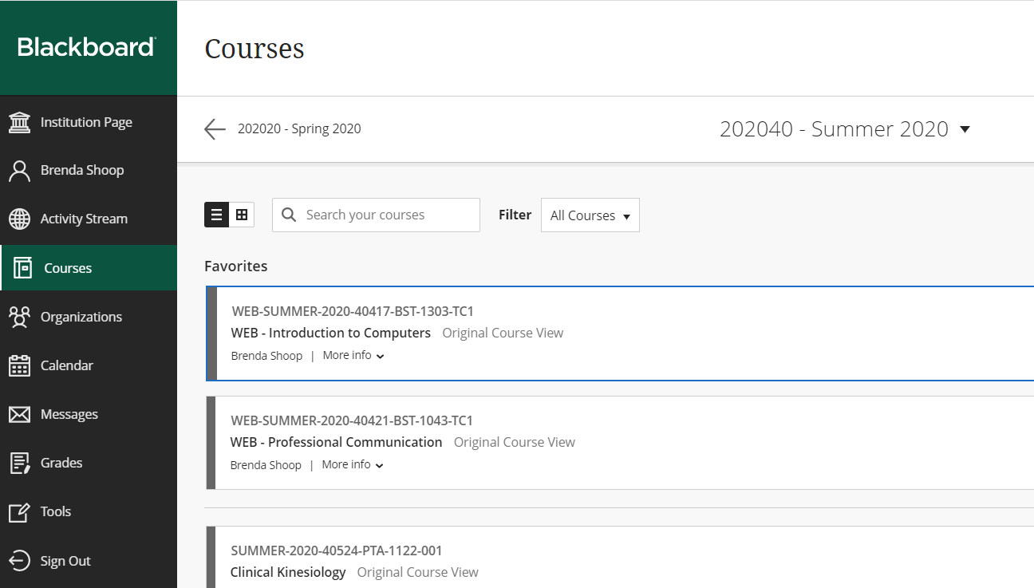

After you click the Sign Out link, a dialog box will open. If you are finished, for security, click the End Session and log out link.



To end the session, click the End Session button. You will be taken back to the login screen and can just close the browser.

