**IMPORTANT R­EQUIREMENT: Immunization Compliance for Incoming Students**

All undergraduate students (incoming freshmen or transfer students) are required to have 2 MMR vaccinations and all graduate students are required to have 1 MMR vaccination.  See <https://www.atu.edu/hwc/healthservices/immunization.php> for exceptions and more information.

***If all of your immunizations are located in WebIZ, the Arkansas State Immunization Registry, they will be automatically loaded to our immunization compliance system and no further action is required.*** However, it is recommended that you check the status of your immunization compliance by following the steps below. If you have any difficulty or would prefer, ***you may also email your immunization record to*** [***hwc@atu.edu***](mailto:hwc@atu.edu)***.*** Please call the ATU Health and Wellness Center if you have questions at 479-968-0329.

If you are an ***out-of-state student*** or received MMR vaccinations out of state, you will most likely need to upload your vaccination information manually. If you are an international student, you will complete the immunization compliance process through the Department of International Students and Scholars. You may contact them at +1(479) 964-0832 or [internationaled@atu.edu](mailto:internationaled@atu.edu).

***Upload or check the status of your immunization compliance.***

Please visit the ATU Health and Wellness Center Patient Portal by visiting <https://atu.medicatconnect.com>.

***Step 1: Log into the ATU Health and Wellness Center (HWC) patient portal (atu.medicatconnect.com).***

Log into the patient portal with your OneTech ID (do not include @atu.edu) and password. Your **admissions acceptance packet** will have your OneTech username included. For help with activating your OneTech ID and password, please visit: <https://webapps.atu.edu/ams/> or call 479-968-0646.

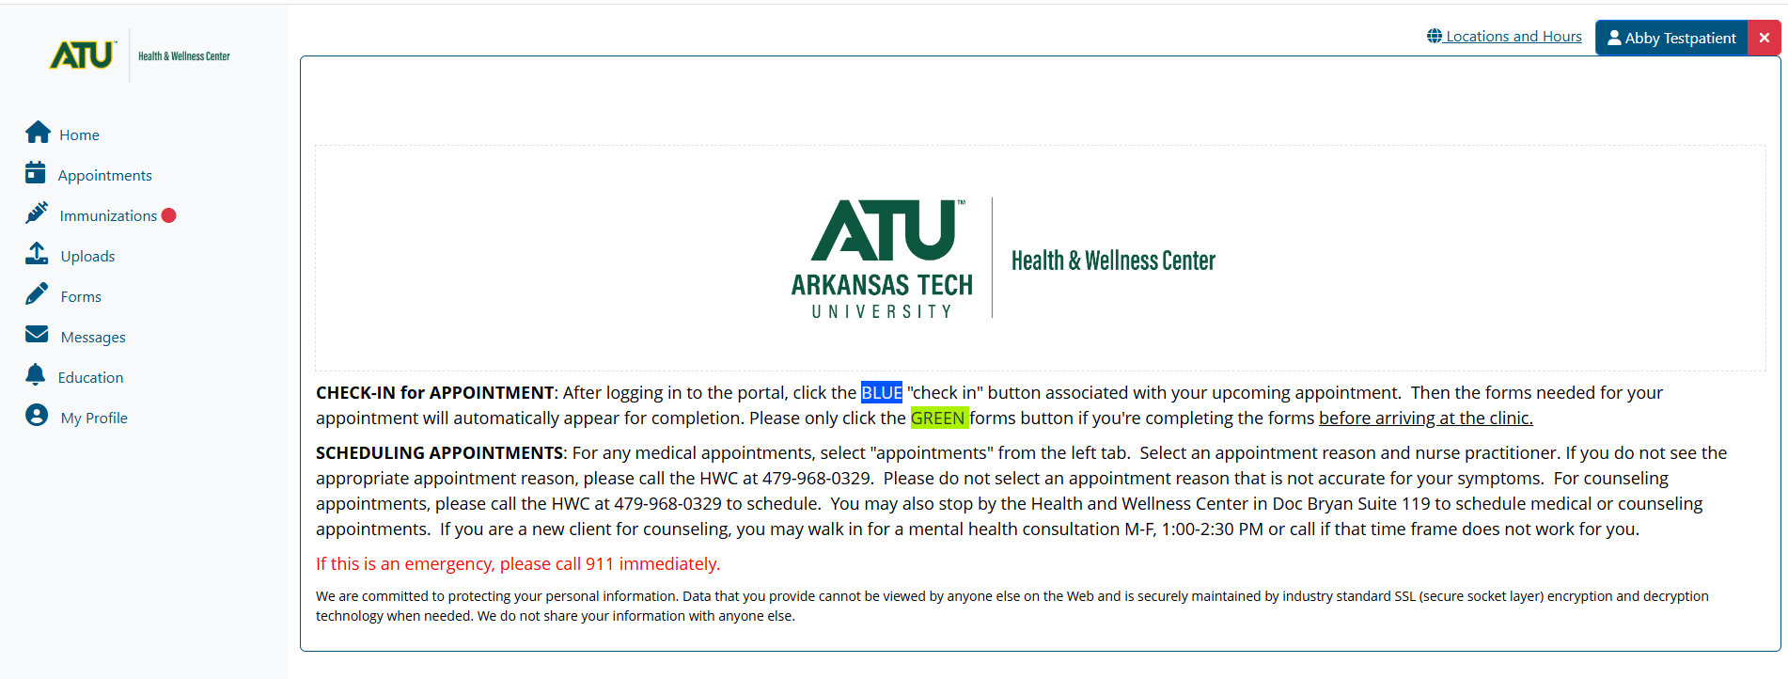

***Step 2: Check for compliance. If not compliant, add MMR dates of administration from your immunization record.***

Please click on the "Immunizations" tab on the left panel.  If there is a red dot • next to “Immunizations”, we are missing immunization information. At the top of the screen, you will see “compliant” or “noncompliant”.   If you see “verified”, please wait 3-5 business days and check back to see if you are compliant or call the ATU HWC for more information at 479-968-0329.   
  
Please see instructions below for adding your MMR vaccination dates to the patient portal:

Click left tab "Immunizations" and select “MMR Vaccine” in the blue heading. Choose the only option in the drop down, “Vaccine for Measles, Mumps, And Rubella (German Measles) Injection.” Add the date of the first dose of MMR and click submit at the bottom right.

***Repeat the process for the second dose of MMR if you are an undergraduate student (incoming freshman). You can only enter one date of MMR vaccination at a time.***

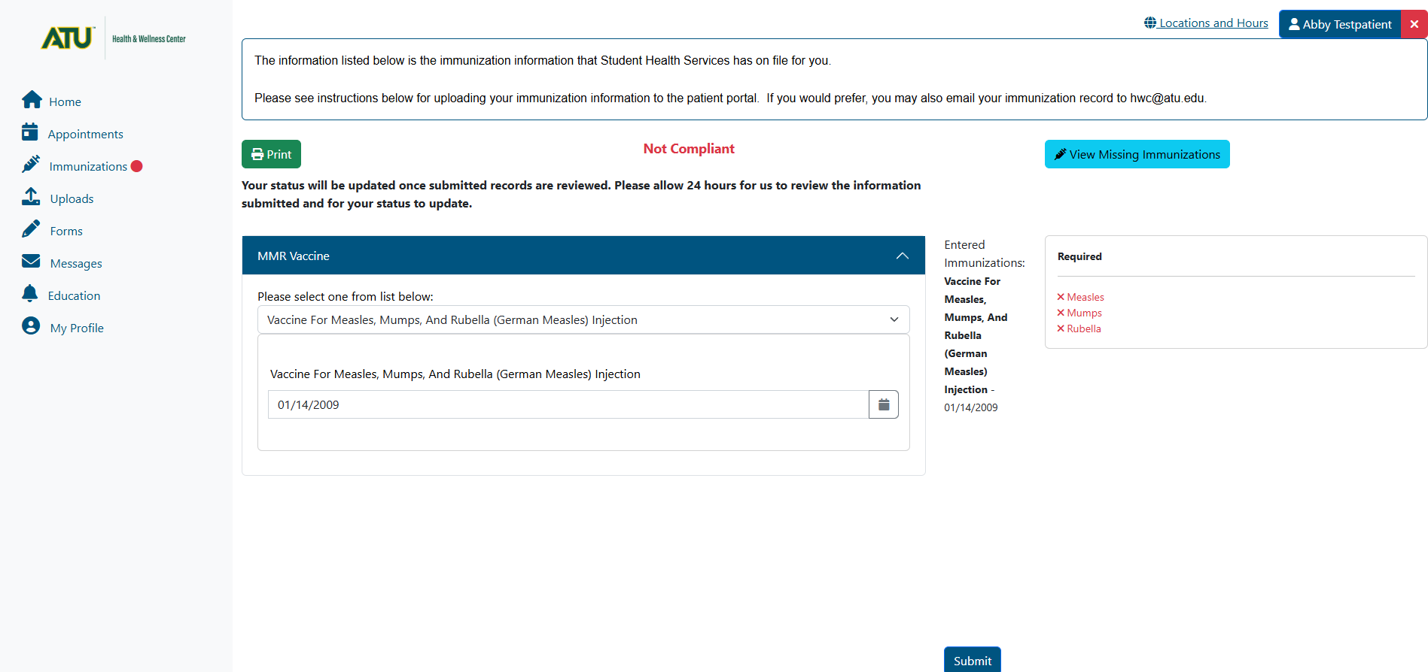

***Step 3: You will be prompted to upload your immunization record.***  If you are not prompted, click on the “Uploads” tab on the left. You **must** upload the immunization record for the ATU HWC to verify your record and change your immunization status to compliant.

Please click “select file” and upload a picture of your record (.gif, .png, .tiff, .jpg, .jpeg) or the actual record file (.txt or .pdf.) from your computer. Files must be smaller than 4 MB in size. Please scan in black and white or at a setting of 150 DPI to create a smaller file.  Then click “submit.”

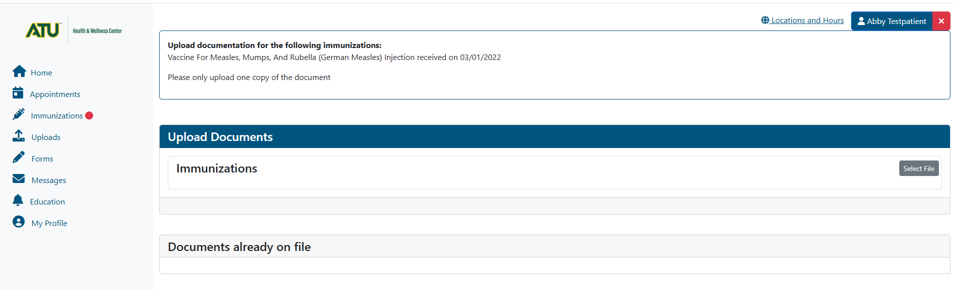

Within 3-5 business days, the ATU Health and Wellness Center will verify your record and mark you compliant. We will reach out to you via your ATU email if there is missing information.

Thank you for your help in keeping our campus healthy.