Guide for submitting work to the Online Research Commons @ ATU for the
1st Annual ATU Research Day Symposium

- Go to this webpage: https://orc.library.atu.edu/
- Click on “My Account” in the top menu.
- Create an account by clicking the “Sign up” button.
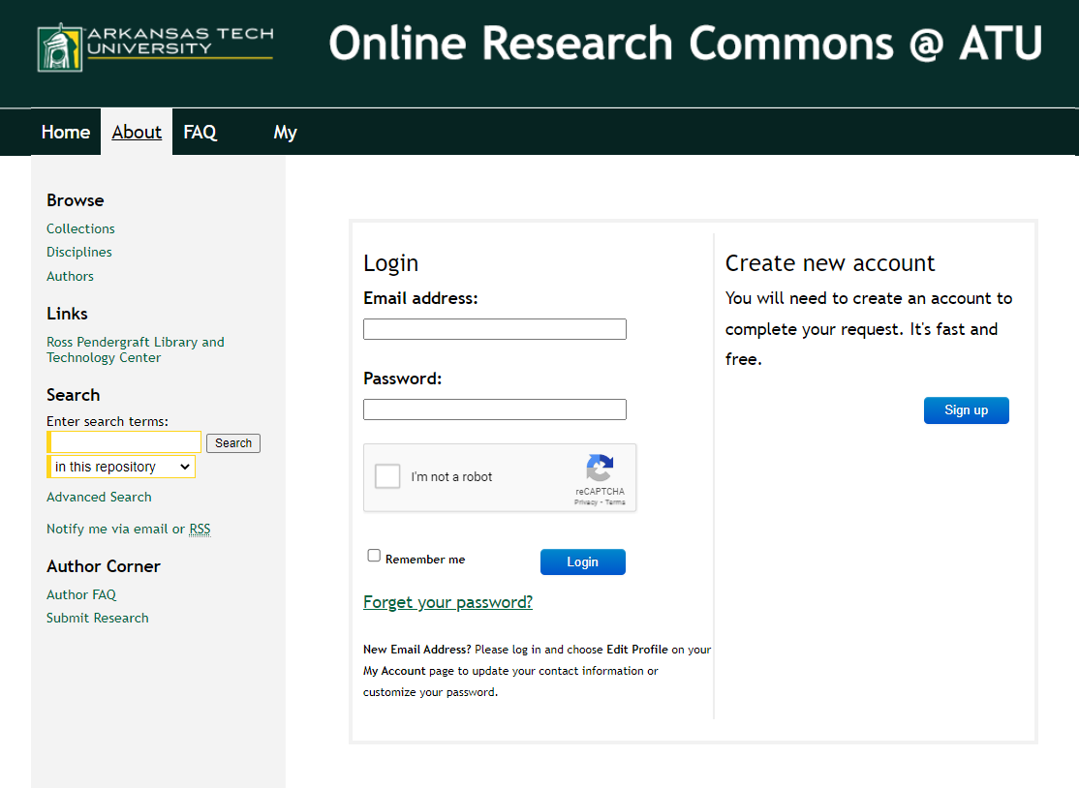
  - Use your ATU email.
  - Create a unique password (Not your ATU account password).

- You will receive a verification link through your email. Click on that link and then log in to your account.

- Go to this webpage: https://orc.library.atu.edu/atu_rs/2023/

- Click on the “Submit Research” button on the left side menu (under “Author Corner”).
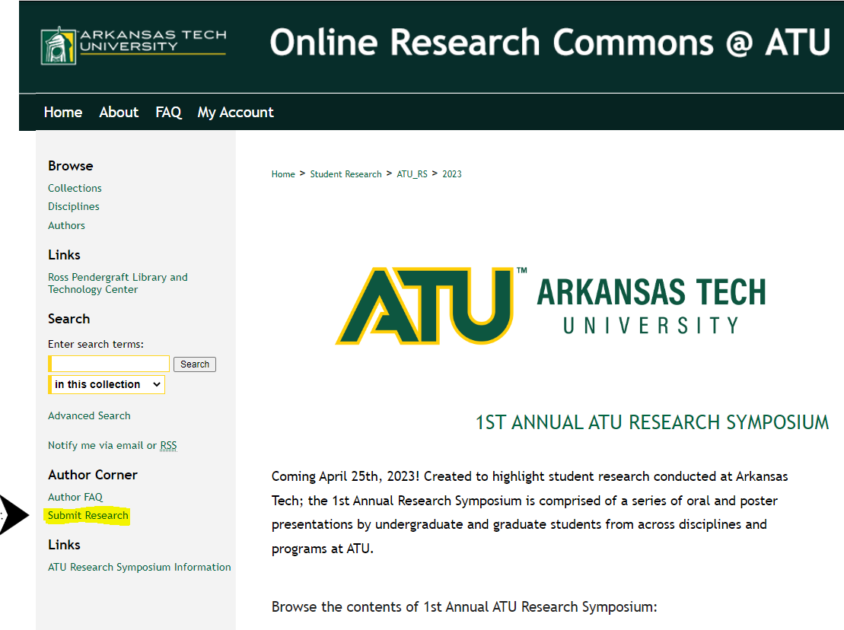
- A Submission Agreement will pop up on your screen. Read the entire agreement, check the box below to acknowledge that you understand and agree to the terms, and click on the “Continue” button.

- Enter the title of your submission. Please use Headline Capitalization, meaning you capitalize the first letter of most words, except for (if, and, to, for, a, the) if they are not the first word of the title.

- Under Presenter Information, enter your ATU email address, first and last name, and “Arkansas Tech University” as the institution. Your middle name or initial is optional.
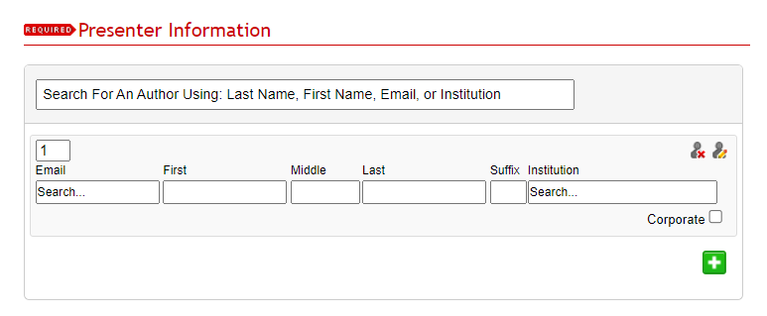
  - If you have co-authors or presenters, click the green “+” button and add their information.

- Enter your T Number.
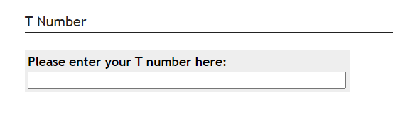
- Enter the type of project you are submitting from the dropdown menu. Your choices are Graduate, Honors, or Undergraduate.
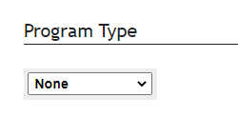
- Enter the name of your Faculty Advisor.
- Enter the Document Type from the dropdown menu.

- Choose either Online or Face-to-Face for your event location.

- Choose which Discipline(s) your presentation falls under by expanding the options by clicking on the “+” button next to your field. Double-click on your chosen discipline to select it. It will appear in the “Selected” field. If you do not see a sub-discipline that fits, select your general discipline.
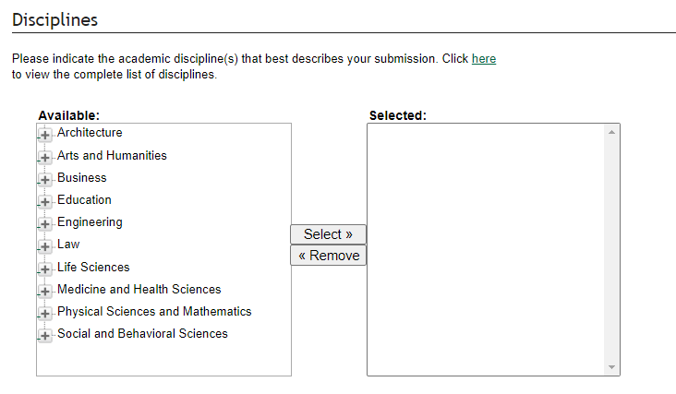

- Under Abstract, copy and paste your presentation abstract into the form.
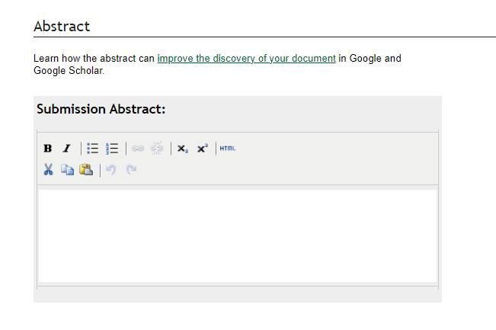
- Leave the Comments fields blank.

- Under Full Text of Presentation, Check “Upload file from your computer.”

- Check the box if you have an additional file to add. You will be prompted to upload the files after you submit the form.

- Click the “Submit” button. Success! It may take a few minutes to submit, so only click the button once.

