Faculty Senate Minutes for April 9, 2019

Meeting was called to order at 3:00pm. Absent: Glen Bishop and Scott Jordan

A vote was called to approve the minutes from the previous meeting. There were three corrections mentioned. 1.) In the minutes it is mentioned that Jeremy Schwehm was the creator of the leadership minor. Dr. Schwehm stated he was not the author of the leadership minor but did have significant input in the development of the “Leadership Tech” curriculum as it is currently being implemented at the university. 2.) Dr. Schwehm also mentioned that he was not on the faculty Grievance committee as stated in the prior month’s minutes. 3. Dr. Josh Lockyer stated he was incorrectly marked present for the previous month’s faculty senate meeting. Senate voted to approve the March minutes with these changes.

Several orders of New business could not be pursued due to the absence of the invited guests

(either sickness/allergies/ family issues) to provide information about the following topics: II. New Business Not Discussed

A. Curricular process (participant/respondent absent)

B. Promotion Increments (participant/respondent absent) C. Degree audits (participant/respondent absent)

D. Policy Website (participant/respondent absent)

E. Medical marijuana (participant/respondent absent) F. Hang Tags (participant/respondent absent)

G. Ensuring course quality (Moved to May 1st meeting)

H. Student Scholarships (tabled until further information is available)

Under Old Business Several items were also not discussed for the reasons given above: A. Free Speech Policy (participant/respondent absent)

B. Book on Policies (participant/respondent absent) C. TIAA/CREF (participant/respondent absent)

E. Class length (Tabled to be discussed at next Meeting)

Under Old business, Susan Underwood gave an HLC Update. Bi‐Weekly meetings are being held and it is expected that a preliminary draft will be complete by May 1st.

A motion was made to reopen “New Business” by Jack Tucci since it was missed at the March meeting. It was reopened and the subject brought up by Dr. Tucci was about VPAA classification. It was approved to re‐open the New business session and discuss. There was

much discussion about how that administrative departments on campus were making academic decisions about programs and implementation. Curriculum issues and other Academic

programs such as course quality and program development were being impeded by non‐ academic departments making policy or blocking decisions on issues other than academic needs. The consensus of the discussion is that “it is felt by many on the senate that academics has taken a secondary role at this institution. In addition, It is felt that the role of VPAA is currently seen as an equal with the other VP’s in the common day functions of Arkansas tech.” The Faculty senate agreed this one topic may be what is hindering the advancement of the progressive educational agenda of the faculty to move this University forward. The senate was unanimous in having the role of the VPAA elevated to a role of Senior Vice president Academic Affairs and Provost of the University.

Jon Clements noted that the title “Provost” was written in the early drafts of the strategic plan but was unaware if it had been deleted. Jon and others also noted that it was in the budget as VPAA and Provost. Pam Carr said that three presidents past, that the VPAA was Senior VPAA and Provost. It was the consensus of the faculty that a statement should be drafted and brought o the senate stating such and be voted on and presented to the president and asked to be sent to the board for their approval. The statement should include such language that the VPAA has final say about academic direction and issues for the university and that all other VP’s serving the institution should be aware they are there to serve to help accomplish successfully the academic mission of this institution. Senator Tucci was asked to draft a statement with input from senators and the statement to be brought for a vote during the May first meeting. The statement was that it should be “as it once was” should be included in this recommendation. Jon Clements made the motion, Jeremy Schwehm seconded the motion.

Open Forum:

David Eschelman brought forward a draft document about departmental program curriculum committees and the regular programmed review of curriculum. A lengthy discussion was held about immediate constraints and program review. The faculty senate believes that curriculum belongs solely in the hands of faculty. The proposed plan (see attached) was discussed at length and amendments were made. The primary change was to allow those who have mandatory program (accreditation or certification process in place already or in the future) be exempt from this requirement. Jack Tucci made a motion to approve with changes, Jon Clements seconded and that it be taken to faculty for review so that faculty input could be garnered and input into the document. Approval was unanimous. (since this meeting, there have been several e‐mail conversations amending/improving the document to be brought to the senate for the May 1st for vote for acceptance.

It came up in this earlier discussion there was some concern about the lack of information and release of the “Best College’s to Work for Survey.” It was suggested that the senate in the past had surveyed faculty and it was about time to review this survey and resubmit it to faculty. This will be brought up for vote at the next senate meeting.

Sean Huss was recognized during the open forum as a visitor to the senate. As former chair of the senate and one of the primary contributing authors of the University’s New promotion and tenure document, he was invited to speak. Sean Huss provided a copy of an e‐mail (see attached) documenting issues that arose during this academic year when the new P&T process was implemented. There was much discussion about specific issues in specific departments. As per Dr. Huss, the primary purpose of the new P&T was to place a balanced approach to the decision making of P&T into the department where the faculty most familiar with that discipline could make the most objective decision of the worthiness of an applicant’s claim towards

tenure and/or promotion. The recent issue has arisen Is that the new policy has not been followed equally by all departments and colleges across campus.

It was noted that part of the problem stems from the fact there has been enormous turnover in department chairs and the scale of work by faculty and administration. It was proposed that some of this could be addressed through our Professional Development days and have training sessions so that both faculty, depart/program chairs/deans would be on the same page as to the importance of the DPTC and its role in the P&T process. A second problem has also emerged is that there are a few (very few) places where the P&T document either may be slightly confusing and/or conflicting in its language. Jack Tucci noted that the authors should be proud that there were so few problems for an undertaking of this magnitude; especially given this was the first year of implementation of a new model of P&T processes.

It was proposed that a new faculty senate committee be formed to address these issues. Pam Carr, Jeremy Schwehm, Carey Ellis and Sean Huss volunteered to work on this issue.

Meeting concluded at 4:55pm

Respectfully submitted,

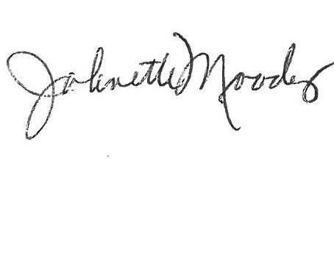

Johnette Moody, D.B.A., President

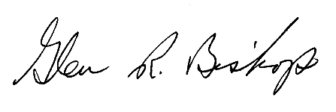

Glen R. Bishop, Ph.D., Secretary

Dr. Sean Huss Email:

Senators,

What follows is a very short list of a few issues I’ve heard about that should be addressed in any handbook rewrite of the DPTC sections. I think the Senate needs to collect more information on issues related to the new system and then offer recommendations on handbook changes to fix them. Remember, this is a new system, so there will be hiccups and contradictions until we work them out. My list below is just a few that I’ve heard about…

Issues:

1. Some sections of the handbook were removed after the Senate copy went to Dr.

Abdelrahman. We need to discuss as a faculty if we would like to have those sections replaced in the current handbook version.

2. There has been some confusion over the interpretation of how to create DPTC criteria for teaching, scholarship, and service, as well as how the DPTC (or its subcommittee) should operate. We need to create a document that walks all departments through the process as intended, as well as update all appendices in the handbook to reflect the process as intended.

a. In some instances, departments are skewing the criteria based on what they consider to be a high level of performance without taking into account the actual work loads of

most professors. Put differently, the criteria in some departments are more aspirational than realistic. This drives down evaluations in both the annual review by department heads and the peer review by DPTC

b. Some departments are not meeting with faculty but instead reviewing their materials as if it were more of a job interview. This will drive down evaluations. (some departments appear to be going “Lord of the Flies” instead of working with faculty to improve.

c. Other departments are just sticking to their old system and refusing to change anything. If we aren’t following the handbook, then what’s the point of a handbook?

3. There is a divergence from the spirit of the rules in application, which has led to a great deal of confusion. We may need to edit the handbook again to make certain it is clear what the DPTC can and cannot do. If the DPTCs are not allowed to offer recommendations but still allowed to vote (a recommendation), then we have a series of paradoxes emerge in how the DPTC should operate. If we don’t clear these up, then we have the old system with new paint. What’s the point of a DPTC if they are not allowed to act fully as an empowered committee (including ability to recommend ratings, etc.)?

a. Clearest example: DPTCs were supposed to maintain the power to offer recommendations on ratings but not ratings proper. A few departments offered such recommendations in their letters (e.g., “…the DPTC recommends a rating of EXCELLENT…”). They were later told to remove those statements out of fear of exposure to lawsuits.

b. The spirit and intent of writing the following sections was to empower the DPTC to make comments and evaluate ALL faculty (which would include a recommendation, not a specific rating). Put differently, the intent of creating the DPTC was to allow the DPTC membership to express an OPINION regarding where faculty stand in annual evaluations, as well as mid‐term and promotion and tenure reviews (we still can report votes on these).

c. THIS WAS THE WHOLE POINT OF THE PARALLEL PROCESSING WE DISCUSSED WHEN WE DID THE PROFESSIONAL DEVELOPMENT DAY ON SHARED GOVERNANCE AND THE UPCOMING HANDBOOK CHANGES…I THINK WE STATED THIS EXPLICITLY IN OUR PRESENTATIONS.

d. Another Example: Are portfolios electronic or are they three‐ring binders. The

handbook allows for both, but we have been instructed to move to

electronic. Electronic certainly solves numerous problems but the handbook allows for both of needs to be clarified.

e. Still Another Example: We tried to eliminate the language of “formative” and “summative” evaluation because it created problems. If the DPTC is doing formative evaluations, does a recommendation on a rating based on criteria set by the DPTC become summative? This language restricts us and creates too much confusion.

4. Relevant Handbook Sections

a. “The Departmental Promotion and Tenure Committee (DPTC) performs annual and mid‐term peer review evaluations of faculty. Additionally, DPTC members vote to recommend or not recommend tenure and promotion for tenured, tenure‐track and instructor‐track probationary faculty as applicable.” (p.19)

b. “The DPTC shall provide a written formative peer assessment of each faculty member’s performance in teaching, scholarship, and service for annual faculty peer review, and mid‐term reviews. These formative evaluations will be submitted to both the faculty member and the department head.” (p.20)

c. “The DPTC is expected to work with the department head to establish guidelines for evaluation of all faculty of each type and rank, and these guidelines would be made available to the faculty members at the start of the evaluation period, giving the faculty member adequate time to meet expectations. Academic evaluation, conducted by learned peers within one’s discipline, is an essential component of the promotion and tenure process.” (p.20)

d. “Annual evaluation at Arkansas Tech University is intended to promote better teaching, scholarship, and service of the faculty. All individuals holding faculty appointments will undergo an annual evaluation of teaching, scholarship, and service by the DPTC and the department head. Annual evaluations will be used in reappointment, promotion, and tenure decisions. Criteria used by the department head in faculty evaluation must be determined in consultation with the DPTC and conform to general disciplinary standards.” (p.26)

e. “The DPTC will review the portfolio with the intent of providing formative feedback on teaching, scholarship, and service for all faculty members. The reviews will be conducted by the DPTC on all full‐time faculty members regardless of rank, tenure, or status. Classroom visitation may be included in the peer review process. Classroom visitations for the purposes of peer review must be scheduled at least three working days in advance of a visit.” (p.26)

f. “The DPTC will provide written feedback that helps mentor and prepare the faculty member for mid‐term review, promotion, and/or tenure. For tenured faculty not

seeking promotion, the DPTC will provide feedback on teaching, scholarship, and service accomplishments for the previous year.” (p.26)

g. “DPTC annual peer reviews are considered to be integral to the annual review process and will be included in the faculty member’s portfolio along with the department head’s annual evaluation.” (p.26)

Hope this helps…

What time is the meeting this afternoon? I will try to come by… Sean

REVISED 3/26/19.

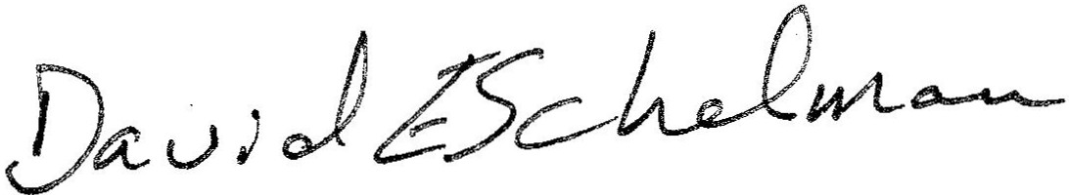

\, ·---------·

1. Each department will establish a curriculum committee that will meet regularly to review the curriculum for their programs. The committee's duties include the following: to create syllabus

standards, to review curriculum *I* syllabi within their programs, to suggest changes, to recommend

means to implement changes, to report on the changes suggested *I* made.

2. The departmental curriculum committees should be made up of 3-5 members. Effort should be made to include a variety of perspectives, including different instructor and delivery models. For example, adjunct instructors and representatives from the Ozark campus may be included on the committees. NOTE: Smaller colleges may choose to have a college curriculum committee instead of a departmental committee.

3. So as not to overwhelm the process, curriculum reviews should be coordinated with the program reviews/specialized accreditation reviews that are already taking place. In other words, the curriculum review should take place chronologically in between each broader program review.

4. The departmental curriculum committees will review courses/curriculum to decide what should be changed and what should remain the same. NOTE: All curriculum programs should be housed within a department or college so that they can be appropriately reviewed.

5. To ensure that courses are being reviewed (vettedL syllabus standards should be developed by the departmental curriculum committees. These standards must be based on those listed in the ATU Faculty Handbook but be clarified in a way to fit the individual department/program/course. For example, to ensure some consistency among multi-section courses, the departmental curriculum

· committees might choose to have more specifistandards for multl section c urses.

6. All changes/revisions to curriculum must be based on and justified by data (information like instructor evaluations of the course, changes to the field, etc.).

7. The departmental curriculum committees' reviews will take into account various il)ftructor models and delivery methods including but not limited to: *v :_..r .fl. -.:r.-.. !...<*

+

* all campuses *n l"- f* --

• concurrent education y/1- \ , *LC.. .J.* ,' *)_*

' * tenure-track faculty *I* instructor-taught courses *$ /"lffJt,;rl.l*

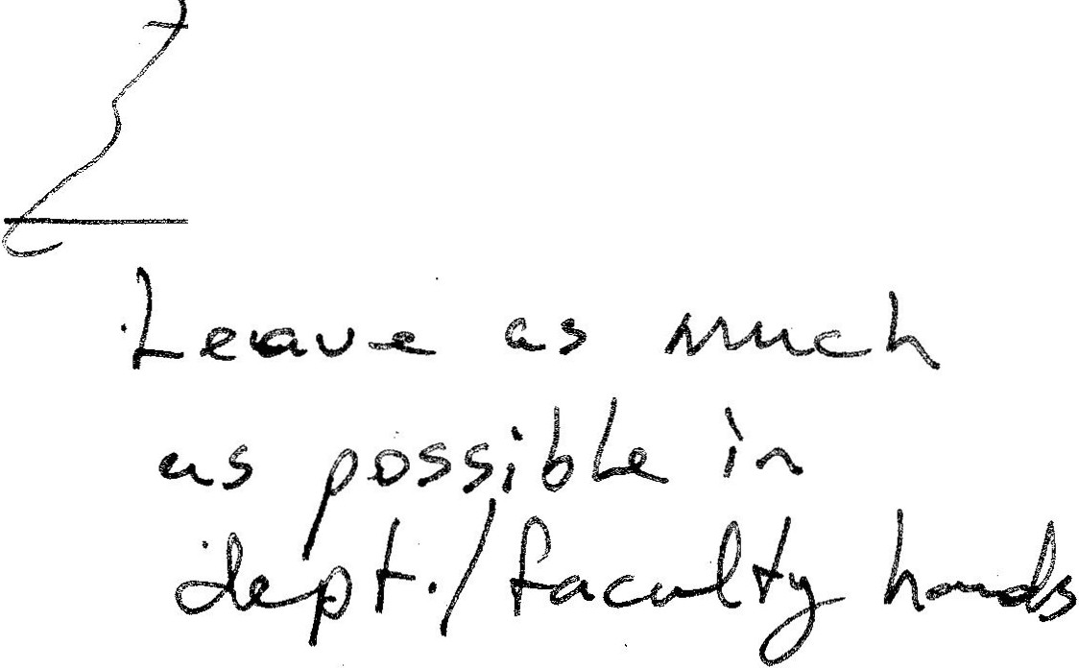

* adjunct-taught courses

* online delivery

* face-to-face delivery

* internships *I* practicums *I* etc.

*IJ.ew \)fAA-*

~~•~~