Minutes of

THE FACULTY SENATE

OF

ARKANSAS TECH UNIVERSITY

The Faculty Senate met Tuesday, October 11, 2016, at 3:00 p.m. in Rothwell 456.

The following members were present:

|  |  |
| --- | --- |
| Dr. Molly Brant | Dr. Johnette Moody |
| Dr. Jon Clements | Dr. Jason Patton |
| Dr. Melissa Darnell | Dr. Michael Rogers |
| Dr. Marcel Finan | Dr. Jeremy Schwehm |
| Mr. Ken Futterer | Dr. Monty Smith |
| Dr. Debra Hunter | Dr. James Stobaugh |
| Dr. Sean Huss | Dr. Bruce Tedford |
| Dr. Shelia Jackson | Dr. Jack Tucci |
| Dr. Chris Kellner | Dr. Susan Underwood |

Dr. V. Carole Smith, Dr. James Walton, and Dr. Dana Ward were absent. Dr. Chris Giroir, Ms. Aubrey Holt, Dr. Jason Warnick, Dr. David Blanks, Dr. Jeff Robertson,   
Dr. Sandy Smith, Dr. Linda Bean, Dr. Tim Carter, Dr. David Ward, Mr. David Mudrinich, Mr. Dustin Simpson, Dr. Cynthia Hukill, Dr. Julie Mikles-Schluterman,   
Dr. Thomas Nupp, Dr. Joseph Stoeckel, Dr. Malcolm Rainey, Dr. Bruce Chehroudi,   
Dr. Erica Wondolowski, Dr. Mohamed Abdelrahman, Mr. Wesley Duke, and   
Ms. Pat Chronister were visitors.

|  |  |
| --- | --- |
| CALL TO ORDER  APPROVAL OF MINUTES | President Huss called the meeting to order, and asked for a motion in regard to the minutes of September 13, 2016.  Motion by Dr. Rogers, seconded by Mr. Futterer, to approve the minutes as distributed.  Dr. Finan asked that the minutes be amended to include Dr. David Hoelzeman in the listing of guests.  Motion carried to approve the minutes as amended.  President Huss then called for a motion to amend the agenda to shift items C, D, and E of New Business to follow item A of New Business to allow Dr. Abdelrahman to participate in those discussions.  Motion by Mr. Futterer, seconded by Dr. Finan, to amend the agenda as requested. Motion carried. |
| VPAA UPDATE | President Huss invited Dr. Mohamed Abdelrahman, Vice President for Academic Affairs, to address the Senate. Dr. Abdelrahman distributed a draft policy for supplemental compensation (Attachment A). He explained that while many other institutions do not permit faculty to receive overloads from grants, he would support a limited overload amount, if the granting agency allowed it. He expressed his desire to identify policies to incentivize research, and invited feedback. Dr. Kellner indicated the proposed supplemental compensation policy could be viewed as a penalty, as faculty have often used compensation from grants to offset the lower salary structure of the institution. Dr. Abdelrahman stated this is what other institutions use, and noted the 20% maximum was for during the academic year, with summer overloads permitted up to 33% of the base salary.  Dr. Patton asked if this included consulting services, and Dr. Abdelrahman stated that was a separate policy which Legal Counsel would be drafting. |
| NEW BUSINESS:  CURRICULAR ITEMS | President Huss called for a motion in regard to the curricular proposals.  Motion by Mr. Futterer, seconded by Dr. Brant, to consider the curricular proposals as a unit by college. Motion carried.  Motion by Dr. Jackson, seconded by Dr. Clements, to approve the curricular proposals from the College of Arts and Humanities as presented:  **College of Arts and Humanities  Department of Art**   1. Delete the following courses from the course descriptions: 2. ART 3123: Art History, Renaissance; 3. ART 4103: Art History, Modern 1789-1945; and 4. ART 4123: Art History, Medieval; 5. Add GAME 2003: Digital 3-D Foundations, to the course descriptions; 6. Modify the Curriculum in Fine Arts, Graphic Design, and Art for Teacher Licensure, as follows: delete ART 3123: Art History, Renaissance, and ART 4103: Art History, Modern 1789-1945, from the Art history electives in footnote 2; and 7. Modify the Curriculum in Game and Interactive Media Design, as follows: delete 3 hours of electives; add GAME 2003: Digital 3-D Foundations; and allow the option of ART 2303: Figure Drawing, ART 3303: Drawing Studio I, or ART 4233: Illustration Studio.   **Department of Behavioral Sciences**   1. Delete the following courses from the course descriptions: 2. RS 3023: Principles and Techniques of Rehabilitation Services; 3. RS 4024: Field Placement in Rehabilitation Science; 4. RS 4034: Field Placement Related to Vocational Rehabilitation; 5. RS 4044: Field Placement Related to Aging; 6. RS 4054: Field Placement Related to Corrections; 7. RS 4064: Field Placement Related to Social Services; 8. RS 4074: Field Placement for Psychology and Sociology Majors; and 9. RS 4094: Rehabilitation Science Field Placement in Addictions; 10. Add the following courses to the course descriptions: 11. IPBL 4893: Collaborative Solutions; 12. RS 3183: Mental Health Issues in Rehabilitation Settings; 13. RS 3203: Interviewing Skills; 14. RS 4023: Case Management Strategies; 15. RS 4104: Service Learning in Rehabilitation Science; 16. RS 4194: Field Placement I; and 17. RS 4294: Field Placement II; 18. Add the note: A grade of C or better required for Rehabilitation Science majors, to RS 2003: Introduction to Rehabilitation Services, and change the title to Introduction to Rehabilitation Science; 19. Add the note: A grade of C or better required for Rehabilitation Science majors, to RS 3123: Ethics in Human Services, and change the title to Ethics and Professional Development; 20. Add the note: A grade of C or better required for Rehabilitation Science majors, to RS 4012: Internship in Rehabilitation Services; 21. Add minors in Addictions, Aging, Child Welfare, Corrections, Social Services, Disability Studies, and Recreation Services; 22. Modify the Curriculum in Rehabilitation Science, as follows: 23. Delete the following: 24. RS 3013: The World of Work; 25. RS 3023: Principles and Techniques of Rehabilitation Services; 26. RS 3073: Organization and Structure in the Rehabilitation-Human Services Setting; 27. RS 4024: Field Placement in Rehabilitation Science; 28. RS 4034: Field Placement Related to Vocational Rehabilitation; 29. RS 4044: Field Placement Related to Aging; 30. RS 4054: Field Placement Related to Corrections; 31. RS 4064: Field Placement Related to Social Services; 32. RS 4074: Field Placement for Psychology and Sociology Majors; 33. RS 4084: Field Placement Related to Child Welfare Services; and 34. RS 4094: Rehabilitation Science Field Placement in Addictions; 35. Add the following: 36. RS 3203: Interviewing Skills; 37. RS 4023: Case Management Strategies; 38. RS 4123: Survey of Counseling Theories; 39. RS 4104: Service Learning in Rehabilitation Science; 40. RS 4194: Field Placement I; and 41. RS 4294: Field Placement II; 42. Allow PSY 3003: Abnormal Psychology, or RS 3183: Mental Health Issues in Rehabilitation Settings; 43. Allow PSY 3063: Developmental Psychology I, or PSY 3813: Lifespan Development; 44. Delete the 12 hours of primary emphasis area and 6 hours of secondary emphasis area; 45. Add a minor in one of the following areas: Addictions, Aging, Child Welfare, Corrections, Social Services, Disability Studies, and Recreation Services; 46. Change Footnote 2 to read select a minor in Additions, Aging, Child Welfare, Corrections, Social Services, Disability Services, or Recreation Services; 47. Change Footnote 3 to read Students who choose to complete a 12 hour internship (RS 4012) will do so either their last or next to last semester and will not take RS 4104 (Service Learning) and RS 4194 (Field Placement 1) and RS 4294 (Field Placement 2); and 48. Add Footnote 4 to read a grade of C or better required for Rehabilitation Science majors; 49. Modify the Curriculum in Sociology, as follows: change the requirement in the introduction section and matrix FROM: RS 2003: Introduction to Rehabilitation Services; and ANTH 1213: Introduction to Anthropology or ANTH 2003: Cultural Anthropology; TO: RS 2003: Introduction to Rehabilitation Services, or CJ/SOC 2003: Introduction to Criminal Justice; and ANTH 1213: Introduction to Anthropology, or ANTH 2003: Cultural Anthropology; and 50. Modify the Curriculum in Ozark-Ouachita Studies**,** as follows: delete SOC 2023: Sociology of the Ozark-Ouachita Region; and add GEOG 3203: Arkansas Geography.   **Department of History and Political Sciences**   1. Delete POLS 2013: Introduction to Political Science, from the course descriptions; 2. Delete POLS 4163: Public Choice Theory, from the course descriptions; 3. Add the following courses to the course descriptions:    1. GEOG 3203: Arkansas Geography;    2. GEOG 4703: Urban Geography Seminar;    3. HIST 3273: Digital History;    4. PHIL 2023: Buddhist Philosophy;    5. PHIL 3043: Clinical Bioethics; and    6. PHIL 3073: Philosophy of Law; and 4. Modify the Curriculum in Political Science as follows:    1. POLS2403: Comparative Government;    2. change POLS2403: Comparative Government, or POLS2413: International Relations, to POLS 2153, or POLS2413: International Relations;    3. Delete the Research Methods, Political Theory, International Relations, and America Politics blocks;    4. Change Political Science Electives to 21 hours with 18 hours upper-level courses required to include one of the following tracks: Law School, Public Policy/Administration, International Relations/Studies, Strategic Studies American Politics, Campaigns, and Elections, and Political Science Graduate School; and    5. Update footnotes to reflect changes.   **Department of Music**   1. Add MUS 1751: Orientation to Music, to the course descriptions; and 2. Modify the Curriculum in Music and Music Education for Teacher Licensure with options in Instrumental Music, Keyboard Instrumental, Keyboard Vocal, and Vocal, as follows: delete TECH 1001: Orientation to the University, and add MUS 1751: Orientation to Music.   Following the motion, Dr. Underwood stated the added course, MUS 1751, appeared to use TECH 1001 content, and asked if the department would have access to those materials.  Dr. Cynthia Hukill, Department Head of Music, indicated her understanding was that had been coordinated. Dr. Chris Giroir, Department Head of College Student Personnel, stated he was not aware of prior coordination, but he would be willing to work with the Music Department.  Motion carried, with the stipulation the Music Department will contact the College Student Personnel Department to coordinate common course materials and content.  Motion by Mr. Futterer, seconded by Dr. Jackson, to approve the curricular proposals from the College of Education as presented:  **College of Education**   1. Add the following to the course descriptions: 2. LEAD 1003: Introduction to Leadership; 3. LEAD 2003: Ethics in Leadership; 4. LEAD 3003: Leadership Skills Development and Group Dynamics; 5. LEAD 4003: Leadership Internship and Capstone Seminar; and 6. LEAD 4103: Special Problems in Leadership; 7. Add the minor in Leadership Studies (Interdisciplinary Studies).   **Department of Curriculum and Instruction**   1. Remove the Prerequisite: Admission to Stage II of the Teacher Education Program from ELED 3113: Human Development and Learning Theories; 2. Remove the Prerequisite: Admission to Stage II of the Teacher Education Program from SPED 3023: Development & Characteristics of Diverse Learners; 3. Modify the Curriculum in Elementary Education as follows: delete MATH 2163: Introduction to Statistical Methods; and add MATH 3033: Methods of Teaching Elementary Mathematics.   Motion carried.  Motion by Dr. Jackson, seconded by Dr. Schwehm, to approve the curricular proposals from the College of Engineering and Applied Sciences as presented:  **College of Engineering and Applied Sciences**  **Department of Agriculture**   1. Modify the Curriculum in Agriculture Business-Business Option as follows: delete AGBU 4043: Appraisal of Farm Real Estate, and add 3 hours of Agriculture Electives.   **Department of Emergency Management**   1. Add a concentration in Emergency Medical Services to the Curriculum in Emergency Management.   **Department of Parks, Recreation, and Hospitality Administration**   1. Change the course number for HA 4116: Internship, to HA 4114; 2. Change the course number for RP 4042: Field Seminar in Interpretive Methods, to RP 4043; 3. Modify the Curriculum in Hospitality Administration Event Management, Foodservices, and Lodging Management Emphasis as follows: change the course number for HA 4116: Internship, to HA 4114, and add two hours of HA electives; 4. Modify the Curriculum in Recreation and Park Administration Interpretation Emphasis as follows: change RP 4116: Internship, to RP 4114: Internship; and add 2 hours approved RP electives; 5. Modify the Curriculum in Recreation and Park Administration Natural Resource Emphasis as follows: change RP 4116: Internship, to RP 4114: Internship; add 2 hours approved RP electives; and add RP 4043: Field Seminar in Interpretive Methods, RP 4991: Special Problems and Topics, RP 4992: Special Problems and Topics, and RP 4993: Special Problems and Topics, to the list of approved RP electives listed in footnote 3; 6. Modify the Curriculum in Recreation and Park Administration Recreation Sport Emphasis as follows: change RP 4116: Internship, to RP 4114: Internship; delete HA 1923: Introduction to Food and Beverage Management, and HA 4253: Club Management, from the list of approved electives; add 2 hours approved electives; and RP 4993: Special Problems and Topics, to the list of approved electives listed in footnote 2; and 7. Modify the Curriculum in Recreation and Park Administration Therapeutic Recreation Emphasis as follows: change RP 4116: Internship, to RP 4114: Internship, and RP 4112: Internship, or RP 4116: Internship.   Motion carried. |
| FACULTY PLAN OF WORK | President Huss invited Dr. Abdelrahman to address the Senate. Dr. Abdelrahman referenced the evaluation procedures outlined in the *Faculty Handbook,* which call for the faculty member and department head to develop a plan for professional improvement for the upcoming year. He stated this should not delve into the number of hours spent in each area, but should instead set a baseline for expectations for both the faculty member and department head. President Huss added the intent was for setting professional goals, not to penalize a faculty member during the evaluation process.  Mr. Futterer expressed concern with the definition of a full teaching load as 80% of the faculty member’s load, stating most faculty consider teaching the full load, with service and scholarship as additional work outside of the regular load. Dr. Abdelrahman stated the definition was more for each course equating to 20%. He noted the 20% for service and scholarship would be flexible and differ between individual faculty and disciplines.  Mr. Futterer clarified, for evaluation purposes, a faculty member could elect to assign a different weight for teaching, such as 60% with 40% weight to service and scholarship.  Dr. Abdelrahman agreed, stating the evaluations would be more flexible, but the weights should always add to 100%. Dr. Abdelrahman thanked the Senate, and excused himself from the meeting. |
| EMPHASIS ON EXTERNAL FUNDING | President Huss asked to hold the discussion on external funding until November when  Dr. Abdelrahman would be able to return to address it. |
| EVALUATION CRITERIA DISCREPANCIES | President Huss asked to hold the discussion on evaluation criteria discrepancies until November when Dr. Abdelrahman would be able to return to address it. |
| PROFESSIONAL DEVELOPMENT ACTIVITIES | President Huss invited Dr. Jason Warnick, Director of the Center for Excellence in Teaching and Learning (CETL), to address the Senate. Dr. Warnick stated, to ensure broader faculty support for future professional development sessions, activities and presentations would first be approved by the CETL advisory group. He also indicated he would be polling faculty for topics and areas of interest, and noted the session with the most positive feedback from faculty had been the day with “conference style” sessions. The comments from the senators regarding professional development included the sessions were too lengthy, internal faculty could be used in lieu of inviting external speakers, and requiring mandatory attendance was discouraging. Dr. Warnick asked for continued feedback and ideas. |
| OLD BUSINESS: FACULTY GRIEVANCE | President Huss distributed the draft of the changes to the Faculty Grievance Committee, including suggested changes from Ms. Jennifer Fleming, Title IX Coordinator (Attachment B). President Huss and Dr. Kellner stated they would present a draft at the November meeting with changes incorporated that the senators could review and vote on. |
| PROMOTION AND TENURE | Dr. Schwehm reported the committee was addressing the changes to the promotion and tenure policy discussed in September, and would again seek feedback from the faculty at large. He stated the committee hoped to return a draft to the Senate in November. |
| EVALUATION OF ADMINISTRATORS | President Huss reported he would speak with Dr. Bowen before the November meeting. |
| FINAL EXAM AND GRADE SCHEDULE | Dr. Rogers reported a survey would be sent to the faculty, asking for input on a reasonable time frame for the submission of final grades after the last final exam period has concluded. |
| TRAVEL PROCESS FOR STUDENTS | President Huss reported improving the function and policies of the Travel Office was the top priority for Ms. Bernadette Hinkle, Vice President for Administration and Finance. |
| SECURITY CAMERAS | Dr. Kellner stated he would have a report for the November meeting. |
| LEVELS OF LIFE INSURANCE | President Huss indicated Ms. Hinkle was aware of the interest in differing levels of life insurance, and he hoped to have an update soon. |
| SHARED GOVERNANCE STATEMENT | President Huss reported the AAUP conference had been eye-opening for those who attended. He expressed a simple statement in the *Faculty Handbook* would not be sufficient to achieve the culture desired, and distributed a list of methods for increasing shared governance (Attachment C). He explained, to be successful, the institution needed to clearly define the roles of the faculty, the administration, and the Board of Trustees. President Huss stated he would be setting up a presentation through Skype with Dr. Joerg Tiede of the AAUP, including a Q&A session to take place in November. |
| PHASED RETIREMENT | President Huss stated he had spoken with Dr. Bowen about a possible phased retirement policy, and she expressed such policies are effective for campuses with an excess of faculty. Dr. Clements added it would also be more beneficial to institutions with greater salary differences between junior and senior faculty. |
| POST-TENURE REVIEW | President Huss asked to reserve the discussion of post-tenure review until the promotion and tenure policy draft returned to the Senate. |
| OPEN FORUM | Dr. Patton requested Legal Counsel be invited to the upcoming meeting to address compensation from consulting services.  Dr. Rogers asked for further discussion on the minimum class enrollment policy and how that number was determined. President Huss responded he would look into it.  Dr. Underwood stated the application process for Professional Development Grants was overly tedious. The senators shared instances of grant applications being denied for technicalities. President Huss stated he would investigate this further. |
| ANNOUNCEMENTS AND INFORMATION ITEMS | Ms. Chronister asked for volunteers for an informal group reviewing potential e-portfolio software programs. She stated two members of the Promotion and Tenure Committee,  Dr. Larry Morell and Dr. Kim Troboy, were included as well as Mr. Ken Wester, Director of Information Systems. Mr. Ken Futterer volunteered to join.  Dr. Stobaugh announced open forums with the Financial Aid Director candidates would be later that week. He also mentioned there would be food trucks at the old Taco Villa building near Thone Stadium during the home football game.  President Huss reported Dr. Beth Giroir, Interim Assistant Vice President for Student Success, had asked the Faculty Senate to send a representative to view the Ellucian software demos for student recruitment and student success modules. Dr. Schwehm responded he would be attending on behalf of the General Education Committee, and would also represent the Senate. |
| ADJOURNMENT | The meeting adjourned at 4:45 p.m. |

Respectfully submitted,

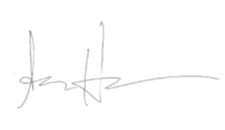

Sean Huss, Ph.D., President

Attachment A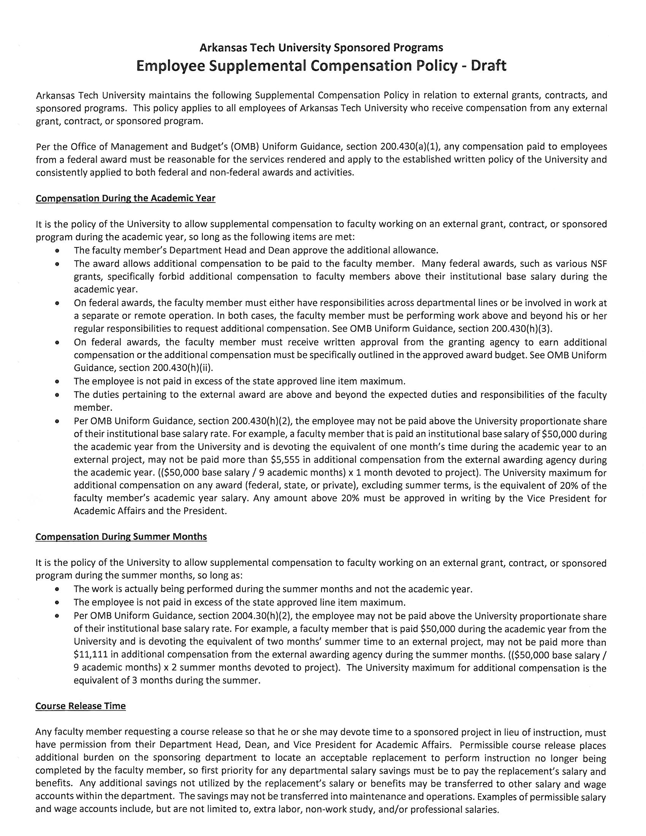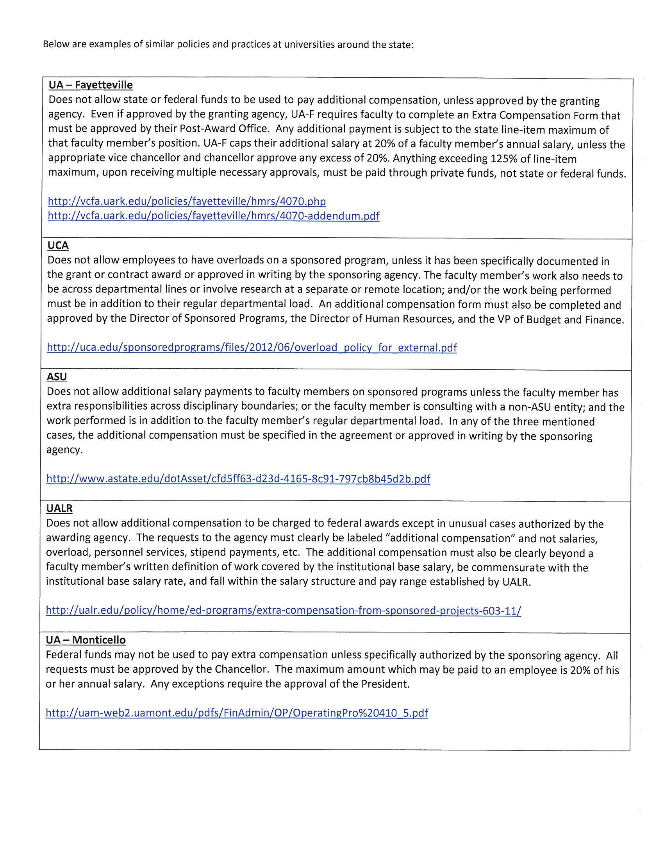

Attachment B  
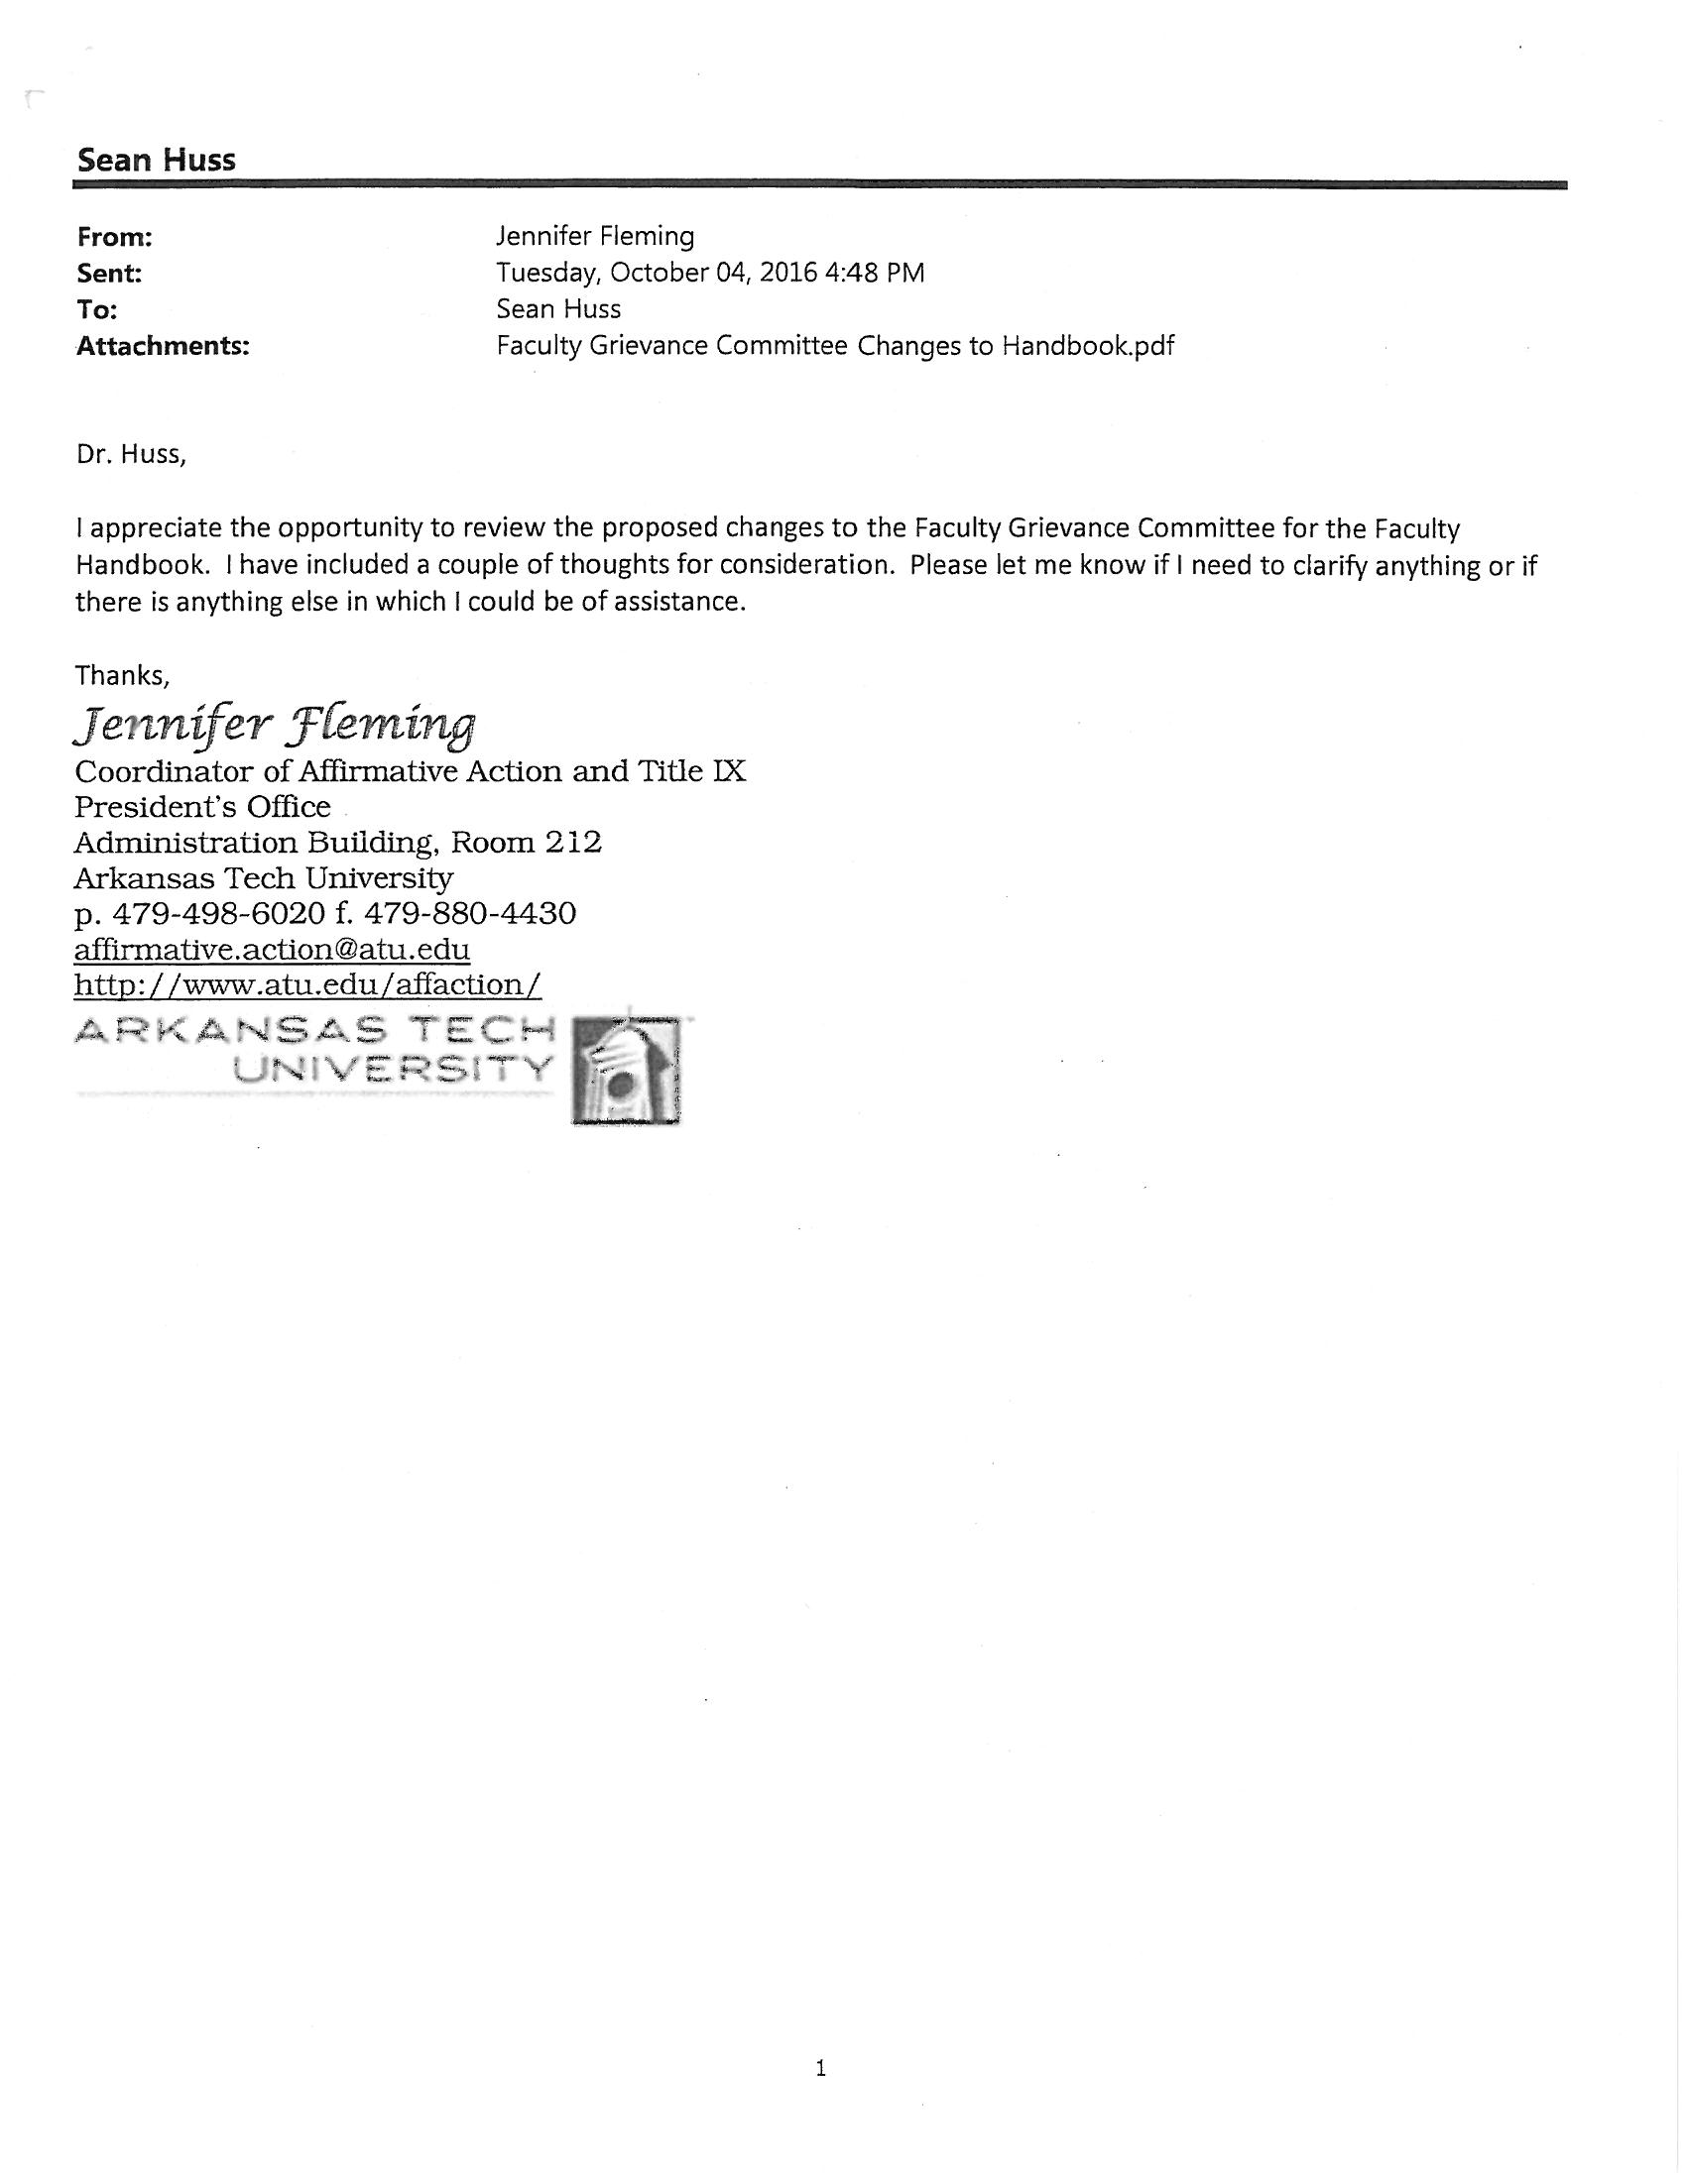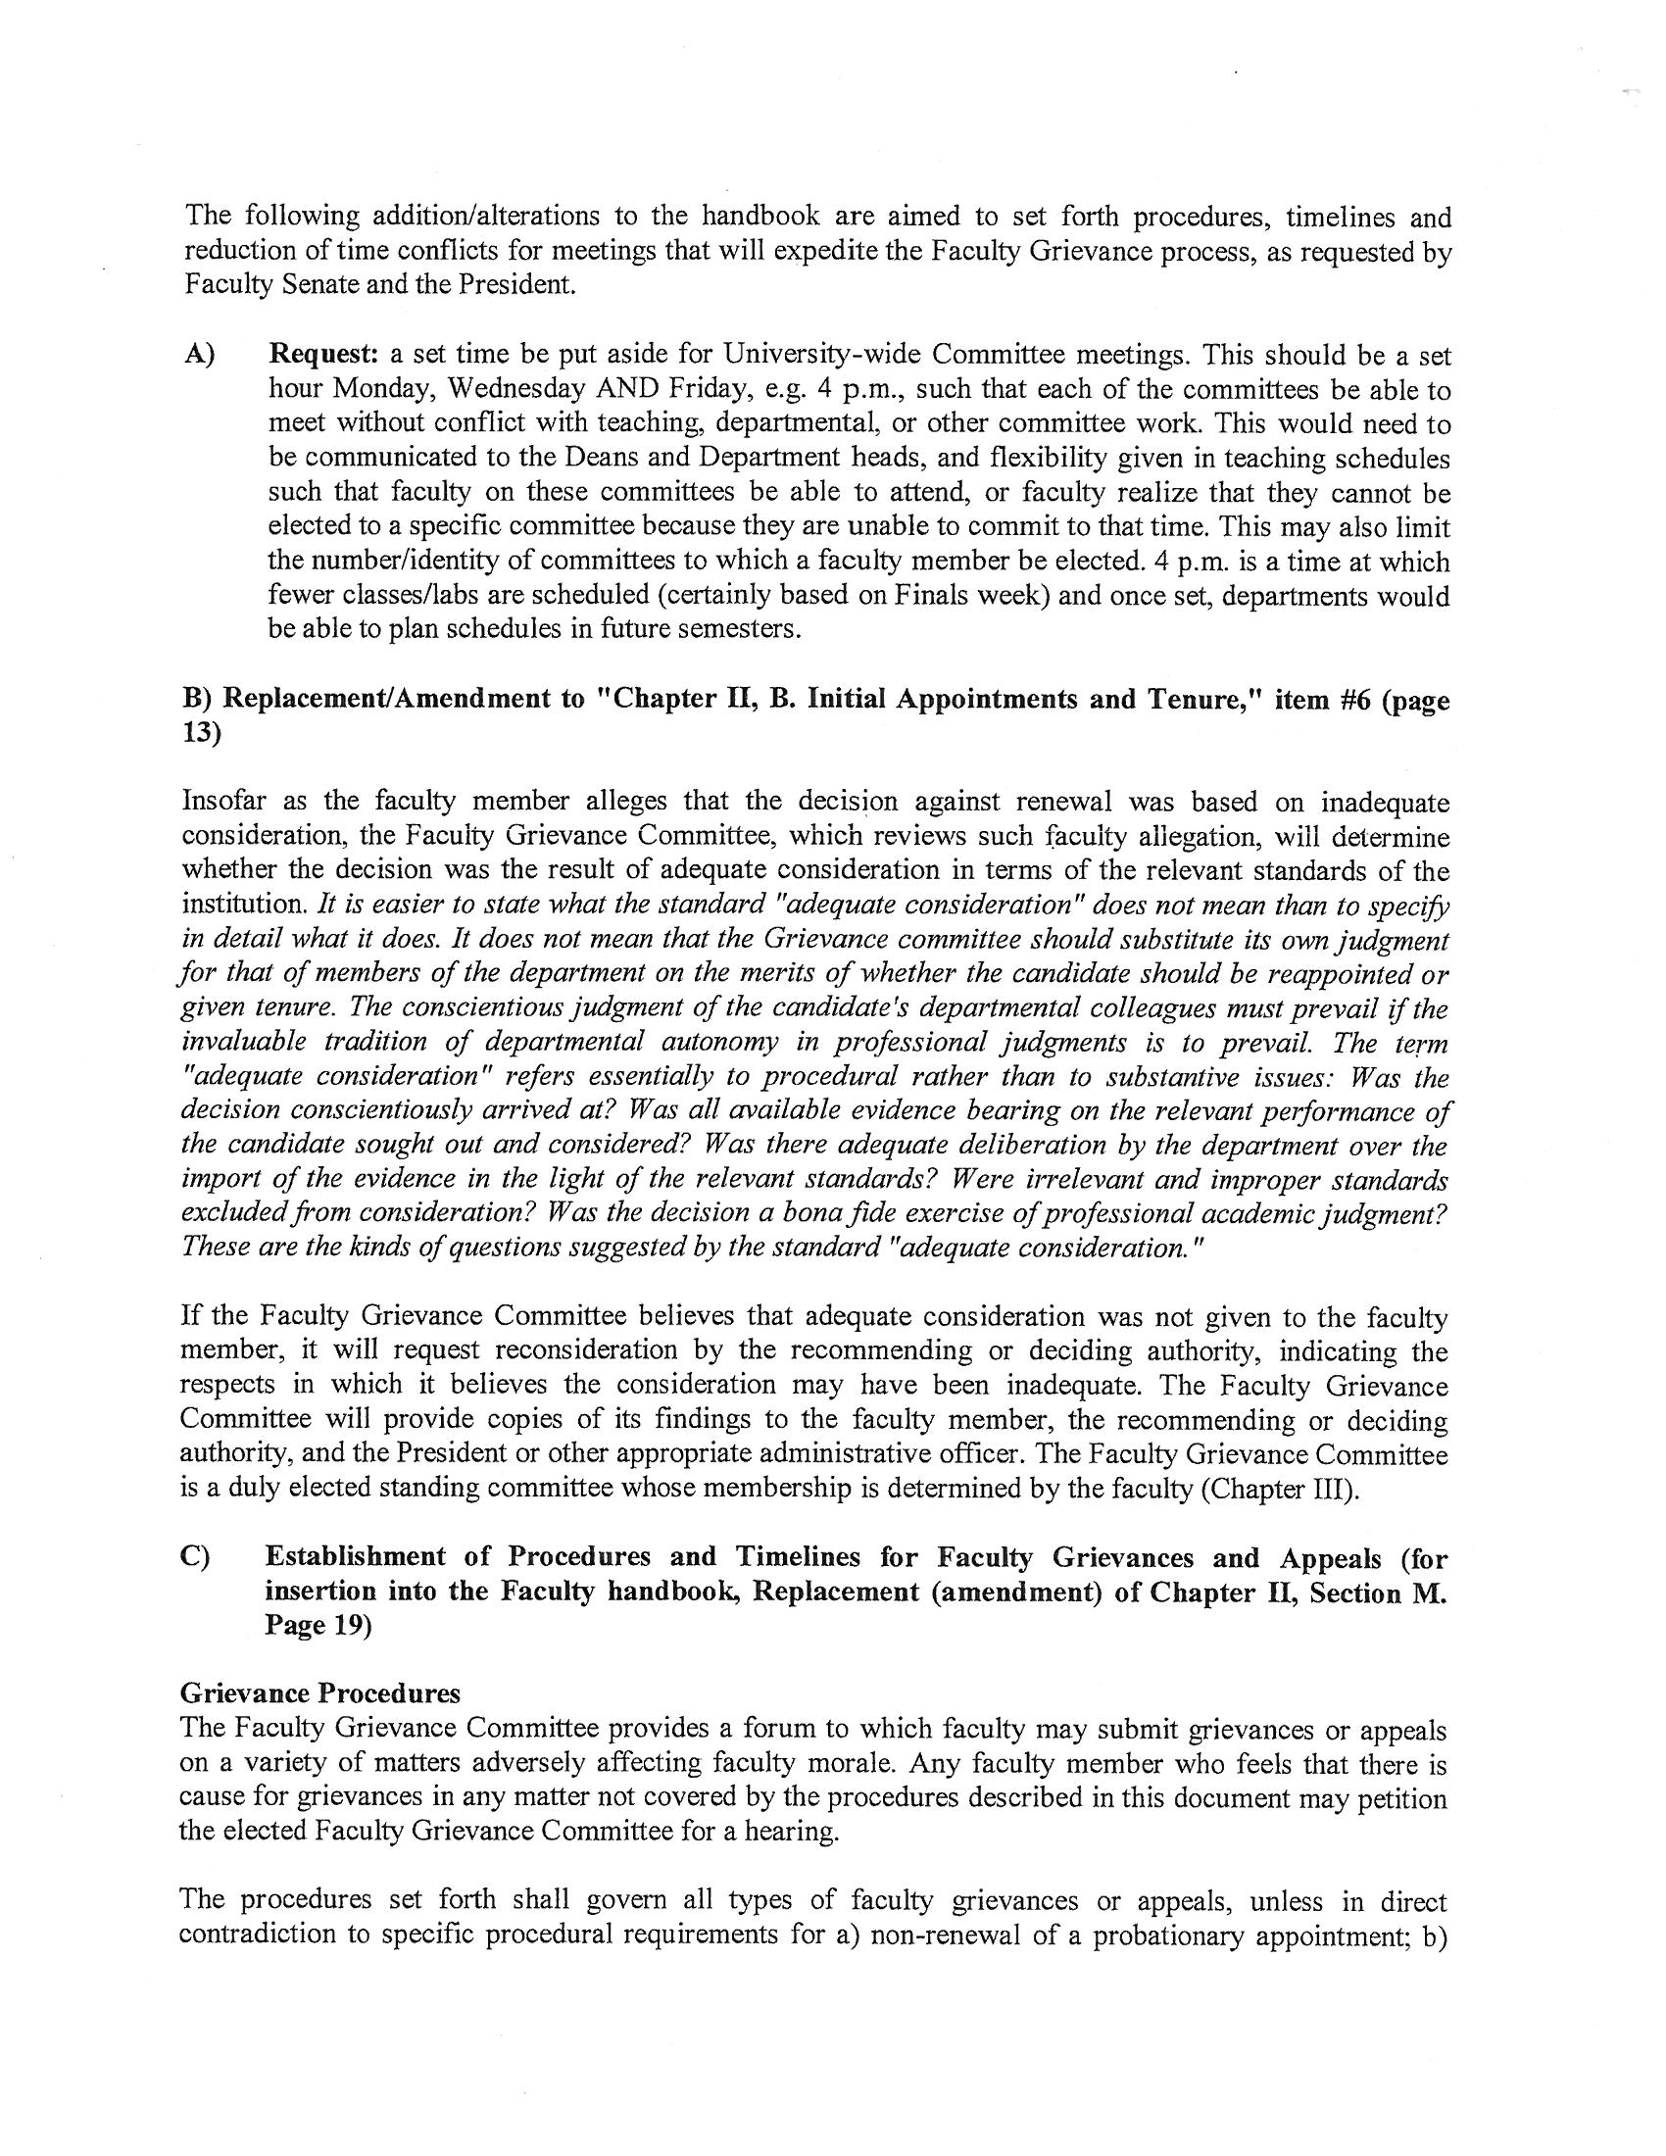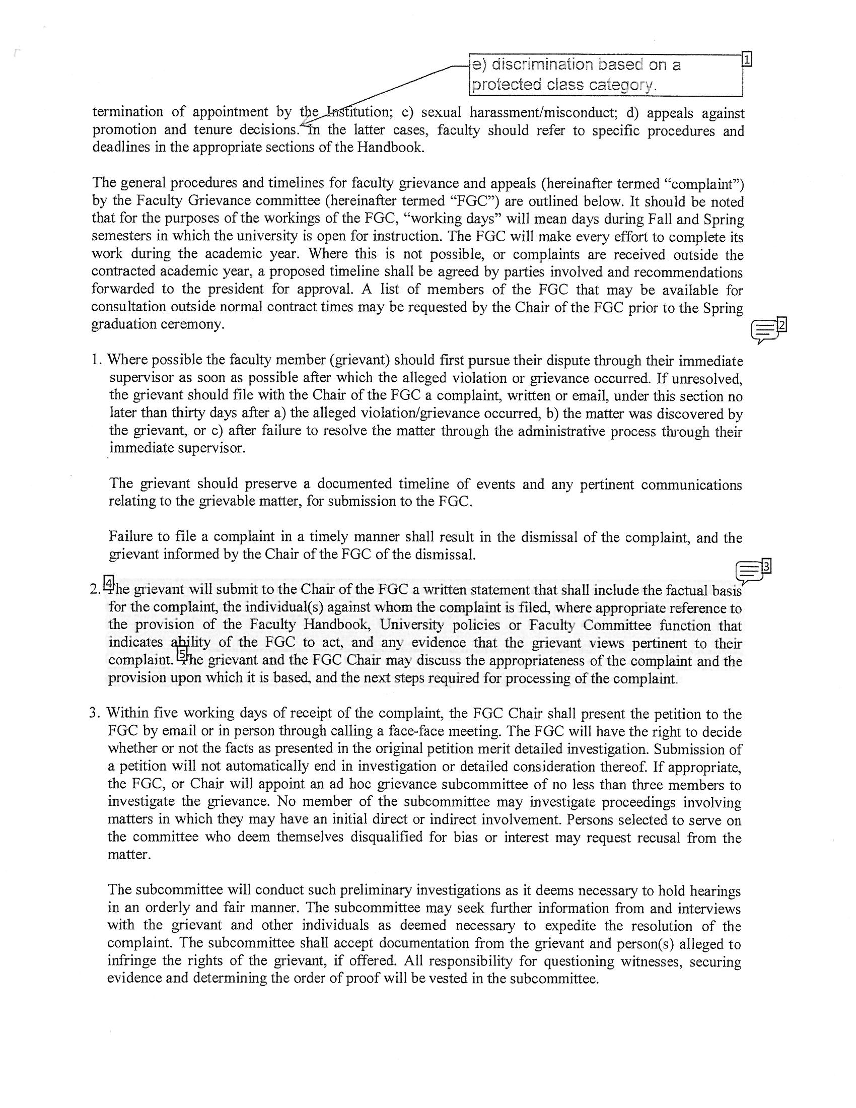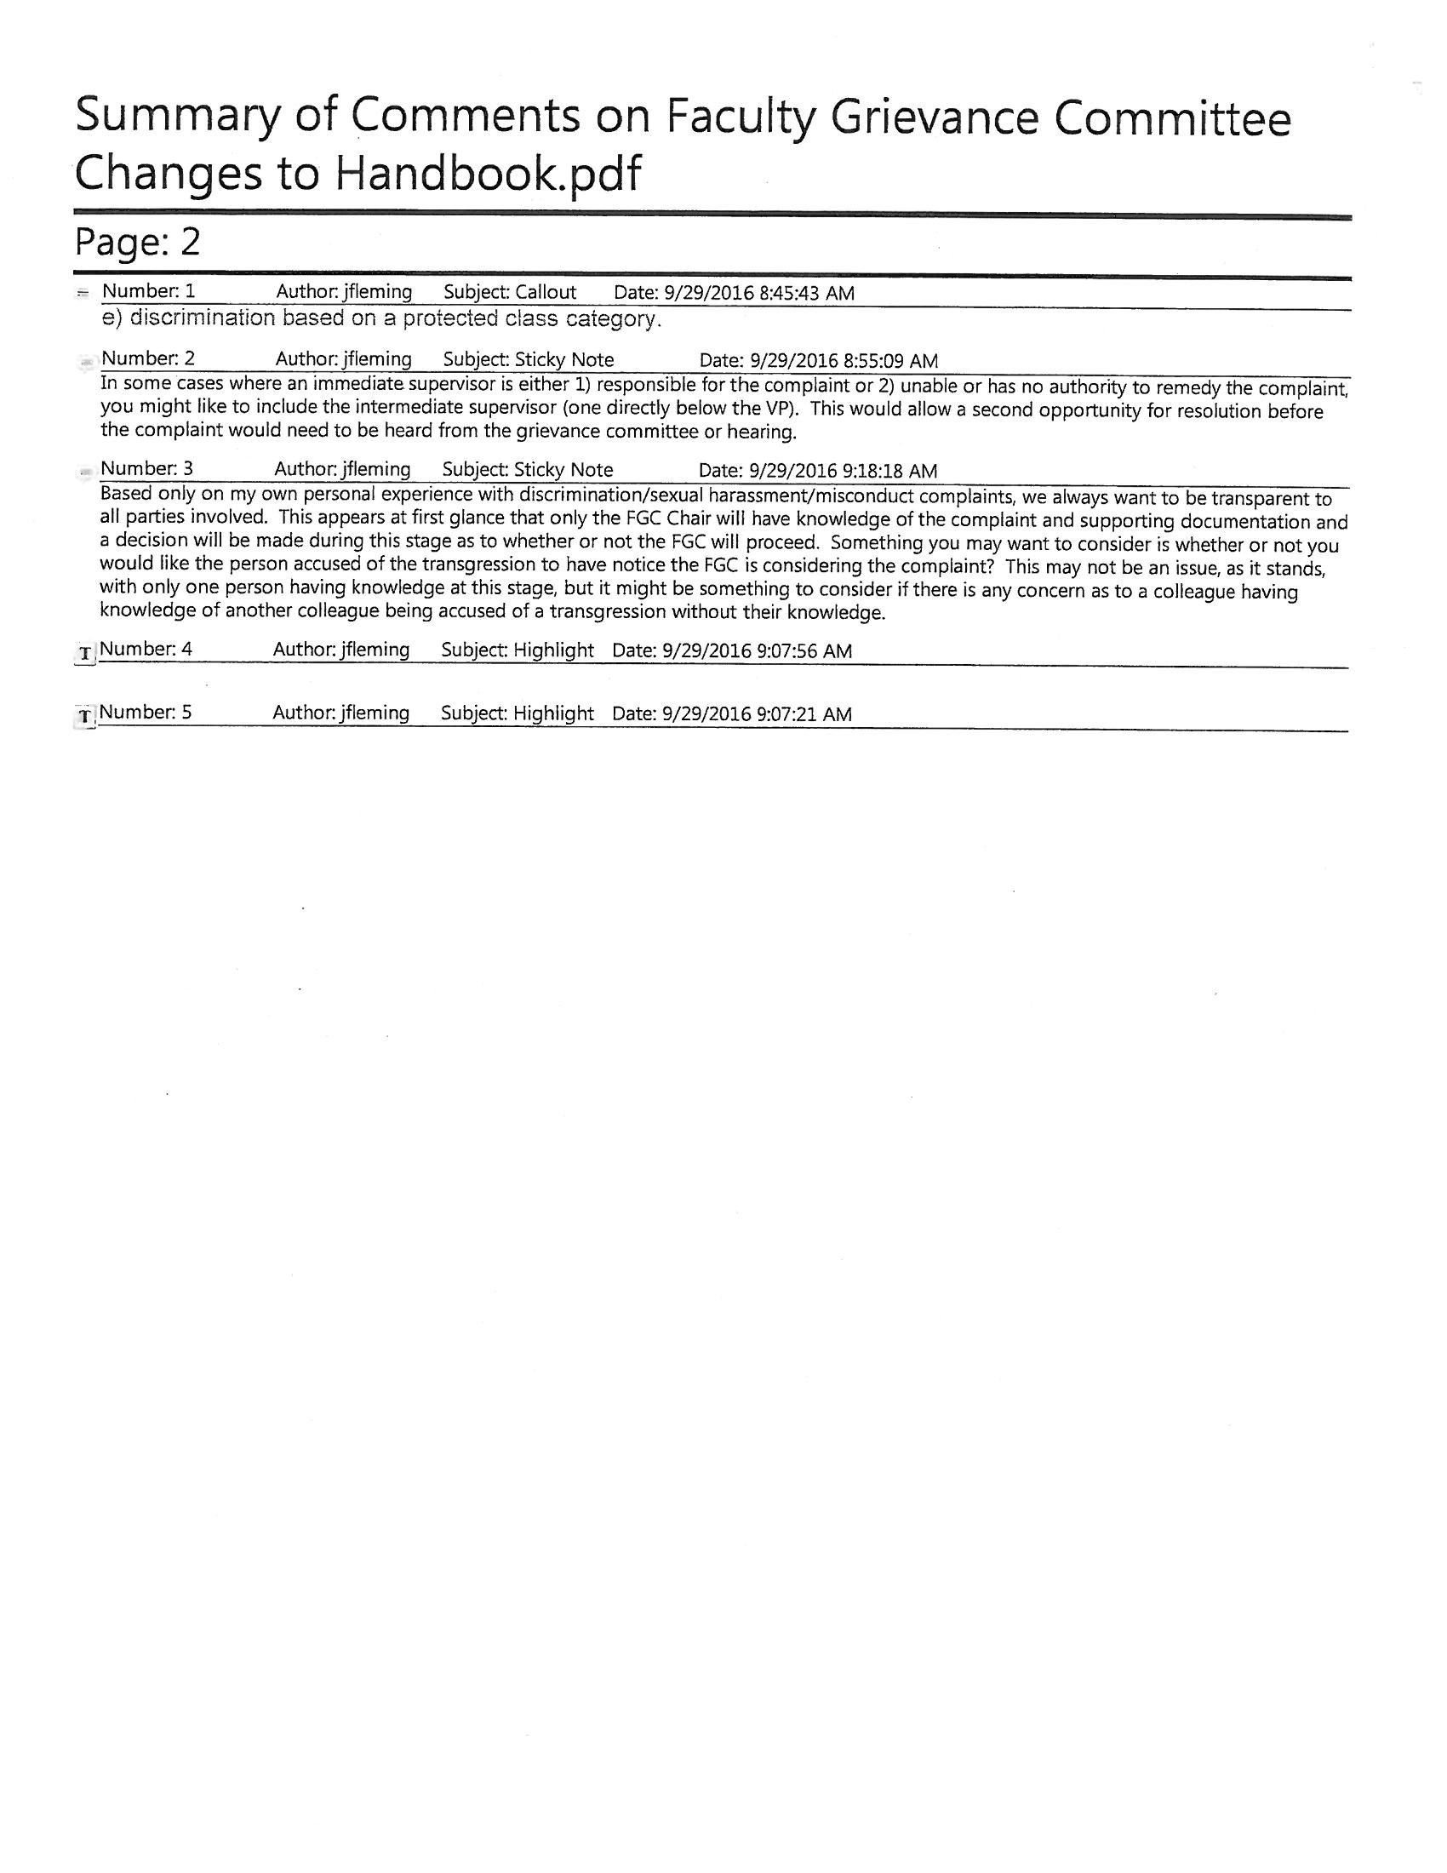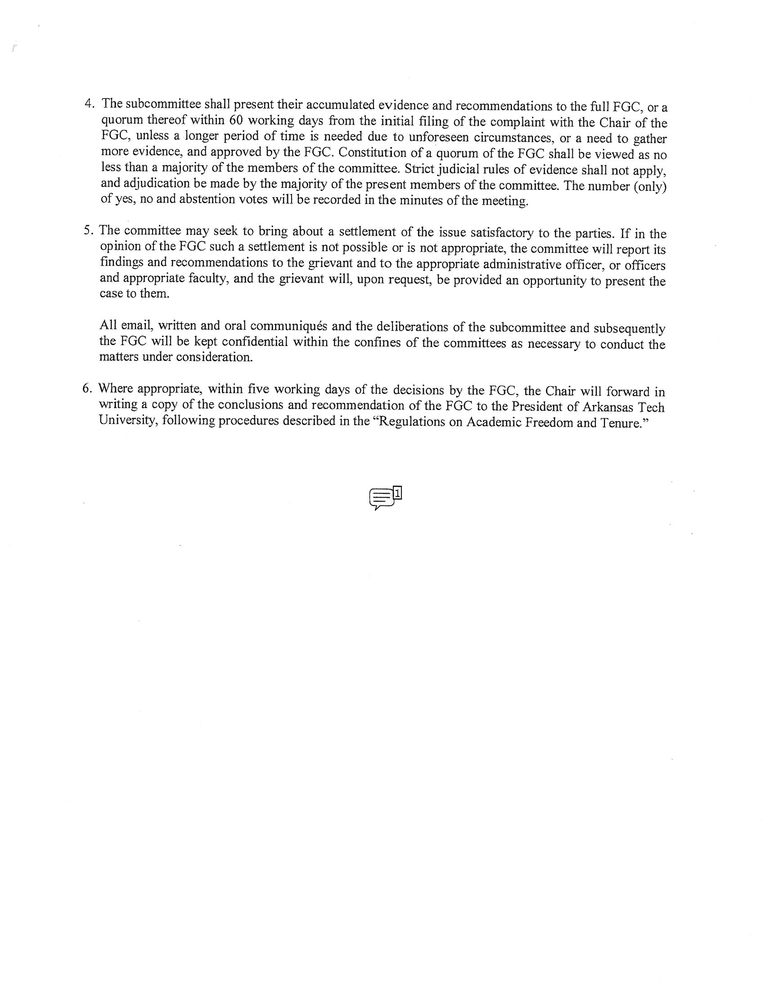

Attachment C

