Calendar
Ozark Campus
Russellville Campus

Calendar Categories (Event Meeting Types)
Alumni – events for Alumni of the University
Athletic- Golden Suns or Wonder Boys athletic events
Campus- events occurring on campus for Faculty and Staff
Community- events open to the general public
Employee- events for employees of the University
Meetings & Conferences
Camps & Clinics
Norman Hall Art Gallery

Public Safety
Residence Life
Student Campus Life- events for SGA, SAB, and Registered Student Organizations
Student Success- events that contribute to student success
Student Wellness- events that are geared to student wellness
Witherspoon Auditorium

Users can add their event to the public facing calendar by completing the description, selecting the meeting type for the category they would like their event to appear under, and checking the featured box. If you would like an image featured please email it to calendar@atu.edu
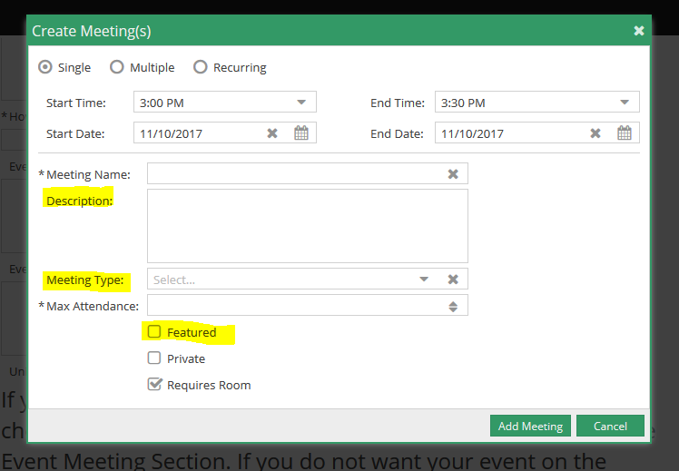

For a campus event that is occurring off campus but needs to be included on the public facing calendar go to www.atu.edu/events and use the Submit My Event to the Calendar link. Also, if you did not enter your description at the time of your event request you can use the same link to enter your information and be sure to include your Ad Astra Reservation Number.

