Instructions For Requesting An Event:
Required: All Events must be made with the minimum lead time listed at the top of each of the forms. If there is not enough lead time it will not let you request the event.
- Ad Astra Link: https://www.aaiscloud.com/ARTechU/
- Log in with your Tech username and password
- Click the Events Tab
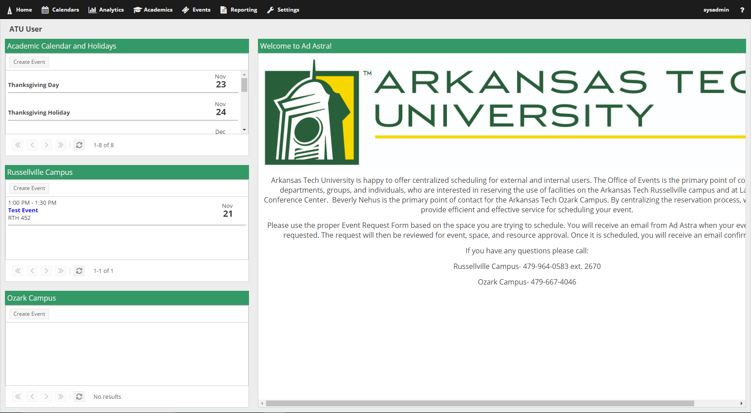
- Once you click the Events tab a drop down will appear and you will click on Request Event.
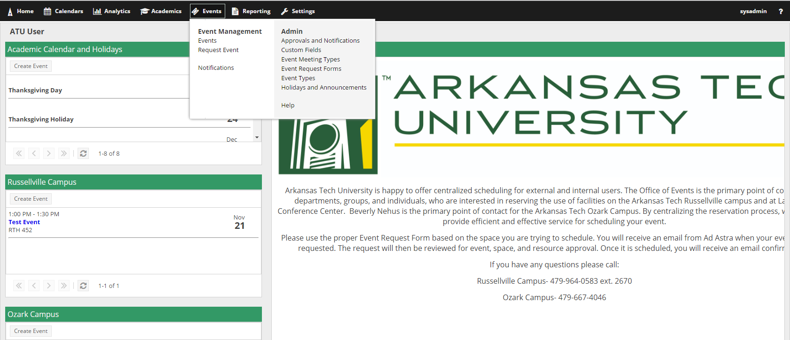
- Once you have done that you will be taken to a pop-up window where you will be able to select whichever event request form you are needing.
- Once you have selected the form you need you will then click Next.
- Fill out the event information on the form.
NOTE: Fields with an (*) require information. If left blank, the system will not allow the request to be submitted.
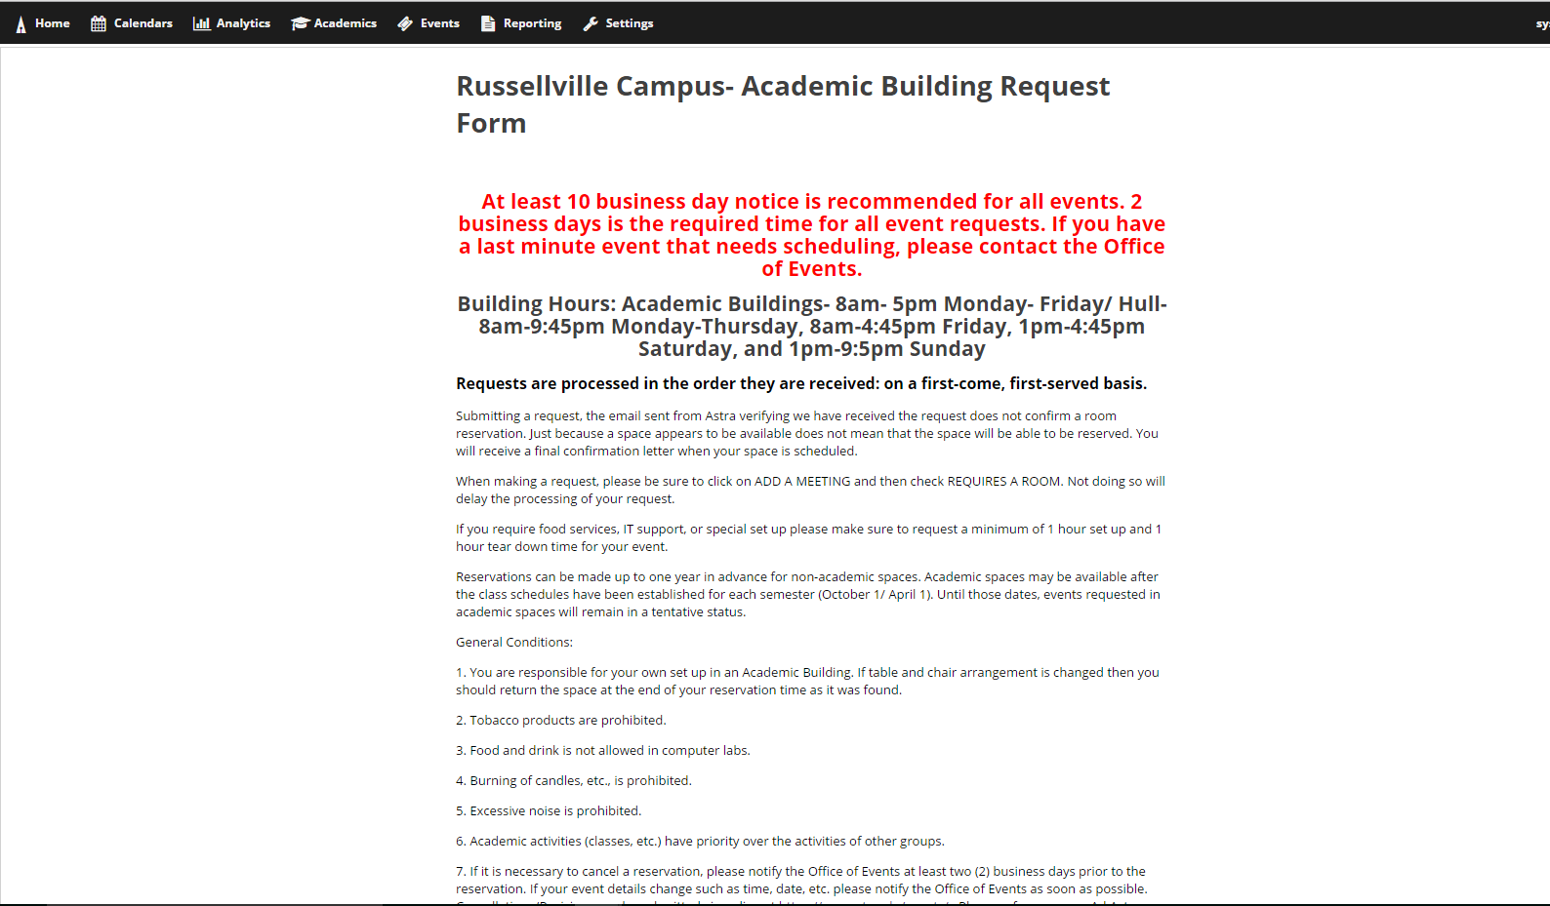
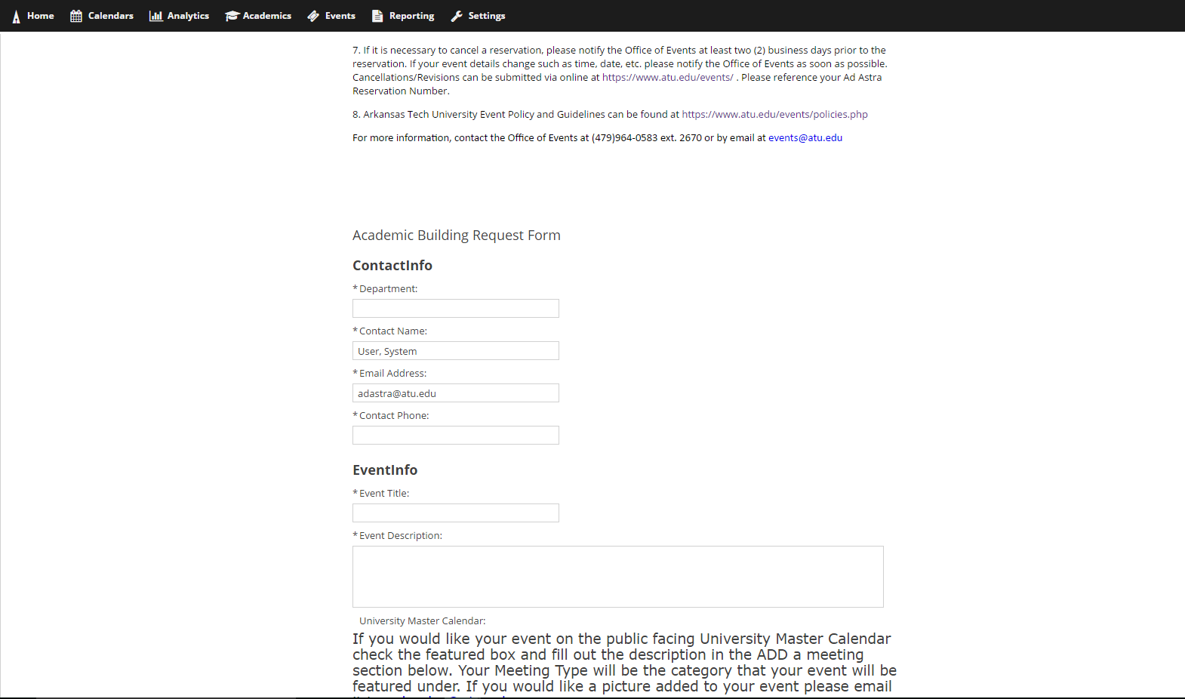
- Once you have filled out the top information you will need to click on Add Meeting
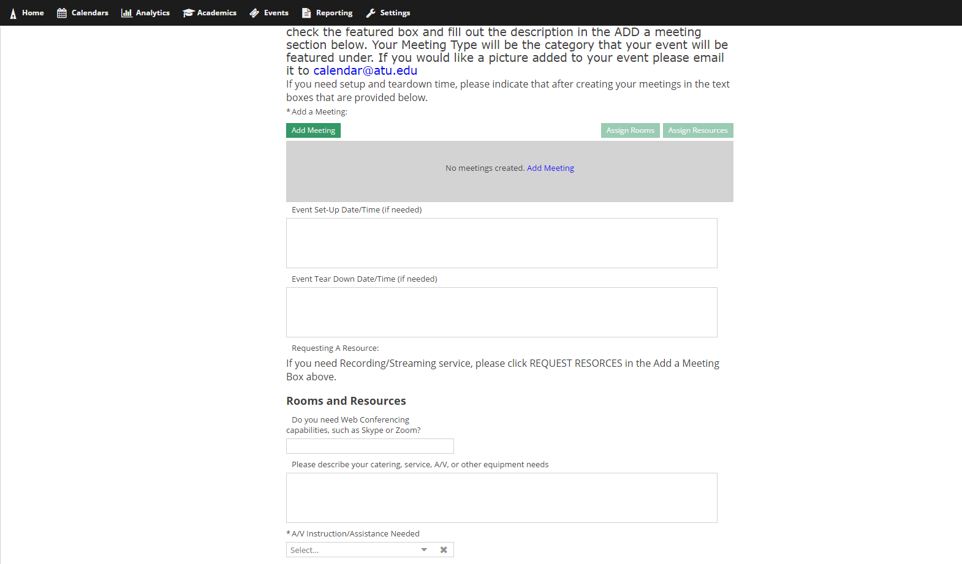
- Once you do that a box will pop-up. You can create a single meeting, multiple meetings that do not have consecutive dates, and recurring meetings.
For Multiple meetings you will click on the days you want the meetings and add the times of the meetings to each meeting. You will then fill out the rest of the information in the Create Meeting(s) box.
For Recurring meetings, you will put the time the meetings will be and then select if they are daily, weekly, etc. You will then select a start date and then either select an end after so many occurrences or an end day. Then you will fill out the rest of the information in the Create Meeting(s) box.
For Single meetings, you will just fill out the Create Meeting(s) box with the information of the meeting. Once you are done with creating your meeting click the Add Meeting button.
- Once you have added your meeting you will then have to assign it a room before you can submit the form. So you will click the Assign Rooms button.
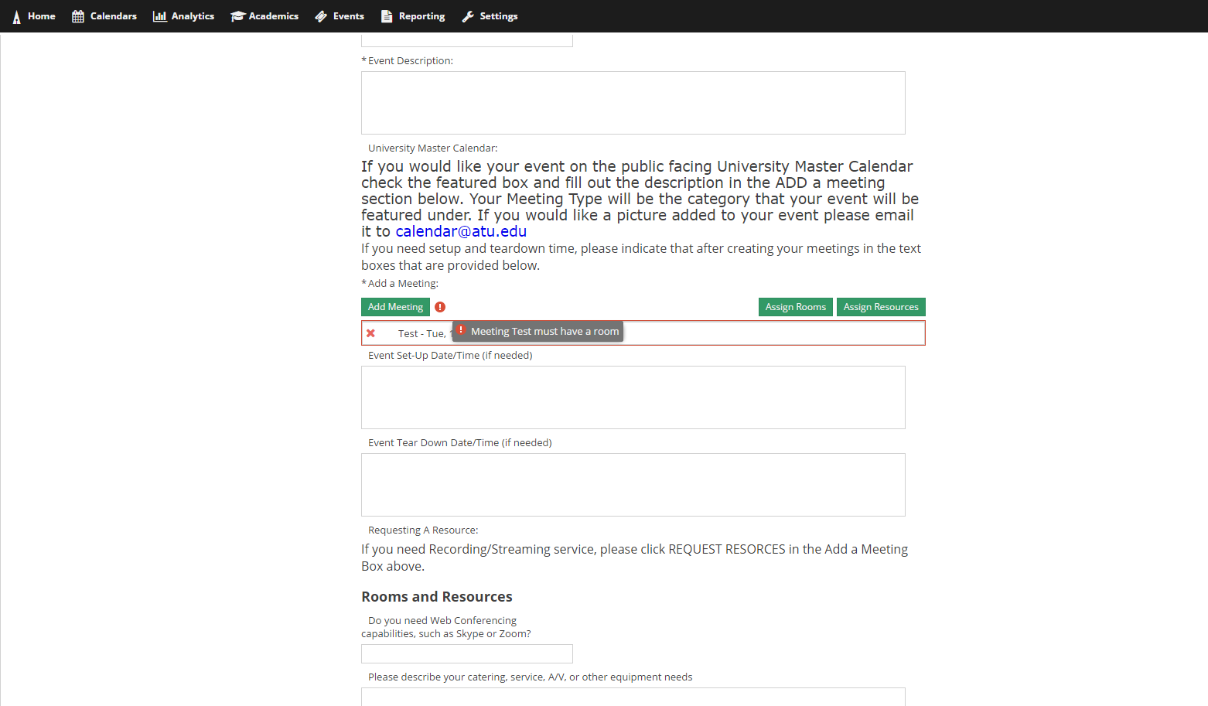
- Once you click the button it will bring you to a pop-up window where you can filter through the rooms on the left. You can filter through the rooms by building and campus or search for a particular room.
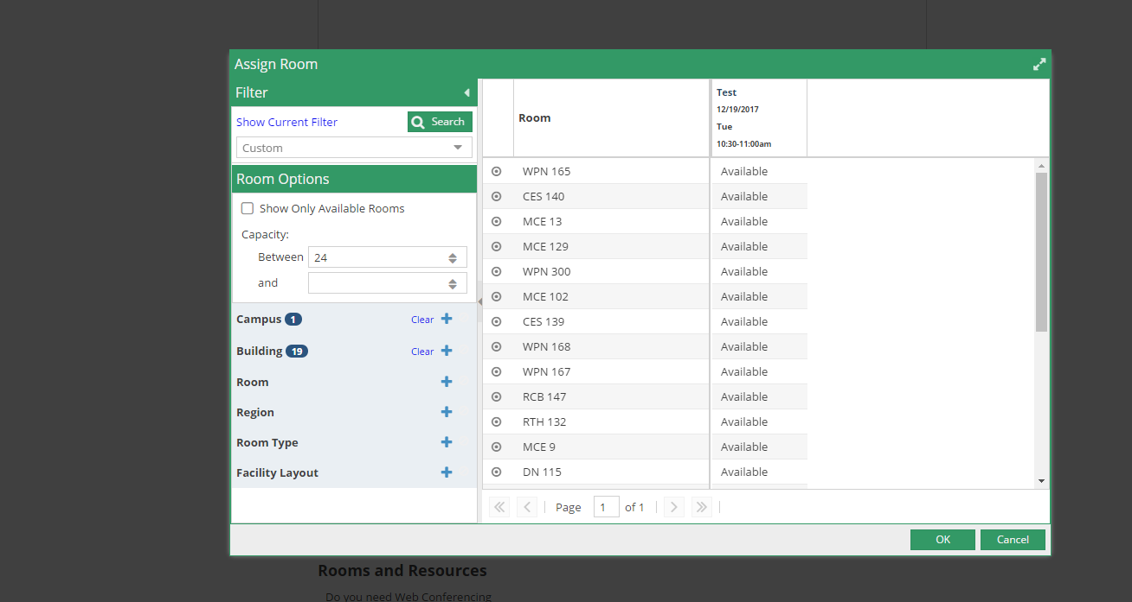
- Once you find the room that you want, you will then click out beside the room where it says available. When you do that it will select the room and the box will show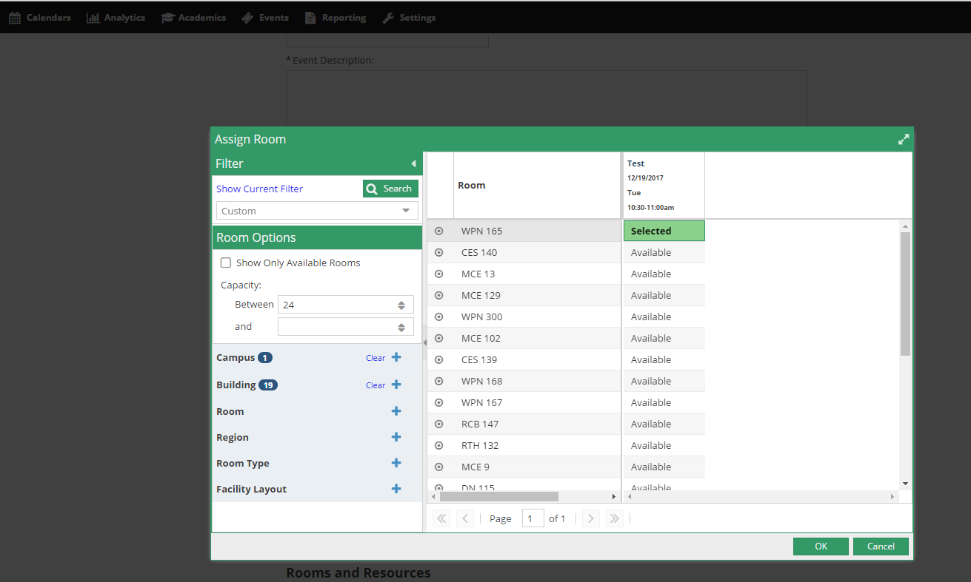 green and say selected.

- Once that is done you will click okay and the pop-up box will disappear.
- If you are in need of a resource you can click the Assign Resources button. This is not required and if your resource is not listed then make sure to note what you need in the Notes section of the form.
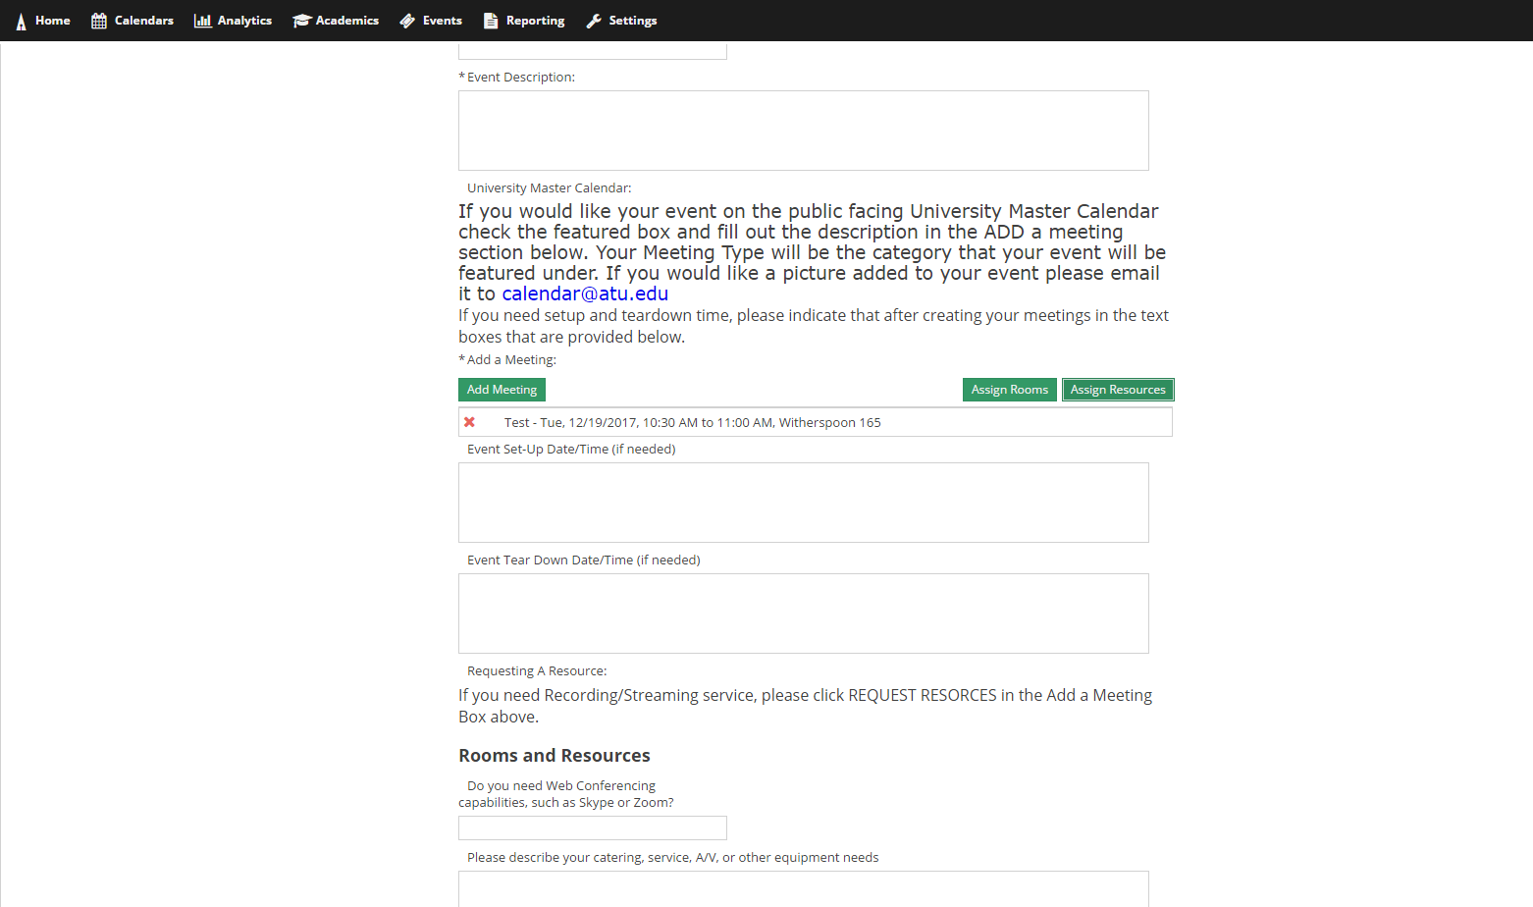
- In the Add Resource box you will see all the resources that you can select. You cannot request a resource that is in RED but you can request those that have no color and say available. Once you have selected your resource you will click the OK button.
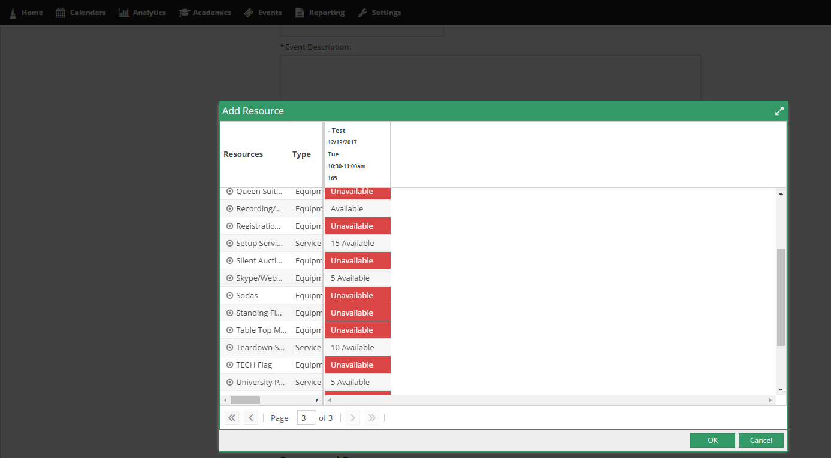
- If you require more resources or if you do not feel comfortable requesting them yourself, you will have to fill out the rest of the form and indicate in detail what you need. Once you have finished filling out the form you will then click submit.
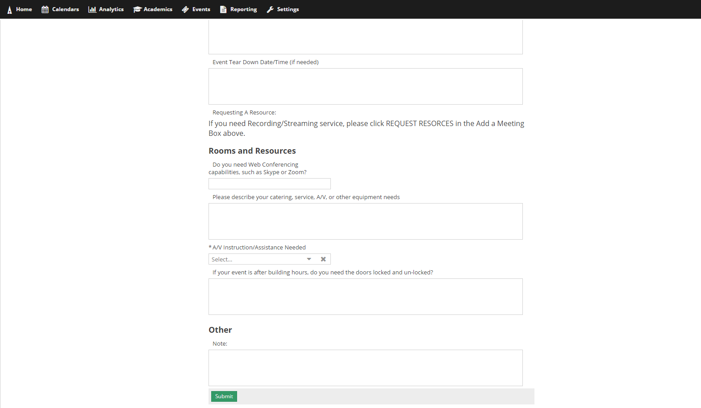

Please Note:
***If you are requesting weekend dates or after hours, you might note that you need to have the doors locked/unlocked by assigning it as a Resource.
*** Please be aware that submitting this form is not a confirmation of a scheduled event. A confirmation email will be sent once your event has been scheduled.
***If you are wanting the event to be on the Campus Calendar, you MUST check the box labeled ‘Featured’. If this is not selected, your event will not be displayed on the Public Facing University Master Calendar.

