​

Ad Astra
Arkansas Tech University is happy to offer centralized scheduling for external and internal users. The Office of Events is the primary point of contact for all departments, groups, and individuals, who are interested in reserving the use of facilities on the Arkansas Tech Russellville campus and at Lake Point Conference Center. Beverly Nehus is the primary point of contact for the Arkansas Tech Ozark Campus. By centralizing the reservation process, we are able to provide efficient and effective service for scheduling your event.
If you are faculty, staff, or a student, log-in to Ad Astra to request your event or to look at a space.
Please use the proper Event Request Form for External Guests. You will receive an email from Ad Astra when your event has been requested. The request will then be reviewed for event, space, and resource approval. Once it is scheduled, you will receive an email confirmation.
If you have any questions please call:
Russellville Campus- 479-964-0583 ext. 2502
Lake Point Conference Center- 479-356-6240
Ozark Campus- 479-667-4046

Instructions For Requesting An Event:
Required: All Events must be made with the minimum lead time listed at the top of each of the forms. If there is not enough lead time it will not let you request the event.
- Ad Astra Link: https://www.aaiscloud.com/ARTechU/
- To log-in to Ad Astra, click the box in the upper right hand corner that says “sign in”. When you do that a box will pop-up. In that box you will enter your Onetech username and password and click “sign in”.
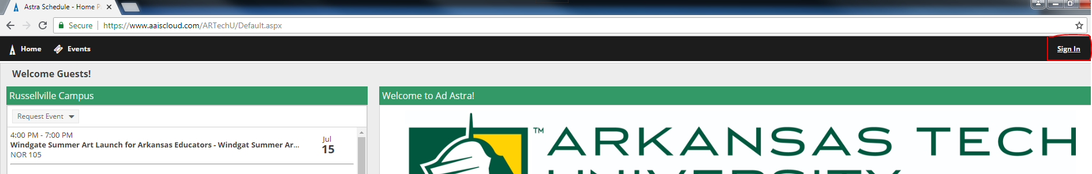
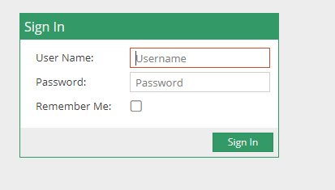
- To see if a space is available, you will click on click the Calendars tab.Once you click the Calendars tab a drop down will appear and you will click on Scheduling Grids.
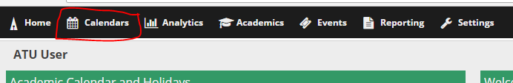
- You will then be taken to the scheduling grid. At the top of the grid you can go to the date you have in mind for your event to see if the space you have in mind is available that day.
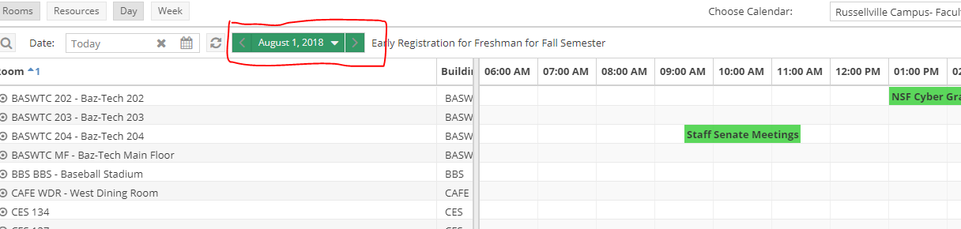

- In the upper left hand side there is a magnifying glass that when you click it, it un-hides the filter panel. This allows you to search for specific buildings or rooms that you may want your event to be held in.
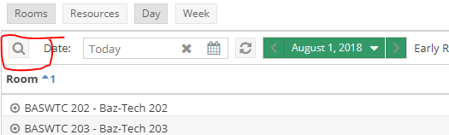
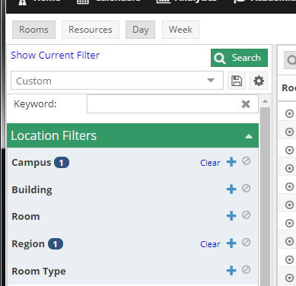

- Once you have checked to see if the space is available, you will now click the Events Tab.
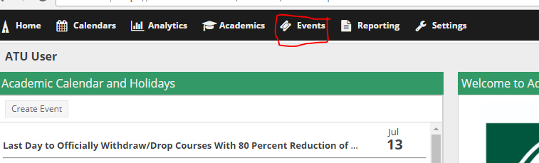

- Once you click the Events tab a drop down will appear and you will click on Request Event.
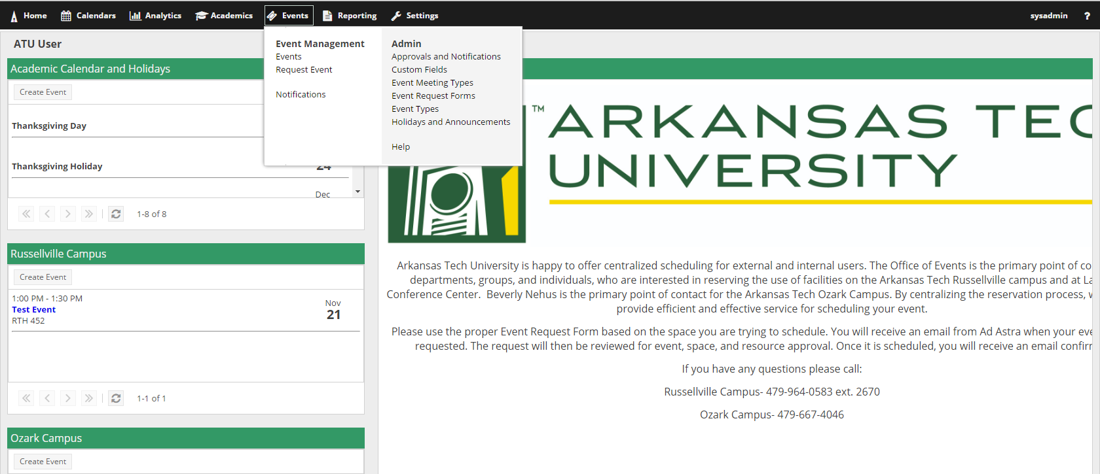
- Once you have done that you will be taken to a pop-up window where you will be able to select whichever event request form you are needing.

- Once you have selected the form you need you will then click “Next”.
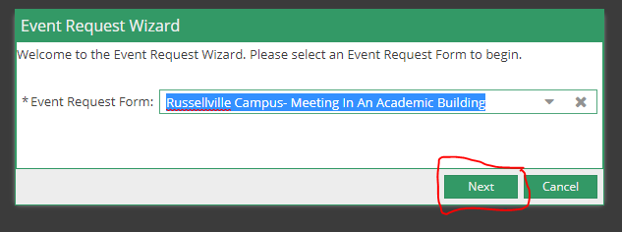
- Fill out the event information on the form.
NOTE: Fields with an (*) require information. If left blank, the system will not allow the request to be submitted.
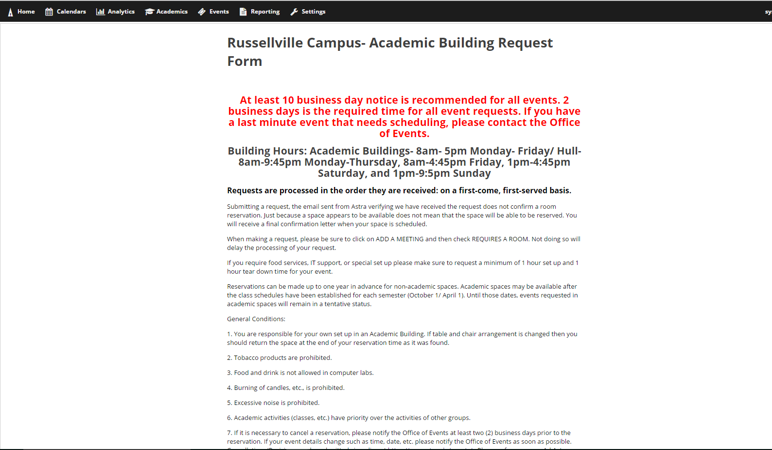
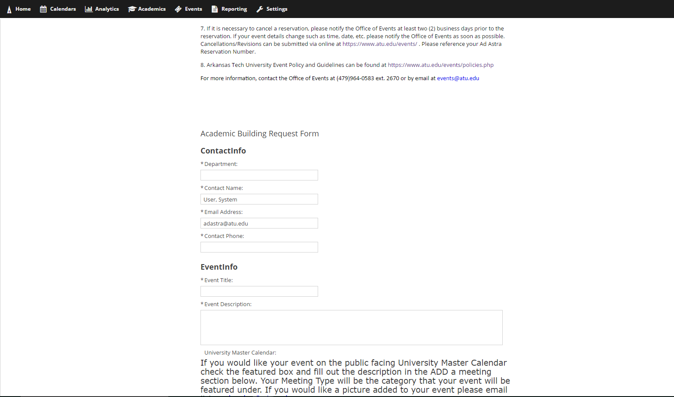
- Once you have filled out the top information you will need to click on Add Meeting
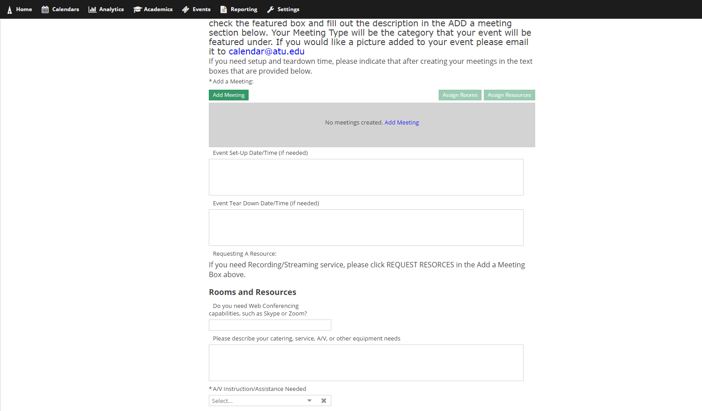
- Once you do that a box will pop-up. You can create a single meeting, multiple meetings (meetings that do not have consecutive dates), and recurring meetings.
For Multiple meetings you will click on the days you want the meetings and add the times of the meetings to each meeting in the start time and end time boxes. You will then fill out the rest of the information in the Create Meeting(s) box.

For Recurring meetings, you will put the time the meetings will be in the start time and end time boxes and then select if they are daily, weekly, etc. You will then select a start date and then either select an end after so many occurrences or an end day. Then you will fill out the rest of the information in the Create Meeting(s) box.
For Single meetings, you will just fill out the Create Meeting(s) box with the information of the meeting. Once you are done with creating your meeting click the Add Meeting button.

- Once you have added your meeting you will then have to assign it a room before you can submit the form. So you will click the Assign Rooms button.
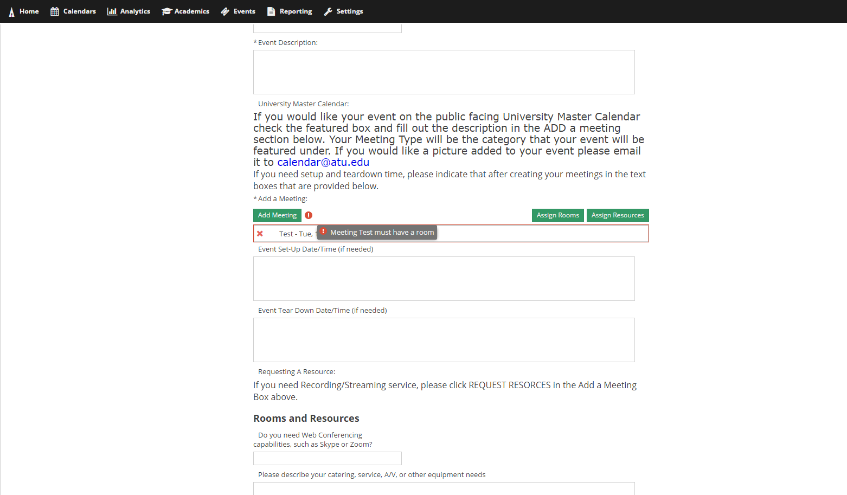

- Once you click the button it will bring you to a pop-up window where you can go through the available rooms on campus using the arrows at the bottom of the Assign Room box.
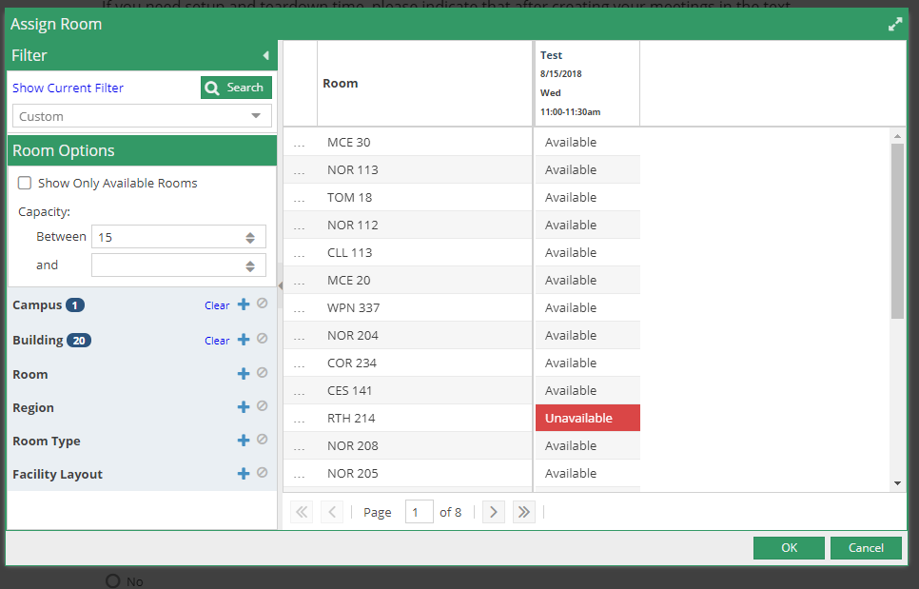
- Once you find the room that you want, you will then click out beside the room where it says available. When you do that it will select the room and the box will show green and say selected.
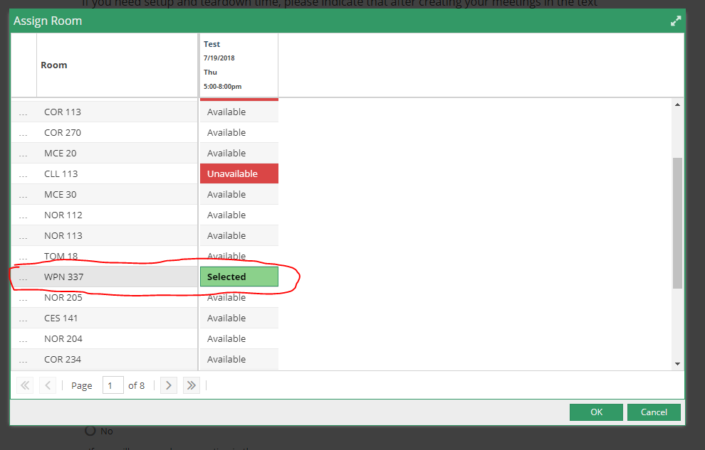
- Once that is done you will click okay and the pop-up box will disappear.

- If you are in need of a resource you can click the Assign Resources button. This is not required and if your resource is not listed then make sure to note what you need in the Notes section of the form.
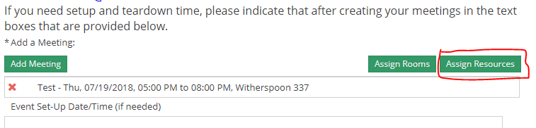

- In the Add Resource box you will see all the resources that you can select. You cannot request a resource that is in RED but you can request those that have no color and say available. When you click in the available box, it will turn green and if it says “15 available”, you will have to type the number of the resource you need. If you have 15 events in one day you would just type 15 in the box after you click on it. Once you have selected your resource and the amount you need, you will click the “OK” button.
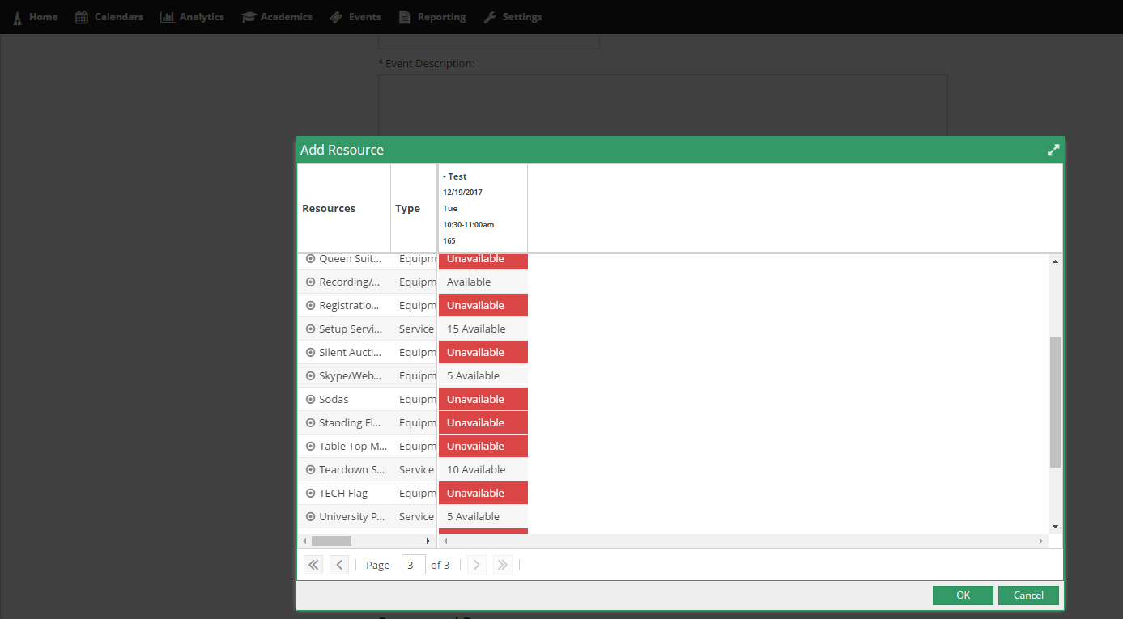

- If you require more resources or if you do not feel comfortable requesting them yourself, you will have to fill out the rest of the form and indicate in detail what you need. Once you have finished filling out the form you will then click submit at the bottom of the page. If you missed a required box (*), the system will not allow you to submit the form until all required information is filled out.
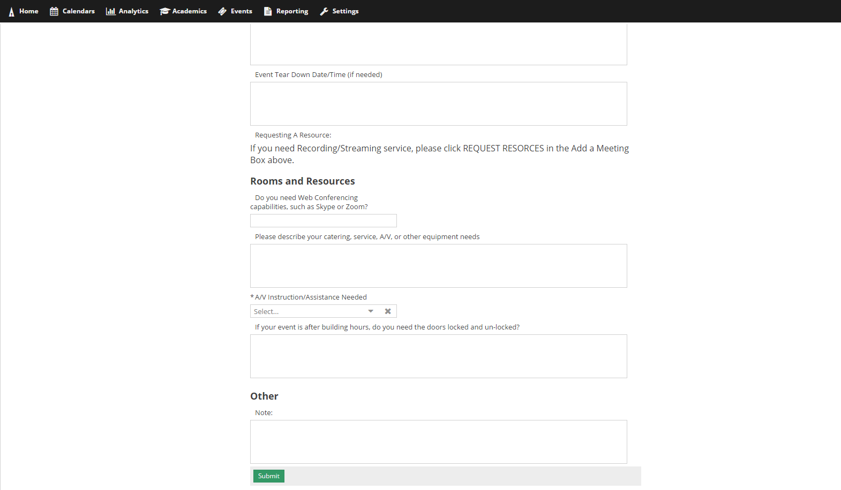

Please Note:
***If you are requesting weekend dates or after hours, you might note that you need to have the doors locked/unlocked by assigning it as a Resource.
*** Please be aware that submitting this form is not a confirmation of a scheduled event. A confirmation email will be sent once your event has been scheduled.
***If you are wanting the event to be on the Campus Calendar, you MUST check the box labeled ‘Featured’. If this is not selected, your event will not be displayed on the Public Facing University Master Calendar.
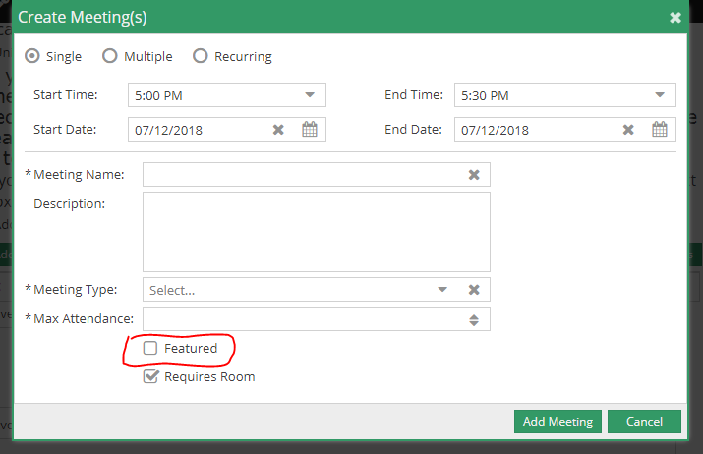

Ad Astra Useful Information

Choosing a request form
- Lake Point Event Request: Use this form to request use of the spaces at Lake Point.
- Russellville Campus- Meeting in an Academic Building: Use this form to request rooms that are in academic buildings on the Russellville Campus.
- Russellville Campus- Athletic Facility: Use this form to request athletic spaces as well as the Green and Gold Room on the Russellville Campus.
- Russellville Campus- Co-Sponsored: Use this form to request the use of spaces on campus for events that are considered co-sponsored events.
- Russellville Campus- Ross Pendergraft Library: Use this form to request rooms in the Ross Pendergraft Library
- Russellville Campus- Baz-Tech, Doc Bryan, Young and Outdoor Spaces: Use this form to request any of the student services spaces such as the meeting rooms in Baz-Tech, the Young Ballroom, and outdoor spaces. Outdoor spaces are labeled as “OES” plus the initials of the outdoor space. Tabling spaces are located under this form as well. When going through the available spaces the tabling spaces will be labeled “TABLE” which will also contain the initials of the actual tabling space.
- Russellville Campus- West Dining Room: Use this form to request the West Dining Room.
- Russellville Campus- Williamson Dining Room: Use this form to request Williamson Dining Room.
- Russellville Campus- Witherspoon Auditorium/Lobby: Use this form to request the Witherspoon Auditorium and/or the Witherspoon Lobby.

Calendar:
https://calendar.atu.edu/pages/mainCal.php
Ozark Campus
Russellville Campus

Calendar Categories (Event Meeting Types)
Alumni – events for Alumni of the University
Athletic- Golden Suns or Wonder Boys athletic events
Campus- events occurring on campus for Faculty and Staff
Community- events open to the general public
Employee- events for employees of the University
Meetings & Conferences
Camps & Clinics
Norman Hall Art Gallery

Public Safety
Residence Life
Student Campus Life- events for SGA, SAB, and Registered Student Organizations
Student Success- events that contribute to student success
Student Wellness- events that are geared to student wellness
Witherspoon Auditorium

Users can add their event to the public facing calendar by completing the description, selecting the meeting type for the category they would like their event to appear under, and checking the featured box. If you would like an image featured please email it to calendar@atu.edu

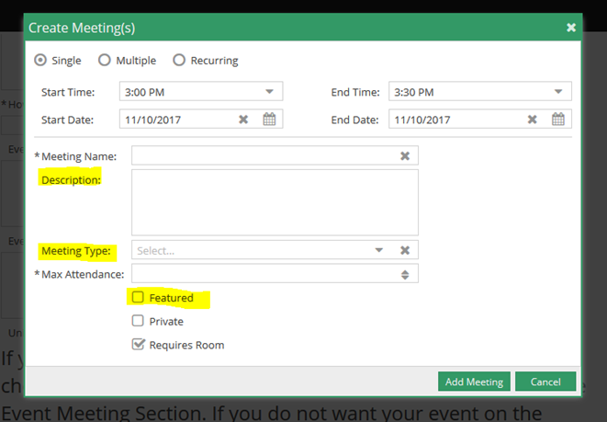

For a campus event that is occurring off campus but needs to be included on the public facing calendar go to www.atu.edu/events and use the Submit My Event to the Calendar link. Also, if you did not enter your description at the time of your event request you can use the same link to enter your information and be sure to include your Ad Astra Reservation Number.

List of resources available to be requested on the Russellville Campus:
Audio Technician: If you need assistance with technology at your event in Doc Bryan Lecture Hall please request an Audio Technician. This resource has to be approved before the event is approved.
Lock and Unlock Service: This service is for the locking and un-locking of rooms and buildings after the building hours.
OIS Tech Support: OIS Tech Support for anyone requiring AV assistance.
Recording/Live Streaming Cart: Recording/Live Streaming Cart that is available for use on the Russellville Campus. There is a minimum of a one-hour setup and teardown time required for this resource. This resource has to be approved before the event is approved.
Skype/Web Conference: Select this resource if this event requires audio and visual communication between one or more remote parties that is NOT facilitated by Zoom. Skype/Web Conference is limited to certain rooms on campus.
Zoom: Select this resource if the event requires audio and visual communication between one or more remote parties that is facilitated by Zoom. Zoom Web Conferencing is limited to certain rooms on campus.

