The Directed Reading Sequence (DRS)
Secondary Strategy
(Klemp, 1997)

The Directed Reading Sequence is a sustained reading activity performed in small groups. This cooperative learning strategy has been shown to be an effective means of reading instruction in content areas for low achieving students. Many teachers cite reluctance to use small groups for fear of encouraging chaos and lost of control; however, cooperative learning not only improves learning form text, but also allows students to witness strategies used by peers in reading expository text. The classroom is purposely organized into teacher-selected groups to promote literacy, providing an opportunity for all students to communicate and learn content area material. Much of this strategy’s success is based on the fact that it has sufficient organization of purposeful tasks. Although the teacher may not always use cooperative activities on a daily basis, the teams are in place to promote interdependence and group and individual accountability.
In the Directed Reading Sequence strategy the teacher facilitates reading of text selections, and students find themselves involved in elaboration, summarization, and retelling of the information they have read. Use of this strategy also increases proficiency in negotiating the literacy demands of text for all learners, including English Language Learners. The Directed Reading Sequence should be taught as a process apart from the lesson prior to its implementation. The teacher can then use the strategy whenever the lesson demands it. The four steps below describe the entire activity:

STEP 1: Text Selection

- Prior to the assigned reading time, the teacher determines which sections of the text match the learner outcomes.
  - “Section” means any portion of the text which accommodates a break in the reading.
  - Sections can be determined by bold sub-headings, points when concept load increases, prediction points, scene or setting changes, or plot deviations.

** If there are sections of text the teacher feels are not applicable to the learning outcomes, she or he may wish omit those portions.

STEP 2: Establishing Roles

- Each group receives a set of role cards prior to the activity.
- According to the teacher’s directions, the class will read a section silently.
- At the end of the allotted reading time, each group will be directed to distribute the role cards.
- The cards, (or laminated strips—see next page), will indicate the roles for the Directed Reading Sequence: paraphraser, verifier, squeezer, and writer. These roles perform the following functions:

  - Paraphraser-- retells what was in the selection in his/her own words.
  - Verifier—listens carefully to the paraphraser to check information; perhaps correcting errors, or add items which may have been omitted. (Groups of 5 may want to have 2 verifiers).
  - Squeezer—considers the information and will orally create one general sentence which captures the essence of the selection.
  - Writer—with group agreement, the writer will write that sentence on an overhead transparency. The squeezer dictates the finalized sentence to the writer.

The teacher may want to share with the class the groups’ summary sentences. This helps students who sometimes have difficulty determining which details to leave out and which ones to keep. The sharing of sentences also allows the teacher to check for comprehension

STEP 3: Intermittent Use

After the selection is read and the sentences developed the group rotates role cards. Over time each member of the group assumes each role.

STEP 4: Extending the Activity

The collected sentences become a group memory of the reading and can be used for follow up activities such as: questions and answer activities, discussion activities, creation of a study guide using student-generated questions, or further reinspection of the text.

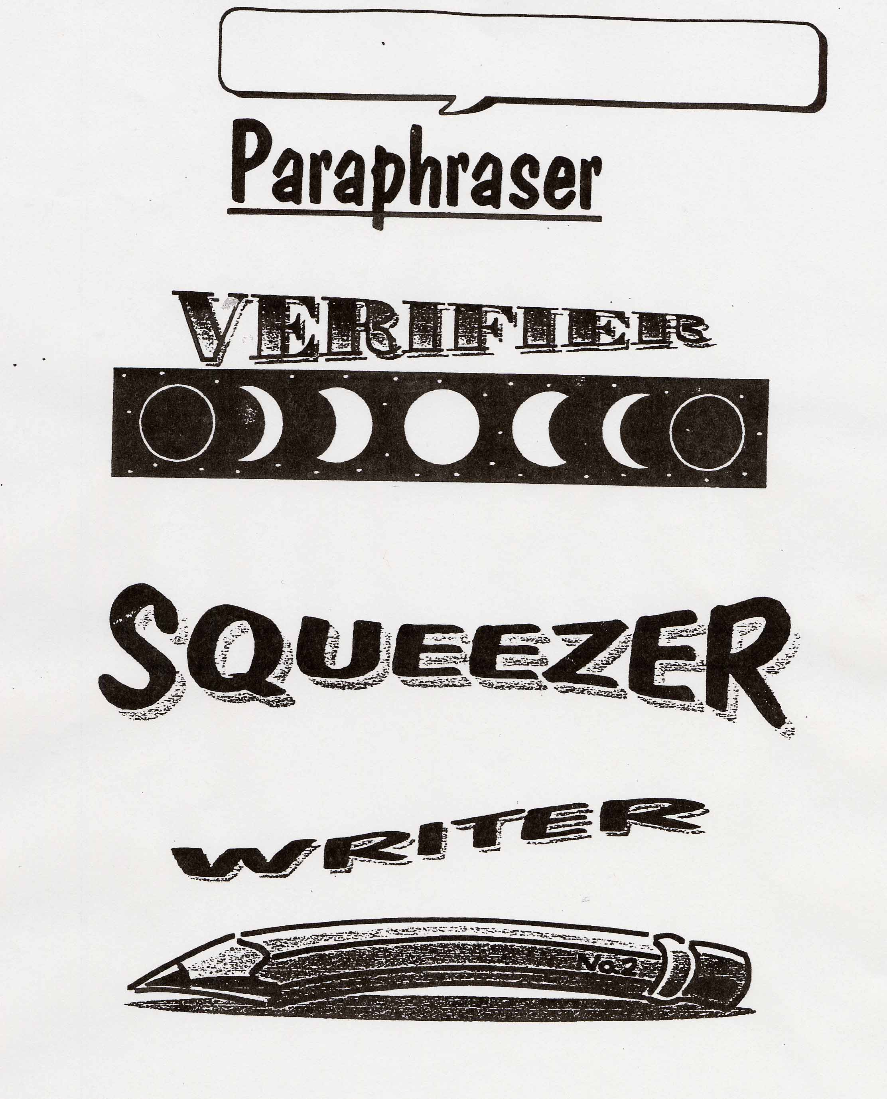

Now try a practice passage…..

Practice

The first truly American art movement was formed by a group of landscape painters that emerged in the early nineteenth century called the Hudson River School. The first works in this style were created by Thomas Cole, Thomas Doughty and Asher Durrand, a trio of painters who worked during the 1820s in the Hudson River Valley and surrounding locations. Heavily influenced by European romanticism, these painters set out to convey the remoteness and splendor of the American wilderness. The strongly nationalistic tone of their paintings caught the spirit of the times, and within a generation the movement had mushroomed to include landscape painters from all over the United States.
One factor contributing to the success of the Hudson River School was the rapid growth of American nationalism in the early nineteenth century. The War of 1812 had given the United States a new sense of pride in its identity, and as the nation continued to grow, there was a desire to compete with Europe on both economic and cultural grounds. The vast panoramas of the Hudson River School fitted the bill perfectly by providing a new movement in art that was unmistakably American in origin. Canvases celebrating such typically American scenes as Niagara Falls, Boston Harbor, and the expansion of the railroad into rural Pennsylvania were greeted with enormous popular acclaim.

Reading passage taken from:
Kaplan Learning Services. (1998). Critical reading seminar. New York: Kaplan Educational Centers.

