**How to Request Accommodations – Guide to Sending Faculty Notification Letters**

1. Go to the Disability Services website at [https://www.atu.edu/disabilities/](https://www.atu.edu/disabilities/%20) .
2. Click on the third icon labeled “Login to the Disability Services Portal”.



3. Enter your OneTech username and password in the appropriate fields.

4. Click the “Sign In” icon to proceed to the Student Dashboard.

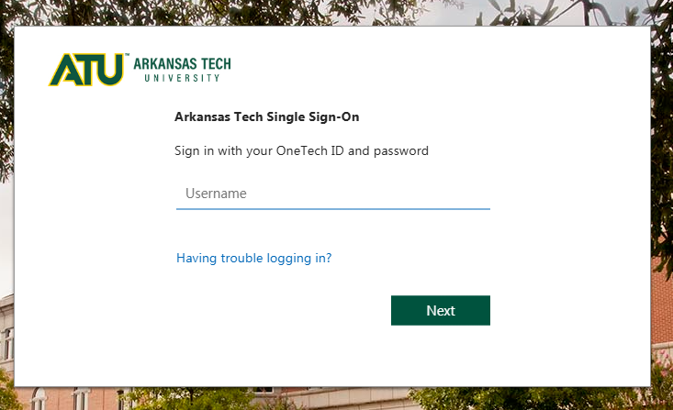

5. If you receive an error message, it means your classes have not yet loaded into the system.  
Please allow up to **48 hours** for your courses to appear.  
If your courses are still not visible after 48 hours, **contact our office for assistance**.

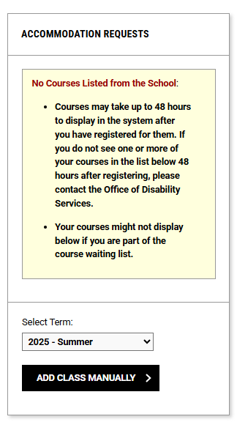

6. You are now logged into the portal and should see your **Student Dashboard**.

7. If you have any **E-Forms pending acknowledgement**, you will need to review and digitally sign them **before you can continue with the renewal process**.

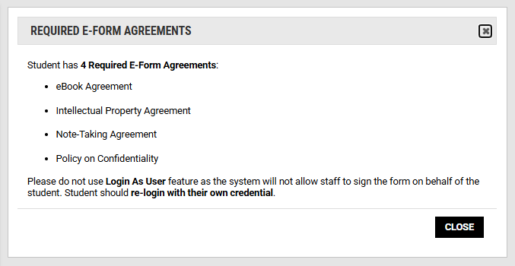

8. On the dashboard, click the **“Add Requests for (#) Classes”** button to begin.

9. Select the classes where you would like your accommodations applied, then choose **“Continue to Next Step.”**

10. Review the list of your approved accommodations and select the ones you need for each class.

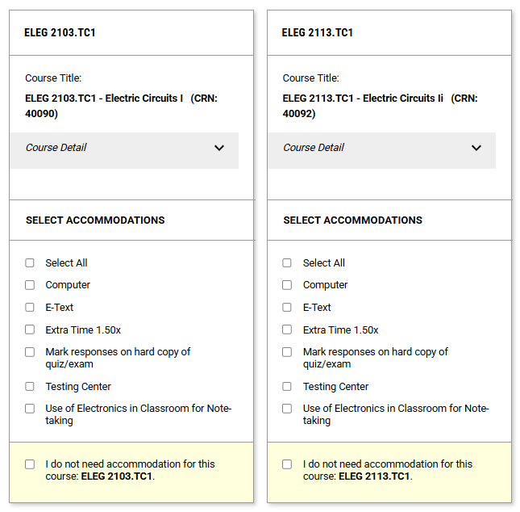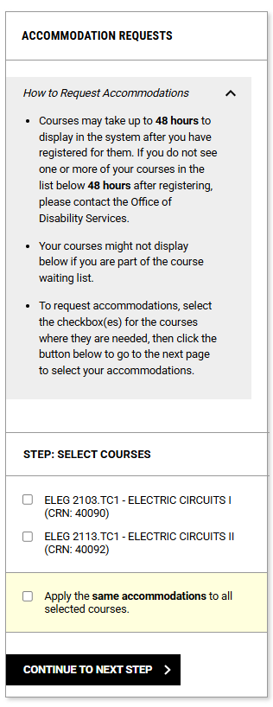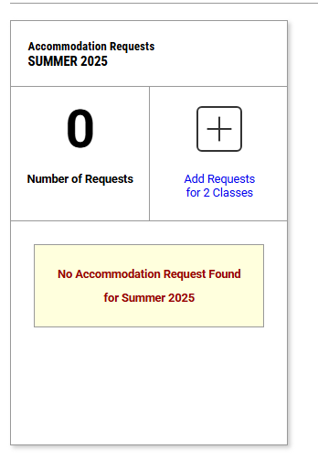

Step 10 10

Step 9

Step 8

11. Check the box next to **“Student Rights and Responsibilities,”** then scroll to the bottom of the page and click **“Submit Request.”**

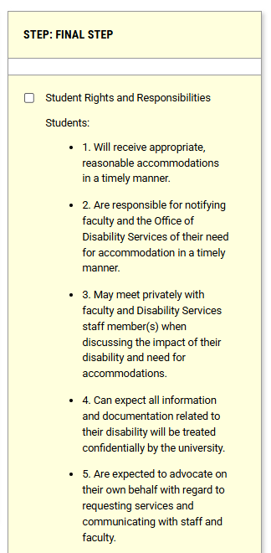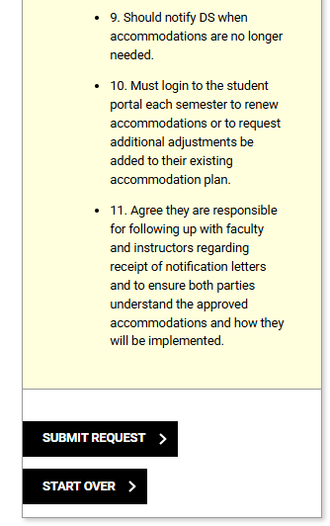

12. Once your letters have been approved you and your professor will each receive a copy of the accommodation letter for the class. 13. You may review your requests from the student dashboard. Please remember that you must log into the portal and submit your request for accommodations each semester.

