**Returning Student Additional Accommodation Request Guide**

1. Go to the Disability Services website at [https://www.atu.edu/disabilities/](https://www.atu.edu/disabilities/%20).
2. Click on the third icon labeled “Login to the Disability Services Portal”.

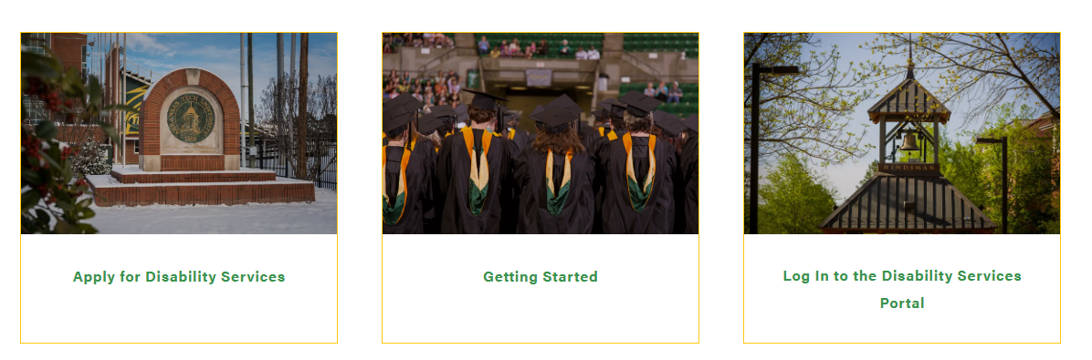

3. Enter your OneTech username and password in the appropriate fields.

4. Click the “Sign In” icon to proceed to the Student Dashboard.

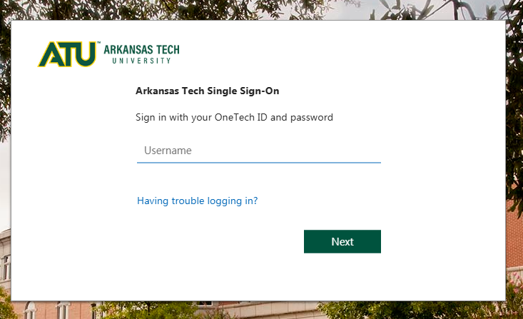

3. Sign In

2. Enter OneTech Username and Password

5. You are now logged into the portal and are at the Student Dashboard. From here, under the “Accommodations” tab, you will select the “Additional Accommodation Request Form” option.

**Please note that this will show you both requests that you have already submitted, as well as allow you to submit an additional request.

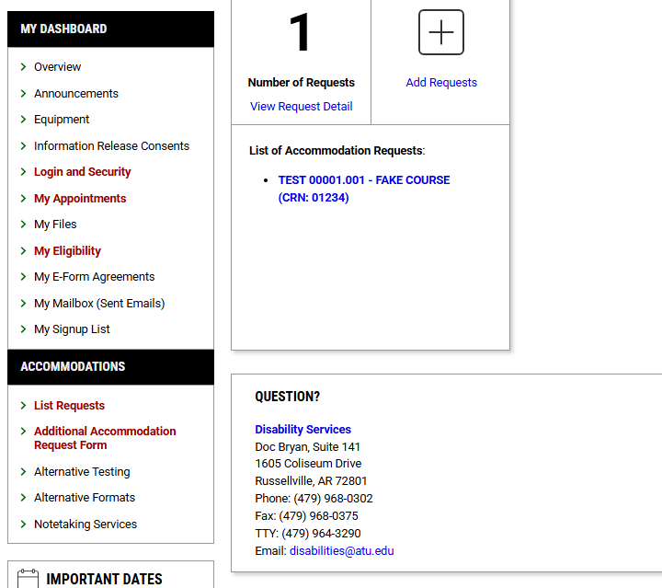

6. Please fill out the required fields and specify what additional accommodations you are requesting.

7. Select the “Submit Request” button once you have finished filling out your information. Confirm you would like to submit the request.

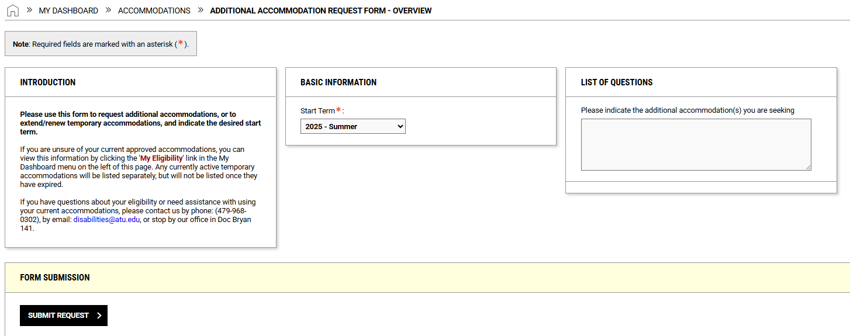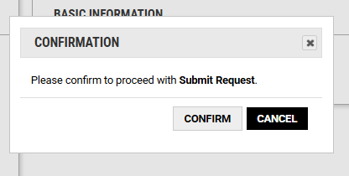

8. You will receive confirmation that your application has been submitted. Scroll to the bottom of the screen.

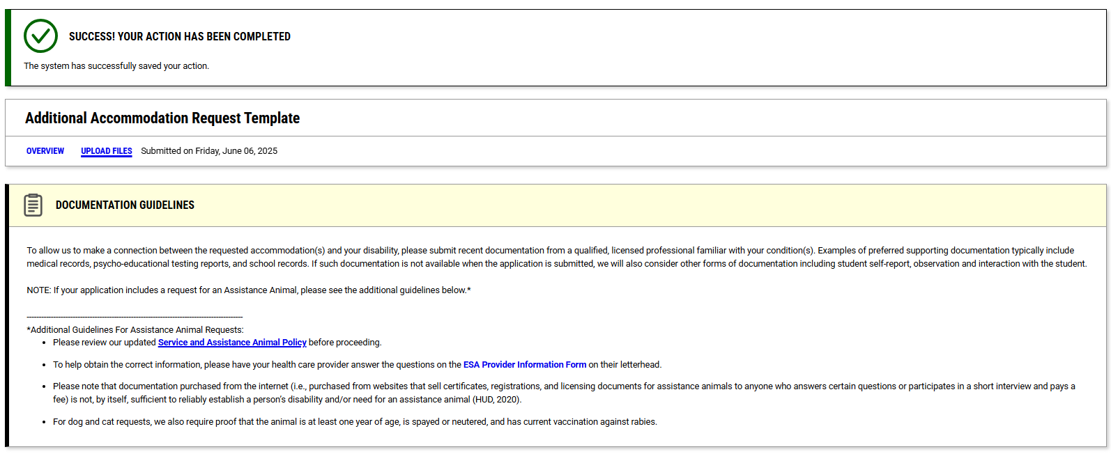

9. Here you will be able to upload documentation supporting your new request. Once you have attached the documentation, select “Upload File.”

