**New Student Application Guide**

1. Go to the Disability Services website.
2. Click “Apply for Disability Services”

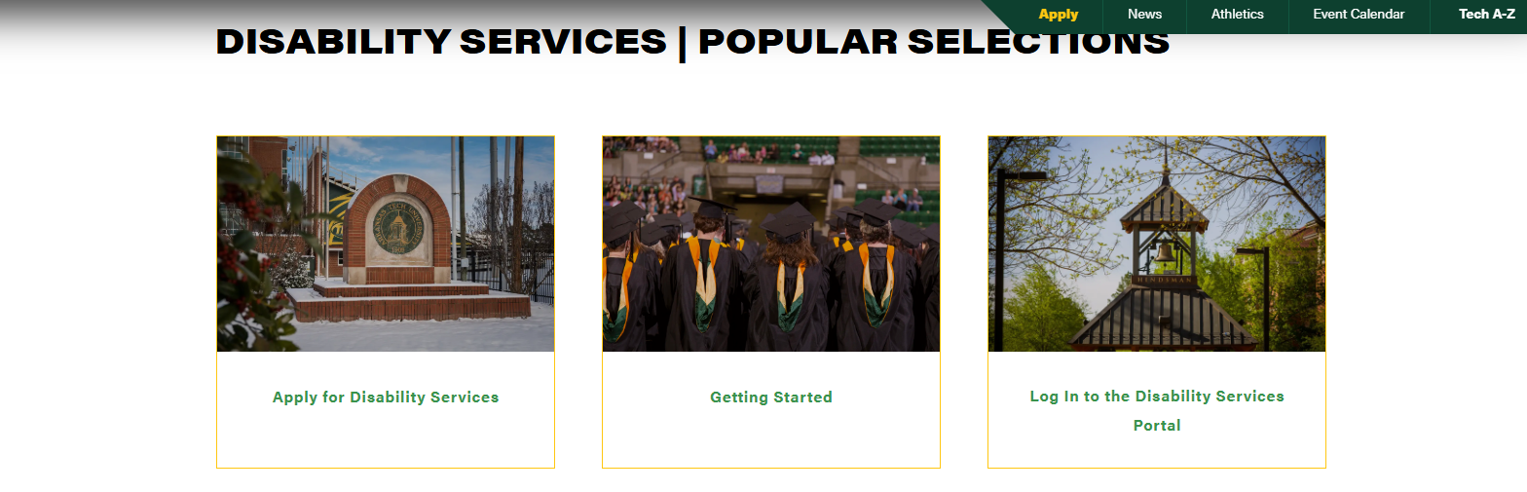

**New Student Application Guide**

3. Use your OneTech username and password to login to the Disability Services portal.

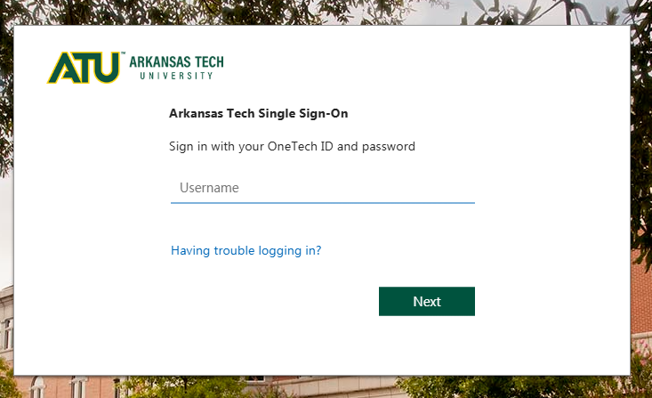

5. Select “Start New Application”

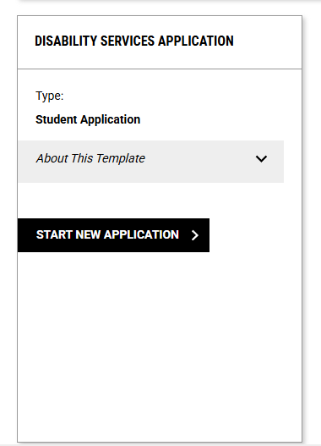

1. Fill out all required fields with your personal information.
2. Click “Create Application Draft”.

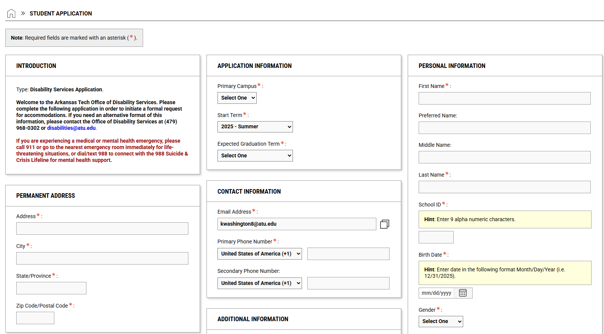

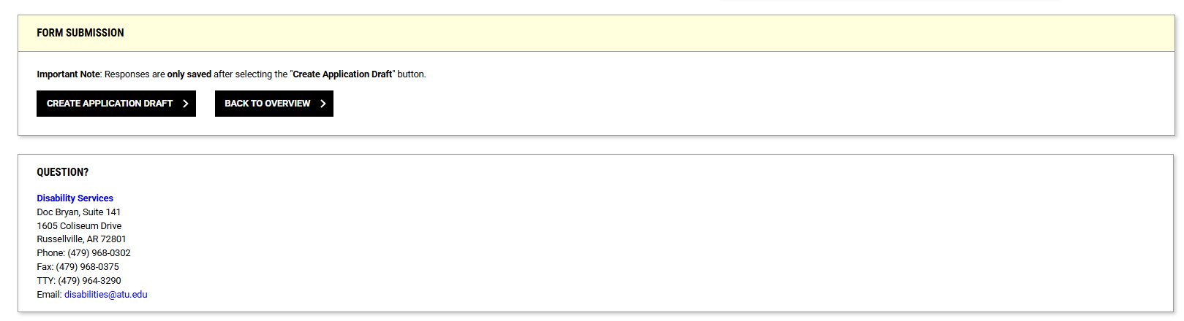

1. Once you have created your application draft you will need to fill out the questionnaire, giving us some information about the nature of your disability and the accommodations you are seeking.
2. To save your application and submit documentation related to your request, select “Save and Upload Documentation.” To sign a release of information giving someone permission to access your information, select “Continue – Information Release Consents.” To continue forward with the process of submitting your application, select “Proceed to Final Review.”

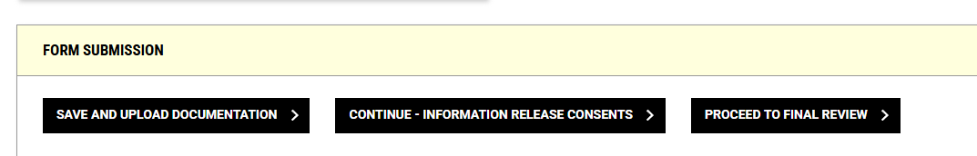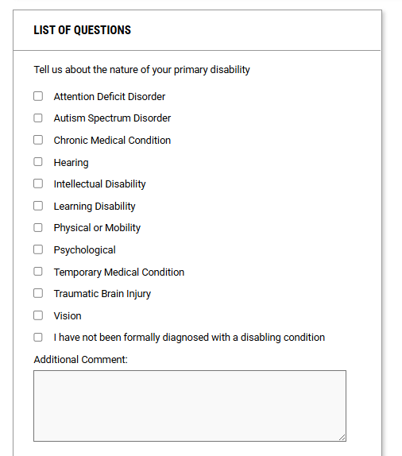

10. Select “Submit Application”. You will receive a confirmation notification that your application has been successfully submitted.

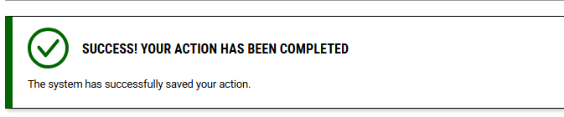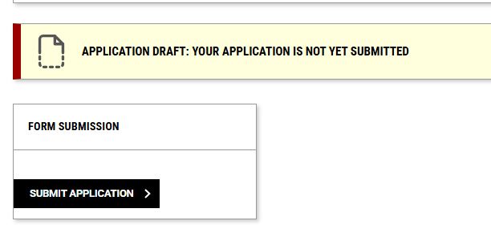

11. You will now be able to track the status of your application by logging in to the Disability Services Portal.

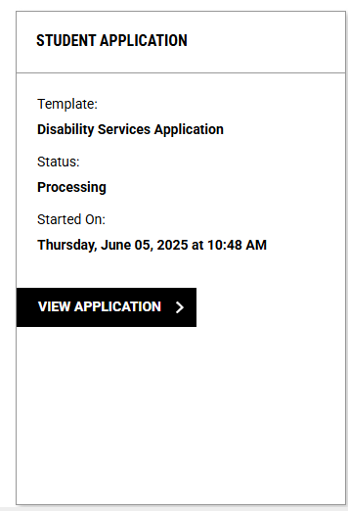

You will then receive an email with [AIM] in the subject line that informs you that your application information was received. If you have not already uploaded documentation using the “Save and Upload Documentation” button shown above, you will receive an additional email requesting documentation with a link to the appropriate page.

1. Congratulations! You’ve completed the initial application process. Watch your ATU email account for correspondence from our office within a few business days. We will email you soon and let you know if we need more information or if it is time for you to contact us for an appointment.

Contact Campus Support

479-968-0646