Instructor AIM Guide: Overview
- Go to the Disability Services website.
- Click “Faculty Resources” tab.
- Select the “Instructor Portal” dropdown and click “Instructor Portal”


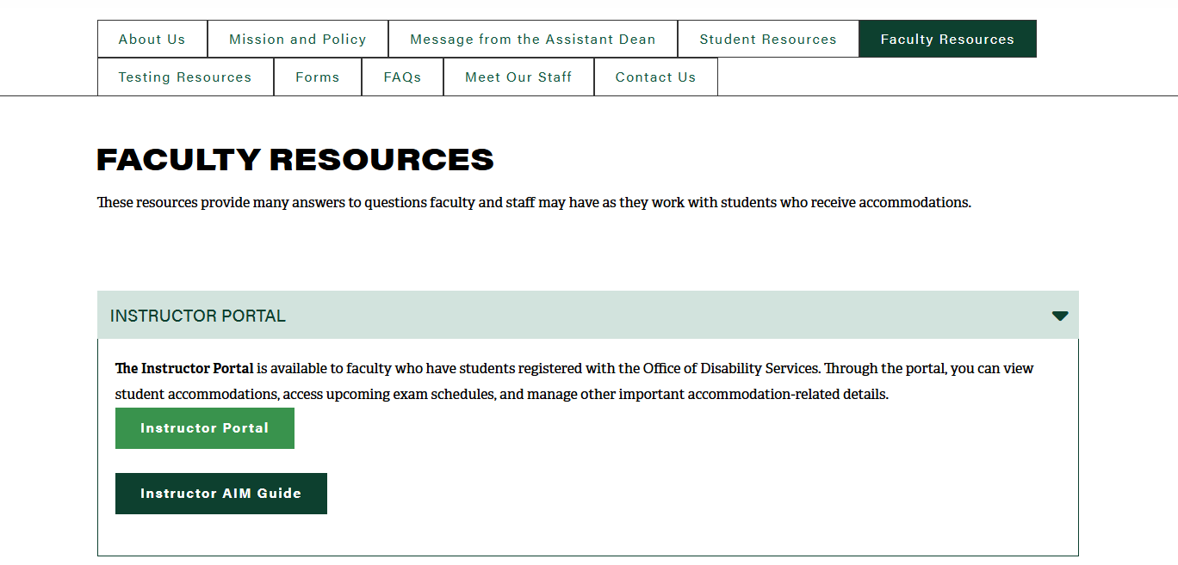


- Use your OneTech username and password to login to the Disability Services portal and click “Next”

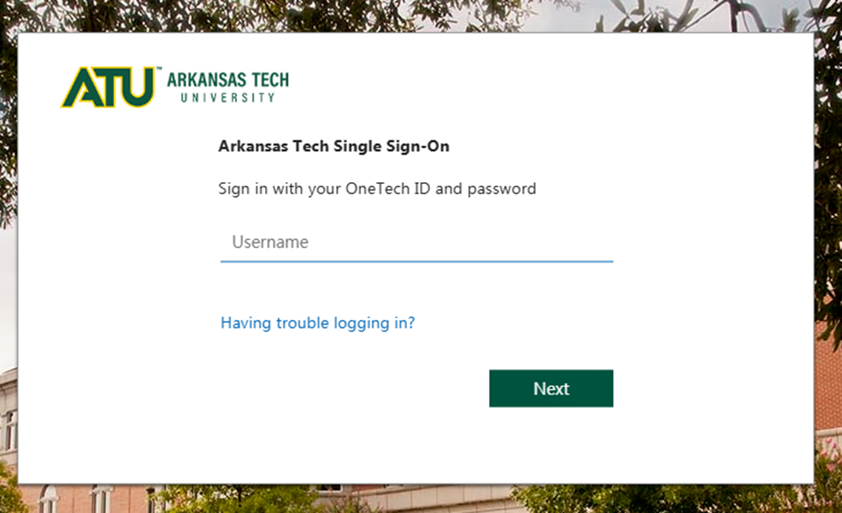

- Read and acknowledge the FERPA agreement. Then select “Continue to View Student Accommodations”

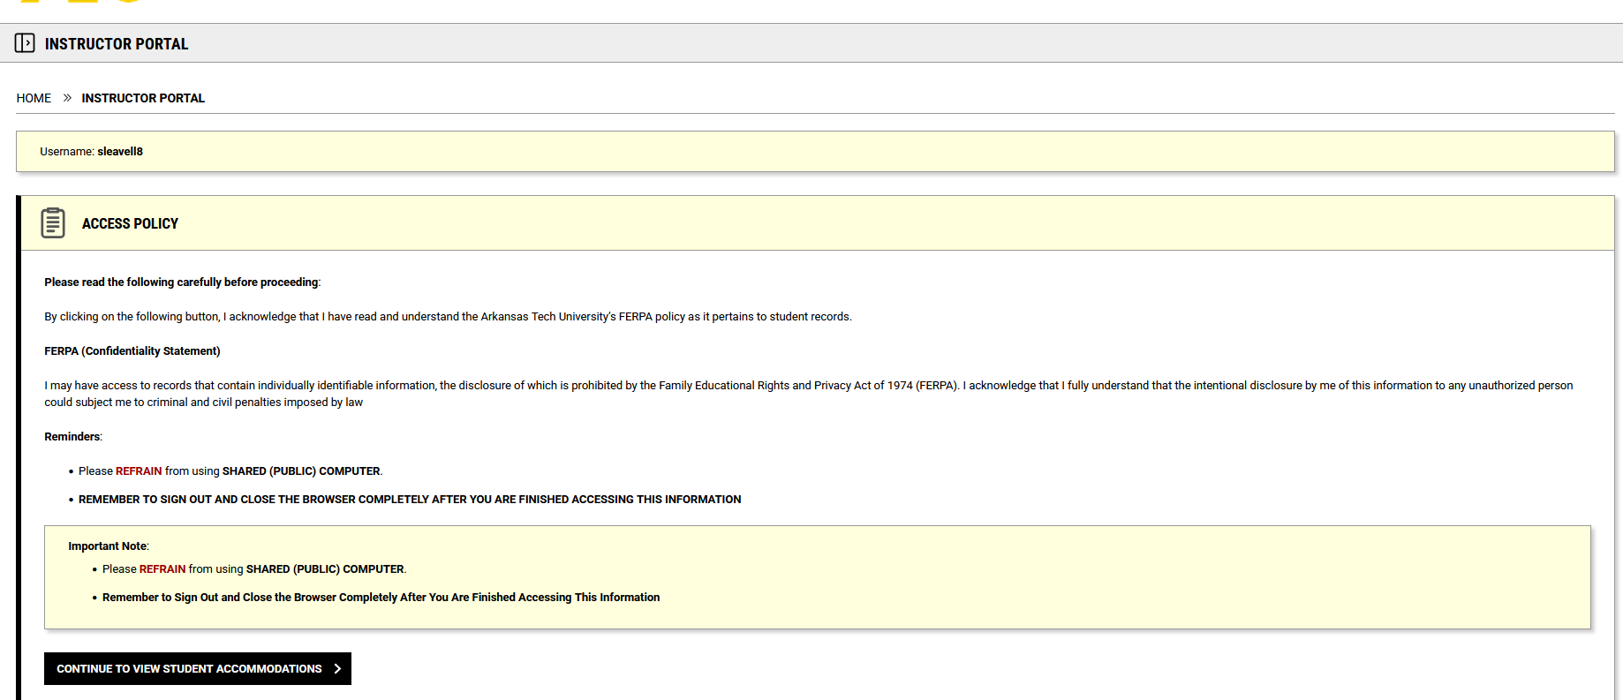

- Access the Instructor Overview Page, where instructors can:
  - See all students with accommodations
  - View the main accommodations requested
  - Check whether they have read the faculty notification letter (Only updated if read through Instructor Access, not via email)
- Defaults to current term and list of requested accommodations. You can select the term you are looking for by using these
buttons “Previous Term” and “Next Term”
- Session Extender: The instructor portal has a Session Extended available that will add 30 minutes to the session. A warning will be displayed when 2 minutes are remaining.

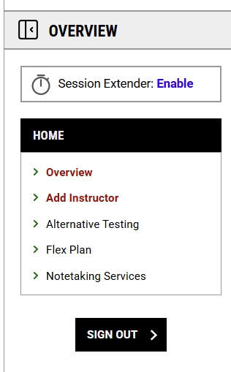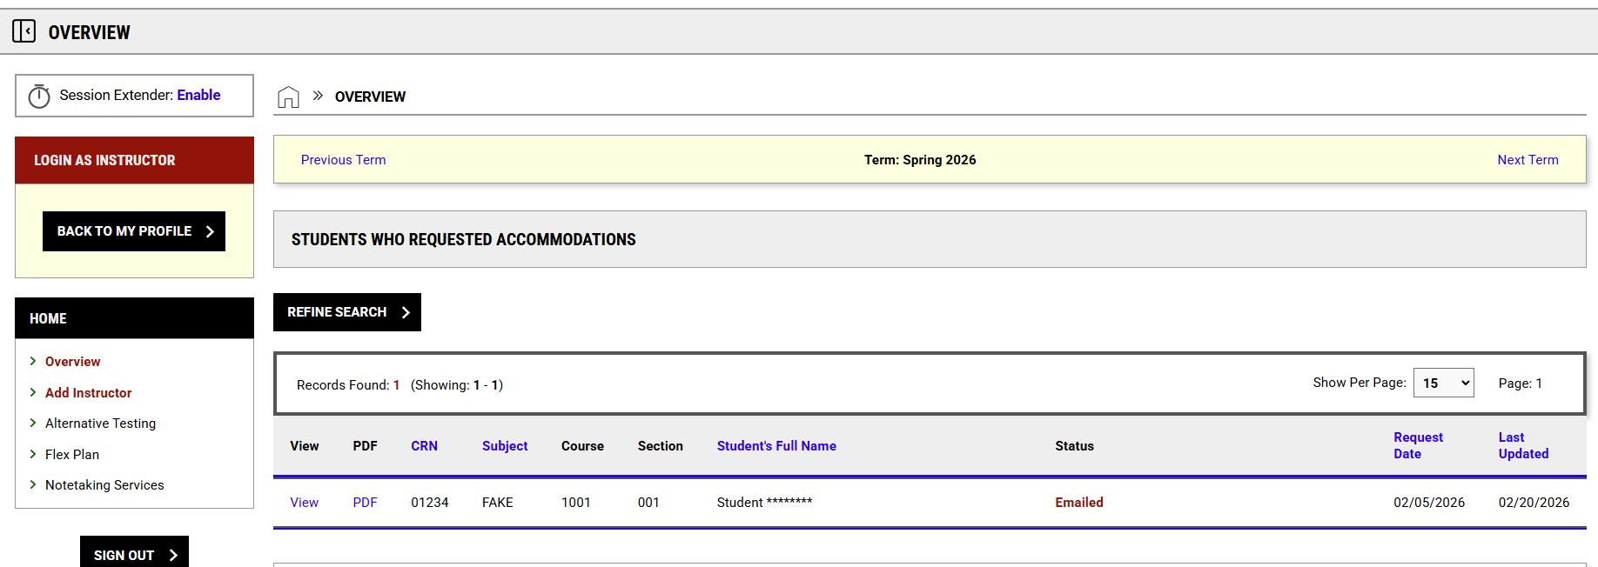

Testing Accommodations

- Select “Exam Instructions”

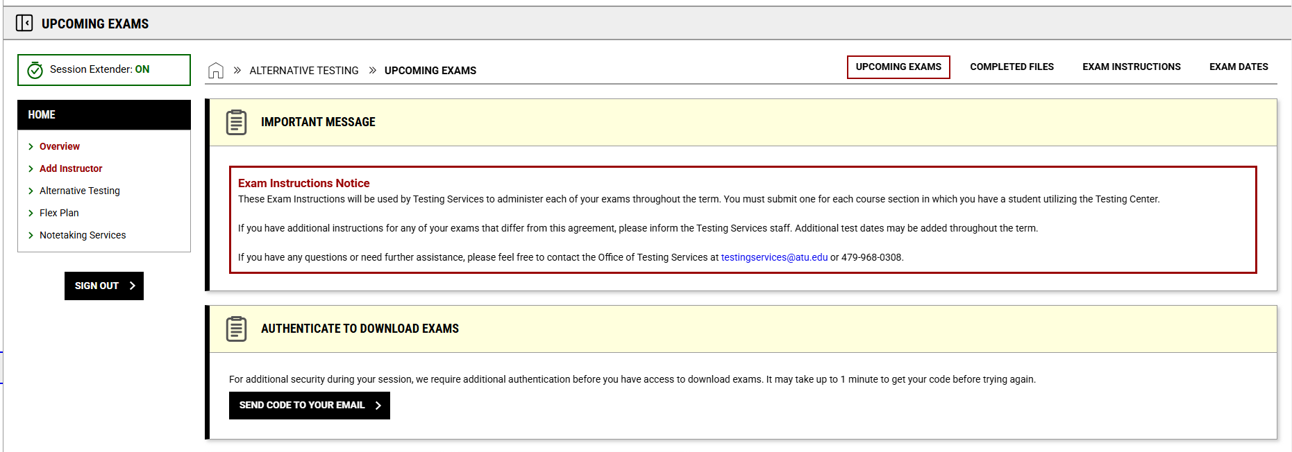

- You can select the Course using the drop down menu.
- Then click “View” to enter in the instructions for each specific class.
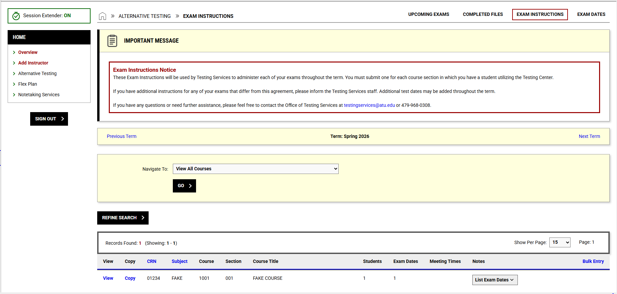

- Fill out the required fields and click “Update and View Exam Dates”.

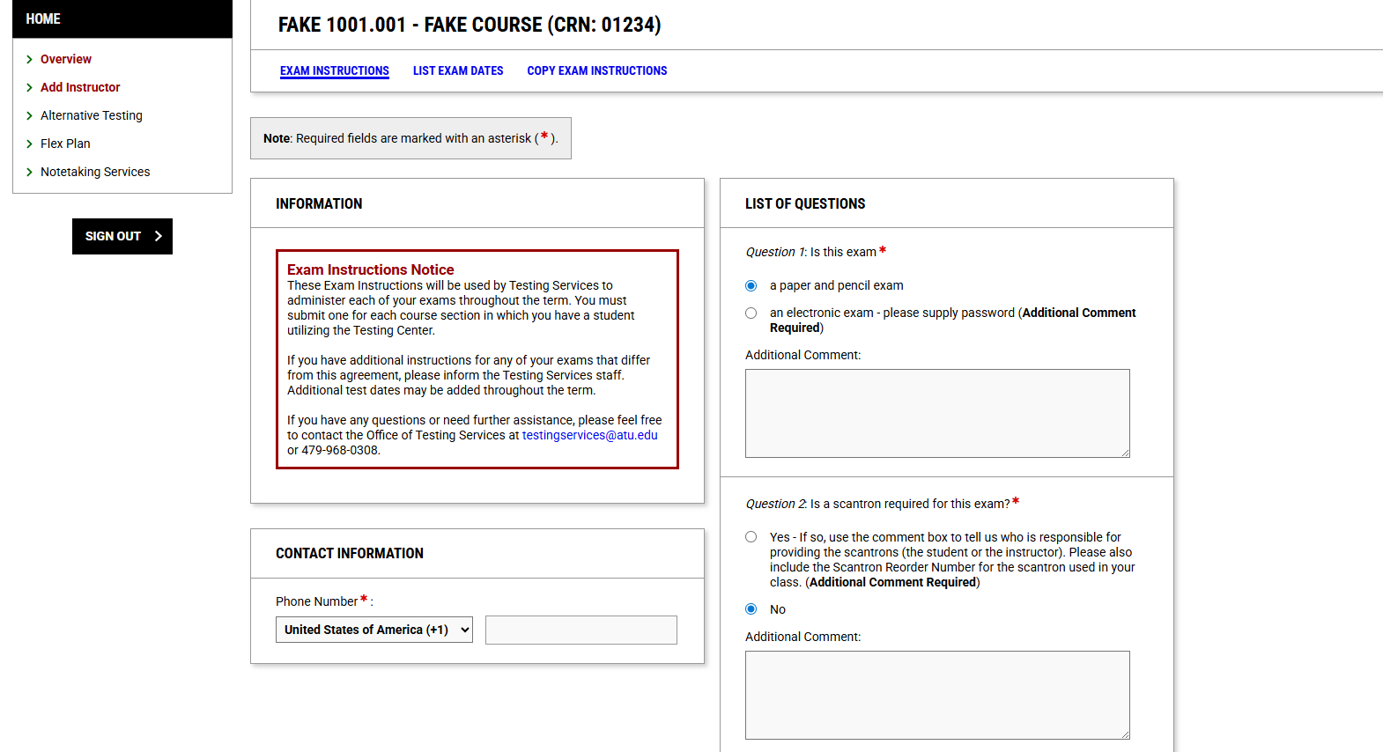
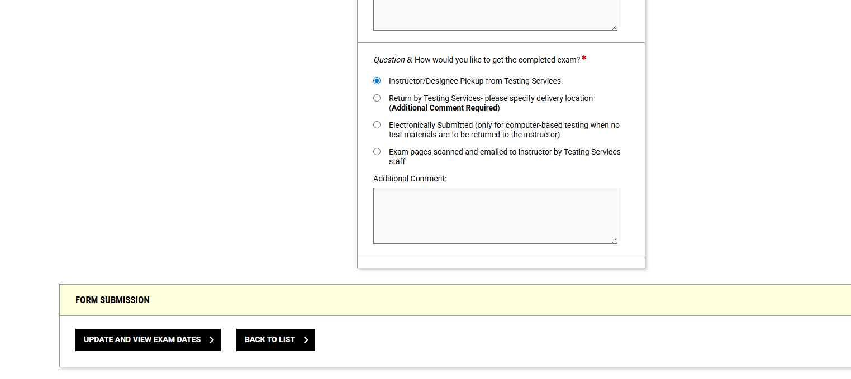

- You can modify exam dates from this menu using the “Modify” button.
- While you aren’t required to input exam dates, the following screen is where you will do so if you would like to specify when the student can take the exam. Please be sure to specify how long the class has to take the exam.
- Once you’ve finished, click “Save”.

