How to Sign a Release of Information
- Go to the Disability Services website at https://www.atu.edu/disabilities/ .
- Click on the second icon labeled “Login to the Disability Services Portal”.

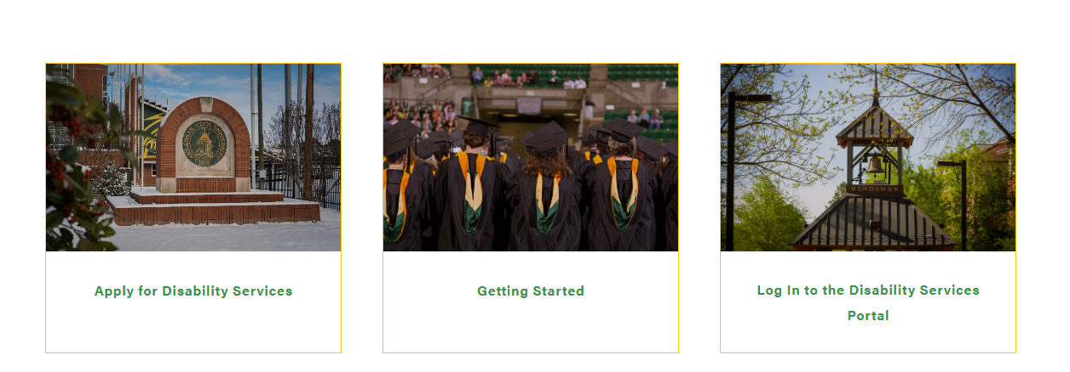

2. Click Here

- Enter your OneTech username and password in the appropriate fields.
- Click the “Sign In” icon to proceed to the Student Dashboard.

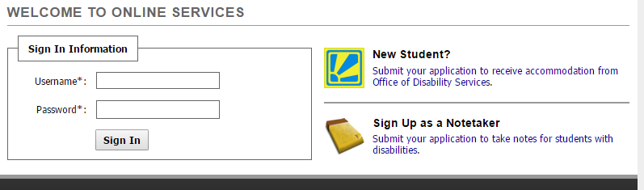
4. Sign In
3. Enter OneTech Username and Password

- Once you have logged into the system, on the left-hand side under “My Dashboard” you will see “Information Release Consents”. Click this.

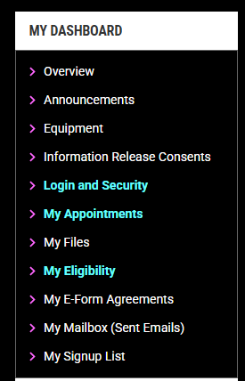

5. Click Here

- Select the type of consent by using the drop down box. Some of the options include spouse or partner, professor, parent or guardian, etc.
- Click “Continue to Specify Additional Information”.

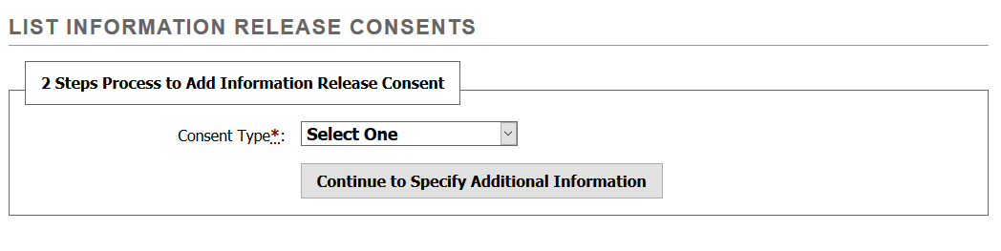
6. Select Consent Type
7. Click Here

- Enter all required information in this section. Then read the statement your consent and check the box. You the “Additional Notes” section you can specific exactly what can be released to this person. Click “Submit Information Release Consent Form”

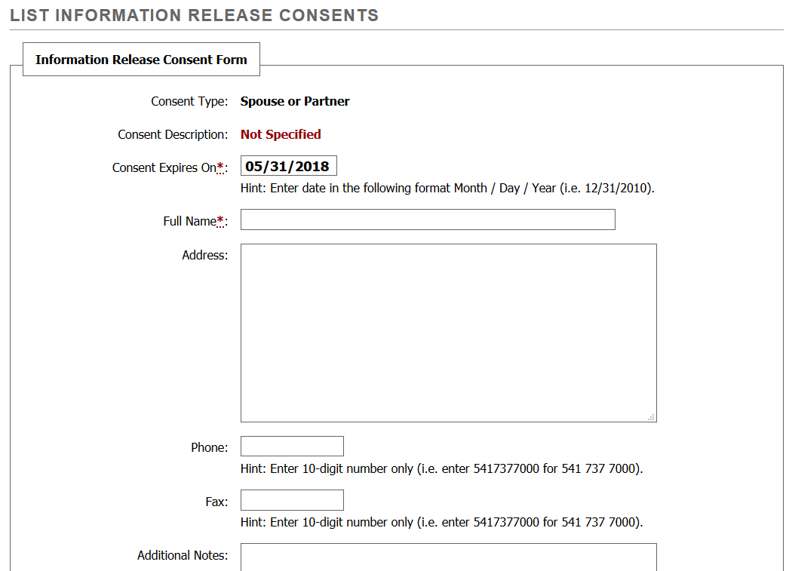
B. Enter their full name.
A. Enter the date you would like this permission to expire. The default is one year.
C. Enter any additional information you would like DS to know here regarding the consent.

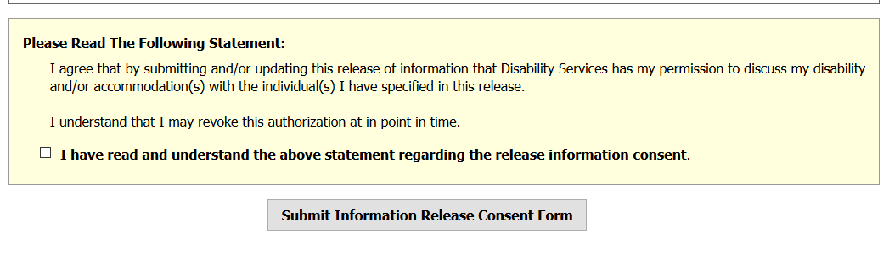
E. Check this box.
D. Read this statement.
F. Click Here

- An email will be sent to your Onetech email address with the information you entered. You may cancel your consent at any time. Follow steps 10-11 to cancel your consent to release information.
- Click “Modify” to cancel your consent.

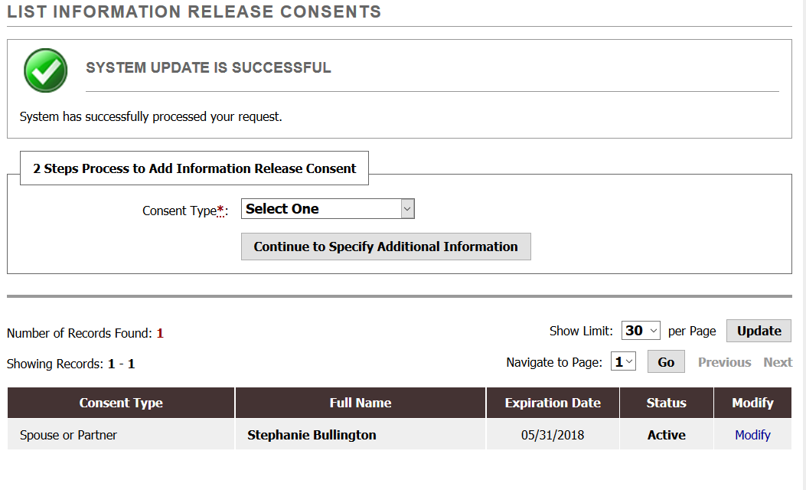
10. Click Here

- Change the status from “Active” to “Inactive” using the drop down box. Then read the statement regarding the release of information consent and check the box. Click “Update Information” to submit the change. You will receive an email regarding this cancellation.

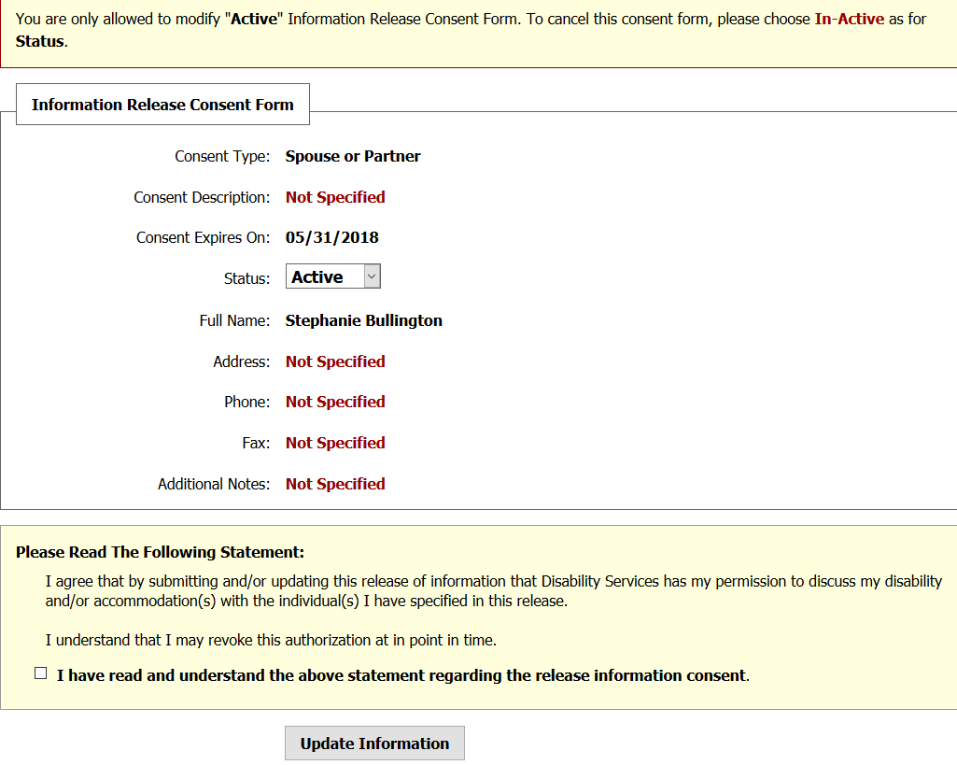
A. Change the status.
B. Read this statement.
C. Check this box.
D. Click Here

