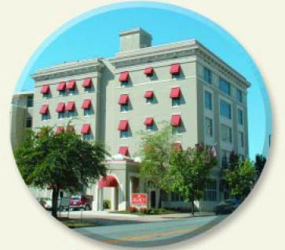
Legacy Hotel: 635 West Capitol Ave. Little Rock

New for 2008: There will NOT be any buses running from War Memorial to the race route! So parking is going to be BAD!

I looked at the parking map for the Race, the Race route and suggested parking for participants and tried to come up with some directions from Russellville. In the past, we have met at the Legacy Hotel. It is fairly easy to see from a distance. Just AVOID Broadway! That is right in the middle of the Race Route!!!

We will meet as a group at 7:30am to take a group picture. Then we can make our way to the Race route. The suggested parking shows several lots in the area so maybe you will get lucky and find a spot!

PLAN: Meet ATU Dean Hall 5:45 am to car-pool
Meet the group at 7:30 am Legacy Hotel
Race Starts: 8:00am

Have a great time!

Directions: Using MapQuest with Start Dean Hall (402 West O Street) and end (Legacy Lodge 625. W. Capitol Ave.)

**I had to make MapQuest avoid Broadway in order to keep the directions from taking you right through the parade route!!!

- Take I-40 E to Little Rock
- Merge onto I-430 S via Exit 147 toward Texarkana
- Merge onto I-630 E via Ext 6 toward Downtown/Baptist Medical Center/University Ave.
- Take the Chester St. exit, Exit 2A\
- Turn Left onto S Chester St.
- Turn Right onto W. Capitol Ave.
- End at 625 W. Capitol Ave.

