Faculty &
Advisor Handbook

2025-2026
FACULTY ACKNOWLEDGMENT

I have received the Department of Nursing Faculty and Advisor Handbook (2025-2026). I understand that the Faculty and Advisor Handbook constitutes the department's general policies and procedures but does not replace the policies and procedures within the ATU Faculty Handbook, ATU Student Handbook, or ATU Undergraduate Catalogs. I acknowledge that I am responsible for the information contained herein.

_______________________________________________________________
Signature

______________________________________________________________
Date

************************
FACULTY SHOULD SIGN AND RETURN THIS FORM TO THE HEAD OF THE DEPARTMENT OF NURSING.
THIS FORM WILL BE PLACED IN YOUR DON FACULTY FILE.

Table of Contents
Accreditation 6
Mission 7
Vision 7
Philosophy 7
Conceptual Framework 10
Integration of Conceptual Framework into Curriculum 13
Student Learning Outcomes 14
Governance 14
Organizational Chart of the Department of Nursing 15
Department of Nursing Bylaws 16
Position Descriptions 21
Department Head 21
Assistant Head/Pre-Licensure Program Director 24
MSN Program Director 25
RN to BSN Program Director 27
Learning Resources Coordinator 30
Simulation Coordinator 31
Faculty Member 33
Adjunct Clinical Faculty 34
Student Nurses Association Advisor 35
Faculty Support 36
New Faculty Orientation 36
New Faculty Mentoring Program 37
Faculty Evaluation Procedures 37
Classroom Peer to Peer Evaluation 38
Evaluation of Clinical Instructor by Clinical Agency 38
Evaluation of Adjunct Clinical Instructor Faculty 38
General Faculty Policies 38
Grievance Policy and Procedure 38
Clinical Faculty Policies 39
Procedure for Faculty Injury or Exposure 39
Emergency Procedures/Violent Critical Incidents 39
Clinical Documents 39
Procedure for Change in Class or Clinical Schedule 39
Policy Regarding Children in the Office/Classroom 40
Faculty Professional Development 40
Utilization of Department Telephones 40
Student Workers 40
Inquiries Regarding Student Schedules 41
Learning Resources 41
Advisor Information 41
General Advisement Guidelines 41
Advisement Encounters 42
Advisement and Registration Procedures 43
Initial Advisement 43
Transfer Students 43
Registration Dates 44
Scheduling an Appointment 44
Registration Process 44
Add/Drop/Change Sections/Withdrawal Procedures 45
Admission to Upper Division 46
Application for Admission 46
Prelicensure and LPN to BSN Program Application (Appendix P) 46
RN to BSN Program Application (Appendix Q) 46
Application Decisions 46
Progression 47
Student Withdrawal 48
Readmission Policy 48
Prelicensure and LPN to BSN Readmission 48
RN to BSN Readmission 48
Retention of Students: The Early Warning Program 49
Degree Audit Process for Graduation 50
Appendix A: Committee Membership Fall 2024 53
Appendix B Minutes Template Faculty Organization 54
Appendix C Committee Minutes Template 56
Appendix D Procedure for Writing Minutes 57
Appendix E Agenda Format 58
Appendix F - Faculty Resources 59
Appendix G University and Department Orientation Checklist 60
Appendix H DPTC Peer Review Long Form 62
Appendix I DPTC Peer Review Abbreviated Form 69
Appendix J Annual Evaluation 72
Appendix K Peer to Peer Evaluation Form 73
Appendix L Evaluation of Clinical Instructor by Clinical Agency 74
Appendix M Evaluation of Clinical Adjunct 75
Appendix N Advisory File 76
Appendix O Faculty Injury or Exposure in the Clinical Setting 77
Appendix P Prelicensure and LPN to BSN Application 78
Appendix Q RN to BSN Application 81
Appendix R Reapplication to Prelicensure/LPN to BSN Program 83
Appendix S Reapplication to RN to BSN Program 84

ARKANSAS TECH UNIVERSITY
Department of Nursing
Faculty & Advisor Handbook
The ATU DON Faculty and Advisor Handbook provides a succinct, ready source of policies and procedures pertinent to the faculty and advisor roles. This handbook does not replace the policies contained in the ATU Faculty Handbook, ATU Undergraduate and Graduate Academic Catalogs, or the ATU Student Handbook.

Accreditation
The Department of Nursing offers undergraduate study in nursing to qualified graduates of high schools, diploma or associate degree nursing programs, and practical nursing programs. Completion of this program leads to a Bachelor of Science degree in Nursing. The ATU nursing programs are approved by the Arkansas State Board of Nursing and the Arkansas Department of Higher Education. The programs are also accredited by the Accreditation Commission for Education in Nursing, Inc. The ATU DON provides accrediting bodies with specific program information regularly.

Accreditation Commission for Education in Nursing
3390 Peachtree Road NE, Suite 1400
Atlanta, GA 30326
Phone: 404-975-5000
http://www.acenursing.org/

Arkansas Department of Higher Education
423 Main Street, Suite 400
Little Rock, AR 72201
Phone: 501-371-2000
http://www.adhe.edu/Pages/home.aspx
Arkansas State Board of Nursing
University Tower Building
1123 South University, Suite 800
Little Rock, AR 72204-1619
Phone: 501-686-2700
http://www.arsbn.arkansas.gov/Pages/default.aspx

Mission
The ATU DON Mission is to promote student success in an innovative, engaging climate that fosters the development of clinical judgment, achievement of personal and professional goals, and lifelong learning.

Vision
The Department of Nursing prepares professional nurses who collaborate and lead members of the healthcare team to provide evidence-based quality care to individuals, families and communities while empowering them to reach their healthcare goals.

Philosophy
The University provides opportunities for intellectual growth, skill development, and career preparation. The faculty of the Department of Nursing at Arkansas Tech University seeks through its professional program to implement the mission of the University, a mission committed to student success, preparing students to meet the demands of an increasingly competitive and intellectually challenging future.
Individuals are complex beings with bio-psychosocial, emotional, spiritual, cultural, and environmental elements. The Department of Nursing is committed to providing opportunities for students to enhance their clinical reasoning and communication skills in therapeutic interventions. The graduate will utilize a clinical judgement model to assist individuals, families, groups and communities to meet their bio-psycho-social, emotional, spiritual, cultural, and environmental needs.
Nursing is a caring relationship that facilitates health and healing. Encompassing the acquisition and critical application of knowledge from nursing and the social, psychological, biological, and physical sciences, nursing meets the health needs of individuals, families, groups, and communities. As a profession with responsibilities and privileges, nursing is concerned with promotive, restorative, and supportive practices aimed to optimize health in the recipients of care. Nursing is publicly accountable to the society it serves, obligated to improve nursing practice through acquisition, utilization, augmentation, and promotion of knowledge and skills, as well as the systematic study of the effects of these practices on human health.
Learning is essentially manifested in a change or reorganization of behavior and is best accomplished through active inquiry and participation in the learning process. Learning is a lifelong, self-initiated process by which knowledge, skills, attitudes, and values are acquired. Learning occurs independently through perception, assimilation, formulation, and synthesis. The teacher functions as a facilitator by establishing a learning climate of mutual respect regarding beliefs, feelings, and opinions, and by providing learning opportunities and guidance with regard to individual differences. Learning experiences are designed to facilitate personal and professional growth within the student's cognitive, affective, and psychomotor domains. The ultimate responsibility for learning rests with the learner.
Nursing education, an integral part of higher education, fosters the generation and application of scientific knowledge through clinical judgement. These learning experiences are organized for an orderly progression through an increasing complexity of nursing situations. During the educational process, the student acquires knowledge of the independent and collaborative functions of the nurse.
Baccalaureate nursing education prepares a person for professional nursing practice. The curriculum is designed to prepare the person for professional nursing practice, to be competent, self-directed, and capable of demonstrating leadership in the application of clinical judgement. The graduate should demonstrate initiative for responsible change, the ability to think critically, and a lifelong quest for knowledge and growth.

Congruency of ATU and CEH Mission with DON BSN Mission and Philosophy

ATU Mission | CEH Mission | BSN Program Mission | DON Philosophy
Arkansas Tech University is dedicated to student success and access by providing an education that will significantly impact social mobility, enabling students to reach their greatest potential. The university has an unwavering commitment to providing life-changing educational opportunities at all levels of higher education through partnerships, research and service initiatives that contribute to the economic, cultural and social well-being of the students and the region it serves. The university will cultivate a vibrant and welcoming community, encouraging students, faculty and staff to achieve their goals in a supportive environment. ADOPTED 12/19/ 2024 | The CEH promotes student success by providing collaborative, engaging and innovative programs in accessible formats to prepare professionals who will positively impact their communities locally, regionally, and globally. | The mission of the DON is to promote student success in an innovative, engaging climate that fosters the development of clinical judgment, achievement of personal and professional goals, and lifelong learning. | The University provides opportunities for intellectual growth, skill development, and career preparation. The faculty of the Department of Nursing at Arkansas Tech University seeks through its professional program to implement the mission of the University; a mission committed to prepare student success, preparing students to meet the demands of an increasingly competitive and intellectually challenging future.  … opportunities for students to enhance their clinical reasoning and communication skills in therapeutic interventions.  … clinical judgment model to assist individuals, families, groups and communities.  … fosters the generation and application of scientific  knowledge through clinical judgment.

Conceptual Framework
The conceptual framework at Arkansas Tech University’s Department of Nursing is composed of four major concepts: person, health, nursing, and environment.
Person
Person, a bio‐psycho‐social, emotional, spiritual, cultural, and environmental being, functions as a unique, integrated "whole." Person is an open system, changing and being changed by the environment. Persons’ relationships are influenced by stages of development at any given point in time and experience in the life cycle. Through interactions, persons attempt adaptation to maintain a high level of health. Health and illness are human experiences, and persons must adapt in order to survive. Adaptive processes and life cycle occur on a continuum, from the moment of conception throughout life. Physiological, psychological, social, emotional, spiritual, cultural, and environmental forces shape the process of adaptation. Persons’ state of health is determined by the ability to adapt. Within this sequence, certain common cognitive, psychological, and motor developmental tasks can be identified. The mastery of these tasks is essential to the achievement of self‐ actualization and optimal health.

Communication is a process by which persons gather information and share ideas, opinions, values, and feelings with others. A person's ability to communicate produces vital forces which can be utilized for positive benefits to self and society. The person has freedom of choice in making decisions related to personal health. This freedom to choose influences the nurse's ability to assist the client to optimal health. Nurses must respect the person's right to make decisions that might conflict with the nurse's own value system. The nurse acknowledges there are times when a person may not make logical choices that would improve health, however, the right to make such choices must be protected.
Health
Health is a condition of physical, mental, and social well-being that reflects adaptation to environmental, physical, and psychological factors. Health is not a static condition; it is dynamic in nature and may change over time in response to new situations, new challenges, and aging. Health is culturally defined and reflects a person’s ability to perform daily activities in culturally expressed ways.
Nursing
Six essential features of professional nursing practice are identified in ANA Nursing's Social Policy Statement (2010, p. 9):
- Provision of a caring relationship that facilitates health and healing;
- Attention to the range of human experiences and responses to health and illness within the physical and social environments;
- Integration of objective data with knowledge gained from an appreciation of the patient or group's subjective experience;
- Application of scientific knowledge to the processes of diagnosis and treatment through the use of judgment and critical thinking;
- Advancement of professional nursing knowledge through scholarly inquiry;
- Influence on social and public policy to promote social justice
- Assurance of safe, quality, and evidence-based practice
The bio‐component of the person directs nursing's attention to the physical needs. The emotional and psycho‐ component requires that the nurse regard the interrelatedness of mind and body. Cultural and social aspects must also be considered in the delivery of nursing care. Since the spiritual component gives quality and aesthetic features to life, it too must be considered. The concept of spirit refers to that which gives meaning, purpose, and direction to life‐‐it may be understood in a religious, philosophic, or humanistic sense. The beliefs of the nurse regarding various aspects of life's spirituality will be motivators in the kinds of care delivered to clients. Therapeutic touch, sensitivity to clients’ needs, religious affiliations, compassion for suffering persons, and comfort measures are all contained in the realm of spiritual aspects.
Nursing behaviors are acquired and synthesized by the nurse in the delivery of appropriate nursing care. The major roles within the scope of nursing behaviors include manager, communicator, teacher, health care provider, researcher, advocate, and collaborator. Research methodology and utilization of well‐designed nursing studies are necessary to provide a scientifically based order and reason to the practice. The activities of nursing encompass the traditional roles and the augmented interdependent roles in collaboration with other members of the health care team. The scope of these activities is flexible and responsive to the changing needs of society. The expanded role of the nurse includes independent functions which assure continuity of care of the client, family, group, or community in a variety of health care settings. Nurses provide care in both basic and advanced nursing practice. Within either basic or advanced practice, the nurse may choose a specialty area. Examples of settings for the practice of basic nursing include homes, schools, hospitals, institutions, community‐based health centers, and businesses. The professional nurse provides quality nursing care utilizing critical thinking. It is based on scientific principles and focuses on optimal health. The nurse functions as a leader in the provision of nursing care that is planned, goal‐directed, and specific to the needs of the patient, family, group, or community.
The nursing process has evolved into a clinical judgment model that includes recognizing and analyzing cues, prioritizing hypotheses, generating solutions, taking action, and evaluating outcomes (NCSBN, 2023). Recognizing cues (assessment) involves identifying relevant information. The analysis of cues requires the nurse to link assessment data (cues) and the client’s condition. Prioritizing hypotheses requires the nurse to begin planning according to priority, then generating solutions. The nurse then acts to achieve a desired response. The final step is evaluation, comparing observed outcomes against expected outcomes. Nursing clinical judgment should be personalized, meeting the client's perceived needs, and collaborative, with other members of the health care team. This process can be utilized in any setting where nursing care is provided to persons, families, groups, or communities.
Environment
Environment considers the external world of persons. The world encompasses the society in which the person lives. This includes the culture set within a geographical location. The environment consists of a group of persons who share certain commonalities, such as goals, values, political ideologies, and socio‐economic status. The community is an interactional unit of this world consisting of health care consumers, health care providers, and health care settings. The structural unit of the community is the family in various traditional and nontraditional family forms. Because a person’s life depends upon the environment, one cannot view the person apart from it. Throughout the life cycle, the person changes and adapts to the environment. The person's response to the environment impacts the possibilities for health, which then guide the nurse in making appropriate nursing interventions.

Integration of Conceptual Framework into Curriculum
 | Person – Life Cycle | Environment | Nursing Roles
Sophomore  Level 0 | Introduction to care of persons throughout the life cycle | Introduction to all care environments | Introduction to all nursing roles
Junior  Level I | Adults  Older adults | Medical-Surgical  Acute Care  Long-term Care | Health care provider  Communicator  Collaborator  Teacher  Researcher  - Read  - Utilize
Junior  Level II | Adults  Children  Families | Surgical  Obstetric  Pediatric | Health care provider  Communicator  Collaborator  Teacher  Researcher  - Read  - Utilize
Senior  Level III | Adults  Families | Medical-Surgical  Intensive Care  Psychiatric | Health care provider  Communicator  Collaborator  Teacher  Researcher  - Read  - Utilize  - Analyze  - Critique  Advocate
Senior  Level IV  RN to BSN | Care of persons of all ages throughout the life cycle | Medical-Surgical  Community  Leadership  Management | Health care provider  Communicator  Collaborator  Teacher  Researcher  - Read  - Utilize  - Analyze  - Critique  Advocate  Manager

Student Learning Outcomes
- Demonstrates clinical judgment, skills and abilities to the provision of safe, competent patient care.
- Demonstrates culturally sensitive caregiving, communication, teaching, advocacy, and management of diverse patient populations and settings.
- Utilizes research evidence and technology to improve the quality and safety of patient care.
- Collaborates with interprofessional health care teams in the delivery of patient care.
- Demonstrates academic achievement reflective of a professional nurse.

Governance
Faculty members participate in the department's governance through committee membership. All full- time faculty members participate in the Faculty Organization Committee, chaired by the Head of the Department of Nursing and on respective Level or Program Committees. The Department Head also assigns each faculty member to serve on one or more DON standing committees: Curriculum, Welfare, Assessment, or Admission and Progression Committee. The Department Promotion and Tenure Committee (DPTC) consists of all tenured faculty at the associate rank or above in the department, excluding the department head. Presiding officers of each committee report to the Faculty Organization Committee. In addition to the standing committees, ad hoc committees are established as the need arises. These temporary committees deal with special issues or topics that fall outside the normal functions of the other committees.
Nursing faculty participate in the governance of the University through an established university committee structure. For detailed information about university governance, faculty are referred to the ATU Faculty Handbook. Current University Committee Membership can be found on the ATU Academic Affairs Website under Faculty Resources. Current DON Committee Memberships can be found in Appendix A.
The DON Organization Chart provides a visual representation of the DON structure and the bylaws detail the operations of each committee, the purpose and functions of the committee, membership and voting privileges, officers and duties, and conduct of meetings. Meeting proceedings are documented and shared in the Department of Nursing Faculty and Staff Blackboard Organization (Appendix B, Minutes Template Faculty Organization; Appendix C, Minutes Template, Committee; Appendix D, Procedure for Writing Minutes, Appendix E Agenda Format).

Organizational Chart of the Department of Nursing

Program Committees
Level Committees
RN-BSN Committee
MSN Committee
Admission &
Progression Committee
*Welfare Committee
Assessment
Committee
*Curriculum
Committee
Health Care Agencies Utilized to Supplement the Curriculum
Faculty Organization
Advisory Committee
Assistant Head
Department Head
Dean, College of Education and Health

DPTC

Legend
_______ Lines of Responsibility
----------- Lines of Advisement and Recommendation
* Student Representation on Committee

Department of Nursing Bylaws
FACULTY ORGANIZATION
ARTICLE I: TITLE, PURPOSE, AND FUNCTIONS
Section 1: Title
The name of this organization shall be the Faculty Organization of the Department of Nursing at Arkansas Tech University.
Section 2: Purpose
The purpose of this organization shall be to act for the Department of Nursing as the academic decision-making body in relation to the delineated functions as specified in Article I, Section 3, of this document.
Section 3: Functions
The Faculty Organization has a major role in the governance of the Department of Nursing and has the following functions:
    - Establishes and maintains policies for the Department of Nursing's faculty which assures smooth functioning of the department.
    - Receives reports and acts on recommendations from the committees of the Faculty Organization.
    - Establishes policies for utilization of budgeted funds for implementation of the total program.
ARTICLE II: MEMBERSHIP AND VOTING PRIVILEGES
Section 1: Membership
Membership shall consist of all members of the nursing faculty who have full- or part- time appointments. The Department Head shall serve as the presiding officer or the chairperson.
Section 2: Voting Privileges
    - The Head will be an ex-officio member and shall vote only to break a tie vote and shall be ineligible to hold office.
    - Those persons who hold full-time appointment status will have voting privileges.
ARTICLE III: OFFICERS AND DUTIES
Section 1: Presiding Officer
The presiding officer shall be the Head of the Department of Nursing. A temporary chairperson will be chosen by this officer to preside over meetings in his/her absence.
Section 2: Duties
The Presiding Officer:
    - Chairs meetings.
    - Receives requests for items to be placed on the agenda.
    - Prepares a written agenda distributed to all members at least two days before the meeting. The agenda presented will be adequately detailed so that the faculty may be prepared to intelligently discuss and vote on issues.
    - Notifies each member in advance regarding meeting date, time, place, and agenda.
    - Calls for regular reports from Standing Committees as part of the agenda.
Section 3: The Secretary
The Departmental Secretary or Faculty Organization Member shall serve as secretary of the Faculty Organization.
The Secretary:
    - Keeps a record of proceedings, proposals made, pertinent discussion, and actions taken in Faculty Organization meetings.
    - Prepares typed minutes from minutes recorded.
    - Takes responsibility for posting minutes on the DON Blackboard site.
    - Takes responsibility for copies of the minutes to be placed in the official file.
ARTICLE IV: MEETINGS
Section 1: Meetings
The presiding officer shall schedule regular meetings during the academic year.
Section 2: Called Meetings
Called meetings may be initiated by the presiding officer, or at the request of at least two (2) voting members, with the notification of all members one week in advance unless it is necessary to immediately conduct business of an urgent nature.
Section 3: Voting
  - A simple majority of votes in favor of an issue shall be sufficient to pass a motion.
  - Voting shall be conducted by any method chosen by the chairperson and accompanied by the approval of the voting member majority.
Section 4: Quorum
A simple majority of voting members shall constitute a quorum.
Section 5: Conduct of the Meetings
The meetings will be conducted according to standard parliamentary procedure.

ARTICLE V: RATIFICATION AND AMENDMENTS
Section 1: General Rules
The business of the Department of Nursing shall be handled through standing and special committees with recommendations for action coming to the Faculty Organization from individual committees. Matters of concern may be referred to the appropriate committees by the Department Head, the total faculty, an individual faculty member, or the students. Interim action is taken when action is necessary between scheduled meetings.
Section 2: Structure
Standing Committees:
    - Curriculum Committee
    - Welfare Committee
    - Assessment Committee
    - Admission and Progression Committee
    - Program Committee
      - Pre-Licensure (Level 0 – IV)
      - LPN-BSN
      - RN-BSN
      - MSN
Section 3: Membership and Voting Privileges
  - Standing committee members shall be chosen by the Department Head. The Department Head shall appoint a chairperson. The committee shall elect a recording secretary. The Department Head will review committee membership annually.
  - A student representative from both the junior and senior year, currently enrolled in the nursing program and duly elected through the Student Nurses’ Association, shall be the student representatives for advice and consultation on the Welfare and Curriculum Committees. Student representatives may attend meetings but will be asked to leave when discussing faculty affairs and specific students. No student representatives will be on the Admission and Progression, Assessment, or Programs.
  - The Learning Resource Coordinator will always serve on the Curriculum Committee.
  - The Department Head will hold ex-officio membership status and will vote only in the case of a tie vote.
  - Full-time faculty members will have voting privileges.
Section 4: Duties of the Chairperson
The Chairperson:
    - Presides at both regularly scheduled and called meetings or arranges for a substitute in case of absence.
    - Prepares the agenda based on items submitted by the committee members and according to a prior plan of action.
    - Notify members of the date, time, and place of meetings and provide the agenda in advance.
    - Prepares assignments for work sessions.
    - Conducts meetings according to standard parliamentary procedure.
    - Calls meetings on a regularly scheduled basis.
    - Presents a report at the regularly scheduled Faculty Organization meetings.
Section 5: Duties of the Secretary
The duties of the secretary shall be the same as those previously outlined in Article III, Section 3.
Section 6: Purposes of the Committee
The purposes of the Standing Committees:
    - Curriculum Committee
      - Plans, evaluates, revises, and refines the curriculum in nursing and makes recommendations in all matters about curriculum.
      - Recommends policies and procedures for developing, using, and deleting learning resources.
    - Welfare Committee
      - Recommends policies concerning student welfare, health, and activities.
      - Prepares and conducts a faculty survey.
      - Prepares faculty/advisor and student handbooks.
    - Assessment Committee
      - Promotes, supports, and monitors academic program assessment activities in the DON.
      - Report DON assessment findings to the Faculty Organization, University, Communities of Interest, and Accrediting bodies.
    - Admission and Progression Committee
      - Recommend policies and procedures for student admission and progression in the nursing major.
      - Responsible for student admission and progression in nursing.
    - Program Committee
      - Coordinates the courses in the curriculum at each level/program to ensure curricular consistency with established standards, guidelines, and competencies.
Section 7: Functions of Standing Committees
    - The Functions of the Curriculum Committee
      - Responsible for development, implementation, and evaluation of total curriculum.
      - Plans, implements, and evaluates curriculum changes and refinements.
      - Encourages requests for educational resources from faculty members and submits these requests for purchase.
      - Reports acquisition of all educational media to the Faculty Organization Committee.
      - Approves textbooks and agencies selected by level faculty for each course.
      - Plans for, implements, and evaluates the acquisition and deletion of library books and periodicals.
      - Submits a report concerning committee activities as a standing agenda item for the Faculty Organization meetings.
    - The Functions of the Welfare Committee
      - Assists students with grievance procedures.
      - Discusses pertinent matters concerning student welfare, health, and activities.
      - Prepares and maintains a Student Handbook and Faculty/Advisor Handbook.
      - Promotes participation in social and professional organizations.
      - Assists in the resolution of faculty grievances and other matters concerning faculty welfare.
      - Develop and implement a program of faculty evaluation.
      - Make a report concerning the committee's activities as a standing agenda item for the Faculty Organization Committee meeting.
    - The functions of the Assessment Committee
      - Systematic evaluation will be performed through the collection of data required by the accrediting body.
      - Evaluation of student satisfaction feedback data will be gathered from end program and course evaluations. Data will be examined for trends looking at student satisfaction with resources, technology, and the learning environment.
      - Aggregated data will be evaluated for congruency with program and student learning outcomes, mission, and goals.
      - Findings will be presented to the Faculty Organization and University Assessment Committee for discussion and decision-making.
    - The Functions of the Admission and Progression Committee
      - Recommends policies for student admissions, progress, and graduation.
      - Reviews student records and makes decisions on student admission and progression within the prelicensure and RN to BSN program.
      - Reports committee’s activities as a standing agenda item for the Faculty Organization Committee meeting.
    - The Functions of the Program Committee
      - Make suggestions for changes to the Program based on student, faculty, and end-of-program evaluations.
      - Formulates options/solutions for student concerns.
      - Monitors student success in the Program.
      - Communicates and coordinates Program.
Section 8: Ratification and Amendments
Rules for ratification and amendments will be followed as previously outlined under Rules of Procedure as utilized by the Faculty Organization Article V, Sections 1 and 2 after presentation to and approval by the Faculty Organization Committee.

Position Descriptions
Positions with the ATU DON include Department Head, Assistant Head, and Pre-Licensure Program Director, MSN Program Director, RN to BSN Program Director, Level Coordinator, Learning Resources Coordinator, Simulation Coordinator, Faculty Member, Adjunct Clinical Faculty, and Student Nurses Association Advisor. Each position contains a description, schedule of hours, qualifications, and duties and responsibilities.

Department Head
The head of the Department of Nursing holds an academic faculty position with administrative workload for accomplishing the responsibilities delegated by the University. Delegated responsibilities encompass general administration, curriculum, academic personnel, and students.
Schedule of Hours
Hours of duty for the Head of the Department are flexible in order to accomplish the mission of the Department of Nursing.
Qualifications
- Holds a current unencumbered license as a registered nursing in the state of Arkansas.
- Holds a graduate degree in nursing
- Holds an earned Doctorate in nursing or a related discipline.
- An adequate experiential background in teaching and clinical areas
- Demonstrates evidence of leadership ability.
Duties and Responsibilities
- General Administration
  - Disseminate communications and information on academic matters pertaining to the academic program.
  - Enforce academic policies.
  - Prepare departmental budgets and purchases.
  - Approve requests for departmental supplies and equipment.
  - Serve as chair of Faculty Organization.
  - Serve in an advisory capacity to standing committees.
  - Prepare Department reports and communications.
  - Supervise office administration.
  - Supervise selection and assignment of student labor.
  - Prepare contracts for clinical agencies.
  - Engage in promotion and public relations related to department--talks to various groups, attendance at regional and national meetings, etc.
  - Report to Dean of College when absence is necessary.
  - Write annual reports etc., as appropriate.
  - Attend Department Head meetings upon notification by Dean of College of Education and Health.
  - Serve on University Academic Council.
  - Review position descriptions.
  - Attend ACEN accreditation workshops with Assistant Head or one other faculty member.
  - Conduct reports and surveys.
  - Proof minutes before signed by committee secretary.
  - Prepare Faculty Organization agenda.
  - Review Self-Study agendas.
- Curriculum
  - Submits prepared course proposals to campus committee for content, organization, and order of sequence.
  - Prepare teaching schedules, including room assignments and estimated class sizes.
  - Approve requisition of textbooks selected by Curriculum Committee.
  - Approve and review all departmental library needs, requisitions and holding.
  - Promote course programs and majors with secondary schools and junior colleges.
  - Initiate programs of instructional improvement.
  - Supervise implementation of curriculum changes.
- Academic Personnel
  - Recommend departmental personnel needs.
  - Supervise the recruitment, interviewing, and recommendations of faculty additions and replacements in consultation with the Dean of the College.
  - Recommends departmental personnel retention, promotion, tenure, leaves of absence, and salaries.
  - Recommend course assignments, teaching schedules, and faculty loads.
  - Supervise quality of instruction--course planning, preparation, presentation, use of learning resources, utilization of library, full use of each scheduled instructional period, grading standards and grade distribution.
  - Encourage faculty professional and social growth, research, additional study, membership in professional organizations, attendance at professional meetings, instructional self-evaluation, and departmental social activities.
  - Acquaint staff members with policies, responsibilities, etc., and counsel when necessary.
  - Maintain faculty morale and teamwork.
  - Communicate evaluations for each full-time faculty member on an annual basis.
  - Collaborate evaluations for part-time faculty with Level Coordinators.
- Students
  - Meet prospective students and advise on selection of courses.
  - Advise transfer students and evaluate transcripts for these students.
  - Promote academic scholarship and utilization of library.
  - Interpret degree requirements in consultation with Dean of the College.
  - Assign departmental academic advisers and assist with the counseling as needed.
  - Assist in planning departmental activities--clubs, etc.
  - Verify applicants for licensure have completed the program.
- Teaching
  - Teach up to 15 credit hours per academic year depending on administrative workload.
  - Serve on MSN thesis committees depending on administrative workload.

Assistant Head/Pre-Licensure Program Director
The Assistant Head of the Department of Nursing position is a faculty position with administrative release workload.
Qualifications
- Holds a current unencumbered license as a registered nurse in the state of Arkansas.
- Holds a graduate degree in nursing
- Holds an earned Doctorate in nursing or a related discipline.
- An adequate experiential background in teaching and clinical areas
- Demonstrates evidence of leadership ability.
Duties and Responsibilities
- Provide appropriate counseling and advising services to students.
- Assist instructors in course development.
- Serve on departmental and campus committees as assigned.
- Act as liaison between health care agencies, Department of Nursing, and Arkansas Tech University, including contracts.
- Is actively involved in public relations efforts between community, Department of Nursing, and Arkansas Tech University.
- Perform administrative duties in absence of the Head of Department of Nursing.
- Consult with Head of Department planning and development.
- Serve as resource person for faculty and Head of Department of Nursing.
- Participate in classroom and laboratory experiences for students.
- Perform other duties as delegated by Head of Department of Nursing.
- Complete substitution forms.
- Complete graduation forms.
- Coordinate Self Study and assist with written reports.
- Attend Self Study workshops with Department Head unless interferes with other duties.
- Update student learning outcomes and levels of achievement in WEAVE and other assessment data as needed.
- Update student learning outcomes and levels of achievement in WEAVE

MSN Program Director
The MSN Program Director position is a position for the graduate faculty member responsible for organizing and directing the MSN program.
Schedule of Hours
The MSN Program Director’s hours should be flexible to meet the educational needs of students as well as the organizational demands of the college.
Qualifications
- Holds a current unencumbered license as a registered nurse in the state of Arkansas.
- Has a minimum of a doctorate in nursing.
- Has adequate experiential background in teaching and clinical areas.
- Demonstrates evidence of leadership ability.
- Maintains graduate faculty status through the Graduate College.
Duties and Responsibilities
- Serve as advisor to all MSN students.
- Review applications and transcripts of new applicants and notify Graduate College of acceptance into MSN program.
- Keep student files updated.
- Register all MSN students and conduct student orientation each semester as needed.
- Update MSN Handbook annually; keep Blackboard MSN Lounge current with handbook, faculty contact information, MSN meeting agendas, and links to useful online resources.
- Coordinate End-of-Course Evaluations for MSN courses.
- Conduct MSN Committee meetings on a regularly scheduled basis and maintain minutes of each meeting.
- Maintain assessment data for MSN program (graduates, attrition, employer surveys, and End- of-Program evaluations).
- Supervise Graduate Assistantship (GA) and GA application and re-application process, and direct GA workload.
- Participate in graduate course teaching.
- Cooperate with other faculty in evaluating and improving the MSN curriculum and all aspects of the program.
- Serve as liaison between the Department of Nursing and the Graduate College.
- Serve as liaison between the Department of Nursing and the Department of Emergency Management.
- Maintain Graduate Faculty application and renewal paperwork.
- Attend regularly scheduled Program Director’s meetings in the Graduate College each semester.
- Supervise faculty election of annual Graduate Student Gala Scholarship recipients and report to Graduate College.
- Maintain MSN student Excel database.
- Complete annual reports for AACN and other national bodies requesting program information
- Complete and submit annual Graduate Program Assessment reports for the Graduate College
- Update student learning outcomes and levels of achievement in WEAVE

RN to BSN Program Director
Description
The RN to BSN Program Director position is a position in the Department of Nursing for an undergraduate faculty member to organize and direct the RN to BSN program.
Schedule of Hours
The RN to BSN Director's hours should be flexible to meet the educational needs of students and the organizational demands of the college.
Qualifications
- A graduate degree in nursing.
- A minimum of a master’s degree in nursing.
- A minimum of three years’ teaching experience in a college preparing registered nurses with one of those years spent teaching in the ATU Department of Nursing.
- A minimum of three years’ clinical experience.
- Possess qualities of leadership and management and competence in nursing.
- Current license to practice as a registered nurse in the state of Arkansas.
- Possess current technology skills.
- Experience teaching online.
Duties and Responsibilities
- Serve as advisor to current and interested RN to BSN students.
- Review applications and transcripts of applicants and interested students.
- Collaborate with RN to BSN administrative professionals to keep student files updated and oversee enrollment.
- Review and verify all accepted student files/admission requirements:
  - (RN licensure, background check, drug screen).
- Review and update RN to BSN policies for the ATU DON Student Handbook annually.
- Maintain the RN to BSN Student Lounge.
- Conduct RN to BSN committee meetings regularly.
- Participate in RN to BSN course teaching.
- Collaborate with faculty and department head in evaluating and improving the RN to BSN curriculum and all aspects of the program.
- Participate in RN to BSN recruitment events, planning, and marketing.
- Update RN to BSN communications regularly (interested student packet, website, etc.).
- Complete and submit RN to BSN reports for curriculum, assessment, and accreditation.
- Participate in advisory board communications and meetings.
- Develop all RN to BSN condensed course schedules in collaboration with the Department Head.
- Communicate regularly with MOU school contacts.
- Provide regular reports to the Faculty Organization committee of the DON.
- Update student learning outcomes and levels of achievement in WEAVE
Level Coordinator
The Level Coordinator’s position is for those faculty members responsible for organizing and directing the activities of an assigned level of the curriculum.
Schedule of Hours
The Level Coordinator’s hours should be flexible to meet the educational needs of students as well as the organizational demands of the college.
Qualifications
- A minimum of a master’s degree in nursing.
- A minimum of three year’s teaching experience in a college preparing registered nurses with one of those years spent teaching in the ATU Department of Nursing.
- A minimum of three years clinical experience.
- Possess qualities of leadership and management skills as well as competence in nursing.
- Current unencumbered license to practice as a registered nurse in state of Arkansas.
Duties and Responsibilities
- Plan and coordinate student clinical experiences in the selected agencies.
- Develop schedule for theory and clinical experiences and communicate the schedule to faculty and students.
- Acts as liaison between health agencies and the Department of Nursing at Arkansas Tech University.
- Assign duties and coordinate teaching assignments for the level members.
- Conduct level meetings on a regularly scheduled basis, maintaining minutes of each meeting.
- Coordinate the construction of examinations and other methods of evaluating student achievement in theory and clinical practice.
- Maintain record of student grades; submit to appropriate office according to Department and University policies.
- Provide Admission/Progression Committee Chair with list of students who have failed or withdrawn from program, or students who have changed status (e.g., full-time to part-time).
- Order textbooks and supplies needed for satisfactory conduct of the course.
- Participate in classroom and clinical teaching.
- Coordinate the evaluation of student performances routinely with written evaluations.
- Administer student course evaluation tools and organize findings for presentation to level members.
- Coordinate counseling activities for nursing students regarding their progress and assist them to best utilize learning experiences.
- Coordinate the preparation of course syllabi.
- Complete an End of Course Report for use by the Curriculum Committee.
- Cooperate with other faculty in evaluating and improving curriculum and all aspects of the program.
- Perform other duties as assigned.
- Report implementation of Department policies regarding progression to Faculty Organization.
- Maintain Blackboard courses.

Learning Resources Coordinator
The Learning Resources Coordinator’s primary role is to enhance student learning through multi-sensory learning resources.
Qualifications
- Current unencumbered license as a registered nurse in the state of Arkansas.
- Demonstrate evidence of mastery of psychomotor nursing skills.
- Possess interpersonal competence in relating to students.
Duties and Responsibilities
- Conduct an orientation program for students in the use of technology.
- Develop and maintain a current list of utilized and available resources for the Department of Nursing.
- Responsible for removing outdated books in Pendergraft Library, at the direction of the Curriculum Committee in the spring/summer at least every five years. Present a list of removed books to the Curriculum Committee in the fall.
- Present current technology resources to the Curriculum Committee in the fall.
- Assess on-going technology and resource needs of the Department of Nursing.
- Distribute learning resources materials to faculty for preview with request for written critique of the material previewed.
- Update file of Departmental library reports.
- Orders learning resources.
- Serve as a member of the Curriculum Committee for the Nursing Department.
- Participate in advising students.
- Participate in theory/clinical teaching.

Simulation Coordinator
The Simulation Coordinator is a full-time faculty for the purpose of enhancing student learning through multi-sensory learning resources.
Schedule of Hours
Schedule is designed to assure full time accessibility to simulation and skills lab.
Qualifications
- Current unencumbered license as a registered nurse in the state of Arkansas, with at least one year of current practice.
- A minimum of master’s degree in nursing.
- Demonstrate evidence of recent performance of nursing skills.
- Possess interpersonal competence in relating to students.
- Prefer previous experience with high and low fidelity simulation equipment.
- Must be able to lift a simulator (up to 100 lbs.).
- Prefer previous experience with a variety of computerized software.
- Obtain simulation certification within two (2) years of hire, such as Certified Healthcare Simulation Educator (CHSE) or equivalent.
Duties and Responsibilities
- Assist faculty with teaching psychomotor skills in the skills laboratory.
- Conduct an orientation program for students in the use of technology resources, skills, and simulation equipment.
- Serves faculty as a resource in developing skills, evaluation tools and scenarios. (Check-off lists, etc.)
- Coordinates equipment, supplies, and other learning resources in the skills and simulation labs for learning activities as needed.
- Serve as a member of the Curriculum Committee of the Nursing Department.
- Participate in theory/clinical teaching in the skills and simulation labs.
- Create and maintain documentation of simulations for curriculum.
- Supervise and coordinate students who are enrolled in NUR 4991 Skills Prep course.
- Coordinates faculty training on simulation equipment, and implementation into courses.
- Maintains facilities and equipment.
- Ensure necessary supplies and equipment are available when needed.
- Maintains inventory of supplies and equipment.
- Maintains updates and provides preventive maintenance on various equipment and technology.
- Coordinates vendor relations ensuring equipment is maintained in optimal condition.
- Obtain needed repairs in a timely manner.
- Provide IT support for all simulation areas.
- Maintain data collection and student faculty evaluation when applied to courses.
- Maintain annual faculty simulation professional development.
- Maintains the Clinical Simulation and Learning Center Policies and Procedures Handbook

Faculty Member
The faculty position is a position in which the faculty member fulfills the teaching, scholarship, and service expectations of the university, depending on their track (tenure versus non-tenure). Refer to ATU Faculty Handbook.
Schedule of Hours
The faculty member’s schedule should be flexible to meet the educational needs of students and the organizational demands of the college.
Qualifications:
1. Hold a current unencumbered registered nurse license to practice in Arkansas.
2. Have at least two years of previous experience in clinical nursing at or above the education program level.
3. Have a minimum of a doctorate in nursing or related discipline for assistant professor, associate professor, and professor levels and a minimum of a master’s degree in nursing for instructor or visiting instructor.
Duties and Responsibilities
1. Develop and teach classroom, lab, and clinical courses as assigned.
2. Engage students in high impact learning practices
3. Participate in departmental, college, and university committees.
4. Report to Level Coordinator as needed and participate in regular Level/Program meetings.
5. Participate in Faculty Organization meetings.
6. Advise students.
7. Adhere to all policies within the Department of Nursing.
8. Maintain education and clinical competencies in areas of instructional responsibilities.

Adjunct Clinical Faculty
The Adjunct Clinical Instructor’s position is to complement the Department of Nursing programs in a clinical role.
Schedule of Hours
The Adjunct Clinical Instructor’s hours should be flexible to meet the educational needs of students as well as the demands of the department and/or college.
Qualifications
- Must have a degree or diploma at or above the type of education program offered.
- Be under the direction of full-time faculty.
- Hold a current unencumbered registered nurse license to practice in Arkansas.
- Have a minimum of two years’ experience in the clinical area.
Duties and Responsibilities
- Report directly to the Level Coordinator for clinical assignment(s).
- Actively participate in student learning in the clinical setting.
- Adhere to all policies within the Department of Nursing.
- Adhere to all policies within the clinical agency (hospital) assigned.
- Supervise the ‘first’ time performance of student skills.
- Meet with Level Coordinator at the beginning of the semester for expectations and as needed for mentoring.
- Dress professionally with ATU Identification visible.
- Attend at least one level meeting during the semester.
- Other duties as assigned by level coordinator, program director, or department head.

Student Nurses Association Advisor
The Student Nurses Association (SNA) Advisor provides professional guidance and oversight of the ATU SNA. A minimum of two faculty advisors shall supervise activities.
Qualifications
- A full-time faculty member in the Department of Nursing.
- Requires at least one year of experience as a faculty member.
Duties and Responsibilities
- Ensure that the organization adheres to the SNA Bylaws.
- Revises Bylaws as required.
- Attend SNA meetings.
- Supervise SNA campus activities that may include but are not limited to:
- Fall and Spring Recognition ceremony
- Fundraising
- Health fairs
- Supervise SNA off-campus projects including communications with representatives of local groups to determine the appropriateness and feasibility of the project.
- Encourage attendance and participation in ASNA Fall Convention.
- Serve as a professional role model.
- Monitors student professional points earned and disseminates to the appropriate Level Coordinator.
- Collection of dues and maintenance of financial records.

Faculty Support
New and current faculty are supported through various University and Departmental resources. Current faculty have access to various departmental resources through contact with the DON Resource Coordinator, and University resources such as the Center for Faculty Life, and Office of Information Systems. Faculty Resources can be found in Appendix F.

New Faculty Orientation
Faculty orientation is the process through which newly-appointed department personnel:
- Become familiar with the University and Department physical facilities.
- Become familiar with the University policies and procedures which affect faculty members.
- Become familiar with the Department policies and procedures.
- Become oriented to the responsibilities and functions of the faculty member’s assignment
- Have the opportunity to work with persons familiar with the department.

Orientation Period
- Orientation for new personnel begins on the first day of employment or contract assignment and continues until the individual and/or the team leader or supervisor feels the individual is secure in the new situation.

- Formal orientation to the University takes place during the first week of employment and is the responsibility of the Vice President for Academic Affairs.

- New faculty are required to participate in the New Faculty Academy organized by the Center for Faculty Life. A week-long orientation takes place during the first week of the contract date. In addition, the New Faculty Academy meets monthly for two hours.

- Formal and informal orientation to the Department begins with the initial pre-employment orientation and may continue through the entire first semester of employment. This is the responsibility of the Department Head and other faculty. A faculty mentor will be assigned to each new faculty member.

- Department orientation includes an introduction to the departmental mission, vision, philosophy, conceptual framework, facilities, policies and procedures, organization, and student affairs in the department (classroom, campus, and clinical laboratory management/function) and other departmental faculty and staff.

In a viable and progressive department, once orientation is completed, faculty will continue to learn and be aware of new information about the department and its programs. Each faculty member is responsible for participating in departmental and university communication networks to maintain current knowledge of the department and university policies and procedures. Information regarding meetings and professional development will be shared through OneTech email. Faculty are required to check their OneTech email on a regular basis.
The University and Department Orientation Checklist is provided to new faculty or staff as a guide during the orientation process (Appendix G)

New Faculty Mentoring Program
New nursing faculty will be mentored by existing faculty to help build relationships that enhance professional growth and maximize potential. The Department Head assigns a mentor to new faculty. More than one mentor may be assigned (if new faculty have responsibilities in more than one level or according to the specific needs of the new faculty member). Unofficial mentors (those who help with day-to-day knowledge) may also be identified by the new faculty member.
The purpose of a Faculty Mentoring Program is to:
- Establish mentor/mentee relationships that foster support, accountability, and responsibility.
- Improve morale by developing a sense of camaraderie in the department and university.
- Retain faculty members to the university and nursing.
Mentor
- Assigned by Department Head.
- A faculty member in the same level as new faculty member.
- Will not evaluate new member.
- Shares nursing education articles with new member.
- Invites new member to observe classes.
- Meets with new member throughout the first semester, as needed.
- Assists with new member’s clinical evaluation of students, if requested.
  - Provide examples of how to document clinical performance on evaluation tools.
  - Provide examples of how to summarize performance at end of each experience.
- Assists with new members with scoring/grading of assignments if requested or needed.
- Assists with use of campus technologies, if needed.

Faculty Evaluation Procedures
Department of Nursing faculty members should refer to the current Arkansas Tech University Faculty Handbook for University policies regarding promotion and tenure. Nursing faculty members must meet the University requirements to be considered for promotion and/or tenure. Faculty member should consult the current ATU Faculty Handbook for faculty evaluation and promotion procedures.

Annual Portfolio
Faculty evaluation procedures within the DON are consistent with those outlined in the ATU Faculty Handbook. Faculty are required to submit an annual portfolio to the Departmental Promotion and Tenure Committee (DPTC) by the designated due date. The DPTC consists of all tenured faculty at the associate rank or higher and performs the annual and mid-term peer review evaluations of faculty. The portfolio provides evidence for evaluation of teaching, scholarship, and service. The DPTC reviews the portfolio evidence using the annual peer review report form (Appendix H, DPTC Peer Review Long Form; Appendix I DPTC Peer Review Short Form). The DPTC chair collects the peer review reports and prepares a summary, which is then submitted to the DON Department Head. The Department Head reviews the DPTC recommendation and prepares a summative evaluation of each faculty member, providing copies to the faculty member, Dean, and Vice President of Academic Affairs (Appendix J, Annual Evaluation). Fillable pdf DPTC Peer Review Forms can be found in the DON Faculty and Staff Blackboard Organization, under Committees within the DPTC folder.

Classroom Peer to Peer Evaluation
Classroom observation may be included in the peer review process. Classroom observation for peer review must be scheduled at least three working days before a visit (Appendix K).

Evaluation of Clinical Instructor by Clinical Agency
Clinical agencies may evaluate the performance of clinical instructors every semester. The department provides the evaluator with a copy of the evaluation form, which the evaluator sends to the ATU Nursing Department Head (Appendix L).

Evaluation of Adjunct Clinical Instructor Faculty
The level coordinator for the clinical adjunct instructor provides an annual evaluation of both didactic and clinical teaching, as appropriate. The level coordinator and adjunct instructor review and sign the evaluation. The signed evaluation form is provided to the department head for review (Appendix M).

General Faculty Policies

Grievance Policy and Procedure
The Department of Nursing follows the university Grievance Procedures outlined in the ATU Faculty Handbook. This policy provides a way for a faculty member to appeal actions such as suspension, termination, denial of tenure, sexual and gender harassment, and issues concerning academic freedom. Faculty are referred to the current Arkansas Tech University Faculty Handbook.
Family Education Rights and Privacy Act (FERPA)
As stated in the Arkansas Tech University catalogs, FERPA legislation seeks to assure confidentiality of the educational records containing information directly related to a presently enrolled student, a former student, or alumni. As a matter of policy, Tech makes every effort to abide within the confines of confidentiality and security of educational records as prescribed in the FERPA laws and regulations. For more information on FERPA, please go to http://www.atu.edu/ucounsel/. Questions about specific access to information or the release of information to any third party should be referred to the Registrar’s Office or the Student Affairs Office.

Clinical Faculty Policies

Procedure for Faculty Injury or Exposure
If an injury or exposure occurs in the clinical setting, faculty must follow the policy of the clinical agency and notify the Department Head as soon as possible (Appendix N). Faculty are referred to the ATU Faculty Handbook and Human Resource policies.

Emergency Procedures/Violent Critical Incidents
The ATU DON adheres to the University’s emergency procedure guidelines, which can be found at https://www.atu.edu/emergency/emergency-procedures.php.
Clinical instructors will inform students of the emergency evacuation assembly points at the start of each rotation. Preceptor students will follow the clinical facility's emergency protocols.

Clinical Documents
Clinical policies can be found within course syllabi. Downloadable forms for faculty can be found in the DON Faculty and Staff Blackboard Organization: clinical incident form, unsafe behavior report form, and the procedure for student injury or exposure.
Faculty Office Hours
- Each faculty member is expected to schedule a minimum of six office hours per week, which are reserved specifically for consultation with students. Office hours should be planned to permit adequate student contact. Office hours may be allocated proportionally to the type of classes being taught. For example, a faculty member with six credit hours of face-to-face classroom instruction and six credit hours of online instruction should be expected to schedule three in-office hours and three online office hours per week. Office hours should be included in the course syllabus and posted on the faculty member's office door.
- Office hours are dedicated to being available for students. If possible, they should not conflict with clinical, class, or meeting time hours. Level faculty may want to consult with each other to ensure that they have sufficient time in common outside of office hours to conduct level business.
- Faculty should remain “in-office” or readily available during office hours.
- During office hours, a DON administrative specialist may ask faculty to see a student. Faculty may accept or decline without explanation.
- During registration periods, faculty may need to be available more than six hours weekly.
- Should faculty need to alter office hours, they should notify the administrative specialists via phone or email and notify students through Blackboard or post to office door.

Procedure for Change in Class or Clinical Schedule
A faculty member who cannot teach a scheduled class or clinical experience due to illness, illness of a family member, or other emergency should implement the following procedures:

- Class - Notify the level coordinator of need for absence and discuss:
  - If another faculty member may teach the scheduled content, or
  - Content will be rescheduled and other content delivered in place, or
  - Content will be delivered in an alternate format (online)
EVERY EFFORT SHOULD BE MADE SO THAT NO CLASS IS CANCELED. IF CLASS IS CANCELED, STUDENTS SHOULD BE NOTIFIED AS SOON AS POSSIBLE AND ARRANGEMENTS MADE FOR STUDENTS TO RECEIVE MISSED CONTENT.
- Clinical – Notify the level coordinator of need for absence and discuss:
  - If another faculty member is available to supervise clinical.
  - If another faulty member is unavailable, the faculty member must notify the students and clinical agency personnel of cancellation as soon as possible. Students must also be notified that the clinical experience will be rescheduled.
ALL CLINICAL HOURS CANCELED MUST BE RESCHEDULED.

Policy Regarding Children in the Office/Classroom
No children are to be present at any scheduled class, group activity, committee meeting, or faculty meeting. Also, no child should be present when a faculty member is with a student in the faculty member's office or during the faculty member's advisement or office hours. Students should not to leave a scheduled class or group activity to supervise the child of a faculty member. If an emergency occurs, the child of a faculty member may be in the office suite for a short time.

Faculty Professional Development
Faculty may request or apply for professional development funds through the University, College, or Department. University funding is requested through the Office of Research and Sponsored Programs. College and Departmental funding is requested through the Dean or Department Head.

Utilization of Department Telephones
- Long Distance - To make business-related calls out of the 479-area code, dial 1 and the number.
- Campus Calls - To make campus calls, use the whole 7 digits of the number, unless it is a 964-0583 number – dial extension only. The Faculty Phone List contains name, position, campus location and campus phone number.
- Local Calls - To make local calls, dial the number.
- Voice Mail - Each faculty member will have access on their office phone and computer.

Student Workers
- The Head of the Department is ultimately responsible for the student worker. To maximize the department's benefit, the Head has delegated this responsibility to the administrative specialist.
- The student worker will arrange their hours with the administrative specialist.
- Requests for services should be channeled through the administrative specialist.

Inquiries Regarding Student Schedules
Any member of the judicial system (law enforcement officers, judges, probation officers, attorneys) inquiring about a student's schedule or ways to contact a student should be referred to the Department of Public Safety (479-968-0222).

Learning Resources
The Learning Resource Coordinator maintains a current list of utilized and available resources for the Department of Nursing. Requests for desk copies of adopted textbooks should be made by Level Coordinators or Program Directors by May 1 and December 1. Acquisition of adopted textbooks after these dates or complimentary copies of books other than adopted textbooks are the responsibility of the faculty member.
The ATU Library provides a variety of faculty services. A list of Services for Faculty can be found on the library website. The ATU Office of Information Systems (OIS) provides a list of all software available for faculty and students. Faculty may request additional software for classroom computers or office computers by completing the Software Request Form on the OIS website, https://ois.atu.edu/software/. Faculty also have access to the Virtual Training Company that provides computer-based training. Faculty should contact OIS to obtain log in information, 479-968-0646 or visit https://ois.atu.edu/.

Advisor Information

General Advisement Guidelines
According to the ATU Advising Handbook, the role of the advisor is to:
• provide accurate and timely information on institutional procedures and policies to students.
• assist students’ transition through their degree programs by encouraging them to develop realistic
self-perceptions yet promote ambitious goals.
• assist students in pursuit of their career goals and objectives.
• connect students to university resources that can help students be successful.
• make use of the Advising Comments section in OneTech to document specific decisions or
problematic areas.
• do preparatory investigation of each advisee’s background and academic history
• promote physical, emotional, and mental health.
• express the core values of the institution to the advisee.
All first-time, incoming freshmen complete their first academic advising appointment and register for classes in the Roy and Christine Sturgis Academic Advising Center (AAC). The AAC continues to advise students until admitted to upper division nursing. Academic advising of transfer students seeking degree completion (LPN to BSN or RN to BSN) and BSN reapplicants are the responsibility of the DON. DON faculty can access a current list of advisees on OneTech, or the administrative specialist provides a comprehensive list of assigned advisees each semester. The workload associated with student advisement is distributed as equitably as possible.
All current upper division nursing students, LPN-BSN, RN-BSN, and graduate nursing students are assigned an advisor in the Department of Nursing (DON). Pre-licensure students may be assigned to any faculty advisor in the DON. LPN to BSN students are assigned to the program director, and RN-BSN students are assigned to either the program director or RN-BSN faculty. MSN students are advised by the graduate program director. Only during general registration or for extenuating circumstances should a faculty member advise a student who is not their assigned advisee. Students seeking advisement are encouraged to schedule appointments; however, advisees may utilize scheduled faculty office hours, or request phone or e-mail advisement. Early registration periods announced by the University does require an appointment.

Advisement Encounters
All DON advisors should document each advisement encounter (face-to-face, phone, or e-mail) on the advising notes form provided in the advisory file (Appendix O) or advising comments on OneTech. Notes should include the purpose of the advisement visit and any discussion or instructions provided to the student. If the student’s plan differs from the recommended curriculum, the rationale and any alternative options suggested should be documented.
A Degree Map is maintained on all students, documenting their progress in the nursing curriculum. Every effort should be made to keep this form up-to-date, noting when students enroll in and complete courses. Faculty are strongly encouraged to utilize Degree Works to advise students. Either method enables the advisor to readily determine student progress. Students have access to their progression online through Degree Works. Degree/Curriculum Maps are updated annually and can be found online:
Undergraduate BSN (Traditional, LPN to BSN, RN to BSN)
https://www.atu.edu/catalog/current/undergraduate/colleges/education_health/nursing/index.php
Master of Science in Nursing: https://www.atu.edu/catalog/current/graduate/programs/ms_sci_nursing_admin.php.
Advisors should be aware of current academic requirements via the ATU Undergraduate and Graduate Catalogs. The student’s advisement record should reflect the year the student was admitted, and that catalog should be used to advise the student. Current and previous course catalogs can be found online at: https://www.atu.edu/catalog/.
Any questions regarding financial aid or scholarships should be referred to the ATU Office of Financial Aid, located in Brown Hall, suite 206. Generally, students receiving scholarship monies must enroll in 15 hours each semester to continue eligibility, and those with federal financial aid should be enrolled full-time (12 hours). The Office of Financial Aid webpage contains general information on the types of financial aid, resources, online forms, a list of staff members, and a frequently asked questions page. Student athletes should be referred to the office of Student Athlete Success for athletic eligibility requirements.
Other policies of importance to student advisement are the Family Education Rights and Privacy Act (FERPA) and Accommodations/Disability Services. FERPA protects the privacy of individual students by placing restrictions on the disclosure of information contained in a student’s university record(s). Absent certain specific exceptions, in order for Arkansas Tech University to honor a verbal or written request for information from a student’s education records by anyone other than the student, a signed authorization from the student must be on file. FERPA information can be found in the ATU catalog and ATU student handbook. FERPA release forms are provided online at: https://www.atu.edu/ucounsel/
The ATU campus values disability as an aspect of diversity and is committed to improving our campus toward an equitable and inclusive environment for all students. Students requiring or requesting accommodation due to a disability should be referred to the Office of Disability Services (ODS). The ODS facilitates services and accommodations that enable students with disabilities to access the same opportunities as their peers with the greatest degree of independence possible. Students who require accommodations are encouraged to contact ODS to assess the student’s needs and prepare a tailored plan of accommodation specifically addressing barriers to academics, activities, or access to facilities. The Director of ODS is responsible for interfacing with students seeking accommodations, obtaining disability related documents, certifying eligibility for services, determining reasonable accommodations, and developing an accommodation plan for students.
The Office of Disability Services serves as the central campus resource for students with disabilities, and it is covered by Section 504 of the Rehabilitation Act of 1973 and Title II of the Americans with Disabilities Act of 1990. This office partners with students, faculty, and staff to enable equal access to programs and services. The Office of Disability Services is located in Doc Bryan Suite 141 and may be contacted in the following ways: Phone: (479) 968-0302; TTY: (479) 964-3290; Email: disabilities@atu.edu.

Advisement and Registration Procedures
All first-time incoming freshmen complete their first academic advising appointment and register for classes in the Academic Advising Center (AAC). The AAC advises students until they are admitted to upper division nursing, then the AAC helps students transition to a faculty advisor in the nursing department. Transfer students are advised in the DON. Once a student is assigned a faculty advisor, all advisement and registration are completed in the DON.

Initial Advisement
During the initial advisement appointment and interview, students complete a biographical and personal data form, and advisement folders are created. Students are provided with:
- Nursing Curriculum
- Admission Criteria
- Academic Integrity Policy
- Licensing Restrictions / Crime Conviction Form
- Essential Abilities and Skills for Admission, Progression, and Graduation
- Student Nurses Association Welcome Letter
RN-BSN students receive general information about the online RN-BSN program, the RN-BSN curriculum and admission criteria. MSN students receive general Graduate College information and requirements, and the MSN curriculum. Advisors review all documents with advisees, then both advisor and student sign the Advisory Note form (Appendix N) or acknowledge electronically.

Transfer Students
ATU will evaluate all transcripts for transfer credit in accordance with the Arkansas Higher Education Department, Arkansas Course Transfer System (ACTS). The advisor should access OneTech to obtain student transfer transcripts and review the courses completed at other institutions that may substitute for ATU nursing coursework. The advisor may ask the transfer student to provide additional information from the transfer institution such as a course description to fully evaluate transfer credits. If the advisor determines a substitution is reasonable, then the online Request for Substitution is completed. The advisor is responsible for completing all substitution requests. Specific questions concerning course transfer credit can be addressed to the head of the DON.

Registration Dates
Designated registration dates are provided on the current academic calendar. Early Registration is for currently enrolled students based on the number of credit hours earned prior to the start of the current semester. Appointments are required, and students will only be advised by their assigned advisor.
During general registration, advisors are available; however, if the student wishes to see his or her assigned advisor, that student is responsible for making an appointment.

Scheduling an Appointment
To schedule an appointment with an advisor, students should contact their advisor directly. Students are provided with the name and contact information for their advisor at their initial advisement appointment or the information can be found on OneTech. Pre-licensure advisors should email advisees with a link and instructions on how to schedule an appointment.

During early registration, students sign up for an appointment with their advisor online or may request phone or email advisement. Nursing faculty availability should be communicated to advisees. Faculty advising students in an online program should be available to advise students via email, phone, or Webex.

Registration Process
- Registration dates are provided on the current academic calendar.

- Advisees should schedule advisement appointments with his or her advisor. During early registration, appointments are required. Only students currently attending classes at ATU may register during early registration. General registration is for those students who missed early registration. General registration can be completed by appointment or drop-in. Late registration occurs only as indicated on the academic calendar and students must submit a Permit to Register Form online through OneTech. Students are charged a late fee.

- Advisee and advisor meet (face-to-face, phone, or e-mail) to review progress and discuss plans for the upcoming semester. Faculty should utilize the appropriate Degree Map (academic progress report) in the advisement folder, noting the courses the student has completed and the courses in which the student will be enrolled. Advisors should be familiar with courses that have pre-requisites, courses that must be completed in sequence, as well as current admission and progression policies provided in the undergraduate or graduate catalog. Advisees are encouraged to utilize Degree Works in OneTech to plan for their advisement appointments. Degree Works is a web-based tool for students and advisors to monitor academic progress towards degree completion.

- Students will then be registered in classes by their advisor or the advisor may elect to provide a student registration code allowing the student to register for classes using the OneTech portal. The ATU office of the registrar provides a faculty and staff resource page that contains Banner (OneTech) training and instructions.

- Advisors should finalize the registration process by recording the visit in the advisory notes file or online via OneTech. The academic progress report should be kept up-to-date, and the current visit should be detailed. If the student’s plan differs from the recommended curriculum, the rationale and any alternative options suggested should be documented.

Should a student have an administrative hold on his or her record, advisement can still take place; however, the student will have to follow up with the appropriate University department to have the hold removed prior to finalizing registration.

Add/Drop/Change Sections/Withdrawal Procedures
The current academic calendar provides the deadlines for add/drop/change section and withdrawal requests.
- Before the semester begins, schedule changes can be made by the student (with their assigned PIN), advisor, or departmental support staff.
- Students enrolled in condensed courses, or classes less than one full semester in length will have different registration, drop, and refund dates. For deadlines that fall on the weekend, requests must be submitted to the Registrar's Office by the last business day before the deadline. The ATU Registrar provides a list of condensed courses with specific add/drop/withdrawal dates by semester.
- Students must submit an Add/Drop Form online through OneTech. Instructions on Adding, Changing, Auditing, or Dropping/Withdrawal are available at https://www.atu.edu/registrar/schedule-changes.php.
The submitted request will go to the student’s advisor for approval.
- Students who choose not to attend Arkansas Tech University after they have enrolled in courses must officially withdraw. Failure to officially withdraw may result in student receiving failing grades and having financial charges applied to the student's account. The detailed withdrawal process is located on the ATU Registrar’s website.
- Advisors should be familiar with the current nursing policies affecting progression and readmission available in the current academic catalog.

Admission to Upper Division
Admission to the ATU DON undergraduate programs are open to any qualified student who has met the admission requirements identified in the current ATU Academic Catalog. Qualified students must submit a program application and any required documentation by specified deadlines. Admission is subject to evaluation by the DON Admission and Progression Committee.

Application for Admission
Qualified students are considered for admission the spring and fall preceding the semesters they plan to enter upper division nursing courses. All transcripts, entrance exam scores, and proof of licensure (if required) are due with the Application to Upper Division by specified deadlines.

Prelicensure and LPN to BSN Program Application (Appendix P)
Applications to the Prelicensure and the LPN to BSN traditional and hybrid programs are submitted securely via the Application to Upper Division Blackboard Organization. Due dates for the Prelicensure and LPN to BSN traditional programs are February 15 for fall admission or September 15 for spring admission. Due dates for to the LPN to BSN hybrid program are May 1 for fall admission and November 1 for spring admission. Admission is limited to the number of clinical positions available. Applications are initiated by the student, completed by the advisor, then reviewed by a second faculty member. Completed applications are reviewed and ranked by the DON Admission and Progression Committee according to the criteria for consideration (see current ATU Academic Catalog).

RN to BSN Program Application (Appendix Q)
Applications to the RN to BSN program are initiated by the student through the RN to BSN administrative professional, by phone (479)498-2832 or email rntobsn@atu.edu. Applications are accepted until all student positions are filled. Priority application deadlines are May 1st for fall admission and November 1st for spring admission. Applications are reviewed by the program director then submitted to the DON Admission and Progression Committee for review and ranking according to the criteria for consideration (see current ATU Academic Catalog).

Application Decisions
Students are notified of application decisions via official University communication (email). Students offered a position should notify the DON of acceptance or declination by the deadline. Student requirements upon program admission are outlined in the DON Student Handbook.

Admission and Progression Criteria for BSN Programs

 | Prelicensure BSN |  | LPN to BSN  Traditional |  | LPN to BSN  Hybrid |  | RN to BSN*
Admission | Fall and Spring |  | Fall and Spring |  | Fall and Spring |  | Fall and Spring
GPA | ≥2.75 |  | ≥2.75 |  | ≥2.75 |  | ≥2.5
Entrance Exam | TEAS -Proficient |  | TEAS - Proficient |  | N/A |  | N/A
Licensure Requirement | None |  | LPN |  | LPN  ≥1,000 hours work |  | RN
Application Deadline | February 15  September 15 |  | February 15  September 15 |  | May 1st  November 1st |  | May 1st  November 1st
Curriculum and Credits  (see current academic catalog) | General Education & Nursing Prerequisites | 48 | General Education & Nursing Prerequisites | 48 | General Education & Nursing Prerequisites | 48 | General Education & Nursing Prerequisites | 52
Curriculum and Credits  (see current academic catalog) | Previous Nursing Credit | N/A | Previous Nursing Credit | 17 | Previous Nursing Credit | 17 | Previous Nursing Credit | 38
Curriculum and Credits  (see current academic catalog) | Nursing Curriculum | 72 | Nursing Curriculum | 55 | Nursing Curriculum | 55 | Nursing Curriculum | 30
Progression  (see current academic catalog) | Level courses must be completed with ≥75% in order to progress.  Failure of two or more upper division nursing courses will result in program dismissal. |  | Level courses must be completed with ≥75% in order to progress.  Failure of two or more upper division nursing courses will result in program dismissal. |  | Level courses must be completed with ≥75% in order to progress.  Failure of two or more upper division nursing courses will result in program dismissal. |  | RN to BSN courses must be completed with ≥70%. Failure of two or more RN to BSN courses may result in program dismissal.
Graduation | 120 hours |  | 120 hours |  | 120 hours |  | 120 hours
Other  Requirements | - Criminal Background check*  - 10 panel urine drug screen*  - Abilities and Skills*  - Scholastic Non-Cognitive Performance Standards*  - Professional/student liability insurance*  - Proof of vaccination: Hepatitis B (3), Tdap within last 10 years, Tuberculosis 2-step method or T-spot (as directed by  contract), annual Influenza, MMR (2 doses), Varicella (2 doses) or positive titer  - American Heart Association BLS Healthcare Provider CPR certification  - Physical Exam/Health Clearance

Progression
Progression policies are outlined in the current ATU Academic Catalog. To progress in the pre‐licensure and LPN to BSN nursing program:
- Students must achieve a “C” or better in all nursing courses with the exception of nursing electives.
- A student in upper division nursing courses may only repeat one nursing course. Following a second failure in any upper division nursing course the student will be dismissed from the program.
- Students who make less than a “C” in any upper division nursing course may not progress into courses for which that course(s) is a prerequisite until the course(s) has been repeated and the required minimum grade attained.
- Students must achieve a passing grade “C” in both the Concepts and corresponding Clinical Nursing course in order to progress within the program. Students who repeat a Concepts course are required to show clinical competency in order to progress. Students who repeat a Clinical course are required to show Concepts competency in order to progress.
  - Clinical competence can be attained by:
      - Taking for credit the corresponding Clinical course
      - Completing NUR 3892, Clinical Competency I or NUR 4892 Clinical Competency II with a grade of “C” or better
  - Concepts competency can be attained by:
      - Taking for credit the corresponding Concepts in Nursing course. Students must maintain a 75% average on all exams.
      - Completing NUR 3792 Concepts Competency I or NUR 4792 Concepts Competency II with a grade of “C” or better
- Students who have a break in enrollment of more than 12 months must prove competency in the most recent semester of nursing classes completed.
- Any student who withdraws from a clinical nursing course (NUR 3404, 3805, 4405, 4804) must have a passing grade at the time of withdrawal in order to withdraw passing. Students failing (“D” or “F”) at the time of withdrawal will receive an “F.”
- An attempt is defined as "any enrollment in any course and dropping it (or changing it to an audit) after the first day of the 10th week of the semester during the Fall or Spring semester, or after the third week of either summer session for any reason, or failure (grade of "D", "F", or "FE") of the course."
- Readmission will not be considered for any student dismissed from the nursing department who obtained a “D”, “F” in two upper division nursing courses. The student may appeal to the Department Head for extraordinary circumstances.
RN to BSN students must also achieve a “C” or better in all nursing courses (with the exception of electives). Students who make less than a “C” may not progress into courses for which that course is a prerequisite until the course has been repeated and the minimum grade attained. Upon the second failure in any RN to BSN course, the student may be withdrawn from the ATU DON and may not be eligible for readmission. The department head will consider exceptions on an individual basis.

Student Withdrawal
Students should notify the level coordinator or program director of their intent to withdraw. The student will meet with the level coordinator or program director for an exit interview, noting the reason for withdrawal. If the student intends to reapply, the reapplication process is provided. Students are reminded that the official University withdrawal procedure is separate from the DON, and it should be requested through OneTech. A copy of the exit interview will be maintained in the student's file.

Readmission Policy

Prelicensure and LPN to BSN Readmission
Any student that fails and upper division nursing course (with the exception of nursing electives), withdraws, or has a break in enrollment (including medical emergencies/complications) must reapply for progression in the nursing program by the end of each fall/spring semester for readmission to the following fall/spring semester. Reapplications must be made by the date immediately following the last day of end of semester final exams. Completion of the reapplication process is the responsibility of the student. Incomplete applications will not be considered. To reapply, the student should schedule an appointment with the level coordinator to complete the “Reapplication to Upper Division” form (Appendix G Reapplication to Upper Division) and write a letter of intent addressing past failure and a plan of action for future success. The reapplication form and letter of intent are then submitted to the ATU DON Admission and Progression Committee. Reapplication decisions will be based on the availability of positions within the repeating level. Should several students reapply for the same level and there are a limited number of positions, GPA ranking in conjunction with letter of intent will guide the committee decision making process.

RN to BSN Readmission
RN to BSN students are required to reapply in the event of failure or break in enrollment. The due date for RN to BSN reapplications is May 1st for fall reentry or November 1st for spring reentry. Completion of the reapplication process is the responsibility of the student. Incomplete applications will not be considered. To reapply, the student should contact the RN to BSN program director to complete the “Reapplication to RN to BSN Program” form (Appendix H Reapplication to RN to BSN Program) and submit a letter of intent addressing reasons for past failure or break in enrollment and a plan of action for future success. All readmission requirements are submitted to the DON Admission and Progression Committee. Reapplication decisions will be based on the availability of positions within the program.

Retention of Students: The Early Warning Program
This program provides a simple method for identifying students who could be at risk of failure due to excessive absences or poor class performance. All faculty and staff are invited to participate in Tech’s mission to improve retention and graduation rates.
- Faculty/staff member recognizes a student who may be at-risk of failing a course. (Typical reasons include excessive absences; failure to complete required course work; missed tests; or left campus, but failed to officially withdraw, etc.)
- Faculty/staff member will contact the Academic Advising Center through Onetech.atu.edu to activate the Academic Early Warning System found under Faculty/Advisor tab and then Academic Links. Other ways to contact them is by e-mail at adviseme@atu.edu or phone 964-0843.
- Academic Advising quickly contacts the student and attempts to identify the problem and devise a solution.
- Information regarding the results of the Advising Centers communication with the student will be relayed back to the reporting person, when possible.
- In the case of excessive class absences, if the student continues to miss class after meeting with the Academic Advising Center, the instructor may request a second contact or follow normal drop procedures regarding students with excessive absences.

By contacting these students during the first or second week in which the problem is identified, the advising center personnel hope to get them back in class and completing required assignments, before they are too far behind. Students unable to successfully return to class will be encouraged to withdraw from the course before failing or receiving an FE for excessive absences.

Financial Aid, Grants, Scholarships
Any questions regarding financial aid or scholarships should be referred to the ATU Financial Aid Office located in Brown Hall, Suite 206, 105 West O Street, Russellville, AR 72801, 479.968.0399, or emailed to fa.help@atu.edu. Generally, students receiving scholarship monies must enroll in 15 hours each semester to continue eligibility, and those with federal financial aid should be enrolled full-time (12 hours). The Financial Aid Office website contains general information on the types of financial aid, resources, online forms, a list of staff members, and a frequently asked questions page.
- Advisors should always ask students to see if they are receiving financial aid or if there is a need for financial aid.
- The student should always consult financial aid when adding/dropping/withdrawing from a course(s) as financial aid eligibility may be affected.
- Student Athletes should always consult with ATU Student Athlete Success before dropping or withdrawing from any course as eligibility may be affected.
Type of Scholarships | Contact | Website
Freshman & Transfer Academic Scholarships | Office of Admissions  Brown Hall, Suite 104  105 West O Street  Russellville, AR 72801  Phone: (479) 968-0343  Email: awaniewski@atu.edu | https://www.atu.edu/scholarships/
Foundation Scholarships | Advancement Office  1509 N Boulder Avenue, ADM 209  Russellville, AR 72801  Phone: (479) 968-0400  Email: advancement@atu.edu | https://www.atu.edu/scholarships/
ATU Nursing Foundation Scholarships | Advancement Office  1509 N Boulder Avenue, ADM 209  Russellville, AR 72801  Phone: (479) 968-0400  Email: advancement@atu.edu | https://www.atu.edu/nursing/scholarships.php.
Outside Organizations Scholarships | Third-Party Scholarships for Students see website link. | https://www.atu.edu/scholarships/third-party-scholarships.php
Arkansas Division of Higher Education Scholarship Application Management System (Workforce Challenge and others) | Arkansas Division of Higher Education  101 E. Capitol Ave., Suite 300  Little Rock, AR 72201 501.371.2000 | finaid@adhe.edu | https://sams.adhe.edu/
Arkansas Single Parent Scholarship Fund | 2102 Riverfront Drive, Suite 102  Little Rock, AR 72202 (479) 927-1402 info@aspsf.org | http://www.aspsf.org/
Graduate Student Scholarships | Office of Research and Graduate Studies  GradCollege@ATU.edu | https://www.atu.edu/gradcollege/funding.php
Military-Connected Tuition Assistance | Office of Veteran Services  Doc Bryan, Suite 104  1605 Coliseum Drive  Russellville, AR 72801  (479) 968.0445  va@atu.edu | https://www.atu.edu/veterans/index.php

Degree Audit Process for Graduation
For students who have met the criteria for the respective degree, a checkbox with a link to the graduation application will appear in their Degree Works audit. Once the registrar has reviewed and approved the application, an email will be sent to the student, advisor, and DON. The receipt of the approved degree audit should be placed in the student’s advisement file. Any changes to the original degree audit will be amended online through OneTech. Faculty and students are referred to the Office of the Registrar for further instruction.

Appendices

Appendix A: Committee Membership Fall 2025
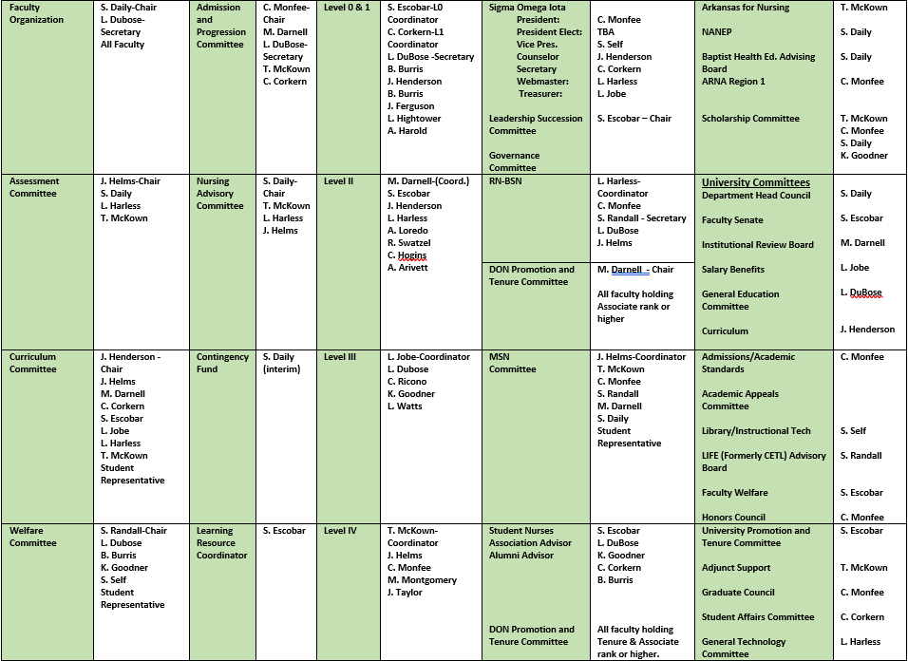

Appendix B Minutes Template Faculty Organization
Date:

P = Present A = Absent

 | Brittany Burris |  | Lisa DuBose |  | Jennifer Helms |  | Terri McKown
 | Chantell Corkern |  | Shaana Escobar |  | Jaye Henderson |  | Cheryl Monfee
 | Shelly Daily, Chair |  | Karmen Goodner |  | Lauren Hightower |  | Shelly Randall
 | Melissa Darnell |  | Lisa Harless |  | Laura Jobe |  | Caroline Ricono

Topic | Discussion | Rationale | Action
I. Call to Order
II. Minutes
III. Report of Committees
A. Welfare

B. Admission/Progression

C. Curriculum

D. Assessment

IV. Reports of Levels
A. Level 0

B. Level 1
C. Level 2

D. Level 3

E. Level 4

F. LPN to BSN

G. RN to BSN

H. MSN

V.

Appendix C Committee Minutes Template
_________________Committee
P = Present A = Absent

Chair

Topic | Discussion | Rationale | Action
I. Call to Order
II. Minutes
III. Old Business
IV. New Business
V. Other
VI. Adjourn
VII. Next Meeting

Appendix D Procedure for Writing Minutes
- Minutes should include committee name, date, time committee members present and absent.
  - The chair of the committee is the first person listed in the Present section.
Example: Present: J. Doe, Chair
  - Members are listed in alphabetical order and noted as present or absent.
- Minutes should begin with a documented call to order time.
- Minutes should be written according to the agenda.
- Minutes should progress with approval of previous meeting minutes, then onto agenda items, old business before new business.
- Minutes are written in complete sentences
- When referring to committee members, use the first initial, followed by the last name.
Example: J. Doe
- The person making the motion should be named. Example: It was moved by J. Doe to . . .
- When any action or recommendation is taken during a discussion, it should be recorded in the Action/Recommendation column. Discussions with no action required should include "No action” in the action column.
- If a motion was made, "Motion passed,” “Motion failed," or “Motion deferred” is documented in the Action column.
- The rationale column should be utilized to document the reason for implemented policies, recommendations, or decisions.
- Whenever an attachment is referred to or provided, it should be identified in the action column with the appropriate agenda item. Attachments must be identified by name/number. "See Attachment “A Name.”
- Adjournment time should be documented.
- Next meeting date should be provided if possible.
- When minutes are complete, secretary shall distribute to committee for review.
- When finalized, secretary shall post to DON Faculty and Staff Blackboard under the appropriate committee folder.

Appendix E Agenda Format

Committee:
Meeting Date:
Time:
Place:
- Call to Order
- Approval of Minutes
- Old Business

- New Business

- Other (if any)

Appendix F - Faculty Resources

Center for Faculty Life – Encouragement and support of faculty teaching, service and scholarship roles by fostering growth, innovation, community, and engagement. CFL contains initiative applications, events calendar, teaching tools, a link for new faculty resources, newsletters and contact information.

https://www.atu.edu/cfl/index.php
Faculty Handbook - General policies and procedures for Arkansas Tech University
https://www.atu.edu/academics/facultyhandbook.php
ATU Faculty Resources - Calendars and schedules, forms, promotion and tenure resources, links to publications (handbooks, catalogs), accreditation information, University committees, professional development, emergency operations, research resources, new faculty information, where to go, and other resources:
https://www.atu.edu/academics/faculty/facultyresources.php
Human Resources – Benefits, resources and forms, workplace notifications, leave of absence and accommodation, and HR contact:
https://www.atu.edu/hr/contact.php
ATU Library – Services for Faculty
https://libguides.atu.edu/services/faculty
Nurse Tim – Various nurse educator trainings. The DON purchases an annual departmental membership. Contact the DON administrative professionals for log in information:
https://nursetim.com/
National Council of State Boards of Nursing – NCLEX information and test plans, clinical judgment model, other faculty resources and publications:
https://www.ncsbn.org/
Office of Information Systems - Account management, email, Blackboard support, outage announcements, data security awareness, IT support for faculty and students, software requests and training, virtual training systems, etc.
https://ois.atu.edu/

Appendix G University and Department Orientation Checklist
  - Institutional responsibilities:
    - Tour of the campus, provide a campus map
    - Information relative to TIAA/CREF, insurance, etc.
    - Provide
      - Arkansas Tech University Faculty Handbook (online)
      - College Catalog (online)
    - Office and building keys
    - Photo ID, name tag

  - Nursing Department responsibilities:
    - Tour of Department facilities
    - Introduction to other faculty
    - Provide Access to DON Blackboard organization course
    - Provide Department Faculty and Advisor Handbook (online)
      - Overview of program to include:
        - Mission
        - Philosophy
        - Conceptual Framework
        - Curriculum Schema
        - Other pertinent facts
          - Organizational structure
          - Weekly schedule
      - Rank and Position descriptions
      - Policies/procedures
        - Preparation of materials to be submitted to administrative specialists
        - Utilization of departmental telephones
        - Sample forms utilized by Arkansas Tech University
    - Provide Department Student Handbook (online)
    - Provide copy of Nursing Program Admission Packet
    - Direct new faculty to online ATU Travel Guide
    - Teaching assignment and related responsibilities
      - Grading guidelines
      - Meetings
    - Committee assignments
    - Arrange tours of clinical facilities to be used by the new member.
    - Office
      - Use of computers
      - Use of copier
      - Supplies
    - Learning Resources
    - Advisement
      - Student
      - Hours
    - Promotion & Tenure Policies
    - Faculty Resource Notebook
    - Textbooks, syllabi, etc.
    - Clinical orientation upon request
      - Making client assignments
      - Guiding pre-post conference
      - Communication strategies
      - Student performance
      - Counseling students
      - Clinical teaching strategies
      - Legal issues
      - Written work
      - Evaluation process
    - Introductory simulation training
    - Introduction to assigned Peer Mentor _____
    - Workload/Contact Hours
    - Annual Evaluations

Appendix H DPTC Peer Review Long Form
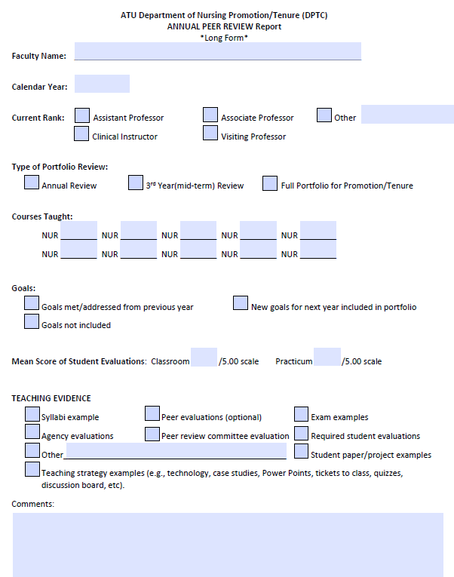

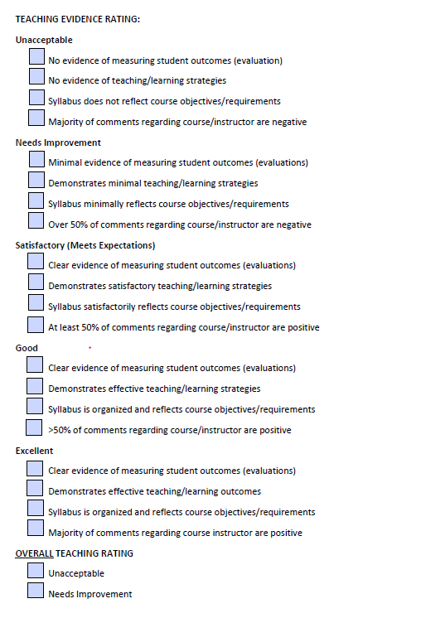

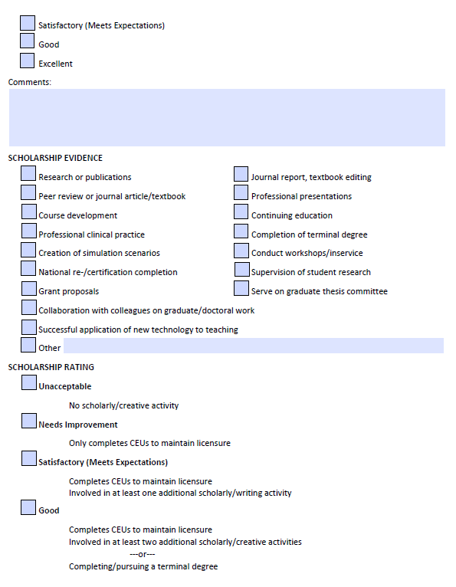

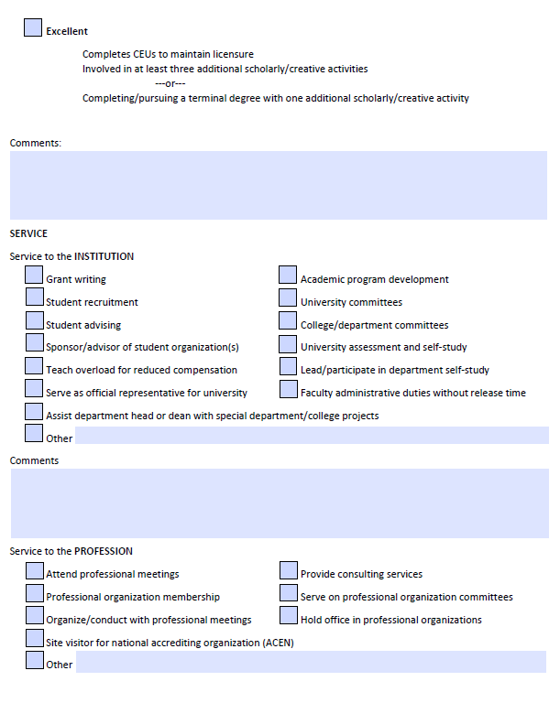

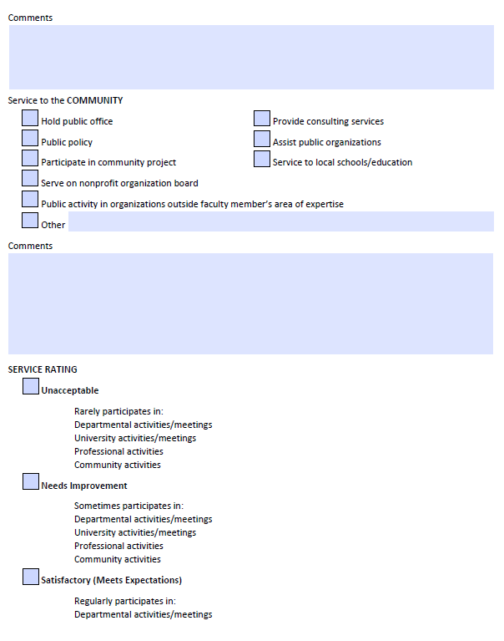

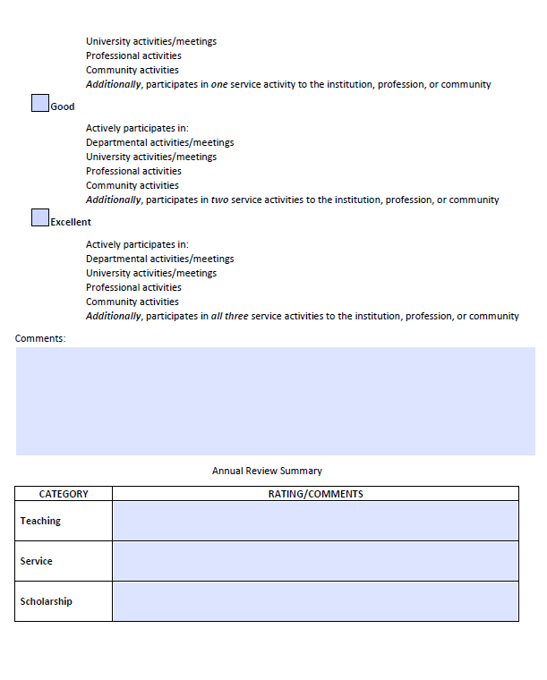

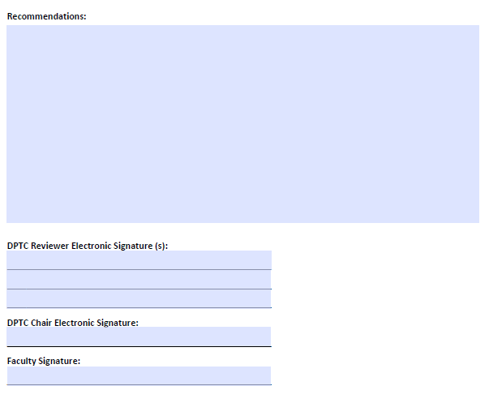

Appendix I DPTC Peer Review Abbreviated Form
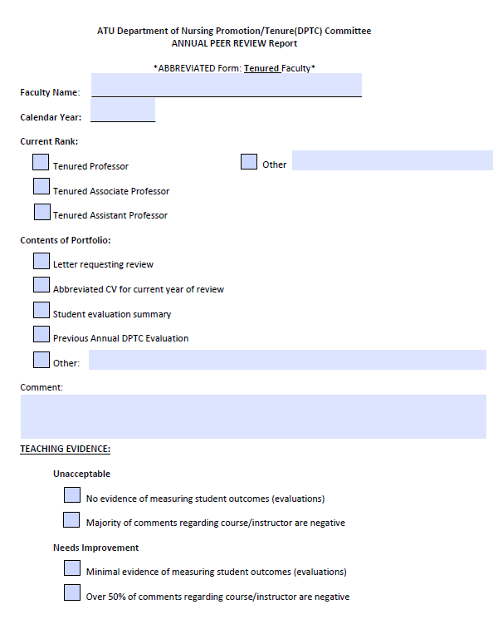

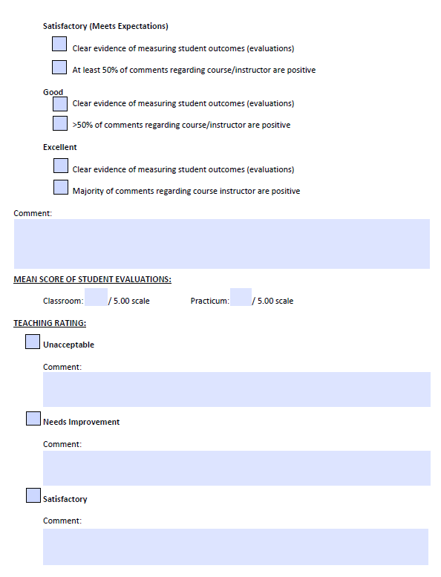

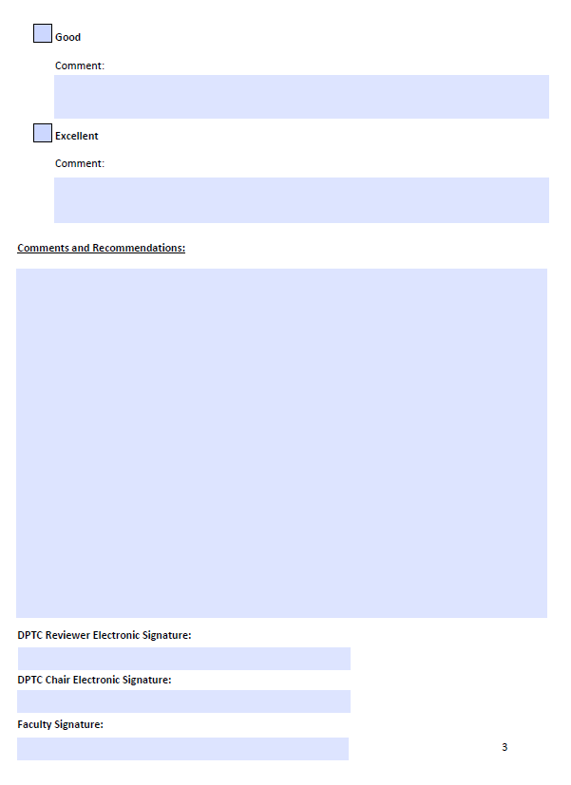

Appendix J Annual Evaluation

Faculty Member’s Name:
Academic Position:
January 20 to December 20
- Pertinent Data
  - Teaching (i.e., number of years of teaching at another university, number of years of teaching at ATU, evaluation rankings of classroom and clinical):
Overall assessment of teaching ____________
  - Scholarship (List professional/academic qualifications such as academic achievements, formal course work, activities, honors and awards, research, publications, presentations, etc.):
Overall assessment of scholarship___________
  - Service:
    - Service to the institution (support of student, advising, any campus sponsored activities, i.e., blood drive, etc.):
    - Department of Nursing Service/Committees:
    - Service to profession (professional memberships, member or officer):
    - Community service (community projects and positions held in them):

Overall assessment of service___________

Professional growth (workshops):

Goals (to improve teaching effectiveness):
SUMMARY:
SIGNATURES:
Faculty | Member | Date
Department | Head | Date

Appendix K Peer to Peer Evaluation Form
Date: _____________
Peer review of: ________________________________________ Course: ____________________
Teaching Techniques Utilized in the Course:

Overall Assessment of the Faculty Member’s Teaching Effectiveness:

Suggestions/Recommendations for improvement:

Peer review performed by: ________________ __________________________

*a copy of this peer-to-peer review was provided to the faculty member to include in their annual portfolio.

Appendix L Evaluation of Clinical Instructor by Clinical Agency
Your evaluation of this nursing instructor will assist the Head of the Department of Nursing in evaluating the instructor's influence and behavior in relationship to clients, students, and activities that facilitate the supervision and teaching of students.
Please rate the faculty member on the criteria listed below by circling the appropriate number as follows: 5=Excellent, 4=Good, 3=Average, 2=Needs Improvement, 1=Poor. If a criterion is not observed, circle NA. Please provide rationale for a rating of 1 in the comments section below.
Name of Faculty Member Being Rated: ________________________________________ Date: ________________
Behavior Observed | 1 | 2 | 3 | 4 | 5 | NA
1. Demonstrates an interest in welfare of your institution.
2. Reflects appropriate role model behavior for student.
3. Adheres to institutional policies and procedures.
4. Maintains open communications with students and staff.
5. Available to students/ staff/ clients when needed.
6. Personal appearance is neat and appropriate.
7. Demonstrates ability in problem solving to promote health.
8. Accepts and supports students in their learning.
9. Gives recognition to staff for assisting with student learning.
10. Organizes and assigns students learning experiences to meet the objectives.
11. Submits clinical objectives to appropriate staff.
Comments:
Signature: _____________________________ Title: _______________________________
Agency: _______________________________ Date: ______________________________

Appendix M Evaluation of Clinical Adjunct

Semester:  Fall  Spring Year: ____________
Adjunct Faculty Name: ____________________________________ Rank: _________________________
Course: ______________________________________________________________________________
Mentor/Level Coordinator: ______________________________________________________________

What worked well? ____________________________________________________________________
_____________________________________________________________________________________
_____________________________________________________________________________________
What could be improved? _______________________________________________________________
_____________________________________________________________________________________
_____________________________________________________________________________________
Suggestions/Recommendations: __________________________________________________________
_____________________________________________________________________________________
_____________________________________________________________________________________
Mentor Evaluation/Recommendations: ____________________________________________________
_____________________________________________________________________________________
_____________________________________________________________________________________
Overall Performance Rating:
❒ Outstanding  Excellent  Meets Minimum Standards  Does Not Meet Minimum Standards

Signature of Adjunct Faculty Member: ___________________________________Date: ________________

Signature of Mentor Date
Signature of Level Coordinator Date

Appendix N Advisory File

ARKANSAS TECH UNIVERSITY
Department of Nursing
Name________________________ Date__________________
Initial Interview:

Student received the following information regarding:
_____BSN Curriculum
_____Admission Criteria (two pages)
_____Advisement Appointment Directions
_____SNA
_____Crime Conviction Release Form
_____Academic Honesty Policy
_____Abilities and Skills Policy
Faculty Signature______________________
Student Signature______________________

Date____________________
Advisory Notes:

Appendix O Faculty Injury or Exposure in the Clinical Setting

If a faculty injury or exposure occurs in the clinical setting, the faculty member should seek immediate care and notify the Department Head as soon as possible. Faculty are required to follow the policies of the clinical agency and Arkansas Tech University.
- Faculty Injury
    - Faculty member should seek immediate care and notify the DON Department Head as soon as possible. Faculty should follow the policies of the clinical agency, ATU Faculty Handbook and ATU Human Resources.
    - All employees are insured under the Worker's Compensation Insurance program without cost to the individual. This program provides benefits in connection with injuries received on the job. Injuries should be reported to the Human Resources Office within twenty-four hours. Faculty members who are injured while acting within the scope of their employment will be eligible to file for Workers’ Compensation insurance.
- Exposure to Blood Borne Pathogens
    - Faculty member should seek immediate care and notify the DON Department Head as soon as possible. Faculty should follow the policies of the clinical agency, ATU Faculty Handbook and ATU Human Resources.
    - Injured faculty should discuss medical history and status with the assessing provider. Assessment of the faculty’s risk status with treatment and follow-up is required. Identification of the source patient and subsequent risk appraisal should be included in the report. See ATU Bloodborne Pathogens Policy.
    - All employees are insured under the Worker's Compensation Insurance program without cost to the individual. This program provides benefits in connection with injuries received on the job. Injuries should be reported to the Human Resources Office within twenty-four hours. Faculty members who are injured while acting within the scope of their employment will be eligible to file for Workers’ Compensation insurance.

Appendix P Prelicensure and LPN to BSN Application
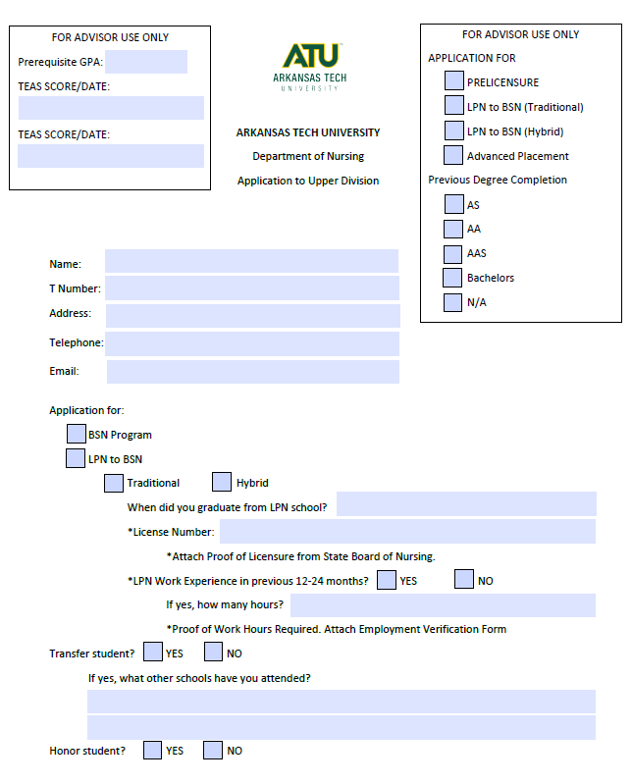

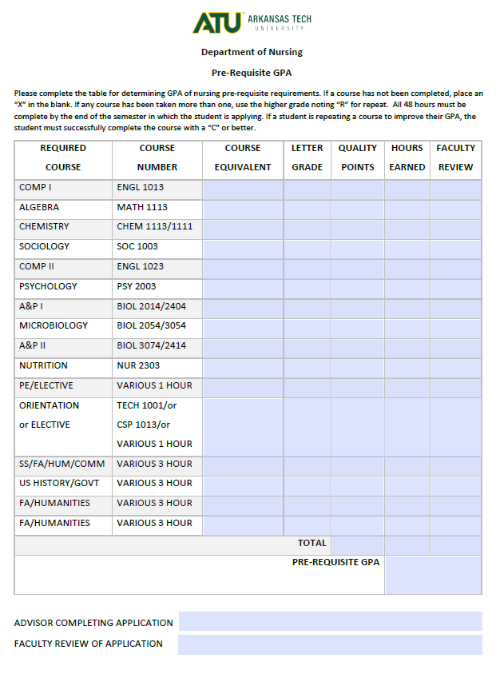
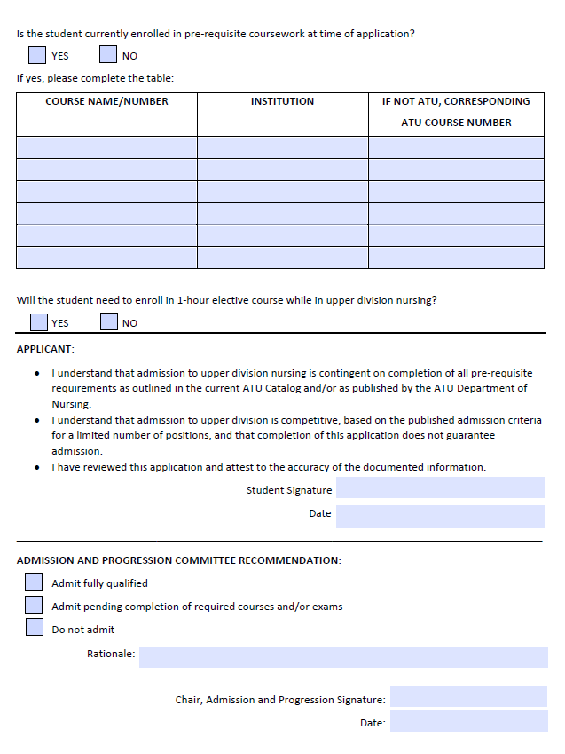

Appendix Q RN to BSN Application
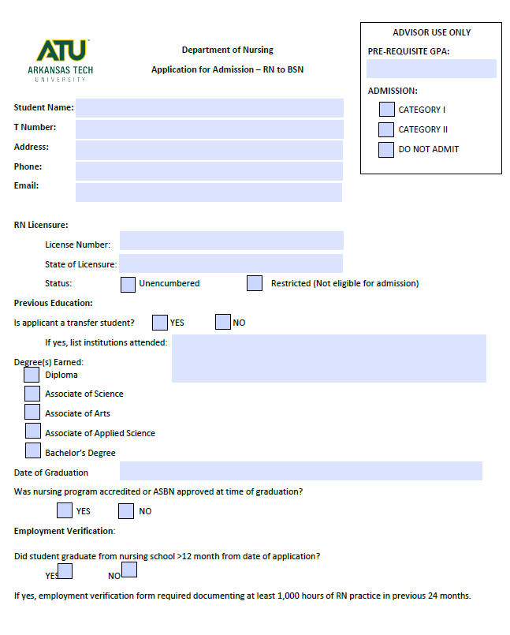
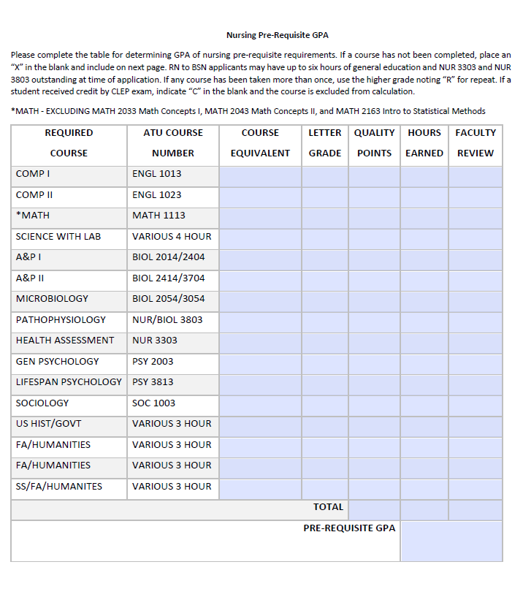

Appendix R Reapplication to Prelicensure/LPN to BSN Program
Reapplication to: □ Level 0 □ Level I □ Level II □ Level III □ Level IV
Program: □ Prelicensure □ LPN to BSN
Student Name: __________________________________ T Number: ________________________
Email: __________________________________________ Phone: __________________________
Prerequisite GPA (48 hours): __________________
Completed Upper Division Courses
LEVEL 0 |  |  | LEVEL I
COURSE | GRADE | QUALITY POINTS | COURSE | GRADE | QUALITY PONTS
NUR 2023 |  |  | NUR 3204
NUR 3103 |  |  | NUR 3213
NUR 3803 |  |  | NUR 3404
NUR 3303 |  |  | NUR 3402
PSY 3813 |  |  | NUR 3513
LEVEL II |  |  | LEVEL III
COURSE | GRADE | QUALITY POINTS | COURSE | GRADE | QUALITY POINTS
NUR 3606 |  |  | NUR 4206
NUR 3802 |  |  | NUR 4303
NUR 3805 |  |  | NUR 4405
 |  |  | Elective (list course)
Level IV |  |  | Cumulative Nursing GPA*
COURSE | GRADE | QUALITY POINTS | *Include 48 hours of general education and completed upper division courses
NUR 4606
NUR 4804
NUR 4903
Student should attach a letter of intent addressing past failure and a plan of action for future success within the nursing program.
Student Signature: ___________________________________________ Date: ________________________________
Faculty Signature: ____________________________________________ Date: _______________________________

Appendix S Reapplication to RN to BSN Program

NAME: ______________________________________________ T#: _____________________________
EMAIL: __________________________________________ PHONE: _____________________________
Prerequisite GPA (required RN to BSN pre-requisites only): ___________/____________Quality Points
Completed RN to BSN Courses
COURSE | HOURS | GRADE | QUALITY POINTS  EARNED
NURN 4002
NURN 4003
NURN 4013
NURSING ELECTIVE:
NURN 4024
NURN 4303
NURN 4034
NURN 4045
NURSING ELECTIVE:
Cumulative Nursing GPA*
*Include pre-requisite and completed nursing courses

Students should attach a letter of intent addressing past failure and a plan of action for future success within the nursing program.

Student Signature: ___________________________________________ Date: __________________

Faculty Signature: ____________________________________________ Date: __________________

