# Navigating to Budget Development

Machine generated alternative text:
_7 
https://inancessb-test.ec.atu.edu:8102FinanceSel'Service/ssb/inanceCommonDashboard 
ARKANSAS TECH 
U N IVERSITY 
My Finance 
Hello Robert, 
Create, edit and approve transactions and view financial information for department / organization. 
My Finance Query 
Create, view and share budget availability, encumbrance and 
payroll queries. 
My Journals 
Create and view draft, pending and completed journals and 
supporting documentation. 
Approve Documents 
View list of documents pending approval. Approve, disapprove, or 
deny. 
Delete Finance Template 
Delete templates for Finance Queries, Budget Development, and 
Purchase Orders. 
o 
My Requisitions 
Create and view draft, pending and completed requisitions and 
supporting documentation. 
Purchase Orders 
Create purchase orders or purchase orders in process. 
Budget Development 
Create and review fiscal year operating budgets for the budget 
development process. 
View Document 
View draft, pending and completed documents with related 
information and approval history. 

# Machine generated alternative text: ARKANSAS TECH U N IVERSITY Budget Development My Finance Budget Development My Worksheets View list of worksheets to update and review. Budget Development Worksheets Create queries to update and review budget worksheets. Budget Development Query Create queries to review Budget Development activity. Maintain Organizaüon Locks Review and update Organization lock statuses setting restrictions on worksheet changes.

Worksheets are where you can change budget amounts

Queries allow you to see multiple budgets on one screen or a single budget.

# How to Look at Budgets

## How to look at a single budget

Machine generated alternative text:
ARKANSAS TECH 
U N IVERSITY 
Budget Development 
Create Worksheet Query 
My Finance 
Create Worksheet Query 
Click Create Query to design a worksheet ofyour choice, or select a saved query and click Retrieve Query to begin with a worksheet template. 
Create a New Worksheet Query 
Create Query 
Retrieve Existing Worksheet Query 
Saved Query 
Select 
Retrieve Query Machine generated alternative text:
ARKANSAS TECH 
U N IVERSITY 
Budget Development 
My Finance 
Budget Development 
My Worksheets 
View list of worksheets to update and review. 
Budget Development Worksheets 
Create queries to update and review budget worksheets. 
Budget Development Query 
Create queries to review Budget Development activity. 
Maintain Organizaüon Locks 
Review and update Organization lock statuses setting 
restrictions on worksheet changes. 

# 

Select Line Item Detail. Click Continue.

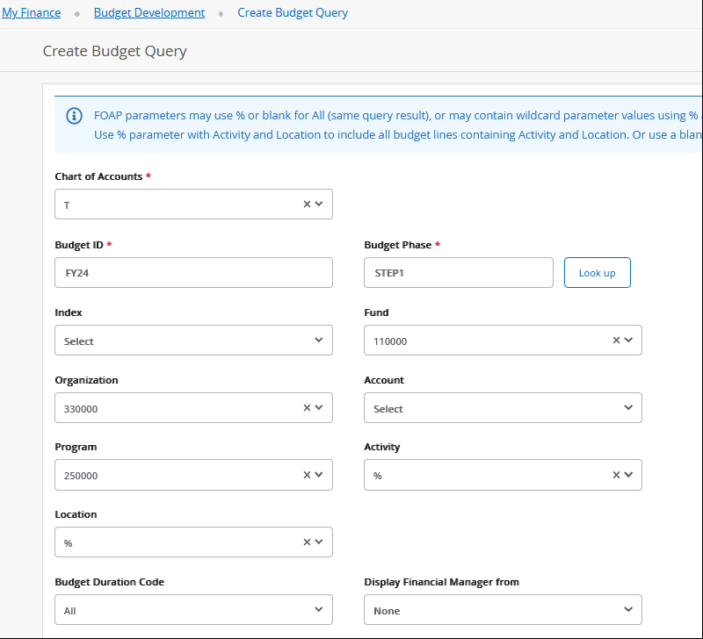

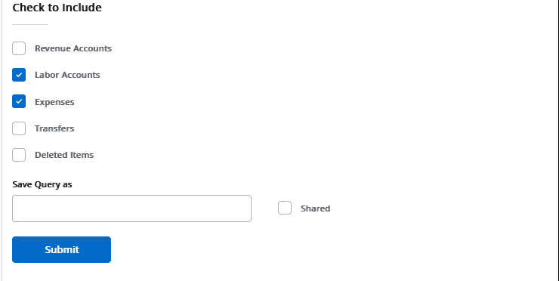

Chart of Accounts is always T. Budget ID will be FY24. Budget Phases will be provided by the VPAF as the budget process unfolds. You may have to work on more than one but there will only be one Phase in use at a time.

Entering the Index code will pre-fill the Fund, Org and Program for you. Remove the Program code because some budgets may have salaries allocated to multiple program codes. Removing it here will allow you to see them all. Unless you want to restrict it to one account line, leave the account blank. We do not currently use Activity or Location.



Select Labor Accounts and Expense Accounts. If you are reviewing a Revenue Step in the budget process, select Revenue Accounts.

In order to see the detail within the line you can click the blue organization and account codes.

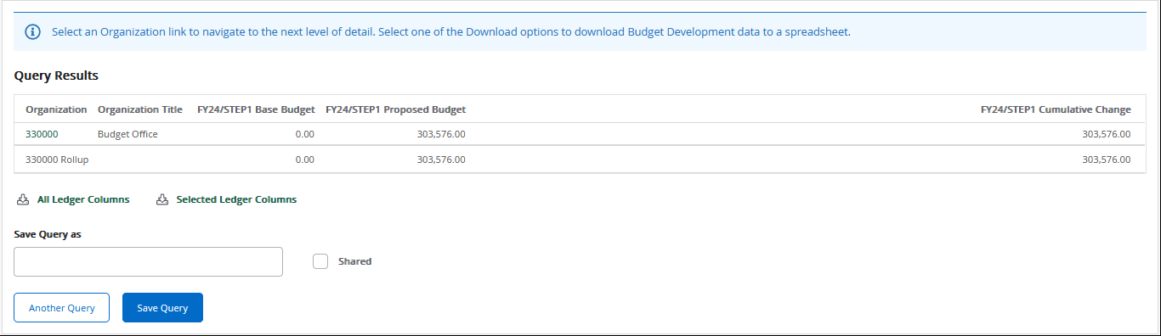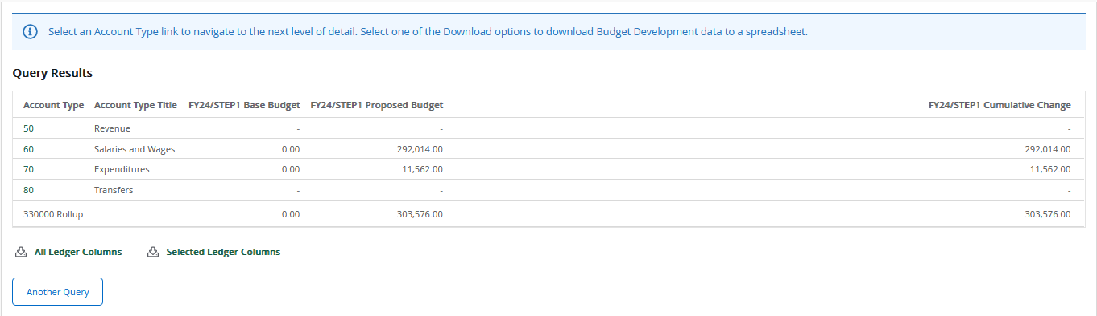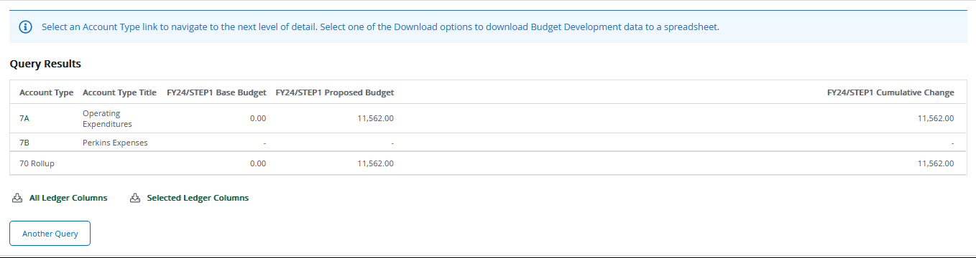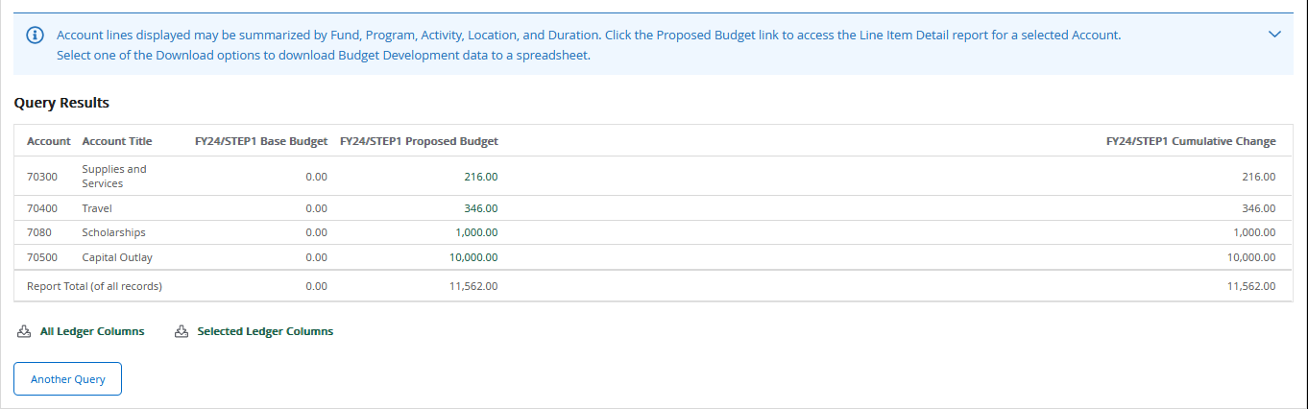

## How to look at multiple Organizations

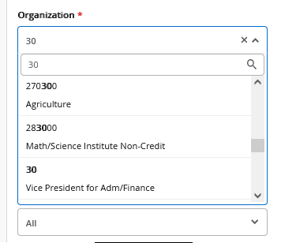Machine generated alternative text:
My Finance 
nugget Development 
Create Budget Query 
Create Budget Query 
FOAP parameters may use % or blank for All (same query result), or may contain wildcard parameter values using % 
use % parameter with Activity and Location to include all budget lines containing Activity and Location. Or use a blan 
Chart of Accounts 
Budget ID 
Select 
Organizaöon 
330000 
Program 
250000 
Budget Duration Code 
Budget Phase 
Look up 
110000 
Select 
Display Financial Manager from 
None 

Navigate to the Create Budget Query page as you did before. Instead of using a 6 digit organization code you will use one of the shorter roll-up codes. For example, if the VPAF wants to see all the budget within their area, they would use 30.

# 

A list of the organizations that fall under the roll-up that you selected will appear along with their total budget amount. You can click on the organization codes to get more detail.

# How to Change Budgets

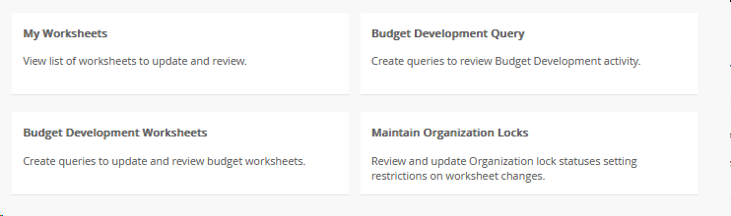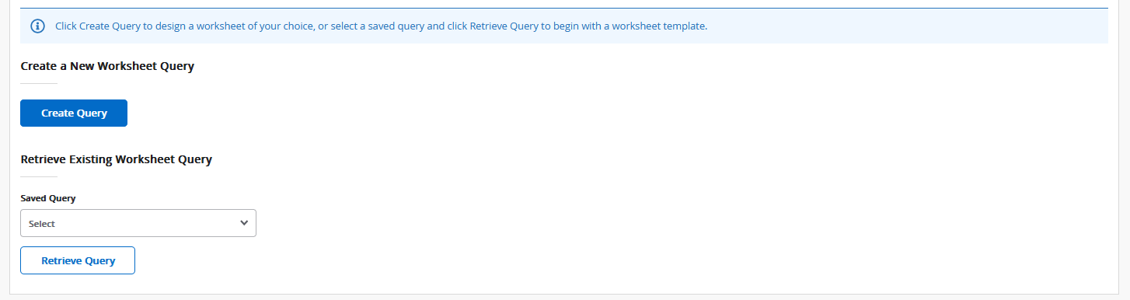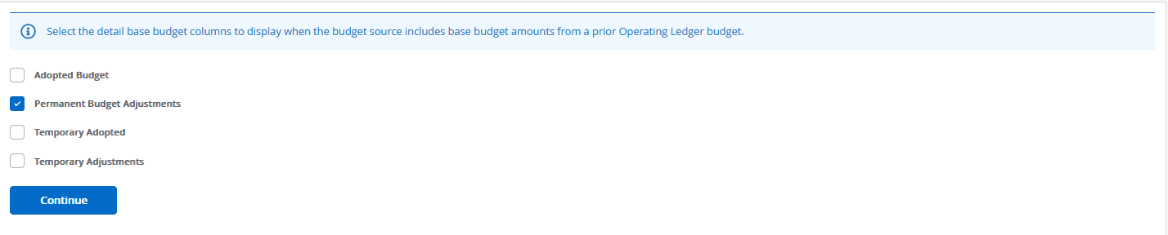Machine generated alternative text:
Chart of Accounts 
Budget ID 
Select 
Organizaöon 
000000 
Program 
Select 
Select 
Budget Duration Code 
Budget Phase • 
Look up 
110000 
Select 
Select 
Display Financial Manager from 
None 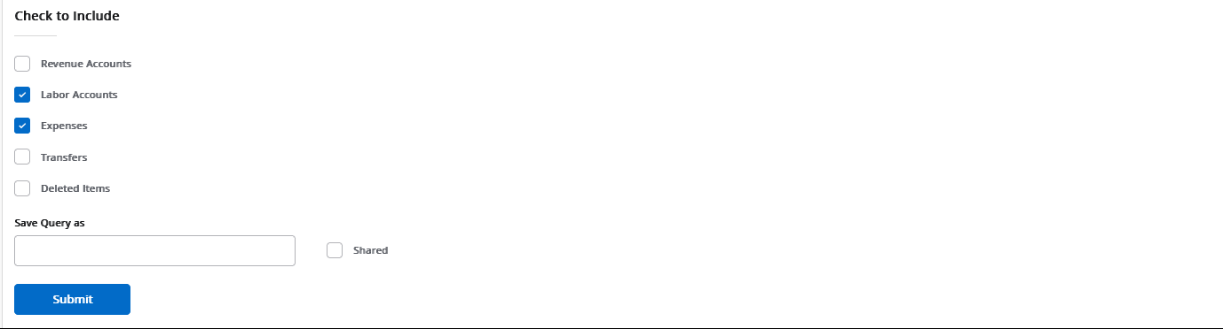

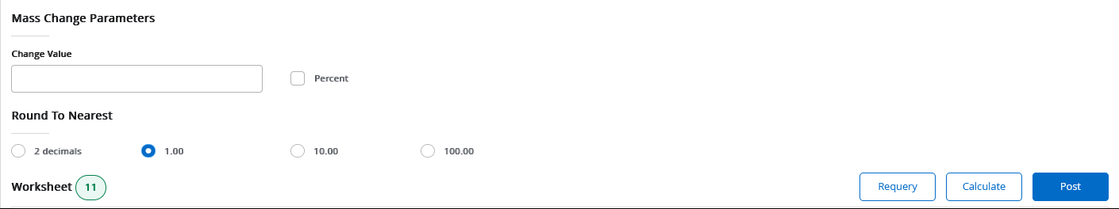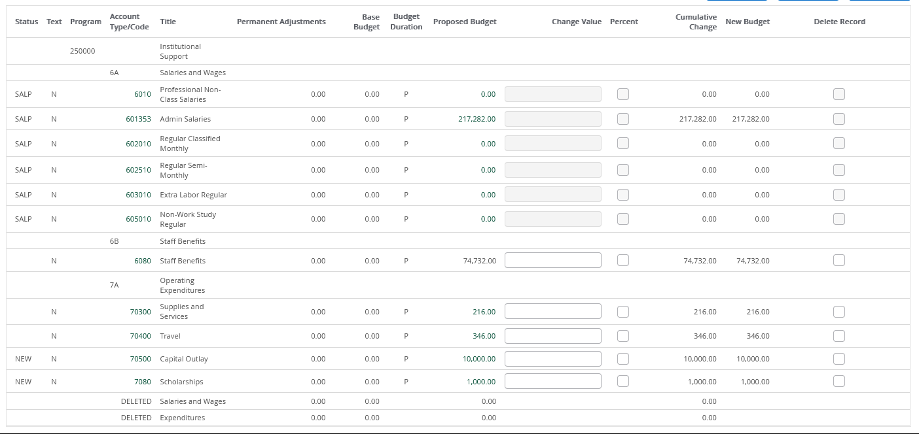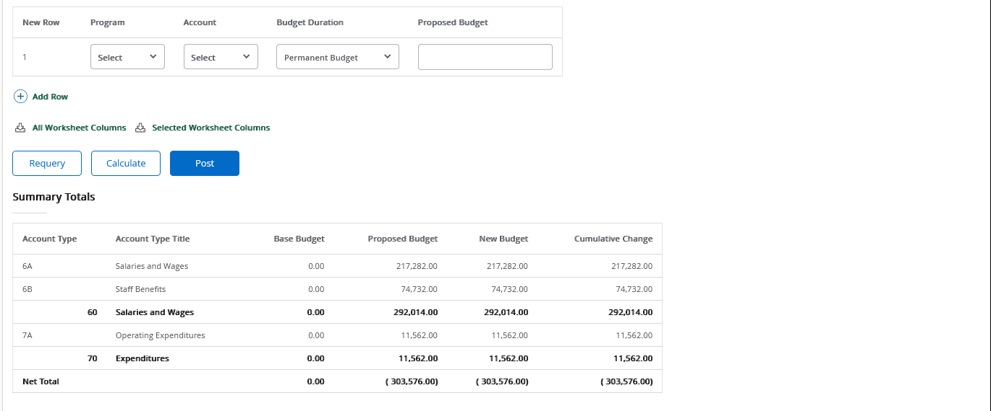

You can increase multiple lines all at once using these options. If you enter a percent or an amount and then click Calculate, it will add it to the Cumulative Change Column below.

Use the Change Value fields to increase or decrease budget lines.

If you need to budget funds in a line that doesn’t appear above, use this section to add a new budget line. Use the program code that defaults to the Index you’re working on. The accounts should only be 70300, 70400, 70500, and 7080. Once you’ve made your changes and added any new lines, click Post to save your changes.