My Finance Query

Banner 9 Self-Service

**One Tech Home**

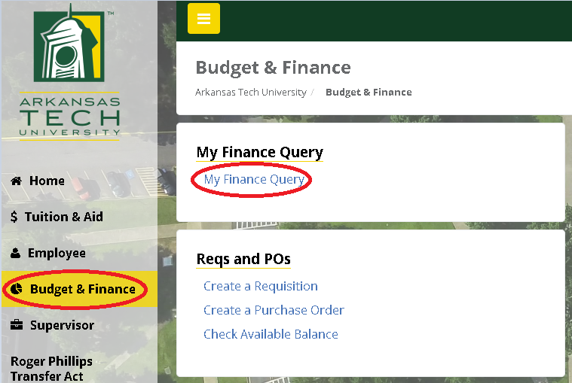

1. Log on to onetech.atu.edu and under the Budget & Finance tab select My Finance Query.



2. Select Favorites or Saved Queries to view previously created queries.

3. Use the Search Query box to retrieve a query by name or description.

**Budget Queries**

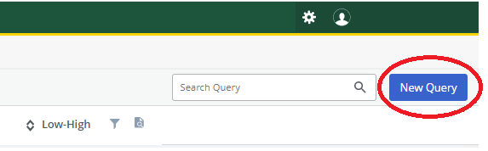

4. Click New Query and click the Select Query Type drop-down list and select Budget Status by Organizational Hierarchy.

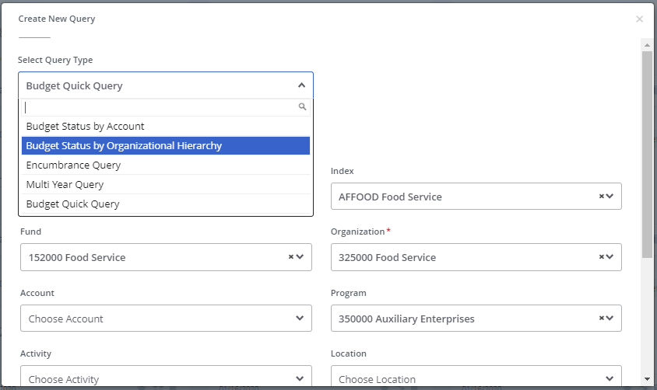

**Budget Queries**

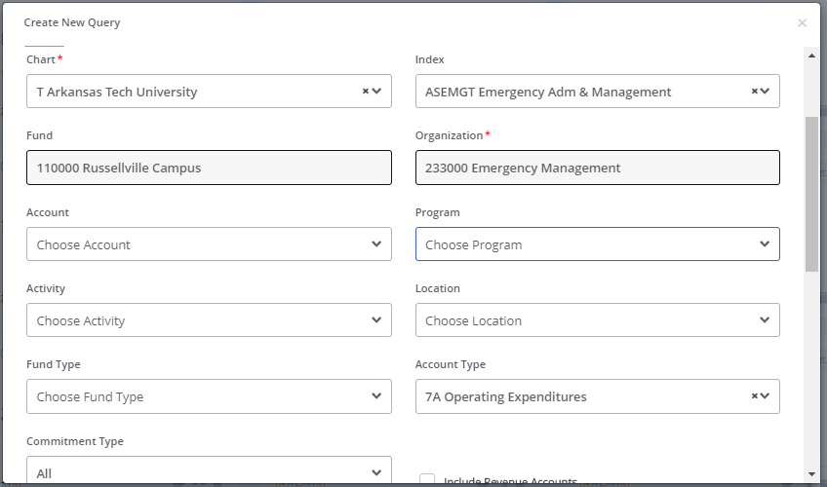

5. Select “T Arkansas Tech University” from the Chart dropdown menu.

6. Enter your Index Code. The Fund, Organization, and Program fields will fill automatically. Verify the fields are correct and delete the program code to ensure everything for the department can be viewed. You may enter an Account Type if desired. Select 7A for Operating Expenditures.

**Budget Queries**

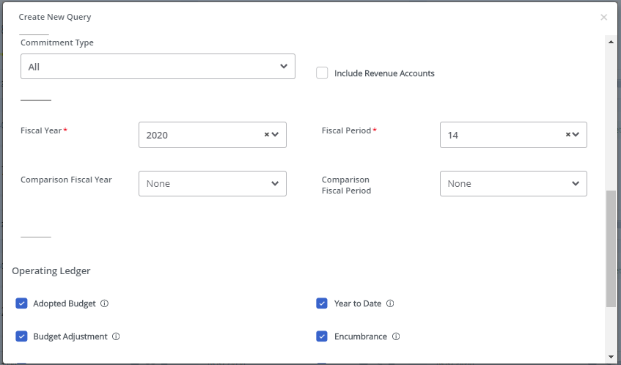

7. The Commitment Type should be set at All.

8. Select “Include Revenue Accounts” if your department generates revenue.

9. Select the Fiscal Year drop-down arrow to choose the current fiscal year.

10. Set the Fiscal Period to 14. It will always stay at 14.

11. The Comparison Fiscal Year and Comparison Fiscal Period drop-down boxes should both be set to None.

**Budget Queries**

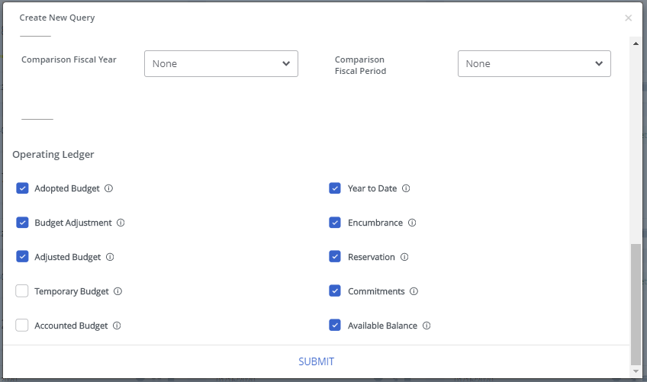

12. Make sure every checkbox beside the Operating Ledger Data columns is selected except for Temporary Budget and Accounted Budget.

13. Click Submit.

**Budget Status by Organizational Hierarchy**

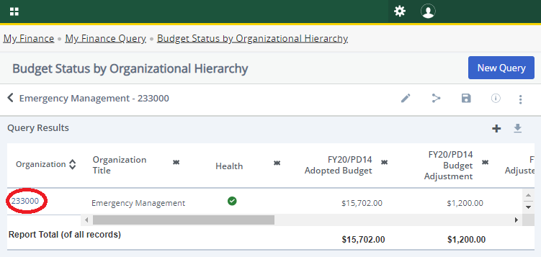

14. A breakdown of the entire budget will now appear. Make sure the department is correct and click on the blue Organization Code to view the different accounts within the budget.

Any items that appear in blue (like the organization code above) can be clicked to obtain more detailed information.

**Budget Status by Organizational Hierarchy**

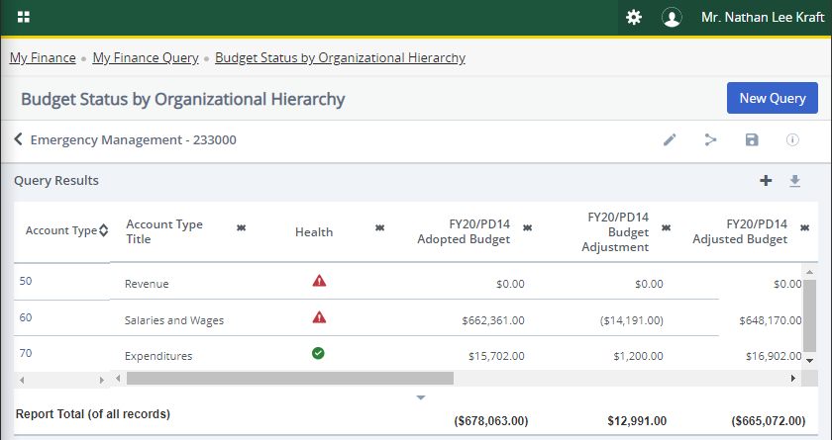

15. The selected Account Types will now appear. 50=Revenue, if any. 60=Salaries and Wages. 70=Expenditures.

16. This page shows the Adopted Budget (Beginning Budget), the Budget Adjustment (any transfers made in or out of the budget), and the Adjusted Budget (Current Budget).

**Budget Status by Organizational Hierarchy**

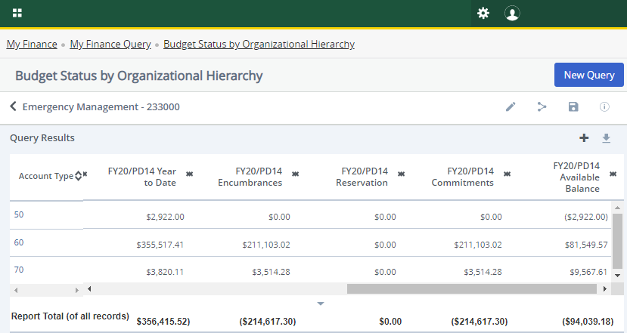

17. Scroll over, if needed, to see the remaining columns.

18. The Year to Date contains all the expenses that have occurred for the current fiscal year.

19. Encumbrances are purchase orders completed and approved as well as direct general encumbrance items such as phone charges, copies, etc.

20. Reservations are completed requisitions that have not yet been turned into purchase orders.

21. Commitments are the sum of encumbrances and reservations.

22. The last column shows the total balance available in each account type.

23. Click on the Account Type you wish to view for more details.

**Budget Status by Organizational Hierarchy**

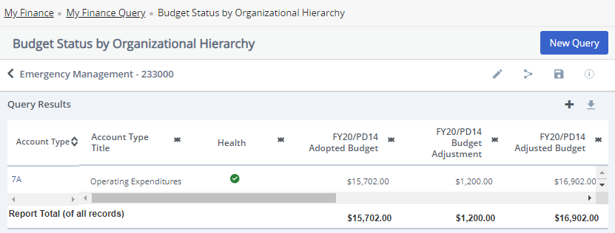

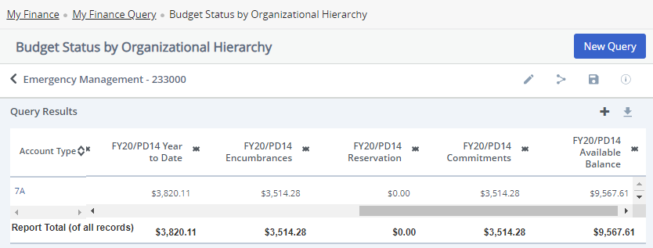

24. For this example, we are viewing the expenditures category (7000).

**25. This is the screen to use for checking available funds before doing requisitions.**

**26.** **When figuring your balance, remember that P-Card charges and Bookstore charges that have not yet been expended will not appear on the report as encumbered or reserved.** **Any charges made for these items will need to be subtracted from the available balance if they have not yet been charged to project a more accurate available balance.**

27. Select 7A Operating Expenditures to reveal the account codes that make up this account type.

**Budget Status by Organizational Hierarchy**

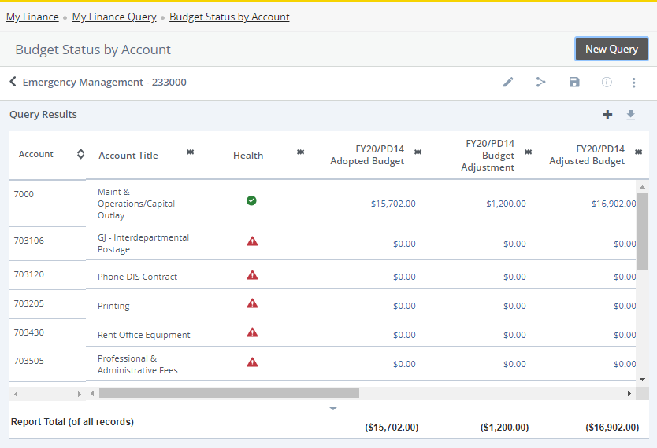

28. This screen will show the General Maintenance and Operations/Capital Outlay account (7000) at the top of the screen with the adjusted budget. Notice that the Available Balance changes back to the Adjusted Budget only, with no expenditures, encumbrances, or reservations subtracted out.

**29.** **Do not use this screen to determine budget availability before doing requisitions. (See step 25 for the correct screen to use)**

30. Below will be all the subcategories that include the expenses, encumbrances, and reservations.

31. You may click on any number in blue to find out more detailed information. You can also right click to open the detail screens in a new tab or window if you prefer.

**Budget Status by Organizational Hierarchy**

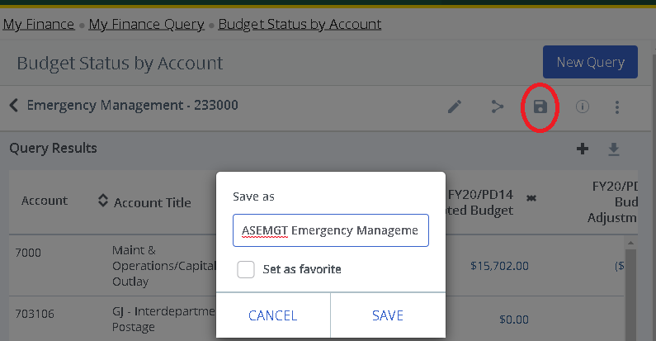

31. To save a query for future use, click the Save As icon. Query names must be unique and cannot be longer than 30 characters. The suggested naming convention is *INDEX Budget Name user initials*.

32. A query can be added to the Favorites tab by checking Set as favorite.

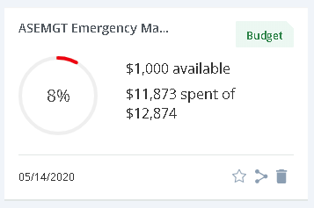

33. A tile for your saved query will now be added to Saved Queries (and Favorites if desired).